RoadSense.ai – Task 5
Data Visualization
Road accident data analysis | India, 2022
Purpose. Visualize the cleaned working dataset to examine accident cases, deaths, the relationship between cases and injuries, and the distribution of existing data-status labels.

1. Dataset and scope
The Task 3 cleaned CSV contains 759 rows and the fields State/UT, District, Accident Cases, Injured, Died, Data Status, Source, and Data Quality Note. The charts use the numeric fields after safe numeric conversion.
The district ranking charts use 27 Tamil Nadu records whose Source field names the Tamil Nadu Transport Department. These are source-labelled candidates for review, not an India-wide ranking. The current Tamil Nadu comparison table in the official report supports accident and death counts; injury figures have not been independently confirmed from that table.

2. Visualization results

Chart 1 – Top 10 Tamil Nadu district records by accident cases
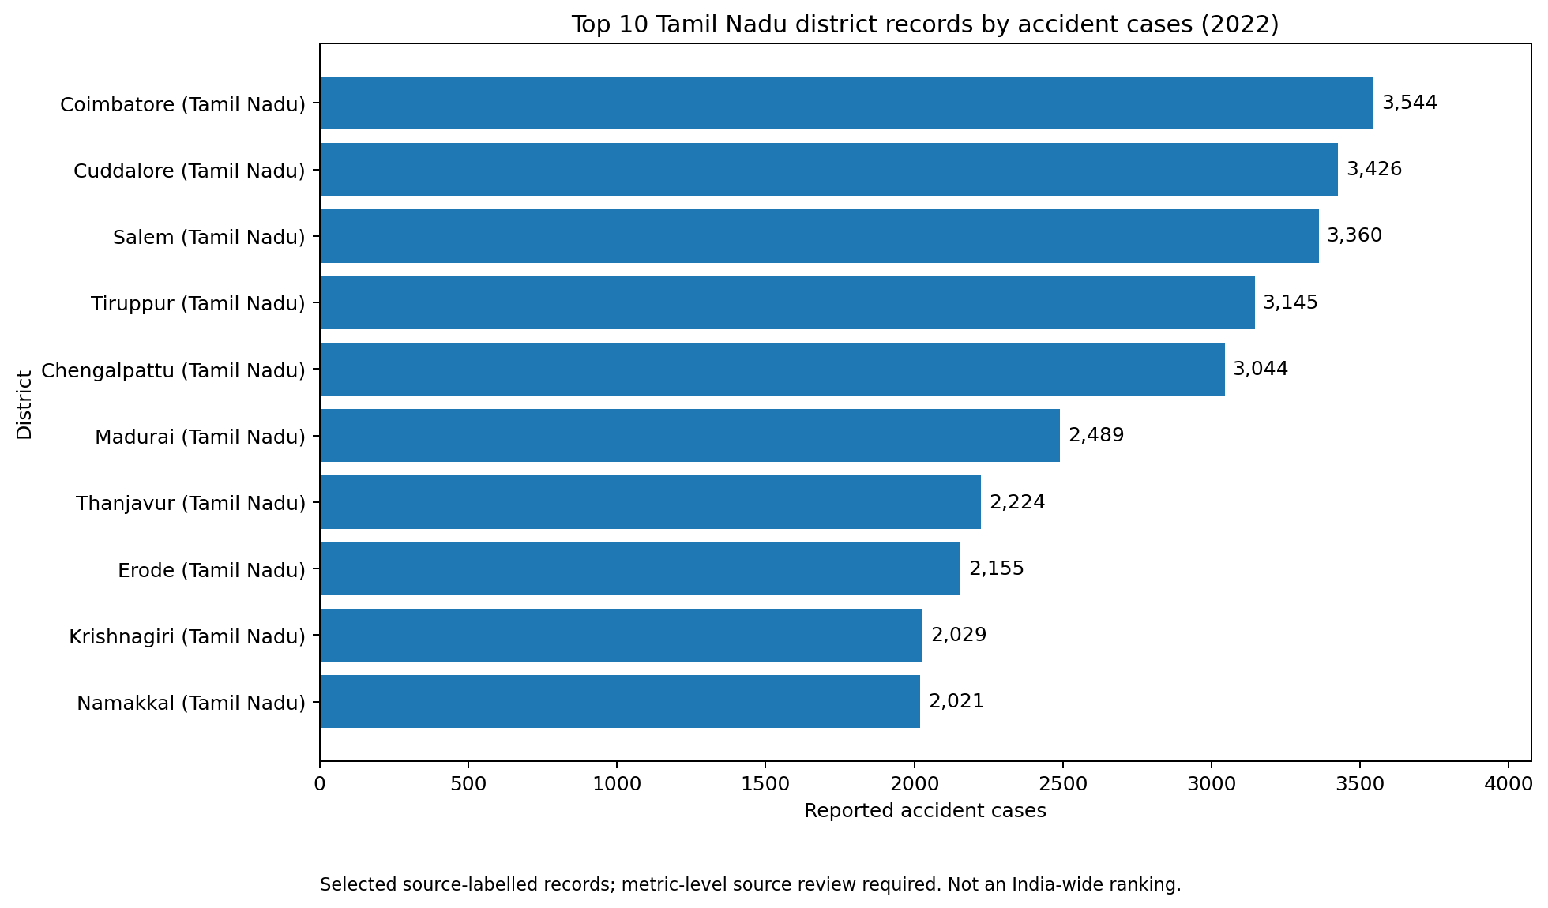
Observation. Within the selected records, Coimbatore has the largest accident-case value (3,544), followed by Cuddalore (3,426) and Salem (3,360). This result describes the selected source-labelled Tamil Nadu rows only.

Chart 2 – Accident cases versus injuries
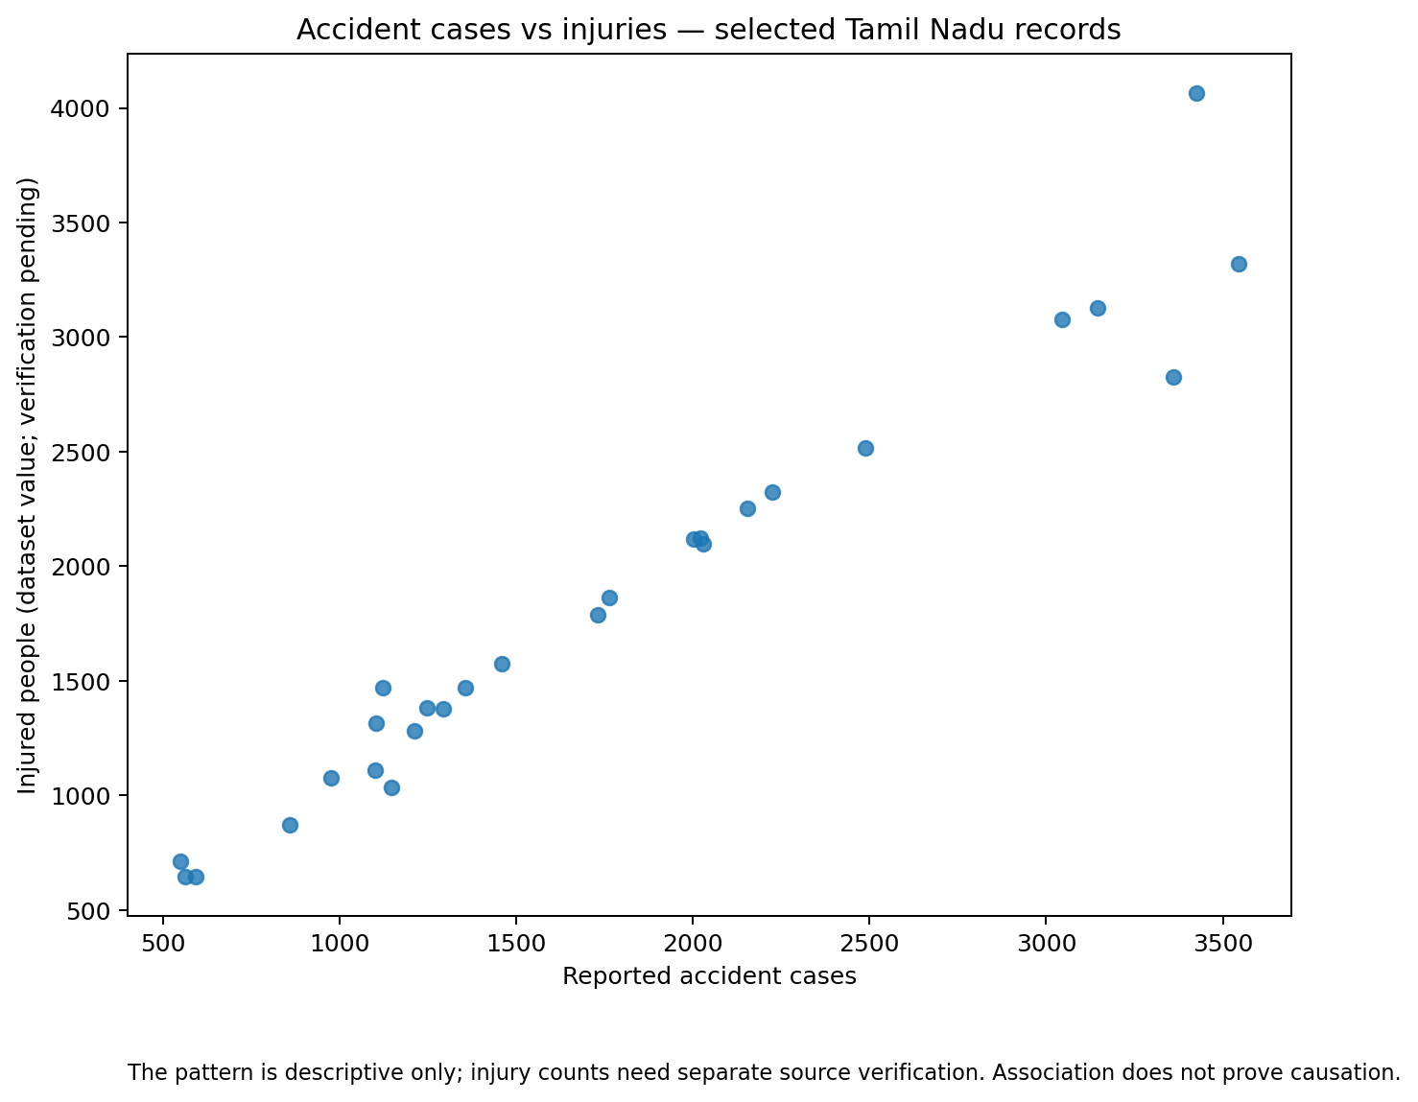
Observation. The scatter plot shows a generally positive visual association: rows with higher accident-case values often also show higher injury values. This is descriptive, not causal. Injury values require separate source verification before substantive conclusions are drawn.

Chart 3 – Top 10 Tamil Nadu district records by deaths
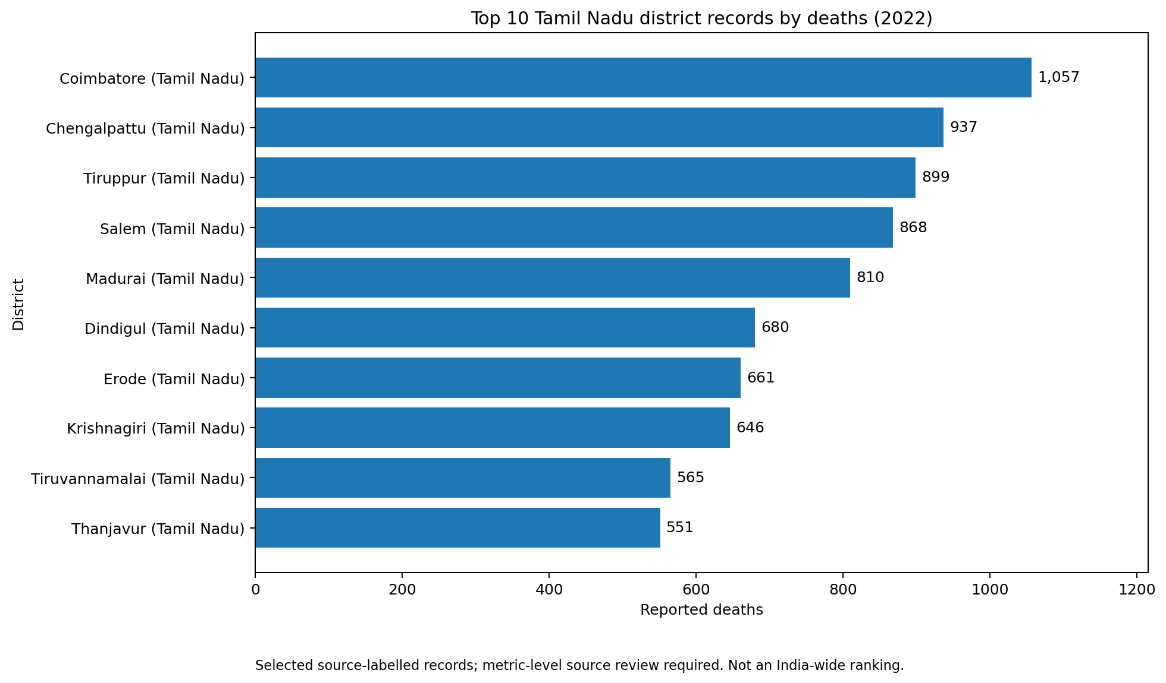
Observation. Within the selected records, Coimbatore has the largest death count (1,057), followed by Chengalpattu (937) and Tiruppur (899). These are rankings among selected records, not an all-India ranking.

Chart 4 – Records by existing data-status label
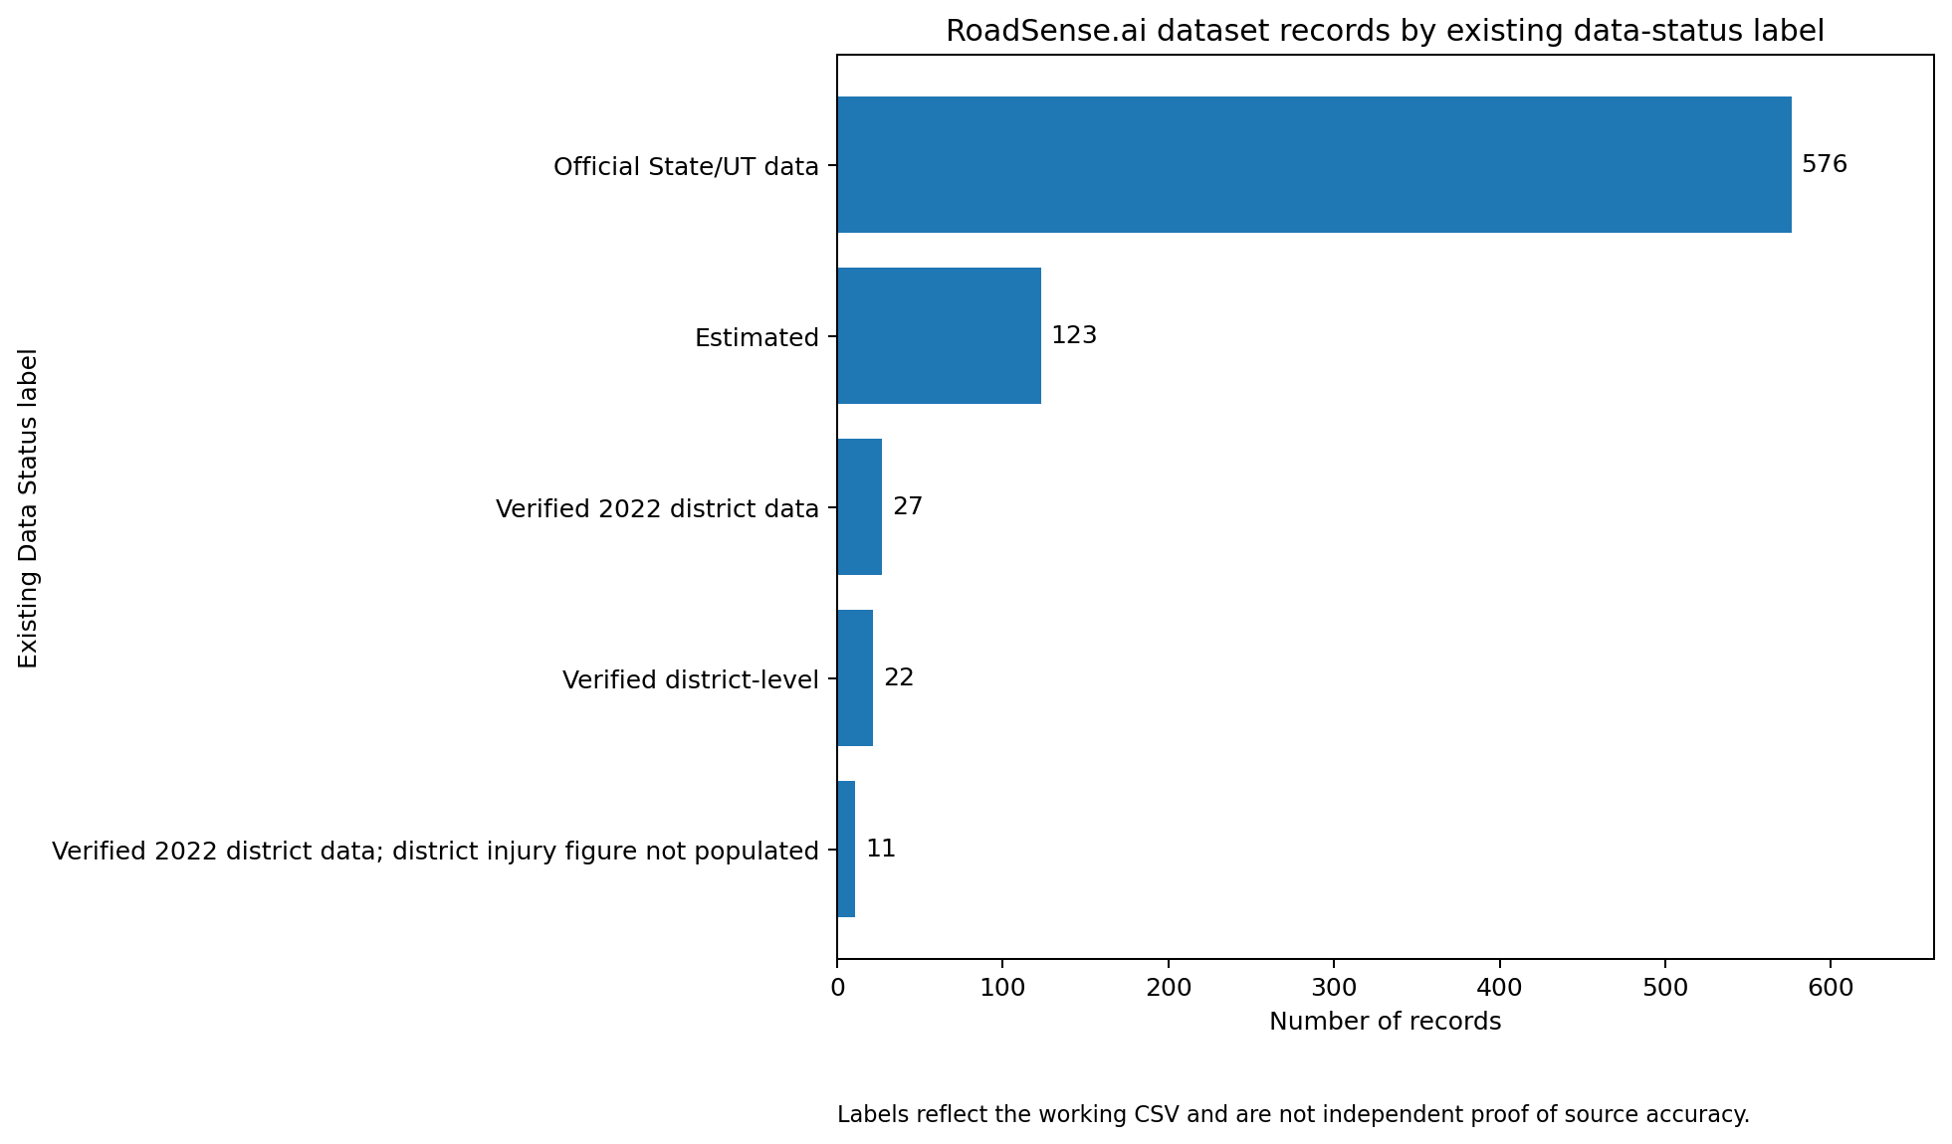
Observation. The working CSV has 759 records. Status-label counts are:
- Official State/UT data: 576
- Estimated: 123
- Verified 2022 district data: 27
- Verified district-level: 22
- Verified 2022 district data; district injury figure not populated: 11

3. Tools and method
Python, Pandas, and Matplotlib were used. The script reads the cleaned CSV, converts accident cases, injuries, and deaths to numeric values, selects the 27 Tamil Nadu records whose Source field names the Tamil Nadu Transport Department, creates the charts, and saves a chart-review CSV. The data-status chart counts existing labels across all 759 rows.

4. Data quality, limitations, and interpretation
- The existing Data Status and Source fields are text labels; their presence alone does not independently prove the accuracy of a record.
- The official Tamil Nadu comparison table checked for this project supports accident and death figures for the selected districts. The injury figures in the working CSV were not verified from that table and need a separate source.
- The rankings are limited to 27 Tamil Nadu records selected by their source description. They must not be described as top districts across India or as a complete ranking of every Tamil Nadu district.
- The dataset contains 123 records labelled Estimated. Estimated district values must not be presented as directly reported district statistics.
- Some rows labelled Official State/UT data may repeat state/UT-level values across district names. Such rows must not be ranked as district data without district-level confirmation.
- Do not add district rows to claim official state totals unless records are complete, mutually exclusive, and supported by the source.
- The available columns do not include geographic coordinates, so a reliable accident hotspot map cannot be built from this CSV alone.

5. Files produced
- RoadSense_AI_Task_5_Data_Visualization.py – improved chart-generation script.
- Task5_Top_Districts_Accidents.png – accident-case ranking chart.
- Task5_Cases_vs_Injuries.png – scatter plot.
- Task5_Top_Districts_Deaths.png – death ranking chart.
- Task5_Data_Status.png – data-status count chart.
- RoadSense_AI_Task_5_Chart_Records_For_Review.csv – rows used in the district charts.

6. Reproduction
Place the cleaned CSV beside the Python script and run:
python "RoadSense_AI_Task_5_Data_Visualization.py"
Dependencies: pandas and matplotlib (install with: python -m pip install pandas matplotlib).

