

**TRIBHUVAN UNIVERSITY**

**INSTITUTE OF ENGINEERING**

**THAPATHALI CAMPUS**

**A Project Report**

**On**

**Book Store Management System**

**Submitted By:**

Anvil Shakya (THA081BEI006)

Aviyan Sharma Khabas (THA081BEI008)

Alok Sharma (THA081BEI004)

Nishan Parajuli (THA081BEI023)

**Submitted To:**

Department of Electronics and Computer Engineering

Thapathali Campus

Kathmandu, Nepal

March,2025



**TRIBHUVAN UNIVERSITY**

**INSTITUTE OF ENGINEERING**

**THAPATHALI CAMPUS**

**A Project Report**

**On**

**Book Store Management System**

**Submitted By:**

Anvil Shakya (THA081BEI006)

Aviyan Sharma Khabas (THA081BEI008)

Alok Sharma (THA081BEI004)

Nishan Parajuli (THA081BEI023)

**Submitted To:**

Department of Electronics and Computer Engineering

Thapathali Campus

Kathmandu, Nepal

In partial fulfillment for the award of the Bachelor’s Degree in Electronics and Communication Engineering.

**Under the Supervision of**

Anup Shrestha

March,2025

# 

# DECLARATION

We hereby declare that the report of the project entitled **“Book Store Management System”** which is being submitted to the **Department of Electronics and Computer Engineering, IOE, Thapathali Campus**, in the partial fulfillment of the requirements for the award of the Degree of Bachelor of Engineering in **Electronics and Communication Engineering**, is a bonafide report of the work carried out by us. The materials contained in this report have not been submitted to any University or Institution for the award of any degree and we are the only author of this complete work and no sources other than the listed here have been used in this work.

Anvil Shakya (THA081BEI006): ________________________

Aviyan Sharma Khabas(THA081BEI008): ________________________

Alok Sharma(THA081BEI004): ________________________

Nishan Parajuli(THA081BEI023): ________________________

**Date:** March,2025

# CERTIFICATE OF APPROVAL

The undersigned certify that they have read and recommended to the **Department of Electronics and Computer Engineering, IOE, Thapathali Campus**, a minor project work entitled “**Project Title**” submitted by **Anvil Shakya, Aviyan Sharma Khabas, Alok Sharma** and **Nishan Parajuli** in partial fulfillment for the award of Bachelor’s Degree in Electronics and Communication Engineering. The Project was carried out under special supervision and within the time frame prescribed by the syllabus.

We found the students to be hardworking, skilled and ready to undertake any related work to their field of study and hence we recommend the award of partial fulfillment of Bachelor’s degree of Electronics and Communication Engineering.

Project Supervisor

…………………………

Department of Electronics and Computer Engineering, Thapathali Campus

**COPYRIGHT**

The author has agreed that the library, Department of Electronics and Computer Engineering, Thapathali Campus, may make this report freely available for inspection. Moreover, the author has agreed that the permission for extensive copying of this project work for the scholarly purpose may be granted by the professor/lecturer, who supervised the project work recorded herein or, in their absence, by the head of the department. It is understood that the recognition will be given to the author of this report and the Department of Electronics and Computer Engineering, IOE, Thapathali Campus in any use of the material of this report. Copying or publication or other use of this report for financial gain without the approval of the Department of Electronics and Computer Engineering, IOE, Thapathali Campus, and author’s written permission is prohibited. Request for permission to copy or to make any use of the material in this project in whole or part should be addressed to the Department of Electronics and Computer Engineering, IOE, Thapathali Campus.

**ACKNOWLEDGEMENT**

We would like to express our sincere gratitude towards the Institute of Engineering, Tribhuvan University for the inclusion of the major project in the course of Bachelors in Electronics and Communication Engineering. We are also thankful to our Supervisor Anup Shrestha and the Department of Electronics and Computer Engineering, Thapathali Campus for providing us with the resources and support which is needed for this project.

Anvil Shakya (THA081BEI006)

Aviyan Sharma Khabas (THA081BEI008)

Alok Sharma (THA081BEI004)

Nishan Parajuli (THA081BEI023)

**ABSTRACT**

This project involves the use of file handling in C that relies on text files to store useful information regarding the day-to-day activites of a book shop. Leveraging the high performace of C, we can ease the tasks with the help of digitalization and shared information. Emphasis on speed, reliability and simplicity with the utilization of file handling techniques helps to reduce manual workload, minimize error and enhance bookstore operations, making it an essential tool for small-medium scale book stores.

**Table of Contents**

**DECLARATION................................................................................................................i**

**CERTIFICATE OF APPROVAL................................................................................... ii**

**COPYRIGHT...................................................................................................................iii**

**ACKNOWELEDGMENT…………………………………………………………...…iv**

**ABSTRACT……………....................................................................................................v**

**List of Figures……………………………………………………………………….…viii**

**List of abbreviations……………………………………………………………………..ix**

**1. INTRODUCTION..........................................................................................................1**

1.1 Background Introduction…………………………………............................1

1.2 Motivation.....................................................................................................1

1.3 Problem Definition.......................................................................................1

1.4 Objectives....................................................................................................2

1.5 Applications..……………………………………………………………………2

1.6 Report Organization……………………………………………………….3

**2. LITERATURE REVIEW..............................................................................................4**

**3. REQUIREMENT ANALYSIS………………………………………………………5**

3.1 Github…………………………………………………………………….

3.2 Visual Studio Code………………………………………………………

3.3 Programming Language and Libraries………………………………….

4. **SYSTEM ARCHITECTURE........................................................................................8**

4.1 Block Diagram of System Architecture........................................................8

4.2 Parts of the Program………………………….............................................9

4.2.1 Store keeper Login…………………………………………………9

4.2.2 Customer Activity Interface………………………………………..10

**5. IMPLEMENTATION DETAILS…………………………………………………...11**

5.1 Implementation of Moduless…………………………………………...11

5.2.1 BSM_main.c……………………………………………………..11

5.2.2 backend.c………………………………………….……………..11

5.2.3 admin_backend.c….……………………………………………..11

5.2.4 customer.c………………………………………………………..11

5.2 Data Flow………………………………………….................................12

5.3 Technical Details……………………………………………………….13

**6. RESULT AND ANALYSIS.........................................................................................14**

6.1 Menu(admin)…………………………………………………………………14

6.1.1 Admin………………………………………………………………14

6.1.2 Adding new books………………………………………………….15

6.1.3 Available books list………………………………………………...16

6.1.4 Total Sales………………………………………………………….16

6.1.5 Updating the book list………………………………………………17

6.2 Menu(customer)……………………………………...………………………18

6.2.1 Searching book…..…………………………………………………18

6.2.2 Second Hand book…..……………………………………………...19

6.2.3 Cart…..……………………………………………………………..19

**7. FUTURE ENHANCEMENETSS..............................................................................20**

**8.CONCLUSSION...........................................................................................................21**

**9. APPENDICES………………………………………………………………………..22**

**REFERENCES………………………………………………………………….............23**

**List of Figures**

Fig 1: Block Diagram of the Application…………………………………………………8

Fig 2: Store Activity Interface ………………...…………………………………………9

Fig 3: Customer Activity Interface ……………………………………………………...10

Fig 4: Main menu and admin credentials………………………………………………...11

Fig 5: Admin Menu………………………………..……………………………………..14

Fig 6: Adding books……………………………………………………………………..15

Fig 7 : Available Book List……………………….…………………………………….,16

Fig 8: Sales Report………………………………. ……………………………………..16

Fig 9: Updated book List………………………………………………………………...17

Fig 10: Customer menu………………………………………………………………….18

Fig 11: Searching for a book that is available…….…………………………………….18

Fig 12: Book that is not available at the store……………………………………………18

Fig 13: Second hand book………………………...…………………………………..….19

Fig 14: Cart……………………………………….……………………………………...19

**List of Abberviations**

BSMS -Book Store Management System

**1. INTRODUCTION**

A Book Store Management System (BSMS) is a software solution designed to streamline and automate the operations of a bookstore. It serves as a centralized platform for managing inventory, sales, customer interactions, and other essential tasks. The system is tailored to meet the needs of bookstore owners, staff, and customers, ensuring efficient operations and an enhanced shopping experience.

**1.1 Background**

Book stores often deal with volumes of books being brought in and traded. This requires intensive amount of time dedicated to record-keeping of each and every functionality that is happening in the store’s day to day activities. But in the modern world, even with the advancement of technologies, traditional methods of record-keeping, such as ledgers and spreadsheet are still common, consequently killing time due to errors and inefficiency. A need for automated systems that aid to the said issues have been a must in today’s world focusing on small-medium sized bookstore to enterprises as well. A BSMS is a software solution dedicated to address those very challenges by automating key store activities such as book cataloging, store maintenance record, dealership records and sales tracking. By digitizing those processes, a BSMS reduces manual effort alongside with better organization, faster access to information and overall improved experience. This project focuses on using the C programming language specifically using file handling, as C is efficient, has low-level control and portability making it an ideal choice for building a compelling system.

**1.2 Motivation**

As our first project on C programming language, we as a group decided to create this straightforward yet purposeful application. A real-world necessity was also observed in numerous situations where automation was deduced to be a viable factor to improve efficiency in these book stores. Alongside with learning and reinforcing our concepts of the programming language for a strong foundation, we looked out to conform to those ideas. Since the chance we were receiving to create for benefactory causes is the main idea, we believe that this system will prove to be a strong example to set up confidence for the upcoming challenges in the later years to come.

**1.3 Problem Definition**

Observing the functioning of a book store, it was not ideal for such a store to have each of its activity stored manually in a physical record file. The issues can be difficulty in tracking of available books, reports about sales, lack of a centralized system to categorize books by genre, author or publisher and many more.

**1.4 Problem Objectives**

The objectives are as follows:

* To automate the manual processes of book store management,
* To maintain database of products specifically books
* To facilitate the employees in their specified tasks,
* To generate reports on book availability, sales and maintenance.

**1.5 Project Applications**

Our proposed project put forward for following applications:

* Strengthening the foundation of programming,
* Developing flexible and easy to maintain application with reliability and efficiency,
* Maintaining the versatility of the program.
* Helping to solve a real world problem with the tools given

**1.6 Report Organization**

This report is divided into 9 chapter. Each chapter discusses different topics related to the project. The outline is stated as below. A basic introduction and motivation along with objectives, applications of the project have been discussed in the chapter. Chapter 2 covers the e important background information and history regarding the book store and our primary goals. Chapter 3 involves the software components required for the completion of this said project. System architecture and flowchart is described in the chapter 4 along with the diagram of the functionality. Chapter 5 involves the implementation details and algorithm to understand the flow of each section though in surface only. In chapter 6, the code was implemented and the results were observed with outputs. In chapter 7, the future enhancements were discussed and finally, in chapter 8 the conclusions were drawn from this project by the team members.

**2. LITERATURE REVIEW**

The selling of [books](https://en.wikipedia.org/wiki/Book) dates back to ancient times. The founding of [libraries](https://en.wikipedia.org/wiki/Libraries) in c.300 BC stimulated the energies of the [Athenian](https://en.wikipedia.org/wiki/Athenian) [booksellers](https://en.wikipedia.org/wiki/Booksellers). In [Rome](https://en.wikipedia.org/wiki/Ancient_Rome), toward the end of the [republic](https://en.wikipedia.org/wiki/Roman_Republic), it became the fashion to have a library, and Roman booksellers carried on a flourishing trade. In [Rome](https://en.wikipedia.org/wiki/Ancient_Rome), toward the end of the [republic](https://en.wikipedia.org/wiki/Roman_Republic), it became the fashion to have a library, and Roman booksellers carried on a flourishing trade. The spread of [Christianity](https://en.wikipedia.org/wiki/Christianity) naturally created a great demand for copies of the[*Gospels*](https://en.wikipedia.org/wiki/Gospel) and other sacred books, and later on for *missals* and other devotional volumes for both church and private use. The modern system of bookselling dates from soon after the introduction of [printing](https://en.wikipedia.org/wiki/Printing). Through the new mechanized process for printing, books became more affordable.  By the nineteenth century, the model of bookselling as we know it began to emerge. A professional group of booksellers in [Leipzig](https://en.wikipedia.org/wiki/Leipzig) decided to form their own association in 1824, and in 1825 the *[Börsenverein der Deutschen Buchhändler zu Leipzig](https://en.wikipedia.org/w/index.php?title=B%C3%B6rsenverein_der_Deutschen_Buchh%C3%A4ndler_zu_Leipzig&action=edit&redlink=1" \o "Börsenverein der Deutschen Buchhändler zu Leipzig (page does not exist))* [German] became the first group to publish outside of the printer's guilds, leading to more people joining the profession without needing to be attached to a guild. The earliest printers were also [editors](https://en.wikipedia.org/wiki/Editing) and booksellers; but being unable to sell every copy of the works they printed, they had agents at most of the seats of learning, such as [Anton Koberger](https://en.wikipedia.org/wiki/Anton_Koberger), who introduced the art of printing into [Nuremberg](https://en.wikipedia.org/wiki/Nuremberg) in 1470[1].The most common types of books printed in large quantities were able to be cheaply produced like [*catechisms*](https://en.wikipedia.org/wiki/Catechisms) and [*almanacs*](https://en.wikipedia.org/wiki/Almanacs) and often not bound at all. It became the foundation for modern book sales and policies such as *copyright infringement* were born. Bookstores often sell other printed matter besides books, such as [newspapers](https://en.wikipedia.org/wiki/Newspapers), [magazines](https://en.wikipedia.org/wiki/Magazines), and [maps](https://en.wikipedia.org/wiki/Map); additional product lines may vary enormously, particularly among independent bookstores. [Colleges](https://en.wikipedia.org/wiki/College) and [universities](https://en.wikipedia.org/wiki/University) often have bookstores on campus that focus on providing course [textbooks](https://en.wikipedia.org/wiki/Textbook) and scholarly books and also sell other supplies.[2]

Learning from the above exquisite history regarding how its beginning of flourishment, Modern book-selling and store-keeping has changed dramatically with the advent of the computers. The best way to maintain, organize, and handle countless books systematically is to implement a book store management system application to ease the process. A book store management system can prove to be viable for said activities. It tracks the records of the books that include its author, price, distributor, sales being produced and overall maintenance records as well. We can find books in an instant that we have in our store, look up activities happening in our stores by managing all the data efficiently and orderly using this system. The purpose of a book store management system is to provide instant and accurate data, thereby saving a lot of time and effort.

Emphasizing on the process, a c library involving time function and stdlib were used. The time library is utilized for the getting time, consequently being added according to the feature’s usage. The stdlib is used to provide functions for memory allocation and type conversion for easy data manipulation.

**3. REQUIREMENT ANAYLYSIS**

Since the problem is to be solved with programming skills, the requirements for the projext involve only software tools.

**3.1** **Github**

It is a [proprietary](https://en.wikipedia.org/wiki/Proprietary_software) developer platform that allows developers to create, store, manage, and share their code. It uses [Git](https://en.wikipedia.org/wiki/Git) to provide [distributed version control](https://en.wikipedia.org/wiki/Distributed_version_control) and Github itself provides access control, bug tracking, software feature requests, task management, continuous integration and wikis for every project.

**3.2 Visual Studio Code**

It is an integrated development environment developed by [Microsoft](https://en.wikipedia.org/wiki/Microsoft) for [Windows](https://en.wikipedia.org/wiki/Windows), [Linux](https://en.wikipedia.org/wiki/Linux), [macOS](https://en.wikipedia.org/wiki/MacOS) and [web browsers](https://en.wikipedia.org/wiki/Web_browser). Features include support for [debugging](https://en.wikipedia.org/wiki/Debugging), [syntax highlighting](https://en.wikipedia.org/wiki/Syntax_highlighting), [intelligent code completion](https://en.wikipedia.org/wiki/Intelligent_code_completion), [snippets](https://en.wikipedia.org/wiki/Snippet_(programming)), [code refactoring](https://en.wikipedia.org/wiki/Code_refactoring), and embedded [version control](https://en.wikipedia.org/wiki/Version_control) with [Git](https://en.wikipedia.org/wiki/Git). Users can change the [theme](https://en.wikipedia.org/wiki/Theme_(computing)), [keyboard shortcuts](https://en.wikipedia.org/wiki/Keyboard_shortcut), preferences, and install [extensions](https://en.wikipedia.org/wiki/Plug-in_(computing)) that add functionality.

**3.3 Programming language and Libraries**

The programming language used is C. The libraries used for the project are given below:

* stdlib.h : This library provides functions for memory allocation, random number generation, process control, conversions, and other utility functions.
* time.h : This header file header file provides functions for manipulating date and time. It includes functions to get the current time, format time, and perform calculations with time.
* stdio.h: This header file provides function for performing input and output operations such as reading from and writing to files, formatting data and interacting with the code
* ctype.h : This header file provides functions to classify and transform individual characters. These functions are useful for tasks like checking if a character is a digit, letter, or whitespace, or converting characters between uppercase and lowercase.
* string.h : This header file is used for manipulating strings (arrays of characters). These functions are used for tasks like copying, concatenating, comparing, and searching strings.

**4. SYSTEM ARCHITECTURE**

The system is a console-based Book Store Management System with two main user roles:

* Admin: Manages the book inventory and generates sales reports.
* Customer: Searches for books, adds books to the cart, and sells second-hand books.

The system is implemented in C and uses file handling for data storage. The components are modular, with separate files for admin and customer functionalities.

The different blocks of the system architecture are explained below:

**4.1 Block Diagram of System Architecture**

The system basically uses a password and a username as a security feature that has to be discussed between the developer and the client to access the admin feature. The customer feature is supposed to be used for the customer access.

User

Menu UI

Fig 4-1: Block Diagram of the Application

**4.2 Parts of the Program**

**4.2.1 Menu UI**

The home page of the application has the title “Book Store Management System” and the menu which shows login credentials for user to complete their respective job on the computer.

**4.2.1.1 Store Keeper Login**

The store keeper login menu requires the login credentials which should be filled up by the respective admin to do the store keeping activities. The store activities are to be decided according to the admin’s wish and necessities.

Admin

Sales report

Exit

Figure 4-2 Store Activity Interface

**4.2.1.2 Customer Login**

The customer section has the primary functions for searching the choice of their books as available in the book store as well as a cart function to buy their choice of a book.

Customer

Product details( book’s name, author’s name and the price)

Exit

Figure 4-3 Customer Activity Interface

**5. IMPLEMENTATION DETAILS**

The program utilizes file handling techniques to approach and solve the problem.

**5.1 Implementation of Modules**

**5.1 .1BSM_main.c**

To display the Displays the main menu and allows the user to choose between Admin Login and Customer functionalities, this main program is the first one to run.

**5.1.2 backend.c**

It is the bridge between the main program and the admin/customer functionalities. Using a hardcoded username and password, the options for adding books, searching available books and sales report is shown and can be chosen based on admins choice and aalso displays options for customer to search for books, have the option to sell their own book as well or add books to the cart for actually buying the book.

**5.1.3 admin_backend.c**

Used for admin-specific functionalities for adding the said books, searching available, updating books and sales report is shown and can be chosen based on function called as passed by the admin’s choice.

**5.1.4 customer_backend.c**

Used for implementing key customer-specific functionalities where the functionalities (searching book by author and genre, cart and selling book) is possible.

**5.2 Data flow**

**Admin Workflow:**

1. Admin logs in using adminlogin().
2. If admin wants to add book, admin selects "Add Book" from adminmenu().
3. addbook() is called, and the admin enters book details.
4. The book is added to book_list.txt.
5. If adming wants to see sales report, admin selects "View Sales Report" from adminmenu().
6. sales() is called, and the sales report is generated from cart.txt and saved to Sales_report.txt.
7. if admin wants to do their activities again then the menu is called again otherwise program is exited.

**Customer Workflow:**

1. Customer selects "Search Book" from customer_menu().
2. If customer wants to search for a book, searchby() is called, and the customer searches for a book by name, author, or genre.
3. The matching books are displayed from book_list.txt.
4. If customer wants to buy a book, customer selects "Add to Cart" from customer_menu().
5. cart() is called, and the selected book is added to cart.txt with a timestamp.
6. If customer wants to sell a book as well ,customer selects "Sell Book" from customer_menu().
7. sellbook() is called, and the customer sells a second-hand book, which is added to both book_list.txt and second_hand.txt.

**5.3 Technical Details**

The system uses text file to store data:

* book_list.txt: Stores the inventory of books.
* Second_hand.txt: Stores second-hand books.
* cart.txt: Stores books added to the cart.
* Sales_report.txt: Stores the sales report.

**6. RESULTS AND ANALYSIS**

**6.1 Menu(Admin)**

**6.1.1 Admin**

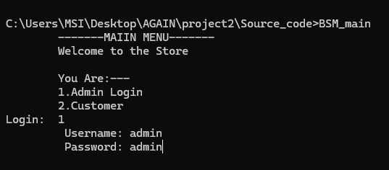

Fig 6.1: Main menu and admin credentialss

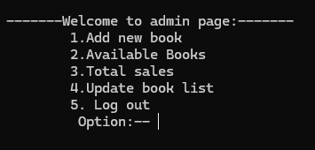

Fig 6.2:Admin Menu

After the admin password and username is provided, the admin functions can be accessed.

**6.1.2 Adding new books(as Admin)**

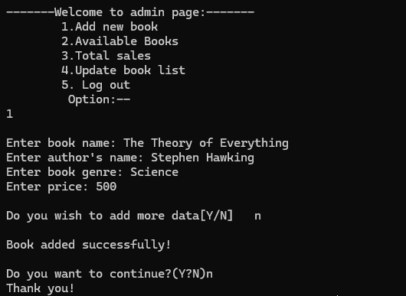

Fig 6.3: Adding books

The book is added to the text file book_list.txt.

**6.1.3 Available books list**

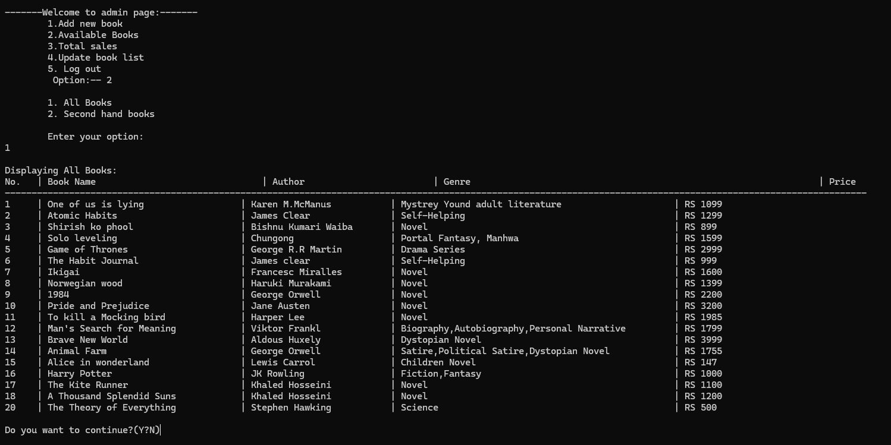

Fig 6.4: available books list

**6.1.4 Total Sales**

The total sales depend upon the cart of the customer. As all books are bought so is the sales added as well. The sales report shows the amount of sales for the current month.

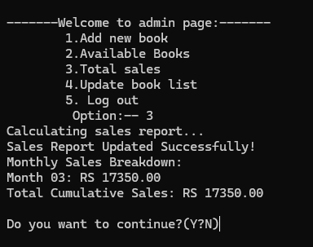

Fig 6.5: Sales Report

**6.1.5 Updating the book list**

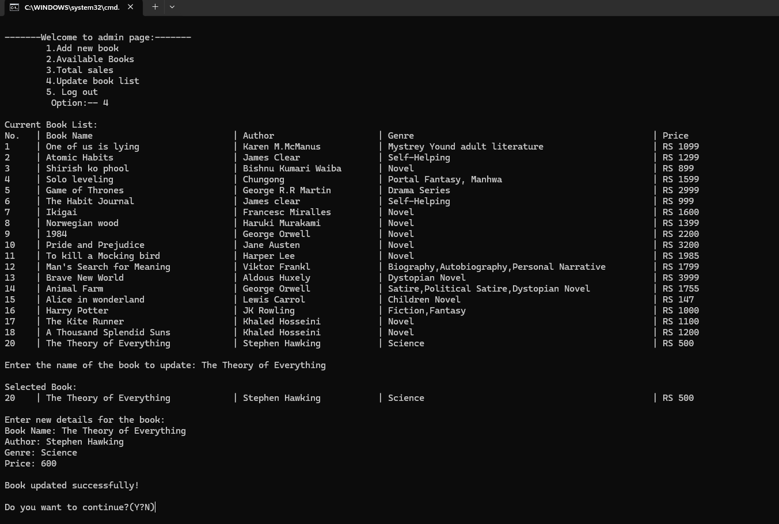

Fig 6.6: Updated book list

If the admin wants to update then the entire book details is fetched and the details are hence edited as per the admin’s choice.

**6.2 Menu(Customer)**

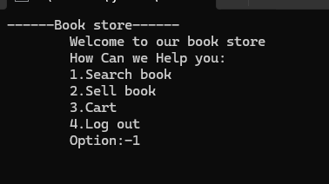

Fig 6.7 Customer Menu

The customer menu is provided given that the user is a customer and needs customer functions.

**6.2.1 Searching book**

The customer can search based on the either author,genre or book name making it versatile on the choice that customer wants based on the available books. Making it easy for the customer to know if the book is available or not.

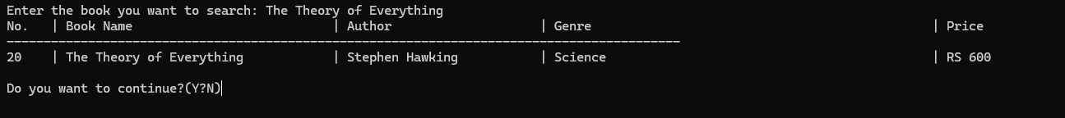

Fig: 6.8 Searching for a book that is available

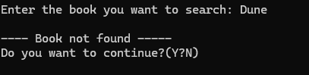

Fig 6.9:Book that is not available at the store

**6.2.2 Selling book as second hand**

The book store has also aimed to have second hand book tracking so that customers can feel the business model to be trustworthy.

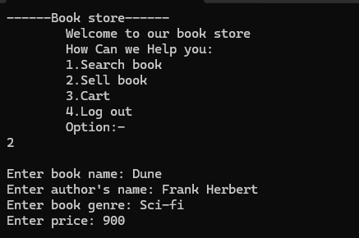

Fig 6.10: Second hand book

**6.2.3 Cart**

The customer, if they want to buy a available book should use cart function keeping in mind about their will to purchase the books.This directly contributes to the sales.

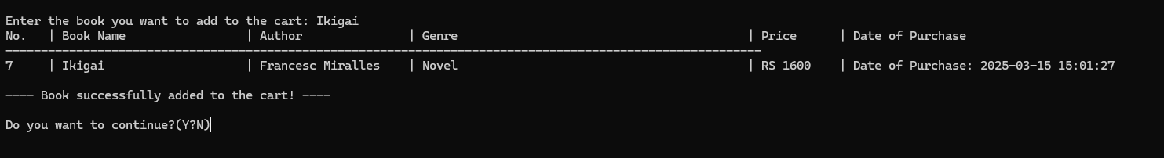

Fig 6-11: Cart

**7. FUTURE ENHANCEMENT**

Major improvements can be done in following areas:

* User Authentication and Authorization with password hashing[3] to create secure credential login for both admin and customer
* Adding more search and filter options for customer
* Integrating online payment method (paypal, esewa) along with a GUI interface for much more easy functionality.
* Allowing data to be exported to excel or database (SQL) files which creates strong integrity and sound management
* Improved error handling for invalid inputs or file.

**8. CONCLUSION**

The development of the Bookstore Management System has successfully addressed the need for an efficient, user-friendly, and automated solution to manage bookstore operations. By integrating features such as inventory management, sales tracking, customer management, and reporting, the system streamlines daily tasks, reduces manual errors, and enhances overall productivity. This project demonstrates the importance of leveraging technology to optimize business processes in the retail and publishing industries. The modular design ensures to meet evolving needs of bookstores especially targeting small scale businesses in a locality. While the current implementation meets the basic requirements, future enhancements such as e-commerce integration, graphical analytics will further support for functionality.

**9.APPENDICES**

Appendix A:Parsing: process of analyzing a sequence of symbols or data (such as text or code) to determine its structure and meaning according to a set of rules or grammar. In computing, parsing is commonly used to interpret and process data from files, user inputs, or network communications. The parsing is an important tool used in the program to carefully extract the data as the format specified in the text files.

REFERENCES

[1] <https://en.wikipedia.org/wiki/History_of_bookselling>

[2] <https://en.wikipedia.org/wiki/Bookselling>

[3] https://supertokens.com/blog/password-hashing-salting