Rolle’s Theorem

In [calculus](https://en.wikipedia.org/wiki/Calculus), ***Rolle's theorem*** or ***Rolle's lemma*** essentially states that any real- valued [differentiable function](https://en.wikipedia.org/wiki/Differentiable_function) that attains equal values at two distinct points must have at least one point, somewhere between them, at which the slope of the tangent line is zero. Such a point is known as a [stationary point](https://en.wikipedia.org/wiki/Stationary_point). It is a point at which the first derivative of the function is zero. The theorem is named after [Michel Rolle](https://en.wikipedia.org/wiki/Michel_Rolle).

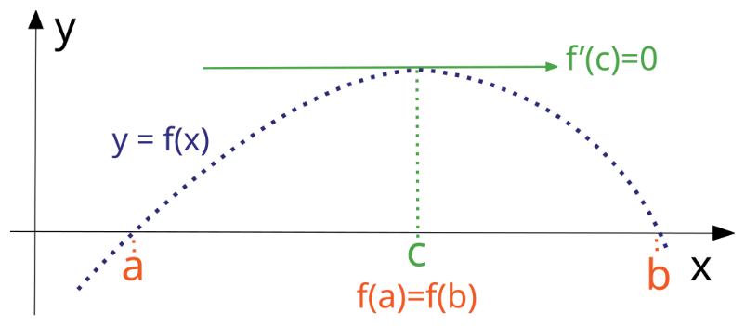

If a real-valued function *f* is continuous on a proper closed interval [*a*, *b*], [differentiable](https://en.wikipedia.org/wiki/Differentiable_function) on the [open interval](https://en.wikipedia.org/wiki/Open_interval) (*a*, *b*), and *f*(*a*) = *f*(*b*), then there exists at least one *c* in the open interval (*a*, *b*) such thatf′(c)=0.

*f’(c)=*0.

If any function satisfies all the conditions of Rolle’s Theorem i.e.

* f(x) is continuous in the closed interval [a,b]
* f(x) is differentiable in the open interval (a,b)
* f(b)=f(a)

There exists *f’(c)=*0 which is the tangent at point c parallel to x axis.

This version of Rolle's theorem is used to prove the [mean value theorem](https://en.wikipedia.org/wiki/Mean_value_theorem), of which Rolle's theorem is indeed a special case. It is also the basis for the proof of [Taylor's theorem](https://en.wikipedia.org/wiki/Taylor%27s_theorem).

Lagrange’s Mean Value Theorem

In [mathematics](https://en.wikipedia.org/wiki/Mathematics), the **mean value theorem** (or ***Lagrange's mean value theorem***) states, roughly, that for a given planar [arc](https://en.wikipedia.org/wiki/Arc_(geometry)) between two endpoints, there is at least one point at which the [tangent](https://en.wikipedia.org/wiki/Tangent) to the arc is parallel to the [secant](https://en.wikipedia.org/wiki/Secant_line) through its endpoints. It is one of the most important results in [real analysis](https://en.wikipedia.org/wiki/Real_analysis). This theorem is used to prove statements about a function on an [interval](https://en.wikipedia.org/wiki/Interval_(mathematics)) starting from local hypotheses about derivatives at points of the interval.

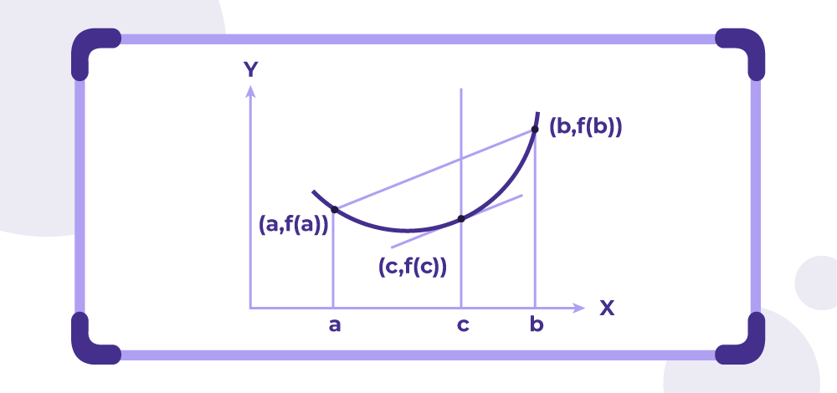

Geometrically speaking, the derivative at c denotes the slope of the tangent of at x = c for f(x). It says there must exist a point in between that interval where the slope of the tangent is equal to the slope of the line joining points x=a and x=b.

Cauchy’s Mean Value Theorem

Cauchy's Mean Value Theorem (CMVT) is a generalization of the traditional Mean Value Theorem (MVT) in calculus. While the classical MVT applies to a single function, CMVT relates two functions over a given interval. The theorem states that if two functions *f(x)* and *g(x)* are continuous on a closed interval [a,b] and differentiable on the open interval (a,b), then there exists at least one point *c* ∈ *(a,b))*such that:

$$\frac{f^{'}\left(c\right)}{g'(c)}=\frac{g\left(b\right)-g\left(a\right)}{f\left(b\right)-f\left(a\right)}$$

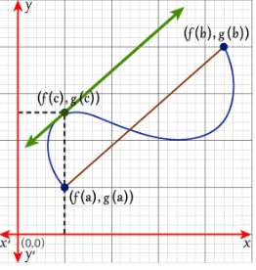

**Secant Lines:**

**Function *f*:** The secant line connecting the points *(a,f(a))*and *(b,f(b))* on the graph of *f* has a slope given by: $\frac{f\left(b\right)-f\left(a\right)}{b-a}$

**Function *g*:** Similarly, the secant line connecting *(a,g(a))* and *(b,g(b))* on the graph of g has a slope: $\frac{g\left(b\right)-g\left(a\right)}{b-a}$

These secant lines represent the average rates of change of f and g over the interval [a,b].

Tangents and Proportionality

* The CMVT asserts that there exists a point c in *(a,b)* where the instantaneous rates of change (slopes of the tangent lines) of *f* and *g* are proportional. Specifically: $$\frac{f^{'}\left(c\right)}{g'(c)}=\frac{g\left(b\right)-g\left(a\right)}{f\left(b\right)-f\left(a\right)}$$
* Geometrically, this means that at some point ccc, the tangent to the curve defined by *(f(t),g(t))* is parallel to the secant line connecting *(f(a),g(a))* and *(f(b),g(b))*

Inter-relationship between the 3 Theorems:

* ***Rolle's Theorem*** is a special case of ***Lagrange's Mean Value Theorem***. If f(a)=f(b)f(a) = f(b)f(a)=f(b), then LMVT guarantees the existence of a point ccc where f′(c)=0f'(c) = 0f′(c)=0, which is precisely the conclusion of Rolle's Theorem.
* ***Lagrange's Mean Value Theorem*** is a special case of ***Cauchy's Mean Value Theorem***. CMVT extends LMVT by considering the relationship between the derivatives of two functions over an interval, providing a more general framework.