**CSER HARMONIZED MEASURE REPOSITORY: Quality of Life Visual Analog Scale**

| **Template topic** | **Definition/Note** |
| --- | --- |
| **Measure name and acronym** | EQ Visual Analog Scale (VAS) |
| **Source citation for original measure** | EuroQol 5 dimensions youth version (EQ-5D-Y)  Wille, N., Badia, X., Bonsel, G., Burström, K., Cavrini, G., Devlin, N., ... & Jelsma, J. (2010). Development of the EQ-5D-Y: a child-friendly version of the EQ-5D. *Quality of life research*, *19*(6), 875-886. |
| **Category of assessment (construct/ CSER framework location)** | Pediatric patient self-reported health-related quality of life/CSER2 Framework: Outcomes/Patient Utility |
| **Description of measure** | Single-item quantitative measure of quality of life; records self-reported health at the time of completion on a vertical Visual Analogue Scale (VAS) |
| **Operational definition of construct** | Health-related quality of life (HRQOL) |
| **Summary of changes made to measure for CSER (“CSER-adapted scale”), if any** | n/a |
| **Time to administer** | 1:00 |
| **Target Respondent(s)** | Patient/Parent |
| **Age range(s) or respondents** | Parent proxy; Designed for self-completion by children and adolescents aged 8-15 years |
| **Number of items** | Original scale: 1 |
| CSER adapted: 1 |
| **Subscales and items per subscale** | Original scale: n/a |
| CSER adapted: n/a |
| **Response scale (including anchor labels)** | Original scale: “The best health you can imagine” (100) and “The worst health you can imagine” (0) |
| CSER adapted: “The best health you can imagine” and “worst health” |
| **Scoring instructions** | Original Scale: recorded as numeric value indicated. Missing values should be coded as ‘999’. |
| CSER adapted: recorded as numeric value indicated. |
| **Validated cutoff scores, if any** | n/a |
| **Norms (if available)** | no norms data have been published to date |
| **Contact for permission to use/adapt (associated cost)** | The EQ-5D-Y is a copyrighted instrument. userinformationservice@euroqol.org |
|  | Examples: Paper and pencil, computer adaptive test, interview |
| **Validated administration modes** | Web, paper, telephone |
| **Original measure languages available** | More than 25 |
| **Evidence for reliability (provide type and values)** | Intraclass correlation coefficients (ICCs) for the VAS were 0.82 in Italy and 0.83 in Spain.  Ravens-Sieberer, U., Wille, N., Badia, X., Bonsel, G., Burström, K., Cavrini, G., ... & Jelsma, J. (2010). Feasibility, reliability, and validity of the EQ-5D-Y: results from a multinational study. *Quality of life research*, *19*(6), 887-897. |
| **Evidence for validity (provide type and values if available)** | convergent validity (up to r = -0.56) |
| **Evidence for sensitivity to change** | Kreimeier, S., & Greiner, W. (2019). EQ-5D-Y as a health-related quality of life instrument for children and adolescents: the Instrument's characteristics, development, current use, and challenges of developing its value set. *Value in Health*, *22*(1), 31-37. |
| **Relevant references in genetics or genomics** | n/a |

**Paste original scale below**

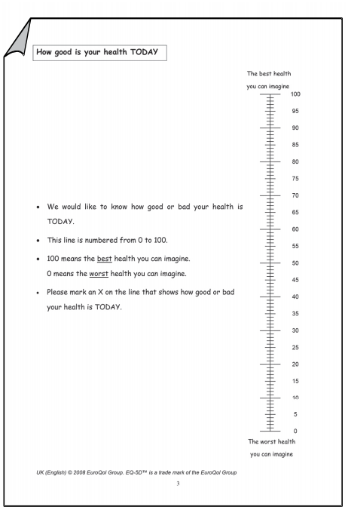

**Paste CSER adaptation below**

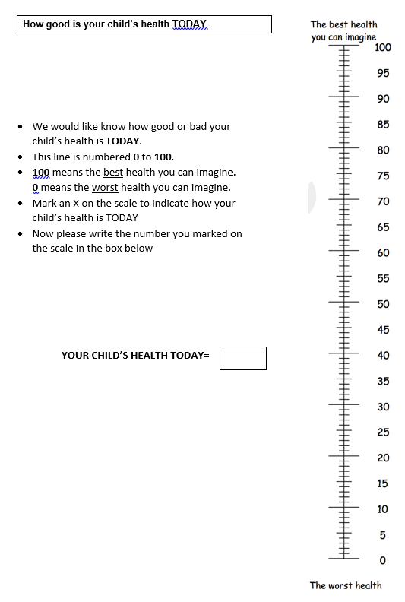

**Paste or list CSER site-specific adaptation/deviation below**

Mt Sinai: Includes second question that asks about child’s health in the last month

UNC: Scale is rotated horizontal