**CSER HARMONIZED MEASURE REPOSITORY: 12-Item Short Form (SF-12) Adult Versions**

| **Template topic** | **Definition/Note** |
| --- | --- |
| **Measure name and acronym** | 12-Item Short Form Version 1 |
| **Source citation for original measure** | **Original Citation for Harmonized Measure**  Ware JE, Kosinski M, Keller SD. A 12-Item Short-Form Health Survey: Construction of scales and preliminary tests of reliability and validity. Medical Care, 1996, 34, 220.  **Original references for SF-36 (populations and methods used to establish reliability and validity of SF-12)**  Ware JE, Snow KK, Kosinski M, et al. SF-36 health survey: Manual and interpretation guide. Boston, MA: The Health Institute, New England Medical Center, 1993.  McHorney CA, Ware JE, Raczek AE. The MOS 36-item short-form health status survey (SF-36): II Psych9ometric and clinical tests of validity in measuring physical and mental health constructs. Medical Care, 1993,31,247.  McHorney CA, Kosinski M, Ware JE. Comparisons of the costs and quality of norms for the SF-36 health survey collected by mail versus telephone interview: Results from a national survey. Medical Care, 1994,32, 551.  **Manual for SF-12 Version 2 (includes Version 1)**  Ware JE, Kosinski M, Turner-Bowker DM, Gandek B. How to score version 2 of the SF-12 Health Survey (With a Supplement Documenting Version 1). QualityMetric Incorporated, Lincoln, RI, 2002. |
| **Category of assessment (construct/ CSER framework location)** | Quality of Life/Outcomes/Patient Utility |
| **Description of measure** | This is a 12-item adaptation of the 36-item Short Form (SF-36) Health Survey used in the Medical Outcomes Study. The measure includes items assessing physical and mental functioning and yields two scores for these two components of quality of life. |
| **Operational definition of construct** | Quality of life is conceptualized a patient perceived and reported outcome reflecting several domains of functioning and experience. The SF-36 include 8 domains of patient functioning and experience including Physical Functioning, Role Physical, Bodily Pain, General Health, Vitality, Social Functioning, Role Emotional, and Mental Health. The SF-12 incorporates these domains using fewer items for each. Two broad domains of both the SF-36 and SF-12 reflect a Physical Health Component and a Mental Health Component. |
| **Summary of changes made to measure for CSER (“CSER-adapted scale”), if any** | It appears that the SF-12 is being used as an Adult patient measure without adaptation. |
| **Time to administer** | Less than 5 minutes |
| **Target Respondent(s)** | Adult patients; Healthy adults in screening programs |
| **Age range(s) or respondents** | Age of population where measure was validated US general population, adults 18 to 75+ |
| **Number of items** | Original scale 12 items |
| CSER2 sites are using the original 12 items |
| **Subscales and items per subscale** | Original scale 2 summary scores; Physical Component—6 items, Mental Component—6 items. |
| CSER adapted same as original |
| **Response scale (including anchor labels)** | Original scale several types of response scales are used; |
| CSER adapted Same as Original |
| **Scoring instructions** | Original Scale Norm-based scoring |
| CSER adapted Same as Original |
| **Validated cutoff scores, if any** | Search conducted; Cutoff scores for individual clinical decision making associated with genetic conditions are not available |
| **Norms (if available)** | Original scale Norm-based scoring |
| **Contact for permission to use/adapt (associated cost)** | No permission needed for SF-12 Version 1; User guide needed for Version 2 available through QualityMetric. |
| **Validated administration modes** | Interview, self-report, paper and pencil, 4-week recall, 1-week recall (acute) |
| **Original measure languages available** | English and translations in many languages are available. |
| **Evidence for reliability (provide type and values)** | Test-retest, internal consistency  Ware JE, Kosinski M, Keller SD. A 12-Item Short-Form Health Survey: Construction of scales and preliminary tests of reliability and validity. Medical Care, 1996, 34, 220. |
| **Evidence for validity (provide type and values if available)** | Extensive evidence for validity of original measure including construct validity, content validity, and face validity. See Ware JE, Kosinski M, Turner-Bowker DM, Gandek B. How to score version 2 of the SF-12 Health Survey (With a Supplement Documenting Version 1). QualityMetric Incorporated, Lincoln, RI, 2002. |
| **Evidence for sensitivity to change** | **See User Guide:**  Ware JE, Kosinski M, Turner-Bowker DM, Gandek B. How to score version 2 of the SF-12 Health Survey (With a Supplement Documenting Version 1). QualityMetric Incorporated, Lincoln, RI, 2002.  **SF-12 may be less sensitive to change than longer SF-36:**  Pickard AS, Johnson JA, Penn A, Lau F, Noseworthy T. Replicability of SF-36 summary scores by the SF-12 in Stroke patients. Stroke, 1999, 30, 1213. |
| **Relevant references in genetics or genomics** | Less evidence for QOL associated with the experience of genetics or genomics for screening or diagnosis and more on QOL associated with heritable conditions. Cardiac screening is an area with accumulating evidence on the SF-12 (see reference below).  McGorrian C, McShane C, McQuade C, Keelan T, ONeill J, Galvin J, Malone K, Mahon NG, Codd M. Family-based associations in measures of psychological distress and quality of life in a cardiac screening clinic for inheritable cardiac diseases: a cross-sectional study. BMC Medical Genetics, 2013, 14, 1.  Mori Y, Downs J, Wong K, Heyworth J, Leonard H. Comparing parental well-being and its determinants across three different genetic disorders causing intellectual disability. Journal of Autism and Developmental Disorders, 2018, 48:1651-1665.  Cohen JS, Biesecker BB. Quality of life in rare genetic conditions: a systematic review of the literature. American Journal of Medical Genetics A, 2010, 1136-1156. |

**Paste original scale below**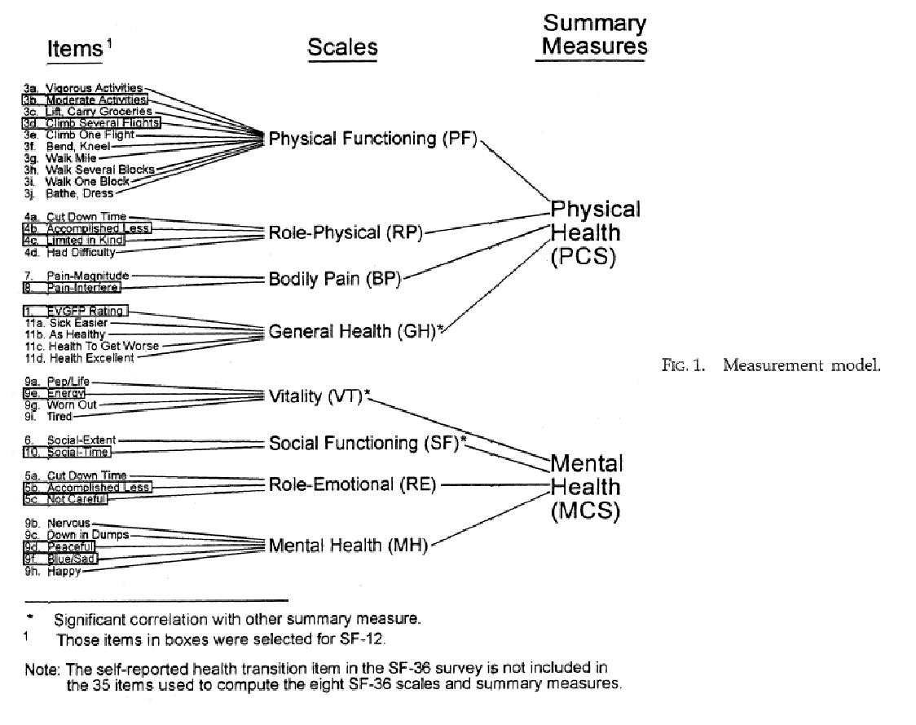

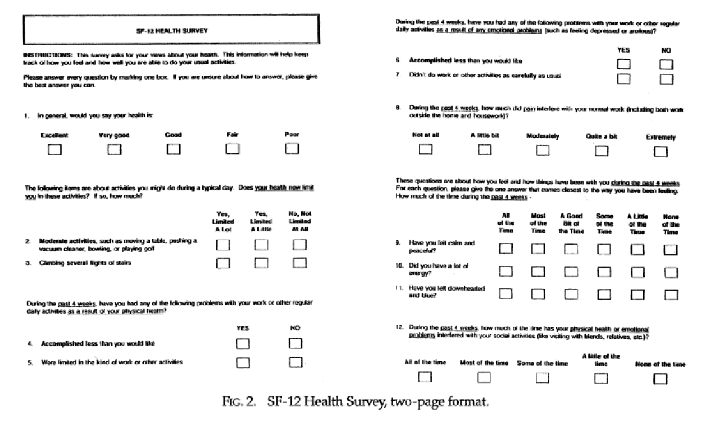

**From original article.**

**Paste CSER adaptation below**

**CSER2 sites appear to be using the SF-12 Version 1 without adaptation.**

**Charm**

**This survey asks for your views about your health. This information will help keep track of how you feel and how well you are able to do your usual activities. Answer each question by choosing just one answer. If you are unsure how to answer a question, please give the best answer you can.**

**In general, would you say your health is:**

**⬜ Excellent**

**⬜ Very good**

**⬜ Good**

**⬜ Fair**

**⬜ Poor**

**The following questions are about activities you might do during a typical day. Does your health now limit you in these activities? If so, how much?**

|  | **NO, not limited at all** | **YES, limited a little** | **YES, limited a lot** |
| --- | --- | --- | --- |
| **Moderate activities such as moving a table, pushing a vacuum cleaner, bowling, or playing golf** | **⬜** | **⬜** | **⬜** |
| **Climbing several flights of stairs** | **⬜** | **⬜** | **⬜** |

**During the past 4 weeks, have you had any of the following problems with your work or other regular daily activities as a result of your physical health?**

|  | **NO** | **YES** |
| --- | --- | --- |
| **Accomplished less than you would like** | **⬜** | **⬜** |
| **Were limited in the kind of work or other activities** | **⬜** | **⬜** |

**During the past 4 weeks, have you had any of the following problems with your work or other regular daily activities as a result of any emotional problems (such as feeling depressed or anxious)?**

|  | **NO** | **YES** |
| --- | --- | --- |
| **Accomplished less** than you would like | ⬜ | ⬜ |
| Did work or other activities **less carefully than usual** | ⬜ | ⬜ |

**During the past 4 weeks how much did pain interfere with your normal work (including work outside the home and housework)?**

⬜ Not at all

⬜ A little bit

⬜ Moderately

⬜ Quite a bit

⬜ Extremely

**These questions are about how you have been feeling during the past 4 weeks. For each question, please give the one answer that comes closest to the way you have been feeling.**

**How much of the time during the past 4 weeks...**

|  | **All of the time** | **Most of the time** | **A good bit of the time** | **Some of the time** | **A little of the time** | **None of the time** |
| --- | --- | --- | --- | --- | --- | --- |
| Have you felt calm and peaceful? | ⬜ | ⬜ | ⬜ | ⬜ | ⬜ | ⬜ |
| Did you have a lot of energy? | ⬜ | ⬜ | ⬜ | ⬜ | ⬜ | ⬜ |
| Have you felt down-hearted and blue? | ⬜ | ⬜ | ⬜ | ⬜ | ⬜ | ⬜ |

**During the past 4 weeks how much of the time has your physical health or emotional problems interfered with your social activities (like visiting friends, relatives, etc.)?**

⬜ All of the time

⬜ Most of the time

⬜ Some of the time

⬜ A little of the time

⬜ None of the time

**NCGenes 2**

**Your Health**

1. **In general, would you say your health is** (*Check one*)**:**

□1  Excellent

□2  Very good

□3  Good

□4  Fair

□5  Poor

1. **The following items are about activities you might do during a typical day. Does your health now limit you in these activities? If so, how much?**

|  | **Yes, Limited**  **A Lot**  (1) | **Yes, Limited**  **A Little**  (2) | **No, Not Limited**  **At All**  (3) |
| --- | --- | --- | --- |
| * + - 1. **Moderate activities,** such as moving a table, pushing a vacuum cleaner, bowling, or playing golf | □ | □ | □ |
| * + - 1. Climbing **several** flights of stairs | □ | □ | □ |

1. **During the past 4 weeks, have you had any of the following problems** **with your work or other regular daily activities as a result of your physical health?**

|  | **Yes**  (1) | **No**  (2) |
| --- | --- | --- |
| * + - 1. **Accomplished less** than you would like | □ | □ |
| * + - 1. Were limited in the **kind** of work of other activities | □ | □ |

1. **During the past 4 weeks, have you had any of the following problems with your work or other regular daily activities as a result of any emotional problems (such as feeling depressed or anxious)?**

|  | **Yes**  (1) | **No**  (2) |
| --- | --- | --- |
| * + - 1. **Accomplished less** than you would like | □ | □ |
| * + - 1. Didn’t do work or other activities as **carefully** as usual | □ | □ |

1. **During the past 4 weeks, how much did pain interfere with your normal work (including both work outside the home and housework)?**

□1  Not at all

□2  A little bit

□3  Moderately

□4  Quite a bit

□5  Extremely

1. **These questions are about how you feel and how things have been with you during the past 4 weeks.** For each question, please give the one answer that comes closest to the way you have been feelings. How much of the time during the past 4 weeks –

|  | **All of the Time**  (1) | **Most of the Time**  (2) | **A Good Bit of the Time**  (3) | **Some of the Time**  (4) | **A Little of the Time**  (5) | **None**  **of the Time**  (6) |
| --- | --- | --- | --- | --- | --- | --- |
| 1. Have you felt calm and peaceful? | □ | □ | □ | □ | □ | □ |
| 1. Did you have a lot of energy? | □ | □ | □ | □ | □ | □ |
| 1. Have you felt downhearted and blue? | □ | □ | □ | □ | □ | □ |

1. **During the past 4 weeks, how much of the time has your physical health or emotional problems interfered with your social activities (like visiting with friends, relative, etc.)?**

□1  All of the time

□2  Most of the time

□3  Some of the time

□4  A little of the time

□5  None of the time