**CSER HARMONIZED MEASURE REPOSITORY [Adult/Parent]: Feelings about Genomic Testing Results**

| **Template topic** | **Definition/Note** |
| --- | --- |
| **Measure name and acronym** | Feelings about Genomic Testing Results (FACToR) – Adult |
| **Source citation for original measure** | Li, M., Bennette, C.S., Amendola, L.M. et al. J Genet Counsel (2018). https://doi.org/10.1007/s10897-018-0286-9 |
| **Category of assessment (construct/ CSER framework location)** | Psychological Utility Domain: Feelings about Genomic Testing Results (FACToR) – Adult/Parent |
| **Description of measure** | Adult and Parent FU1 survey:   * 12 items and 4 subscales * Five answer options for each of the 12 items [not at all, a little, somewhat, a good deal, or a great deal] * Question do not differ in content between adult and parent survey- except in adult word “you” is replaced with “your child’s” in parent survey. |
| **Operational definition of construct** | The Feelings About genomiC Testing Results (FACToR) is an instrument to measure the psychosocial impact of returning genomic findings to patients in research and clinical practice. |
| **Summary of changes made to measure for CSER (“CSER-adapted scale”), if any** | 4 out of 12 questions have slight word changes, see CSER adaptation below. Measure questions 6, 9, 11,12 have been slightly revised. |
| **Time to administer** | 1:40 minute |
| **Target Respondent(s)** | Adult patient/Parent |
| **Age range(s) or respondents** | Adult patient (adult survey)  Parent (parent survey) |
| **Number of items** | Original scale 12 |
| CSER adapted: FACToR – 12 items- in both Adult/and Parent versions |
| **Subscales and items per subscale** | Original scale 4: Negative emotions, Positive experience, Uncertainty, Privacy concerns |
| CSER adapted 4: Negative emotions, Positive experience, Uncertainty, Privacy concerns |
| **Response scale (including anchor labels)** | Original scale: not at all, a little, somewhat, a good deal, or a great deal |
| CSER adapted: not at all, a little, somewhat, a good deal, or a great deal |
| **Scoring instructions** | Original Scale: Respondents are asked to indicate how much they had each specific feeling in the past week by circling one answer for each question: not at all (0), a little (1), somewhat (2), a good deal (3), or a great deal (4). |
| CSER adapted: The following questions ask about how you felt after receiving your genetic test results. Please indicate how much you had each specific feeling in the past week by circling the one answer for each question: not at all (0), a little (1), somewhat (2), a good deal (3), or a great deal (4). |
| **Validated cutoff scores, if any** | Negative emotions: 0-12  Positive experience: 0-16  Uncertainty: 0-12  Privacy concerns: 0-8 |
| **Norms (if available)** | Original scale 12 items |
| **Contact for permission to use/adapt (associated cost)** | Contact corresponding author, Donald L. Patrick, [donald@uw.edu](mailto:donald@uw.edu). No known costs. |
| **Validated administration modes** | Online or postal mail |
| **Original measure languages available** | English |
| **Evidence for reliability (provide type and values)** | Li, M., et. al. All four subscales of the FACToR demonstrated good test-retest reliability: the ICC was 0.65 (95% CI: 0.24–0.84) for the negative emotions subscale, 0.83 (95% CI: 0.63–0.92) for the positive feelings subscale, 0.91 (95% CI: 0.80–0.96) for the uncertainty subscale, and 0.86 (95% CI: 0.69–0.94) for the privacy concern subscale |
| **Evidence for validity (provide type and values if available)** | Li, M., et. al. Patients who received a positive genomic finding had the highest scores on the negative emotions subscale (mean score: 1.6; SD: 2.7), the positive feelings subscale (mean score: 10.0; SD: 2.4), and the uncertainty subscale (mean score: 3.6; SD: 2.9), followed by those who received a VUS finding (mean scores on those subscales: 0.8, 8.0, and 2.3; SDs: 1.6, 4.3, and 2.8) and those who received a negative finding (mean scores: 0.6, 6.0, and 1.6; SDs: 1.1, 4.2, and 2.0) |
| **Evidence for sensitivity to change** | NA |
| **Relevant references in genetics or genomics** | Search was conducted and no additional references were available |

**Paste original scale below**

Negative emotions

1. How upset did you feel about your genetic test result?

3. How anxious or nervous did you feel about your genetic test result?6. How sad did you feel about your genetic test result?

Positive feelings

2. How happy did you feel about your genetic test result?

5. How relieved did you feel about your genetic test result?

13. How much did you feel that you understood clearly your choices for disease prevention or early detection?

17. How helpful was the information you received from your genetic test result in planning for the future?

Uncertainty

8. How frustrated did you feel that there are no definite disease prevention guidelines for you?

9. How uncertain did you feel about what your genetic test result means for you?

10. How uncertain did you feel about what your genetic test result means for your child(ren) and/or family’s risk of disease?

Privacy concerns

15. How concerned did you feel that your genetic test result would affect your health insurance status?

**Paste CSER adaptation below [*changes to original measure are in green, number correlates with original measure question above]***

## NECESSARY] Feelings about Genomic Testing Results (FACToR) – Adult

FACToR – 12 items- Adult version. In the Parent version “you” is replaced with “your child’s”, the question do not differ.

The following questions ask about how you felt after receiving your genetic test results. Please indicate how much you had each specific feeling in the past week by circling the one answer for each question: not at all, a little, somewhat, a good deal, or a great deal

1. How **upset** did you feel about your genetic test result? [1.]

2. How **happy** did you feel about your genetic test result? [2.]

3. How **anxious or nervous** did you feel about your genetic test result? [3.]

4. How **relieved** did you feel about your genetic test result? [5.]

5. How **sad** did you feel about your genetic test result? [6].

6. How **frustrated** did you feel about recommendations for your care based on the genetic test result? [8.]

7. How **uncertain** did you feel about what your genetic test result means for you? [7.]

8. How **uncertain** did you feel about what your genetic test result means for your child(ren) and/or family’s risk of disease? [10.]

9. How much did you feel that **you understood clearly** **your choices for care** based on the genetic test result? [13.]

10. How **concerned** did you feel that your genetic test result would affect your ability to get or keep health insurance? [15.]

11. How **helpful** was the information you received from your genetic test result in planning for the future? [17.]

12. How **concerned** did you feel that your genetic test result might make it hard for you to get a job or keep a job? [18.]

**Paste or list CSER site-specific adaptation/deviation below**

1. **CHARM, KPNW:**

The following questions ask about how you felt after receiving your genetic test results. Please indicate how much you had each specific feeling in the past week by checking one answer for each question: not at all, a little, somewhat, a good deal, or a great deal.

|  | **Not at all** | **A little** | **Somewhat** | **A good deal** | **A great deal** |
| --- | --- | --- | --- | --- | --- |
| How **upset** did you feel about your genetic test result? | ⬜0 | ⬜1 | ⬜2 | ⬜3 | ⬜4 |
| How **happy** did you feel about your genetic test result? | ⬜0 | ⬜1 | ⬜2 | ⬜3 | ⬜4 |
| How **anxious or nervous** did you feel about your genetic test result? | ⬜0 | ⬜1 | ⬜2 | ⬜3 | ⬜4 |
| How **relieved** did you feel about your genetic test result? | ⬜0 | ⬜1 | ⬜2 | ⬜3 | ⬜4 |
| How **sad** did you feel about your genetic test result? | ⬜0 | ⬜1 | ⬜2 | ⬜3 | ⬜4 |
| How **frustrated** did you feel about recommendations for your care based on the genetic test result? | ⬜0 | ⬜1 | ⬜2 | ⬜3 | ⬜4 |
| How **uncertain** did you feel about what your genetic test result means for you? | ⬜0 | ⬜1 | ⬜2 | ⬜3 | ⬜4 |
| How **uncertain** did you feel about what your genetic test result means for your child(ren) and/or family’s risk of disease? | ⬜0 | ⬜1 | ⬜2 | ⬜3 | ⬜4 |
| How much did you feel that y**ou understood clearly your choices for care** based on the genetic test result? | ⬜0 | ⬜1 | ⬜2 | ⬜3 | ⬜4 |
| How **concerned** did you feel that your genetic test result would affect your ability to get or keep health insurance? | ⬜0 | ⬜1 | ⬜2 | ⬜3 | ⬜4 |
| How **helpful** was the information you received from your genetic test result in planning for the future? | ⬜0 | ⬜1 | ⬜2 | ⬜3 | ⬜4 |
| How **concerned** did you feel that your genetic test result might make it hard for your to get a job or keep a job? | ⬜0 | ⬜1 | ⬜2 | ⬜3 | ⬜4 |

## **NYCKidSeq – Parental Return of Results #1 (RoR1) Survey**Feelings and Perceptions Toward Genomic Test Results

“In the next series of questions, we will ask you about your feelings about the genetic test results you received and how satisfied you were with the way your results were given to you. We will also ask you about what outside resources, if any, you will use to learn more about your child’s test results.”

1. **Feelings about Genomic Testing Results (FACToR) – Parent (CSER harmonized – NECESSARY)**

**“The following questions ask about how you, as a parent, felt after receiving your child’s genetic test results. Please indicate how much you had each specific feeling after receiving your child’s genetic test results by circling the one answer for each question: *not at all, a little, somewhat, a good deal*, or *a great deal*.”**

1. How **upset** did you feel about your child’s genetic test result?
2. How **happy** did you feel about your child’s genetic test result?
3. How **anxious or nervous** did you feel about your child’s genetic test result?
4. How **relieved** did you feel about your child’s genetic test result?
5. How **sad** did you feel about your child’s genetic test result?
6. How **frustrated** did you feel about recommendations for your child's care based on the genetic test?
7. How **uncertain** did you feel about what your child’s genetic test result means for your child?
8. How **uncertain** did you feel about what your child’s genetic test result means for other family members’ risk of disease?
9. How much did you feel that **you understood clearly your child’s choices** for care based on the genetic test result?
10. How **concerned** did you feel that your child’s genetic test result would affect his or her ability to get or keep health insurance?
11. How **helpful** was the information you received from your genetic test result in planning for your child’s future?
12. How **concerned** did you feel that your child’s genetic test result might make it hard for them to get or keep a job?
13. How **guilty** did you feel about your child’s genetic test result?
14. How **much loss of control** over your child’s life did you feel because of your child’s genetic test result?
15. **KidsCanSeq Study, Baylor**

NA

1. **NCGENES 2 Study, UNC**

**The following questions ask about how you, as a care giver, felt after receiving your child’s diagnostic test results.** Please use the response options on Card J. The response options are “Not at all,” “A little,” “Somewhat,” “A good deal,” and “A great deal.”

|  | **Not at all**  (1) | **A little**  (2) | **Somewhat**  (3) | **A good deal**  (4) | **A great deal**  (5) |
| --- | --- | --- | --- | --- | --- |
| 1. How **upset** did you feel about your child’s diagnostic test result? | □ | □ | □ | □ | □ |
| 1. How **happy** did you feel about your child’s diagnostic test result? | □ | □ | □ | □ | □ |
| 1. How **anxious or nervous** did you feel about your child’s diagnostic test result? | □ | □ | □ | □ | □ |
| 1. How **relieved** did you feel about your child’s diagnostic test result? | □ | □ | □ | □ | □ |
| 1. How **sad** did you feel about your child’s diagnostic test result? | □ | □ | □ | □ | □ |
| 1. How **frustrated** did you feel about recommendations for your child’s care based on the diagnostic test result? | □ | □ | □ | □ | □ |
| 1. How **uncertain** did you feel about what your child’s diagnostic test result means for your child? | □ | □ | □ | □ | □ |
| 1. How **uncertain** did you feel about what your child’s diagnostic test result means for other family members’ risk of disease? | □ | □ | □ | □ | □ |
| 1. How much did you feel that **you understood clearly your child’s choices** for care based on the diagnostic test result? | □ | □ | □ | □ | □ |
| 1. How **concerned** did you feel that your child’s diagnostic test result would affect his or her ability to get or keep health insurance? | □ | □ | □ | □ | □ |
| 1. How **helpful** was the information you received from your diagnostic test result in planning for your child’s future? | □ | □ | □ | □ | □ |
| 1. How **concerned** did you feel that your child’s diagnostic test result might make it hard for them to get or keep a job? | □ | □ | □ | □ | □ |
| 1. How **guilty** did you feel about your child’s diagnostic test result? | □ | □ | □ | □ | □ |
| 1. How **much loss of control** over your child’s life did you feel because of your child’s diagnostic test result? | □ | □ | □ | □ | □ |

1. **P3EGS UCSF**

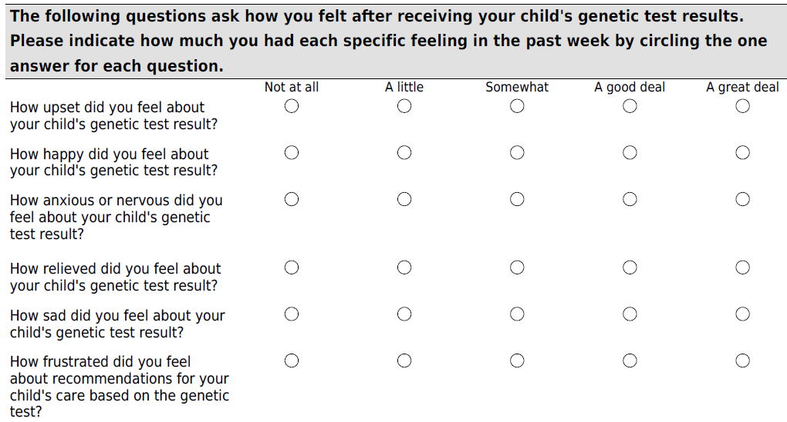

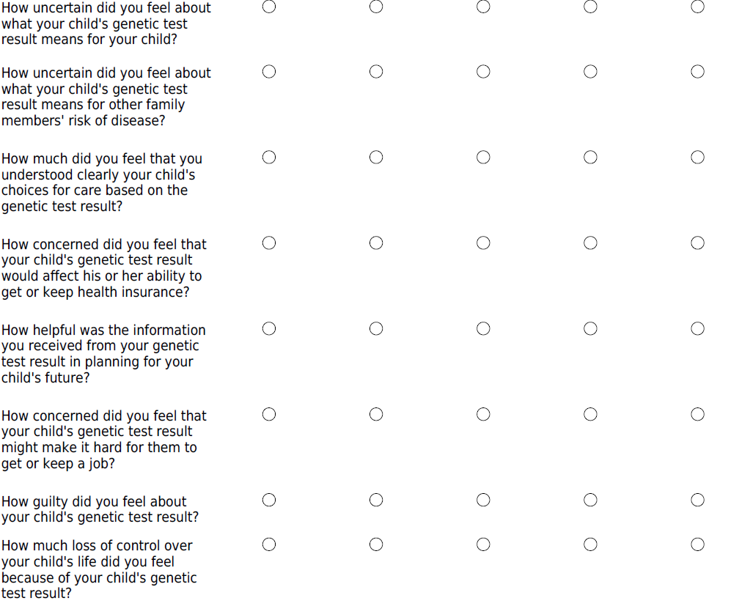

1. **SouthSeq 4 months HudsonAlpha**

The Feelings About genomic Testing Results (FACToR) Questionnaire *(Key Covariate: ROR, 1-month ROR, 4-months ROR)*

The following questions ask about how you, as a parent, felt after receiving your child’s genetic test results. Please indicate how much you had each specific feeling in the past week by choosing the one answer for each question.

|  | Not at all | A little | Somewhat | A good deal | A great deal |
| --- | --- | --- | --- | --- | --- |
| How **upset** did you feel about your child’s genetic test result? |  |  |  |  |  |
| How **happy** did you feel about your child’s genetic test result? |  |  |  |  |  |
| How **anxious or nervous** did you feel about your child’s genetic test result? |  |  |  |  |  |
| How **relieved** did you feel about your child’s genetic test result? |  |  |  |  |  |
| How **sad** did you feel about your child’s genetic test result? |  |  |  |  |  |
| How **frustrated** did you feel about recommendations for your child’s care based on the genetic test? |  |  |  |  |  |
| How **uncertain** did you feel about what your child’s genetic test result means for your child? |  |  |  |  |  |
| How **uncertain** did you feel about what your child’s genetic test result means for other family members’ risk of disease? |  |  |  |  |  |
| How much did you feel that **you understood clearly your child’s choices** for care based on the genetic test result? |  |  |  |  |  |
| How **concerned** did you feel that your child’s genetic test result would affect his or her ability to get or keep health insurance? |  |  |  |  |  |
| How **helpful** was the information you received from your genetic test result in planning for your child’s future? |  |  |  |  |  |
| How **concerned** did you feel that your child’s genetic test result might make it hard for them to get or keep a job? |  |  |  |  |  |
| How **guilty** did you feel about your child’s genetic test result? |  |  |  |  |  |
| How **much loss of control** over your child’s life did you feel because of your child’s genetic test result? |  |  |  |  |  |