Danielle Chow

PSET #10 Write-up

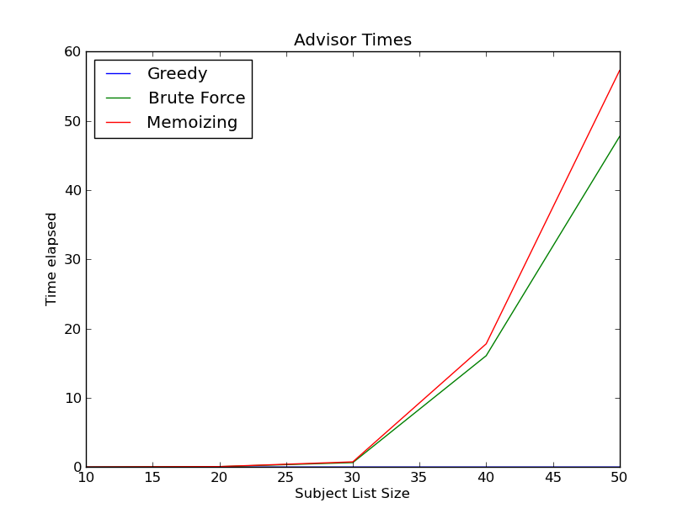Problem 5: Performance Comparison

As shown by the graph, for the brute fore and memorizing advisors, the larger the subject list size, the larger the time elapsed. This makes sense because there are a larger number of permutations to consider in finding a global optimum. However, the greedy advisor is not affected as much by the list size, because he/she only considers the best ratio that falls within the parameters and nothing else. The amount of time taken appears to grow exponentially as the list size increases, this makes sense if we think of the decision making process as a decision tree.