**Danielle Chow**

**Problem Set 7: Simulating the Spread of Disease and Virus Population Dynamics**

**Part A**

**Problem I: Probabilities**

1. Probability of catching the flu = $1/{10}$

Probability he catches the flu in September, October, and November = ${(1/{10})}^{3}$ = $1/{1000}$

1. Probability of catching the flu = $1/{10}$

Probability of not catching the flu = $9/{10}$

Probability he catches the flu in September and then again in November, but not in October= [${(1/{10})}^{2}$][$9/{10}$]= $9/{1000}$

1. Probability of catching the flu = $1/{10}$

Probability of not catching the flu = $9/{10}$

Probability he catches the flu exactly once in the three months from September through November= [${(9/{10})}^{2}$][$1/{10}$]= ${89}/{1000}$ X 3 possibilities = ${267}/{1000}$

1. Probability of catching the flu = $1/{10}$

Probability of not catching the flu = $9/{10}$

Probability he catches the flu twice= ${(1/{10})}^{2}$][$9/{10}$]= $9/{1000}$ X 3 possibilities= ${27}/{1000}$

Probability he catches the flu thrice= ${(1/{10})}^{3}$ = $1/{1000}$

Probability he catches the flu two or more times in the three months from September to November= [Probability he catches the flue twice]+[Probability he catches the flu thrice]= [${27}/{1000}$]+[$1/{1000}$]= ${28}/{1000}$ = $7/{250}$

**Part B**

**Problem III: Running and Analyzing a Simple Simulation (No Drug Treatment)**

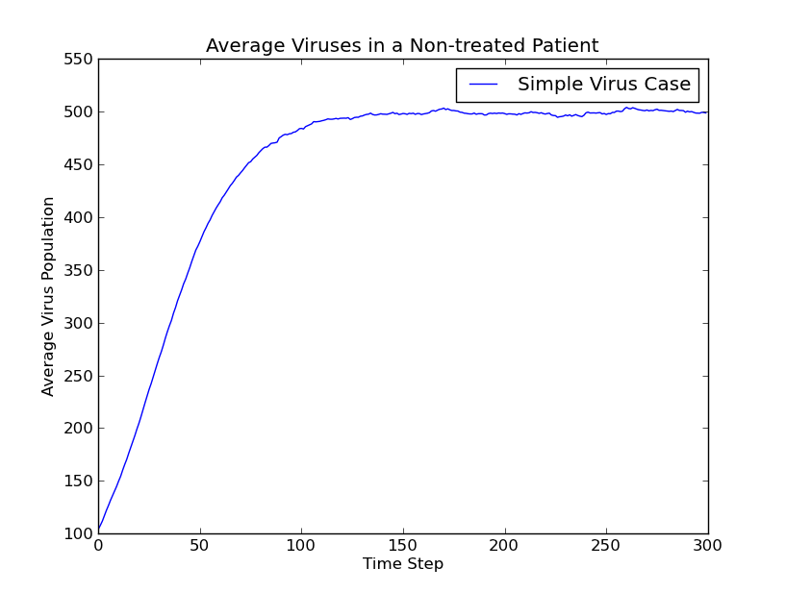

It takes approximately 125 time steps before the population stops growing.

**Problem V**: **Running and Analyzing a Simulation with a Drug**

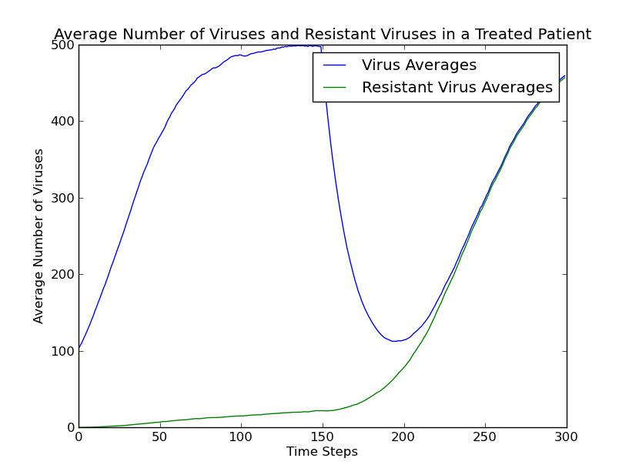

The virus population increases until 150 time steps have passed. This makes sense because the patients are given drugs at the 150-time step. The number of resistant viruses grows slowly, which makes sense because of the small probability of mutation and the growing effect of the drugs on reproduction. After 150 time steps have elapsed, the total population of viruses drops drastically, arrives at a minimum, and then begins increasing exponentially, eventually becoming asymptotic with the graph of resistant viruses. At some point, around 225, all of the non-resistant viruses have dies out, and only resistant viruses remain. Tiny fluxes in the graph remain due to mutant non-resistant viruses.