Danielle Chow

Problem 1: The Effect of Delaying Treatment on Patient Disease

1. Number of Trials and Why: It takes about 50 trials, because before then the graphs don’t show a good trend, and too far after 50 trials the graphs take a very long time to load.
2. 0-50 cured: no

Percent in remission at the end: 0%

1. Relationship between Number cured and Delay: more delay=fewer cured

Problem 5: Voting Results!

1. Obama Electoral Voted:312

Romney Electoral Votes: 226

Wins: Obama

Number of Votes Won by: 15

1. Histogram:

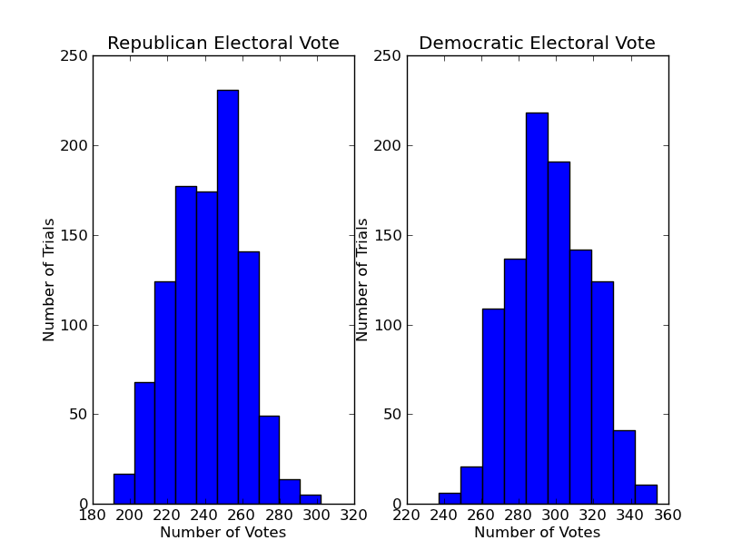

Avg. Electoral Votes Romney: 242

Avg. Electoral Votes Obama: 297

Confidence Interval Romney: [203.43611755756169, 279.75788244243836]

Confidence Interval Obama: [258.61611755756167, 334.93788244243831]

1. Obama: 977

Romeny: 22

Tie: 1

Problem 6: Popular Votes

1. Obama Popular Votes: 156,467,564

Romney Popular Votes: 153,335,090

Win: Obama

Wins By: 3,132,474

1. Histogram:

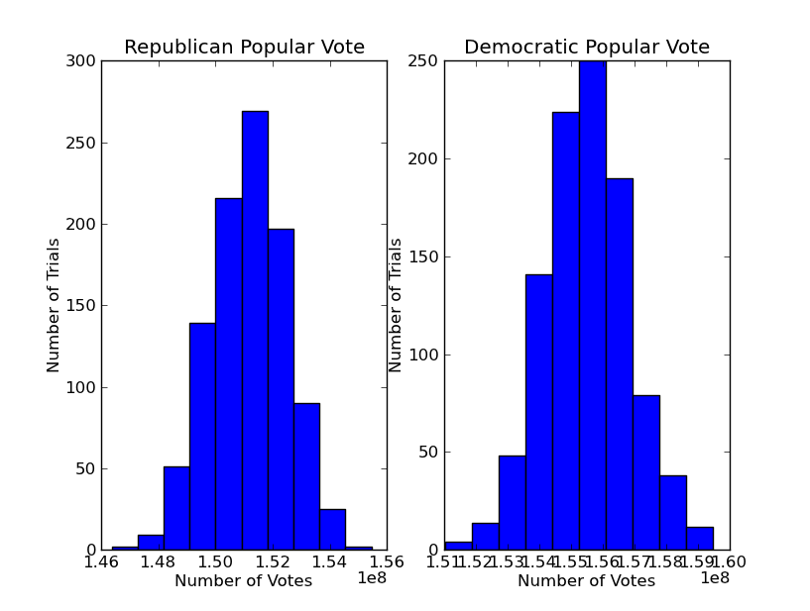

Avg. Obama Votes: 156,676,146

Confidence: [154132855.52536923, 159219435.91711181]

Avg. Romney Votes: 153,126,508

Confidence: [150583218.08288819, 155669798.47463077]

1. Obama wins ~91.1%

Tie~0%

Problem 7:Popular vote versus Electoral College votes

1. Yes
2. 0%

Problem 8: So who won the presidential elections?

Yes, it predicts Obama winning, and Obama did win…