Danielle Chow

PSET #9 Write-up

Part A:

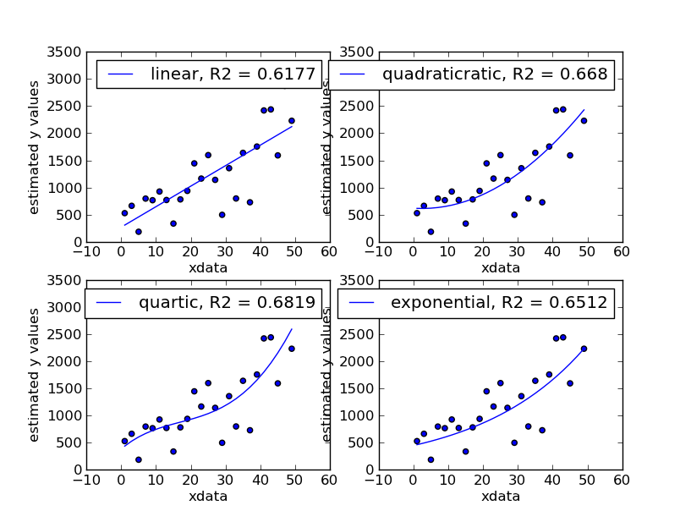

Data 1

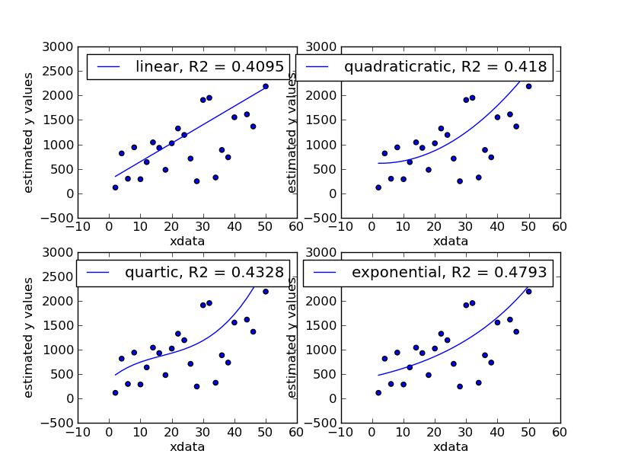

Data 2

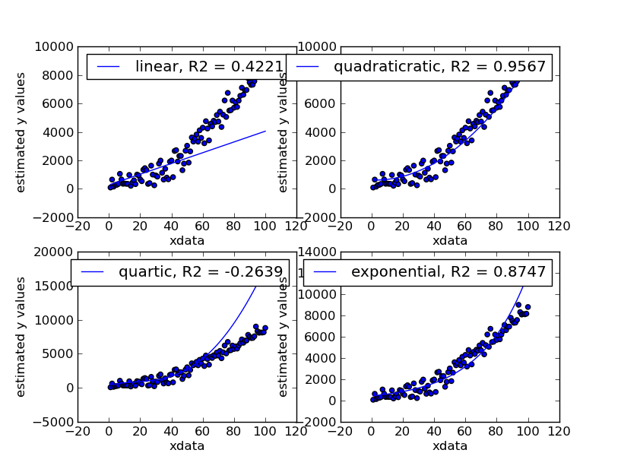

Data 3

From the first two graphs there is no defined “best” model, but from the data in the third set, it is clear that the quadratic model is the best fit for the data. With such a large R2 value, 0.9567 we would assume that the birth/growth rate of the cows would continue to be exponential and be approximately 33,000 at 200 days.

Part B:

Under the limit that the alien spaceship can only carry 1.0 ton of cargo, the brute force method allows for the fewest trips across the galaxy (4 trips) when compared to the greedy method (5 trips). However, after running the code to see how long each method takes, we can see that the greedy method is faster (~0.117 s) than the brute force method (~1.750 s) which makes sense considering that the greedy method does not run nearly as many permutations of the cow list.