Summer Internship Overview
I carried out my summer Internship as an AEH Intern at Accenture under the IE-DevInfra learning stream. During the internship, I was assigned to a project team supporting a large US-based pharmaceutical and healthcare client. This provided me with exposure to the infrastructure and operations side of IT environments, allowing me to understand how large-scale systems are managed, monitored, and maintained. I also gained insight into the functioning of the Command Center team, which plays a critical role in ensuring system availability, monitoring system health, managing incidents, and maintaining operational stability across business-critical services.
The internship combined structured learning with practical project work, enabling me to develop both technical and professional skills. Through guided learning modules, and hands-on activities, I was introduced to core concepts in cloud computing, DevOps, infrastructure automation, monitoring, and containerization. The exposure to industry-standard tools and workflows provided valuable insight into how modern organizations operate and deploy deliverables.
A major component of the internship was the execution of a capstone project focused on building a cloud-based DevOps Infrastructure Health Dashboard. The project involved deploying and managing infrastructure on a cloud server platform (Azure), creating scripts and manual dashboards for monitoring the server health, implementing Infrastructure as Code using Terraform, setting up monitoring and alerting with Prometheus and Grafana, containerizing applications using Docker, and deploying services on a Kubernetes environment.

Objectives:

- To gain practical exposure to enterprise infrastructure and operations environments.
- To understand the fundamentals of DevOps, cloud computing, automation and develop hands-on experience with industry tools such as Azure, Linux, Terraform, Docker, Kubernetes, Prometheus, and Grafana.
- To understand server health by monitoring key system metrics and automating health checks, alerts, and routine monitoring tasks.
- To containerize applications and monitoring tools, making them portable, easy to deploy, and accessible across different environments.
- To enhance problem-solving, troubleshooting, documentation, and presentation skills through the successful completion of an end-to-end capstone project.

Scope of Work
The scope of this internship included gaining foundational knowledge through training in Agentic AI, Generative AI, and Cybersecurity before progressing into the DevInfra domain. The primary focus of the project was to understand how modern organizations monitor and manage the health of their infrastructure to prevent system failures and service disruptions. The work involved building a solution capable of continuously tracking server health, identifying potential issues before they became critical, and improving visibility through automation and monitoring. In addition, the project explored how such solutions can be made portable, repeatable, and easier to deploy across different environments while maintaining proper documentation and presentation of the overall solution.

Industry needs and Practices
Modern organizations rely on servers to run important applications, websites, and business services. If a server runs into issues such as high resource usage, storage shortages, or service failures, it can lead to downtime and impact users. To avoid this, organizations continuously monitor the health of their infrastructure and use automation to detect and respond to problems early. Over time, manual management has been replaced by automated monitoring, alerting, and deployment practices that improve reliability and efficiency. This project was based on these industry practices and focused on understanding how infrastructure can be monitored, managed, and maintained proactively before issues become critical.

Tools and training received
During the internship, I underwent training in Agentic AI, Generative AI, Cybersecurity, and Infrastructure Engineering before moving into the DevInfra domain. The training covered fundamental concepts. In addition, several industry-standard tools were introduced and used throughout the capstone project to gain practical experience in modern DevOps practices
Tool / Technology | Purpose
Microsoft Azure | Cloud platform used to host and manage infrastructure
Linux | Server administration and system management
Git & GitHub | Version control and project collaboration
Bash Scripting | Automation of server monitoring tasks
Python | Development of the health dashboard
Terraform | Infrastructure as Code
Prometheus | Collection of server monitoring metrics
Grafana | Dashboard creation and visualization
Docker | Containerization of applications and services
Kubernetes | Container orchestration and deployment
Microsoft Copilot | Learning support, troubleshooting assistance, documentation, and understanding technical concepts

Project Description
In a real-world environment, problems such as high resource usage, low disk space, or service failures can go unnoticed and eventually lead to downtime. This project focused on building a small-scale Health Dashboard that could continuously monitor the health of a server, provide early warnings when something looked abnormal, and reduce the need for constant manual checks. It also helped demonstrate how repeatable deployment practices can be used to create a reliable solution similar to those used in modern organizations.

Methodology
The project was carried out in four phases, with each phase building on the knowledge and solution developed in the previous one.
The first phase focused on setting up a cloud-based Linux environment and understanding the fundamentals of server administration while developing a dummy customer website on the server.
In the second phase, the focus shifted to understanding server health, identifying key system indicators, and developing monitoring solutions capable of detecting potential issues before they became critical.
The third phase involved improving the reliability and maintainability of the solution through automation and the adoption of professional monitoring practices.
Finally, the completed solution was packaged and deployed in a manner that made it portable, repeatable, and easier to manage across different environments.
This phased approach allowed the project to progress from basic infrastructure setup to a complete monitoring solution.

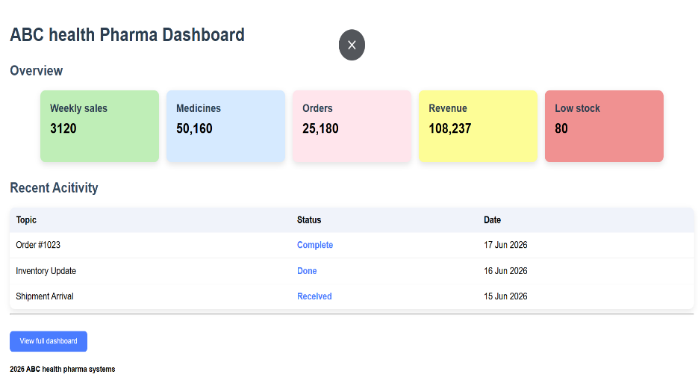
Implementation

Phase 1 – Environment Setup
- Created and configured a virtual machine on Microsoft Azure using the Azure for Students subscription and established secure SSH connectivity using PuTTY and PuTTYgen.
- Gained hands-on experience with basic Linux commands, file system navigation, and server administration tasks.
- Developed a simple sample healthcare-themed web page using Nginx to understand web server hosting and deployment.
- Set up Git and GitHub for version control and organized project files in a structured repository.
- Explored Linux user management, file permissions, and process management concepts.

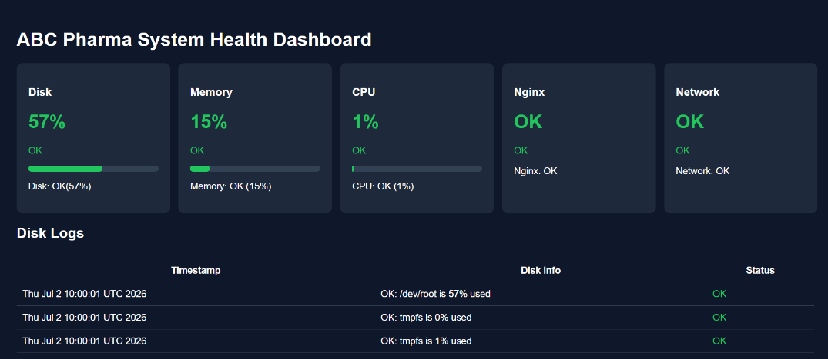
Phase 2 – Monitoring and Dashboard Development
- Studied key server health indicators such as CPU, memory, disk usage, and network activity, along with their normal operating thresholds.
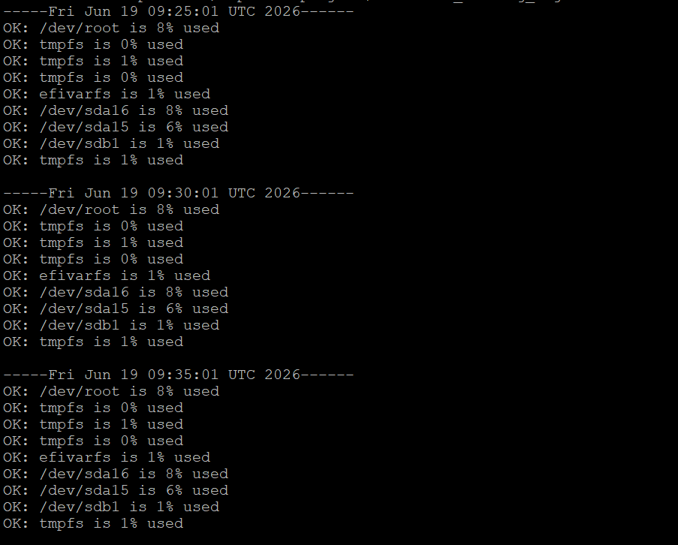
- Developed Bash scripts to generate server health summaries and provide warnings when critical thresholds were exceeded.
- Automated health checks, logging, and log maintenance using cron jobs to ensure continuous monitoring with minimal manual intervention.
- Built a simple Flask-based dashboard to display server health information in an easy-to-understand format.
- Performed stress testing on CPU, memory, and disk resources to validate the accuracy and reliability of the monitoring solution.

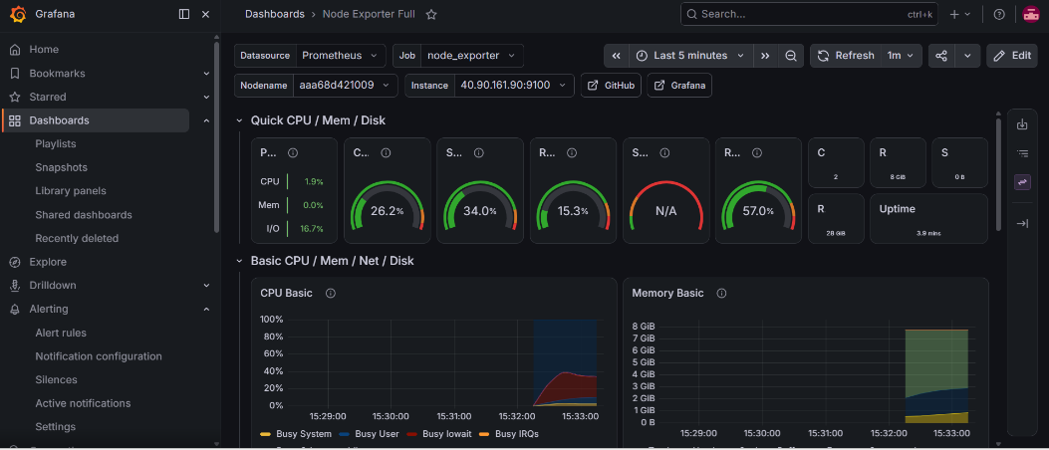
Phase 3 – Automation and Observability
- Configured Node Exporter and Prometheus to automatically collect and store server health metrics such as CPU, memory, disk, and network usage.
- Integrated Grafana with Prometheus and developed interactive dashboards to visualize server performance and health in real time.
- Implemented Infrastructure as Code (IaC) using Terraform to provision, destroy, and recreate cloud infrastructure witnessing self-healing
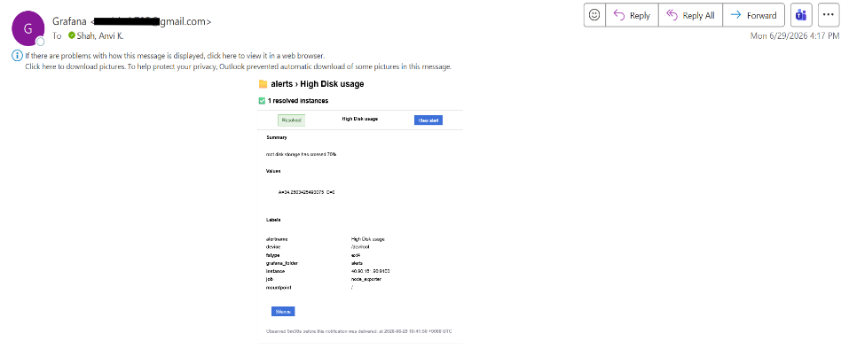
- Configured automated email alerting to notify users when critical CPU and disk usage thresholds were exceeded.

Phase 4 – Containerization and Orchestration
- Learned the fundamentals of Docker, including the workflow of Dockerfiles, images, and containers, and implemented containerization for the Flask dashboard, Prometheus, Grafana, and Node Exporter.
- Published custom Docker images to Docker Hub and maintained the project source code and configurations in a GitHub repository.
- Gained an understanding of Kubernetes architecture, including clusters, nodes, pods, and self-healing concepts using Minikube.
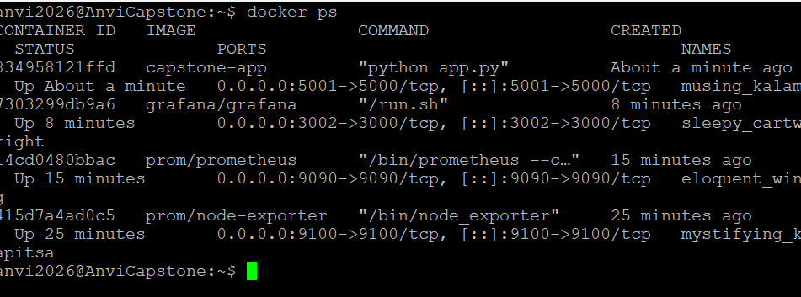
- Deployed the containerized applications on a Kubernetes cluster, practiced scaling and self-healing operations, and exposed services for external access through NodePort.

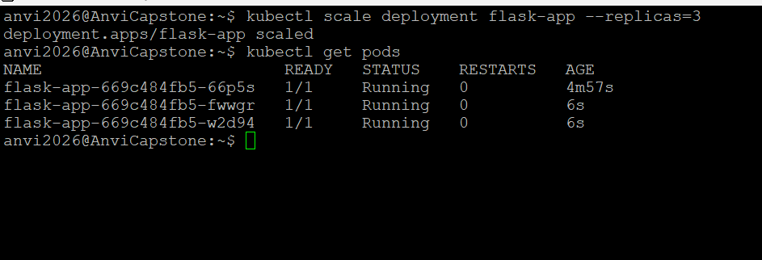

Results and Observation
- Successfully developed and deployed a complete Infrastructure Health Dashboard capable of monitoring server health and displaying key system metrics in real time.
- Implemented automated health checks and email-based alerting, enabling early warning when CPU or disk usage crossed defined thresholds.
- Built a professional monitoring solution using Node Exporter, Prometheus, and Grafana to provide continuous visibility into server performance.
- Containerized the application and monitoring stack using Docker, making the solution portable and easy to deploy across different environments.
- Successfully deployed and tested the containerized applications in a Kubernetes environment, validating concepts such as scaling, self-healing, and service exposure.
- Maintained a well-documented GitHub repository containing source code, infrastructure configurations, deployment files, and project documentation for easy reproduction of the solution.

