HASHICORP VAULT

TO get started we have to install local exe file given on the website 64 bit windows version

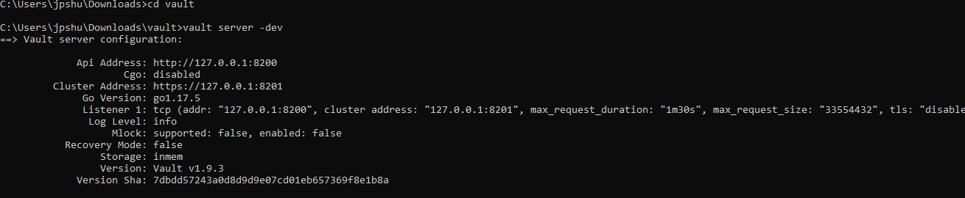

This will start the server locally and then open another instance of the CMD prompt.

Token and sealkey will be provided

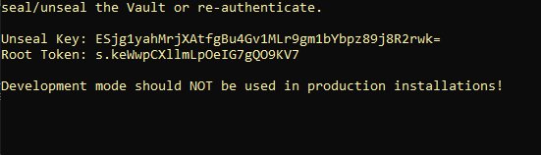

This one is at the first CMD prompt. Open the second cmd and start setting variables.

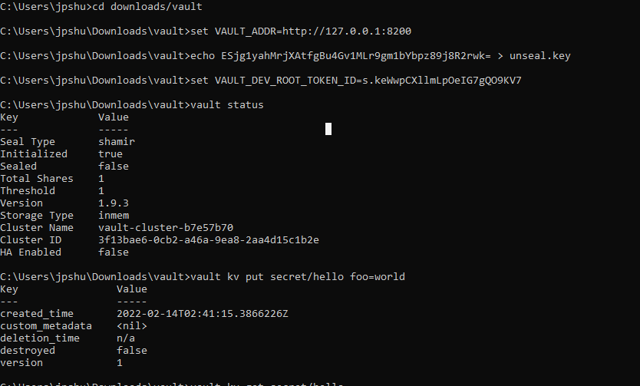

In the second prompt observe the commands above see the secret getting saved.

See below how to retrieve the keys back once saved.

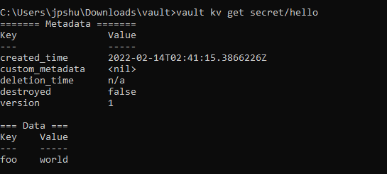

USE BASH if you want to convert DOS to bash shell.

STEP2 CREATECLOUD ENVIRONMENT AND USE TOKEN TO PULL AND PUSH KEYS USING CLI

The new cluster should look like this.

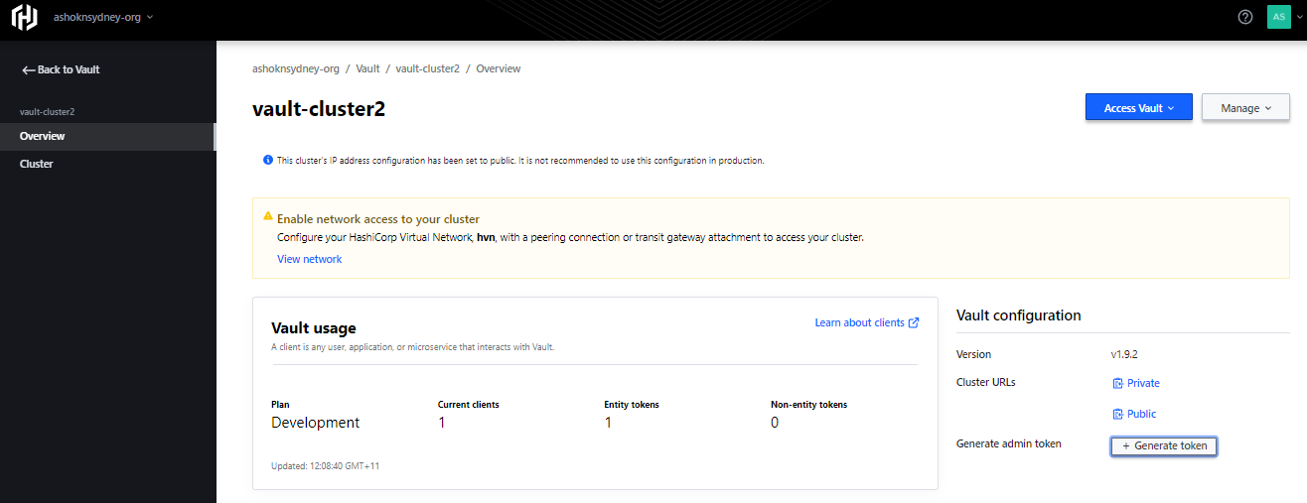

Both public and private access to be there.

Public URL is used to save and access token.

The end point of public should look like this

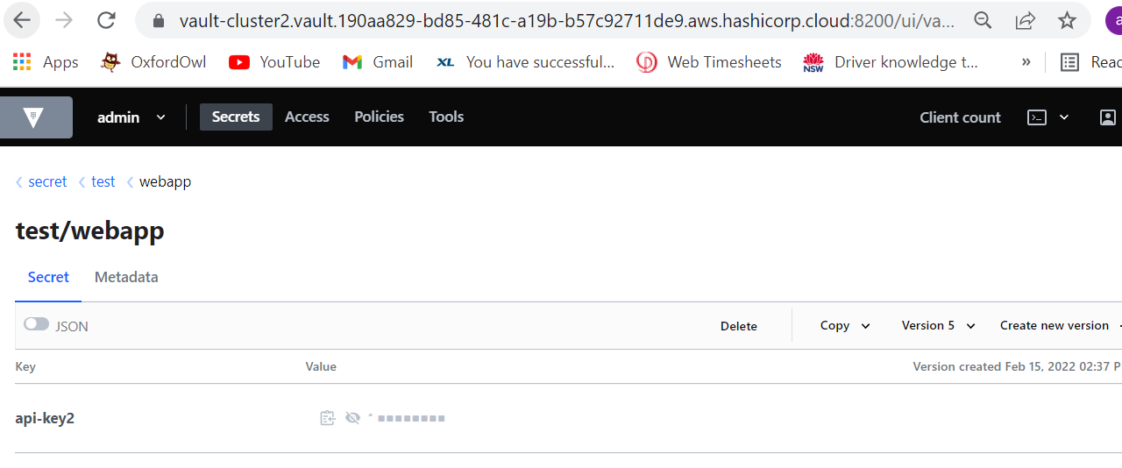

Where keys are pushed and pulled,

Use same endpoint to export vault addr. Use the token as below and now you are connected to cloud.

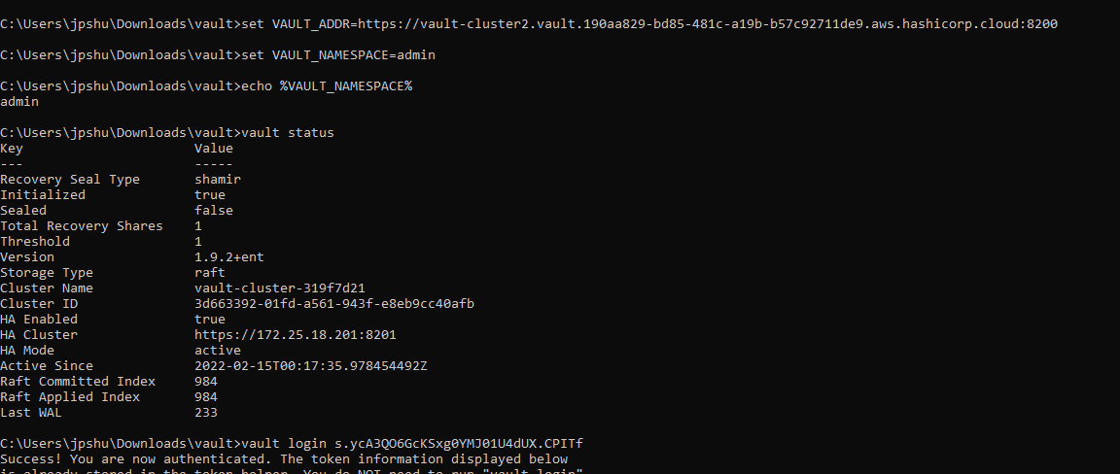

Using CLI this is how we save the key.

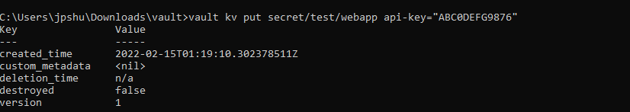

NOW CLI and be replaced and use CURL commands

Which enable scripting to store on cloud.

I change to bash shell and create file to save keys.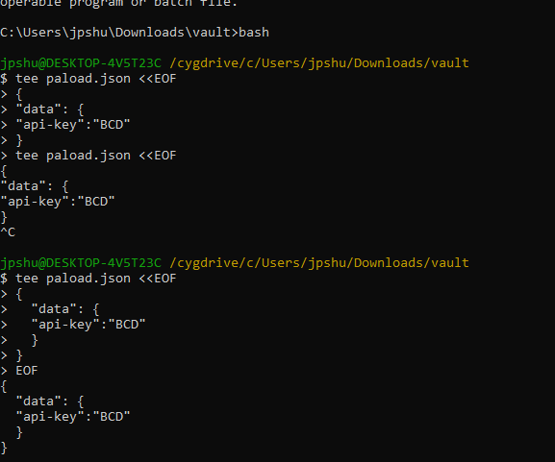

Then I upload using curl command onto cloud.

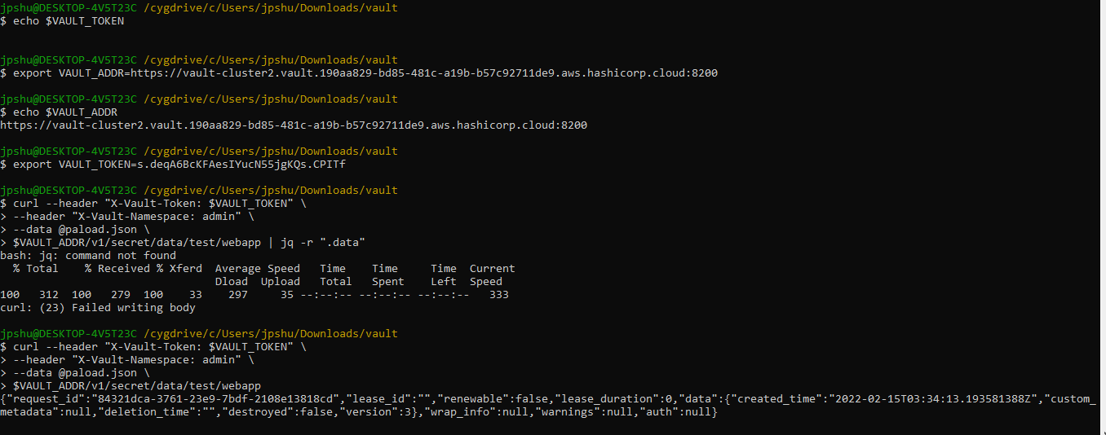

Once upload is done I see the key and the stored location.

