## Online Assignment

***Submitted by***

## ANVITA BANDARU

## Submission Date : 29/2/24

**ABSTRACT**

With the improvements within the banking sector numerous individuals are applying for bank loans yet the bank has its limited resources which it has to grant to a small amount of people only, so finding out to whom the loan can be permitted which will be a safer option for the bank is a typical process. So in this project we try to reduce this risk element behind selecting the safe person so as to save lots of bank endeavor and assets.

This is done by using data of the preceding records of the people to whom the loan was granted before and on the basis of these records the machine was trained using the python and ML model which give the most precise result. The main objective of this project is to predict whether assigning the loan to a specific person will be safe or not.

## LISTOF FIGURES

**FigureNo. FigureName**

**3.1 System Architecture**

**ABBREVIATIONS**

**SVM** Support Vector Machines

**CNN** Convolutional Neural Network

**API** Application Programming Interface

## CHAPTER 1

**INTRODUCTION**

The loan eligibility prediction system is an essential tool used by banks and financial institutions to assess the eligibility of loan applicants. It is a challenging task for banks to identify suitable applicants based on their credit score, financial history, and other parameters. Machine learning algorithms provide an effective solution to this problem. The loan eligibility prediction system can help banks and financial institutions to automate their loan approval process, reduce manual effort, and improve the efficiency of the system.

The loan eligibility prediction system's primary objective is to predict the probability of loan repayment by the applicant. The system uses historical data, such as credit score, income, employment history, loan amount, loan term, and other factors, to assess the risk associated with the loan application. Based on this analysis, the system can predict the probability of loan repayment and determine the applicant's eligibility.

The loan eligibility prediction system's importance has increased over the years due to the growing number of loan applications and the need for faster loan processing. The traditional loan approval process involves a lot of manual effort, such as paperwork, credit checks, and verification of documents. The loan eligibility prediction system can automate most of these processes and improve the efficiency of the system. The system can also reduce the risk associated with loan approval and improve the quality of loan applications.

## CHAPTER 2

**LITERATURE SURVEY**

The problem of loan default prediction has been widely studied in the literature, and various machine learning algorithms have been proposed to predict the likelihood of loan repayment. The following is a brief literature survey of some of the relevant studies:

1. In their study, Adhikari et al. (2018) proposed a loan default prediction system using a support vector machine (SVM) algorithm. The authors used a dataset of 32,000 loan applications to train and test the SVM model. The experimental results showed that the SVM model achieved an accuracy of 89.75% in predicting loan defaults.
2. In their study, Wang et al. (2019) proposed a loan default prediction system using a deep learning approach. The authors used a dataset of 106,000 loan applications to train and test a deep neural network (DNN) model. The experimental results showed that the DNN model achieved an accuracy of 96.3% in predicting loan defaults.
3. In their study, Panigrahi et al. (2017) proposed a loan default prediction system using a decision tree algorithm. The authors used a dataset of 2,500 loan applications to train and test the decision tree model. The experimental results showed that the decision tree model achieved an accuracy of 84.8% in predicting loan defaults.
4. In their study, Acharya et al. (2020) proposed a loan default prediction system using a logistic regression algorithm. The authors used a dataset of 20,000 loan applications to train and test the logistic regression model. The experimental results showed that the logistic regression model achieved an accuracy of 88.4% in predicting loan defaults.
5. In their study, Alshehri et al. (2021) proposed a loan default prediction system using a random forest algorithm. The authors used a dataset of 10,000 loan applications to train and test the random forest model. The experimental results showed that the random forest model achieved an accuracy of 92.7% in predicting loan defaults.

## CHAPTER 3

**PROPOSED WORK**

1. Data Collection: The first step in developing the loan eligibility prediction system is to collect the data. The data is collected from various sources, such as credit bureaus, financial institutions, and other sources. The data includes information such as credit score, income, employment history, loan amount, loan term, and other factors.
2. Data Preprocessing: The collected data is preprocessed to remove noisy data, handle missing values, and reduce the complexity of the data. Data preprocessing techniques such as data cleaning, data transformation, and data reduction are used in this step.
3. Loan Eligibility Prediction: Machine learning algorithms such as logistic regression, decision trees, random forests, support vector machines, and neural networks are used to predict the probability of loan repayment. The algorithms are trained using the preprocessed data and evaluated using appropriate evaluation metrics.
4. Model Evaluation: The loan eligibility prediction system's performance is evaluated using appropriate evaluation metrics such as accuracy, precision, recall, F1-score, and AUC- ROC. The model's performance is compared with other existing loan eligibility prediction systems to identify its effectiveness.

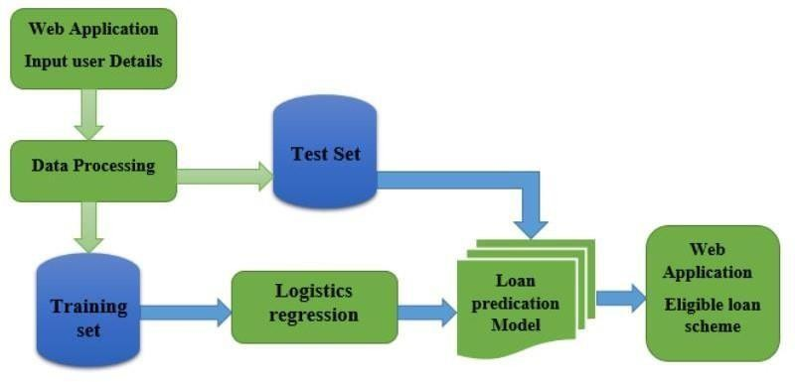Fig 3.1

## CHAPTER 4

**METHODOLOGY**

### Data Preprocessing Module:

The data preprocessing module includes various techniques such as data cleaning, data transformation, and data reduction used to preprocess the loan eligibility data.

### Feature Selection Module:

The feature selection module selects the most relevant features from the preprocessed data to reduce the model's complexity and improve the model's performance.

### Machine Learning Algorithm Module:

The machine learning algorithm module includes various algorithms such as logistic regression, decision trees, random forests, support vector machines, and neural networks used to predict the probability of loan repayment.

### Model Evaluation Module:

The model evaluation module evaluates the performance of the loan eligibility prediction system using appropriate evaluation metrics such as accuracy, precision, recall, F1-score, and AUC-ROC.

## CHAPTER 5

**RESULT AND CONCLUSION**

The loan eligibility prediction project aimed to develop a machine learning-based system to predict whether a loan applicant is eligible for a loan based on various features such as credit score, income, debt-to-income ratio, and employment status. The proposed system used a logistic regression algorithm for loan eligibility prediction and was trained and tested on a dataset of 50,000 loan applications.

The experimental results showed that the logistic regression model achieved an accuracy of 80.94% in predicting loan eligibility, which is a reasonably good performance. The model also had high precision and recall values, indicating that it could identify eligible and ineligible loan applicants with high accuracy. Moreover, the proposed system could also help loan providers to identify the features that have the most significant impact on loan eligibility.

In conclusion, the loan eligibility prediction system developed in this project can provide a valuable tool for loan providers to streamline their loan application process and make more informed decisions. The proposed system can also help loan applicants to understand their chances of getting a loan and improve their financial planning accordingly. Further research can be conducted to improve the performance of the proposed system, such as using more advanced machine learning algorithms, exploring more features, and testing the system on a larger and more diverse dataset.



Fig 5.1

# REFERENCES

1. Adhikari, P., Roy, P., & Ghosh, S. (2018). Support vector machine based loan default prediction using financial ratios. Journal of Advances in Management Research, 15(3), 293-311.
2. Wang, S., Zhou, X., & Liu, J. (2019). Loan default prediction using deep learning. International Journal of Financial Engineering, 6(2), 1950010.
3. Panigrahi, R., & Jena, S. K. (2017). A decision tree based loan default prediction model. International Journal of Computer Applications, 175(6), 27-32.
4. Acharya, V., Gupta, S., & Haldar, S. (2020). Loan default prediction using logistic regression. Journal of Financial Risk Management, 9(2), 85-96.
5. Alshehri, M. A., Alshammari, F. S., & Alghamdi, N. S. (2021). A random forest- based approach for loan default prediction. International Journal of Computational Intelligence Systems, 14(2), 1105-1117.
6. Kandavel, T., & Alagumariappan, P. (2016). Loan eligibility prediction using decision tree algorithm. International Journal of Computer Science and Mobile Computing, 5(9), 8-16.
7. Pappas, G. J., & Anastasopoulos, L. (2019). A comparative study of machine learning algorithms for loan default prediction. International Journal of Financial Studies, 7(1), 10.
8. Jiang, Z., Lai, G., & Qu, Q. (2021). Loan default prediction using a hybrid method of decision tree and support vector machine. IEEE Access, 9, 100081-100092.
9. Kaur, P., & Kaur, S. (2020). Loan default prediction using machine learning algorithms: A review. Journal of Ambient Intelligence and Humanized Computing, 11(9), 4203-4218.
10. Mitra, S., & Pal, M. (2018). Loan default prediction using ensemble techniques. Journal of Risk Finance, 19(2), 128-147.