**Anvith S G BL.EN.U4CSE22004**

**Nithish Kushal Reddy BL.EN.U4CSE22043  
  
1. Sector Market Cap Trends**

**What it says**:

* This chart displays the aggregated market capitalization of various sectors.
* The "Financials" sector has the largest market cap, followed by "Industrials" and "Materials."

**Why it is drawn**:

* To identify dominant sectors in terms of overall valuation.

**Reasoning**:

* Understanding market capitalization trends helps investors identify sectors with high economic significance or potential for growth.

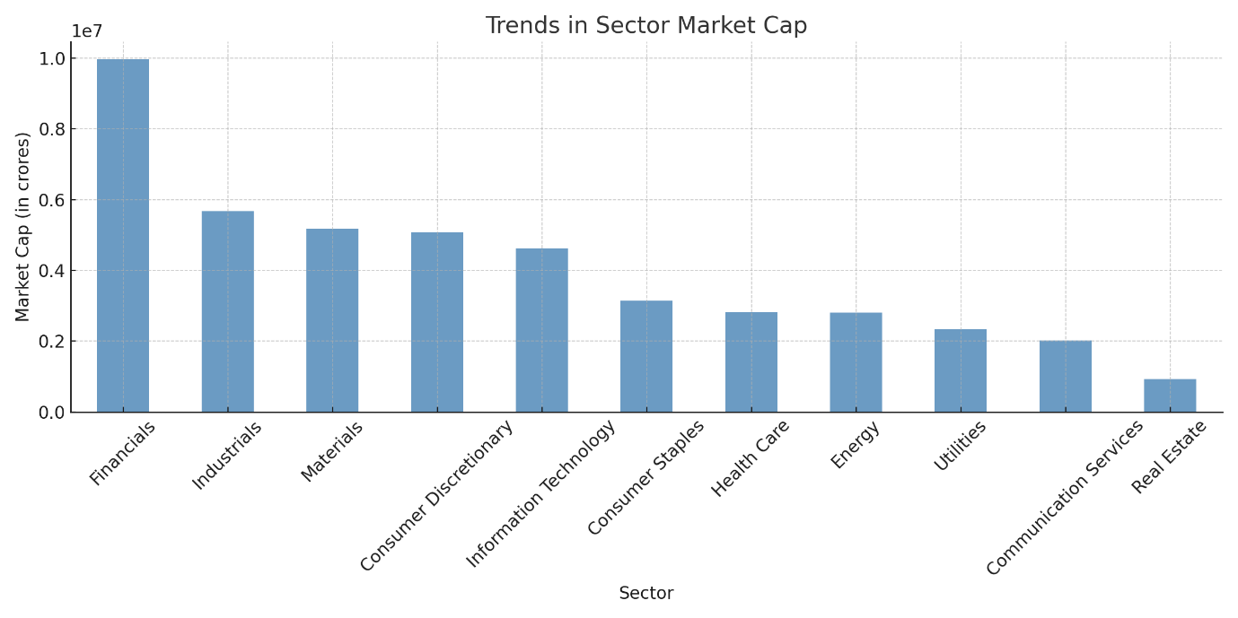

**2. Institutional Holdings Comparison**

**What it says**:

* This chart compares average changes in institutional holdings (MF, FII, DII) for each sector.
* For example, utilities have the highest DII and MF holdings changes, while sectors like "Consumer Staples" show less activity.

**Why it is drawn**:

* To analyze the confidence and investment behavior of institutional investors across sectors.

**Reasoning**:

* Institutional holdings reflect market confidence and potential growth prospects. Monitoring these trends helps in evaluating investor sentiments.

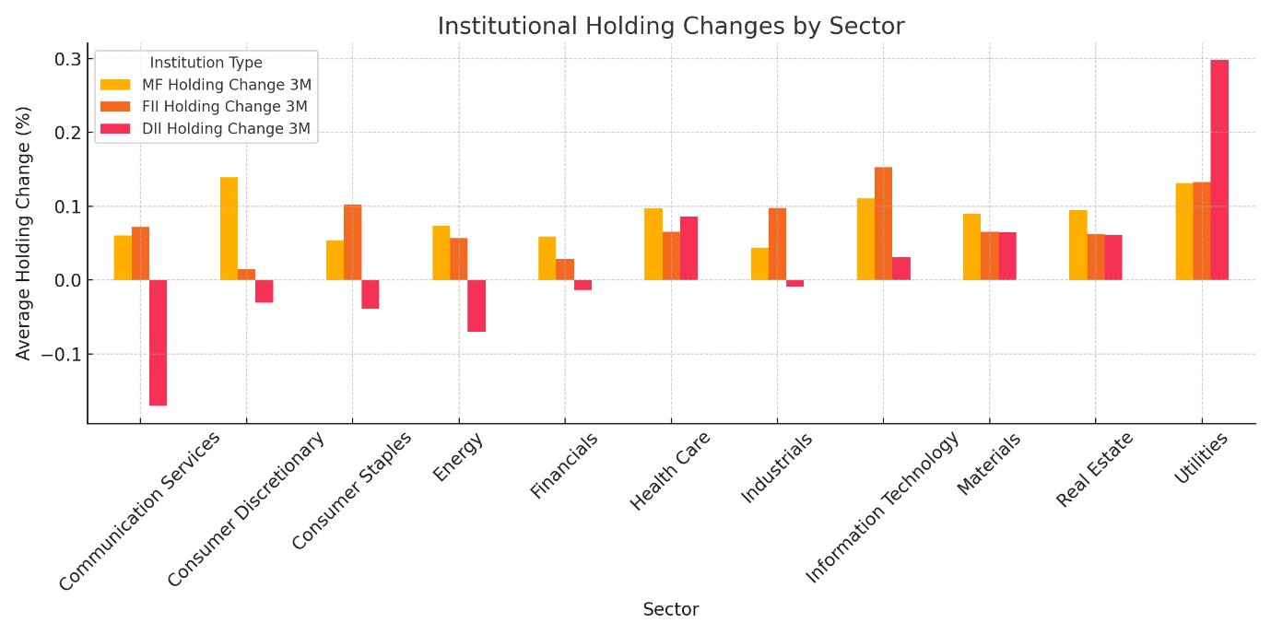

**3. Top-Performing Sectors: Market Cap and EPS**

**What it says**:

* This chart highlights the sectors with high market capitalization alongside EPS trends.
* For example, "Energy" has a high market cap but moderate EPS, whereas "Financials" show robust EPS growth.

**Why it is drawn**:

* To compare valuation (Market Cap) with profitability (EPS) trends across sectors.

**Reasoning**:

* High market cap sectors with strong EPS growth are likely to provide sustainable investment opportunities.

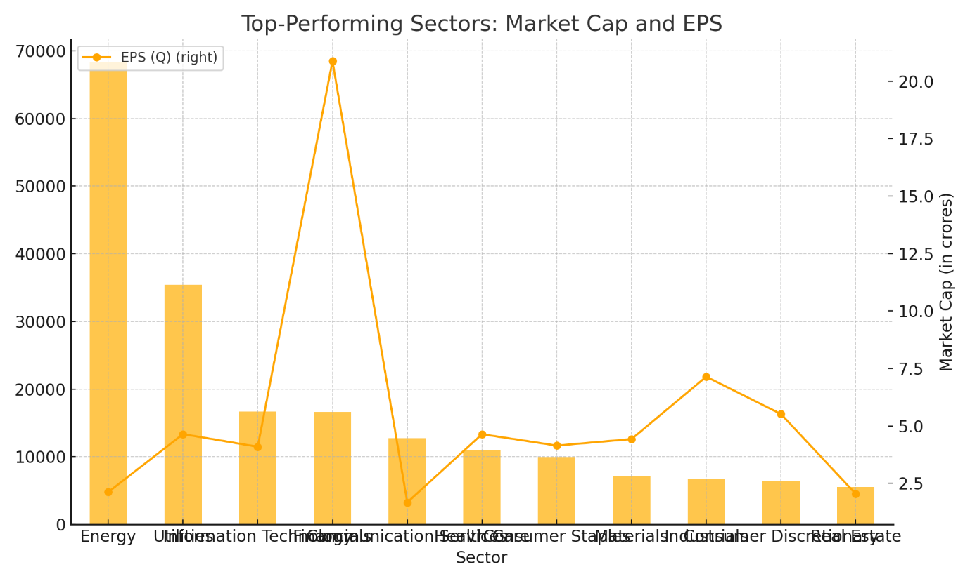

**4. Average EPS Growth by Sector**

**What it says**:

* This chart compares average EPS growth across sectors.
* "Financials" and "Industrials" have the highest EPS growth, indicating strong profitability growth trends.

**Why it is drawn**:

* To identify sectors with significant profit growth over time.

**Reasoning**:

* EPS growth reflects the company's ability to generate profit, crucial for long-term investment decisions.

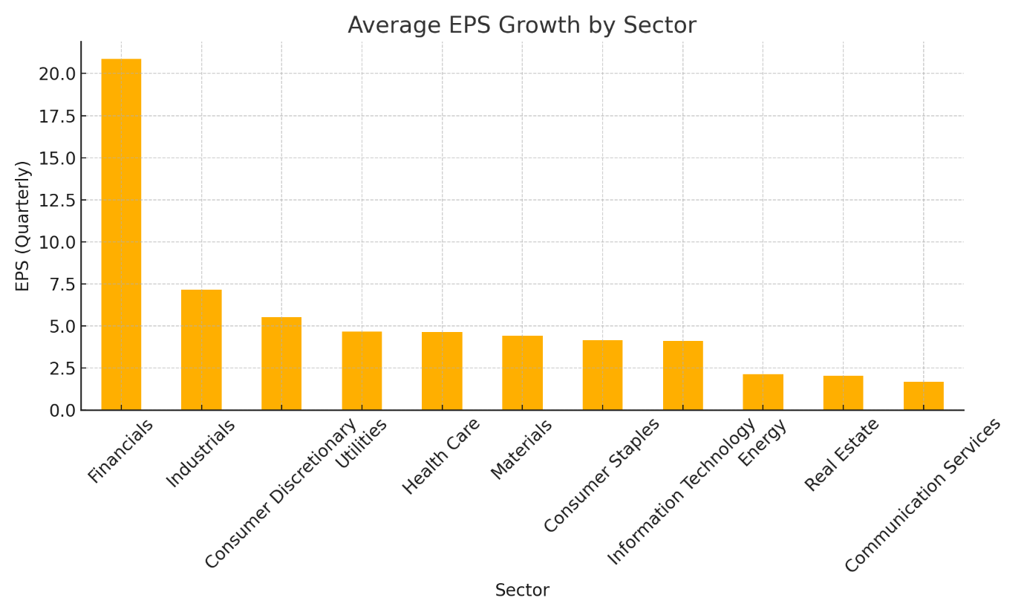

**5. Average Dividend Per Share by Sector and Recommendation Level**

**What it says**:

* This chart shows average dividend distribution by sector and recommendation level (R2: 0, 1, 2).
* For example, "Health Care" has high dividend payouts, especially for highly recommended stocks (R2=2).

**Why it is drawn**:

* To evaluate the dividend-friendliness of sectors and compare their appeal to dividend-seeking investors.

**Reasoning**:

* Dividends are a key indicator of financial stability and shareholder return. Investors focused on income rely on these trends.

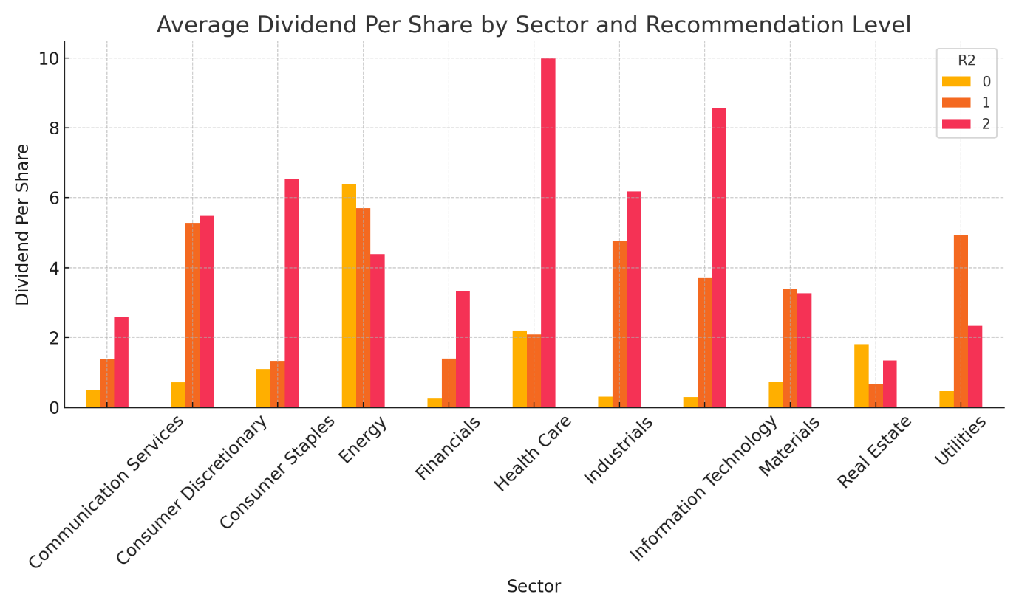

**6. Average Debt-to-Asset Ratio by Sector and Recommendation Level**

**What it says**:

* This chart compares the average debt-to-asset ratio across sectors for different recommendation levels.
* "Utilities" and "Materials" have higher debt-to-asset ratios, which may indicate leveraged operations.

**Why it is drawn**:

* To assess financial stability and risk levels across sectors.

**Reasoning**:

* Sectors with lower debt-to-asset ratios are generally less risky for investment, especially in volatile markets.

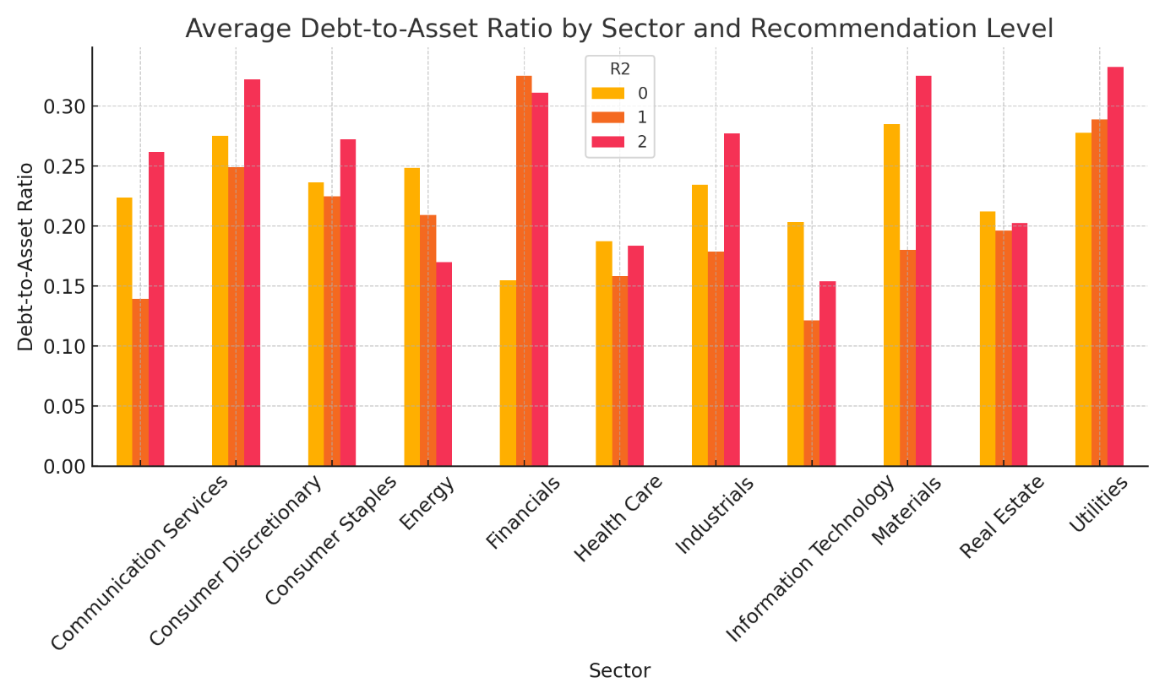

**7. Average Institutional Holding Change by Recommendation Level**

**What it says**:

* This chart shows how institutional holdings (MF, FII, DII) vary with recommendation levels.
* Stocks with a recommendation level of R2=2 have the highest institutional interest.

**Why it is drawn**:

* To connect recommendation levels with institutional confidence.

**Reasoning**:

* High institutional interest in R2=2 stocks confirms alignment between expert recommendations and investor confidence.

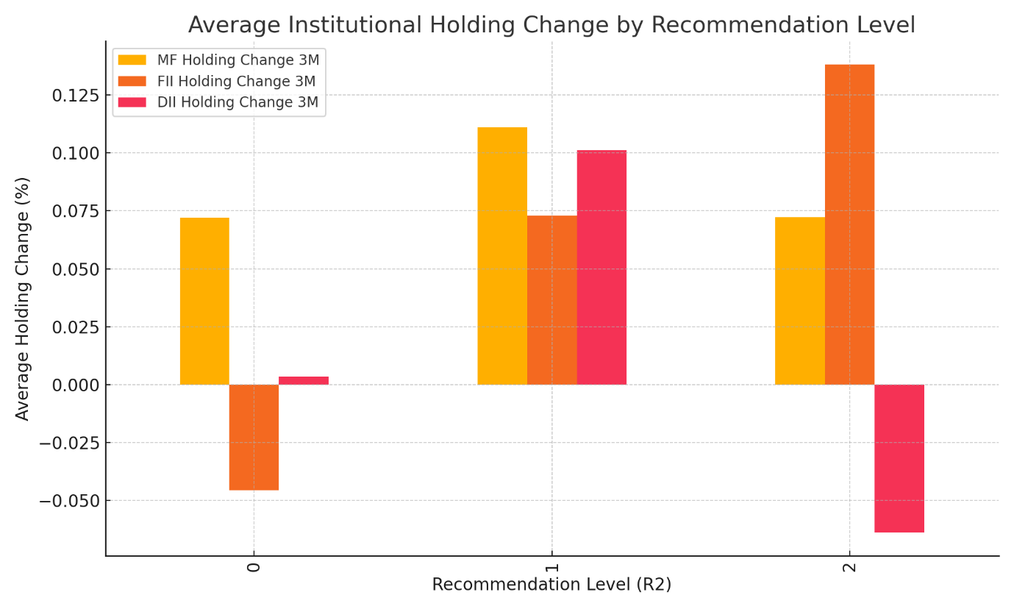

**8. Stock Distribution by Sector and Recommendation Level**

**What it says**:

* This stacked bar chart illustrates the distribution of stocks across recommendation levels for each sector.
* For example, "Industrials" and "Financials" have more highly recommended stocks.

**Why it is drawn**:

* To identify the quality of stocks within each sector based on recommendations.

**Reasoning**:

* Helps investors focus on sectors with a higher proportion of high-quality, highly recommended stocks.

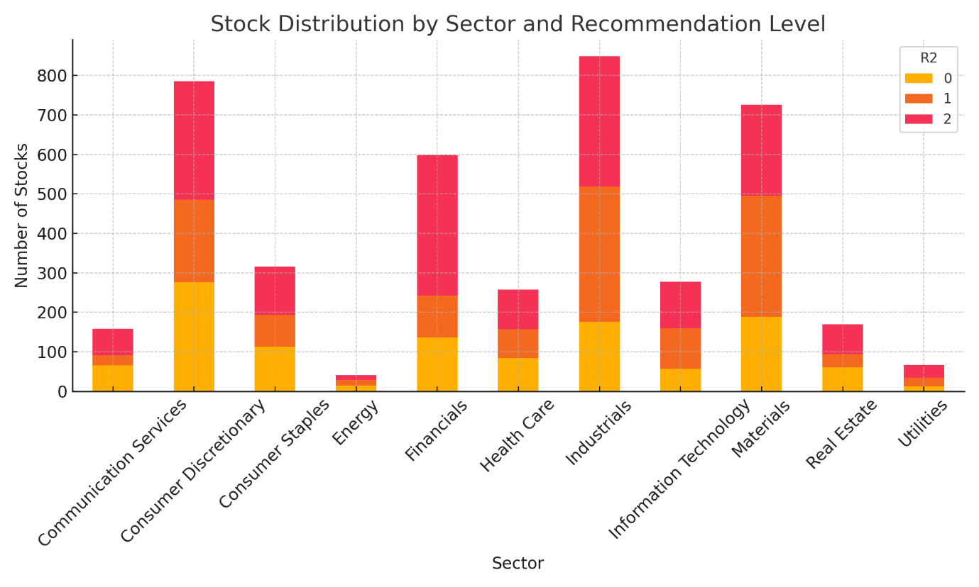

**9. Market Capitalization vs. EBITDA Margin**

**What it says**:

* This scatter plot visualizes the relationship between market cap and EBITDA margin across recommendation levels.
* Sectors with higher EBITDA margins generally have higher market capitalizations.

**Why it is drawn**:

* To examine the operational efficiency's impact on valuation.

**Reasoning**:

* EBITDA margin reflects operational efficiency, and its relationship with market cap indicates the valuation efficiency of sectors.

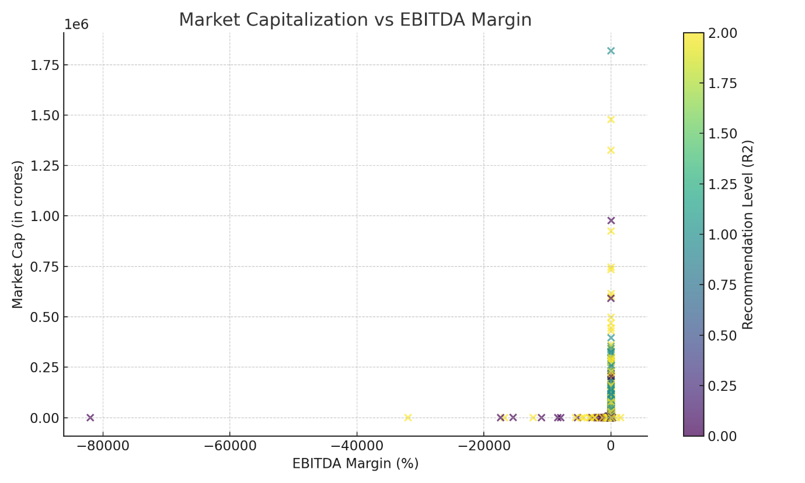

**10. ROE vs. ROCE by Sector**

**What it says**:

* This scatter plot compares Return on Equity (ROE) and Return on Capital Employed (ROCE) across sectors.
* There is a positive correlation, with some sectors like "Financials" showing exceptional efficiency.

**Why it is drawn**:

* To evaluate profitability and capital efficiency across sectors.

**Reasoning**:

* ROE and ROCE together reflect the ability of a company to generate profit and utilize its capital effectively.

