**Pronunciation Perfect: A Smart Pronunciation Evaluation System**

G Anvith Reddy

*Department of Computer Science   
 Amrita School of Engineering,*

*Amrita Vishwa Vidyapeetham,* Bengaluru, India.  
[BL.EN.U4AIE21041@bl.students.amrita.edu](mailto:BL.EN.U4AIE21041@bl.students.amrita.edu)

Ch. Partha Sai Saketh   
 *Department of Computer Science   
 Amrita School of Engineering,*

*Amrita Vishwa Vidyapeetham,* Bengaluru, India.[BL.EN.U4AIE21068@bl.students.amrita.edu](mailto:BL.EN.U4AIE21068@bl.students.amrita.edu)

Vaan Amuthu Elango

*Department of Computer Science   
 Amrita School of Engineering,*

*Amrita Vishwa Vidyapeetham,* Bengaluru, India.  
[e_vaanamuthu@blr.amrita.edu](mailto:e_vaanamuthu@blr.amrita.edu)

*Abstract –* The Project ***strives to redefine language learning by offering personalized feedback on pronunciation accuracy. Through cutting-edge speech recognition technology, the system analyses user speech against correct pronunciations, providing tailored exercises for improvement. With its intuitive interface and adaptive learning features, Pronunciation Perfect aims to enhance language proficiency effectively and engagingly.***

***Keyword: Speech-Based, Emotion-Enhanced Learning and Assessment System, Pronunciation Perfect, language learning, pronunciation accuracy, speech recognition, adaptive learning, real-time feedback, personalized exercises***

**I. INTRODUCTION**

Pronunciation Perfect, an integral part of the broader "Speech-Based Emotion-Enhanced Learning and Assessment System," zeroes in on refining pronunciation—a cornerstone of language mastery. The project's core objective is to furnish users with a comprehensive toolset for real-time pronunciation enhancement.

In today's interconnected world, effective communication stands as a linchpin skill. Pronunciation Perfect rises to this challenge by delivering instantaneous feedback on pronunciation, empowering users to refine their language skills across diverse scenarios, spanning from language acquisition to public speaking endeavours.

At the heart of Pronunciation Perfect lies state-of-the-art speech recognition algorithms. These algorithms scrutinize user speech, juxtaposing it against correct pronunciations to pinpoint areas necessitating improvement. Leveraging adaptive learning methodologies, the system tailors exercises based on individual performance metrics.

The system commences by capturing user speech input, followed by processing via sophisticated speech recognition algorithms. Phonetic representations are identified, then cross-referenced with correct pronunciations to furnish personalized feedback. Acoustic modelling, language modelling, and machine learning algorithms bolster accuracy and adaptability.

Acoustic modelling empowers the system to discern between diverse speech sounds, while language modelling ensures context-sensitive evaluation. Machine learning algorithms dynamically adjust feedback based on user performance, facilitating continuous skill enhancement.

Pronunciation Perfect heralds a paradigm shift in language learning and assessment, empowering users to attain proficiency in spoken language skills. With its user-friendly interface and adaptive learning capabilities, the system presents a transformative learning journey, tailored to meet the diverse needs of language learners across the globe.

**II. LITERATURE SURVEY**

In this paper [1], the authors introduce an innovative approach to speech recognition by blending data augmentation and ensemble methods, leading to enhanced accuracy. They employ feature perturbation for data augmentation, augmenting the training dataset, and employ ensemble techniques to integrate multiple models. This novel system proves effective in real-world French ASR tasks, showcasing its potential for improving speech recognition performance in practical applications.

The paper [2] introduces a language learning app for low-cost tablets in rural India, addressing the lack of teachers and technology. It uses speech recognition to give instant feedback on pronunciation, even without internet access. Learners can progress at their own pace and fix mistakes on the go, making learning engaging and motivating. Features like recognizing longer sentences and providing visual feedback enhance the learning experience. Future plans include improving support for Indian languages like Hindi and Malayalam.

This research [3] is based on innovation in speech recognition which has experienced through the experiment on nano physics specific quantum convolutional neural network (QCNN) that we have made. The paradigm is a new one that get the best out of Quantum as well as classical protocol treating inter alia the issues of scalability and accuracy of voice recognition apps. The ability of the quant filters to reduce the input strength as such is confirmation that quantum computers have what it takes upstage the speech recognition as well as the text converting, and their potential is vast. Furthermore, the second part of the process which is the said layers added to the QCNN model, the tool demonstrated that it is a great candidate for chatbots which are among the very known virtual assistants like Alexa and Siri.

In this research, [4] the suggested multimodal intermediate-level fusion workspace integrates the speech recognition system output and visual movement information. This infrastructure alleviates the deficiencies of the one-way audio speech recognition systems, which are unable to accommodate the hearing-impaired, and they are also unable to handle the disruptive noise and differing pronunciations. It comes up with the analysis for a model based on transformers and turns out that the former has lower WER coefficients in terms of noisy audio than baseline systems. Benchmark datasets LRS2 and Grid are used for the evaluation of this multimodal approach because it decreases the WER significantly and provide better insights than the unimodal methods on some datasets. Finally, the future studies would use unlabelled data and knowledge distillation methodology alongside others to also improve the performance of the model.

This work [5] aims at a speech emotion recognition system, utilising different machine learning algorithms which are coupled to deep learning classifiers to improve the accuracy and tolerance of the system. To improve the recognition system and make it more generalised and stronger, 3 databases are used namely Berlin, SAVEE and TESS. It is seen that the model which involves CNN and LSTM accounts for 94% accuracy among all other classifiers suggesting its potency of classifying emotional speech using data from various databases. The research discloses the way SER can be designed to utilize data fusion and deep learning models which will ultimately improve the accuracy of emotion recognition by AI.

The paper [6] focuses on a spell correction framework that is based on an Automated Speech Recognition (ASR) system developed from a deep recurrent neural network (RNN). This framework is supported by a model that is built using Bidirectional Encoder Representations from Transformers (BERT) in the aim of improving transcription accuracy. Ongoing performance deficiencies of ASR systems, where the job of proper transcription remains a challenging one, push decision makers towards advanced spell-checking solutions. It is methodology of experimenting that evaluates the WER, CER sentence, and BLEU score using three different accent corpora to examine the effect of spell correction with BERT pre-trained model on ASR. The outcomes of the experiments reveal that spelling error detection and correction model is capable to notice and solve spelling mistakes successfully. It attained a considerably low WER in several datasets generated by voxforge, NPTEL, and librispeech corpora.

The paper [7] describes about the modern uses of hidden markov models (HMMs) are typically described in this piece by analysing the current capabilities of the speech recognition system. Voice Quest is an important step forward in digital communication technology. This essay aims to appraise Voice Quest and explain its significance. Simplification and ease of searching are what Voice Quest seeks to achieve. Essentially, we should establish a database that can host some questions, which are typically asked for, as well as their corresponding replies. Every time there is a new query from any user, our database is checked first to see if there exists an exact match before converting the input question into text form. After finding such answer, it is saved inside the database so that when user asks same question voice response could be played back accordingly with it being written like text in the system. All this makes Voice Quest important because it allows for no typing or pressing buttons. Every word must countif you want to maximize your writing’s impact.

This research [8] presents a speech augmentation method for automated speech recognition (ASR) systems using a dense convolutional recurrent network (DCRN). It suggests using voice enhancement for two purposes: augmenting data and acting as an ASR preprocessing frontend. The paper uses a three-step training approach for preprocessing and a KL divergence-based consistency loss for data augmentation. Results on an English video dataset from social media show notable gains in ASR performance: an average relative improvement of 11.2% was achieved with data augmentation, 8.3% with preprocessing, and 13.4% when both strategies were combined. The results demonstrate the effectiveness of speech enhancement approaches in enhancing the resilience and accuracy of ASR, especially when used as preprocessing and data augmentation techniques.

The research of the paper [9] is concentrated on identifying speakers in harsh acoustic conditions by putting emphasis on the positives of DNN embeddings and i-vectors. The methodology is concerned with the evaluation of both the single-channel (monaural) and multi-channel speech enhancement approaches. It employs the masking based MVDR beamformers for multi-channel enhancement as well as the convolutional recurrent networks (CRNs) for monaural speech enhancement. Results of experiment explicitly show that the complex summarization of the spectrum employs convolutional recurrent networks jointly with gammatone frequency cepstral coefficients (GFCCs) leads to drastic decrease in the speaker verification errors for the systems of both i-vector and x-vector. Continually, spear in smooth weight \(x\) performance by multi-channel speech augmentation; this error diminishing is more apparent in a rank-1 estimation of the MVDR beamformer, hampered only by accurate steering vector estimation. The research paper highlights the importance of speech hostile augmentation methods in effective speaker recognition under noisy conditions.

In this paper [10], you will find a comprehensive review of the deep learning methods applying to audio-visual speech enhancement and separation. It uses various aspects, such as training goals, evaluation methods, techniques of fusion, sound and visual features, and deep learning techniques. This illustrates the application of multimodal sources as well as the effectiveness of data-driven approaches. The authors also uncover strategies for audio-visual sound source separation and speech restoration from silent videos, which can be used for audio-visual speech separation and enhancement. Moreover, the diverse audio-visual speech datasets and evaluation mechanisms including often-employed ones will be paid attention from various angles to compare and evaluate the system performance. In sum, the study possesses a solid understanding of current state of this field highlighting both the progress and the gap as well.

**III. METHODOLOGY**

**Data:**

Have used sp2_anvith.wav and Bhanumathi_weds_Rajat for all the experiments

**Method:**

For the experiments on the recorded speech, a Python environment was deployed, using the Librosa package for audio processing tasks. Initially, the speech file was imported into the workspace using the librosa.load() method, allowing for additional analysis.

In the primary phase of this experiment, the aim is to study the complexities of speech recognition and synthesis by using state-of-the-art techniques such as LSTM and Bi-LSTM networks, coupled with a set of signals processing methodologies, including Short-Time Fourier Transform, Mel-Frequency Cepstral Coefficients (MFCC), and Linear Predictive Coding (LPC) coefficients.The main objective is decoding and understanding spoken language by looking at the acoustic signals that are produced while talking. The process begins with loading a recorded speech signal from a WAV file, which is essential raw data for our model. We extract the salient features embedded within the speech signal from a set of signal processing techniques, which are STFT, STCT, MFCC, and LPC coefficients. These extracted features serve to segment and classify the intricate phonetic elements perceptible in recorded speech. Guided by LSTM and Bi-LSTM models, we attempt to construct models good enough in figuring out and understanding spoken words to bridge the gap between raw audio data and linguistic meaning. The model's architecture comprises bidirectional LSTM layers and Dense layers for temporal modeling and sequence classification. Dropout layers are incorporated for regularization. Compiled with optimizer, the model minimizes categorical cross-entropy loss.

In the subsequent phase of the experiment, the focus is on speech synthesis through the novel approach of phoneme segmentation and synthesis. The main purpose is deciphering and figuring outspoken language from its acoustic signals as these are the ones producing speech. We first record a sample sentence "Bhanumathi weds Rajat" in many Indian scripts, including Devanagari and Telugu, which serves as the material to experiment with speech recognition and synthesis.Next, transcription of the recorded speech to textual form was performed with the help of established tools such as Speech Recognition and pyttsx3. The segmentation of phonemes had to be done strictly to be able to isolate the target word "Bharat" from it. The original audio signal of the word "Bharat" and the artificially created speech are loaded and displayed using matplotlib. The waveform graphs show the strength of the sounds as they change over time, making it easy to compare the natural and artificial audio.

However, this approach opens new ways in synthesizing speech and thus increases the level of complexity. One of the possible difficulties associated with this type of method is the creation of unnatural prosody that results from the joining of the phonetic transitional sound elements. Also, the disproportion in pronunciation can appear which further explains the mismatching of phonemes and accent differences that make them from the synthesized word. Moreover, faulty phoneme choice or alignment can spoil the quality of intelligibility of synthesized speech.

Through these experiments, we aim to gain insights into the mechanisms underlying speech recognition and synthesis, exploring the capabilities and limitations of advanced neural network architectures and signal processing techniques in the context of linguistic analysis and artificial speech generation.

**IV. RESULTS**

The investigations yielded varied insights into the nature of the recorded voice signal. Analysis of the waveform offered information on its length and magnitude range. Through these analyses, we gain a comprehensive understanding of the recorded voice signal's frequency characteristics and dynamics. This includes insights into its overall frequency content, temporal characteristics, segment-specific frequency composition, and time-varying spectral features. Such analyses contribute to a deeper comprehension of the underlying structure and variability in the voice signal, aiding in further interpretation and processing.

After running the initial part of our code, the output of the code is depicted in Fig.1 and it shows a sophisticated design for handling sequential data like speech signals. It begins with a bidirectional LSTM layer that captures temporal relationships in both directions, generating 256-dimensional hidden states. Next, a Time Distributed dense layer reduces the dimensionality of these sequences to 64 dimensions at each time step. A dropout layer is used for regularization by randomly dropping units during training. Another bidirectional LSTM layer continues processing the sequences, followed by a Time Distributed dense layer that outputs sequences of dimension 10, matching the number of classes in the dataset. Overall, the model consists of the specified components.

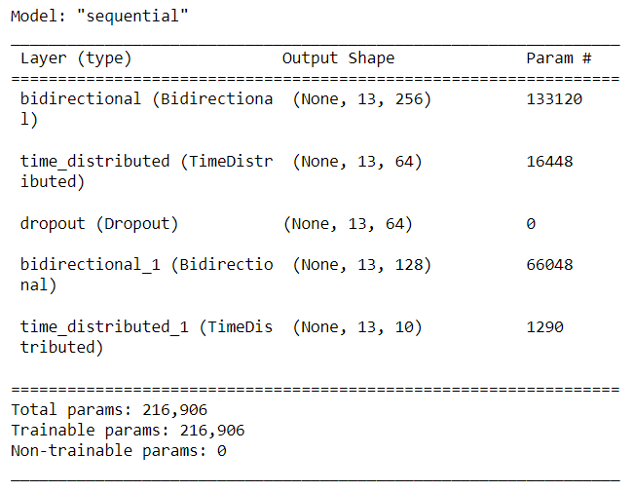

Fig(i): Results of Question A1

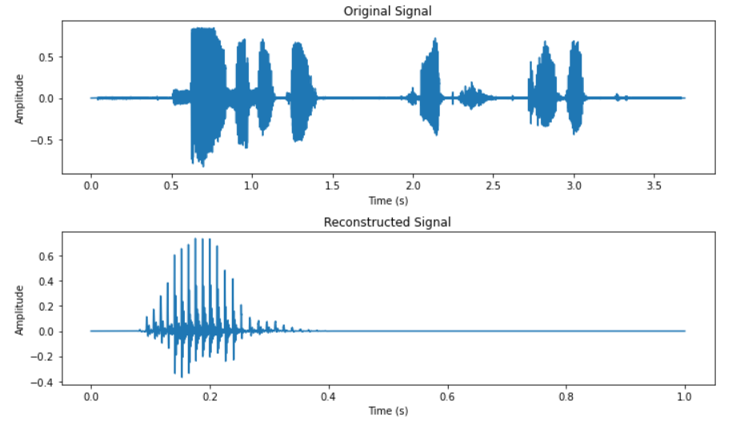

Fig(ii): Results of Question A2, showing the Original signal and the Re-constructed Signal

**V. CONLCUSION**

As a whole, this experiment utilizes LSTM and Bi-LSTM networks for speech recognition tasks. Several techniques such as Short-Time Fourier Transform, Mel-Frequency Cepstral Coefficients (MFCC), and Linear Predictive Coding (LPC) coefficients were used to analyze different aspects of speech. In one experiment, the phrase 'Bhanumathi weds Rajat' was spoken, and the word 'Bharat' was synthesized by combining phonemes from the recording. However, there were issues with this method because of the errors in phoneme segmentation or inaccuracies in representing Indian scripts. It is advisable to validate Indian scripts to ensure practicality before use. Their successful use of demonstrates their effectiveness as a powerful tool for analyzing speech data, leading to further progress in signal processing and machine learning.

##### **REFERENCES**

2. Ilyes Rebai, Yessine BenAyed, Walid Mahdi, Jean-Pierre Lorré,''Improving speech recognition using data augmentation and acoustic model fusion'',2017,Pages 316-322.
3. A. Jayakumar, Raghunath, M., S, S. M., S, A., Sadanandan, A., and Prof. Prema Nedungadi, “Enhancing speech recognition in developing language learning systems for low cost Androids”, in 2016 International Conference on Computational Techniques in Information and Communication Technologies (ICCTICT), 2016
4. Thejha B., Yogeswari S., Vishalli A, Jeyalakshmi J., “Speech Recognition Using Quantum Convolutional Neural Network” , Proceedings of 8th IEEE International Conference on Science, Technology, Engineering and Mathematics, ICONSTEM 2023(SCOPUS)
5. A. Kumar, D. K. Renuka, S. L. Rose and M. C. Shunmugapriya, "Attention based Multi Modal Learning for Audio Visual Speech Recognition," 2022 4th International Conference on Artificial Intelligence and Speech Technology (AIST), Delhi, India, 2022, pp. 1-4,
6. Sasidharan Rajeswari, S., Gopakumar, G., Nair, M. (2021). Speech Emotion Recognition Using Machine Learning Techniques. In: Sharma, H., Saraswat, M., Yadav, A., Kim, J.H., Bansal, J.C. (eds) Congress on Intelligent Systems. CIS 2020. Advances in Intelligent Systems and Computing, vol 1335, pp 169–178, 2020.
7. Shunmuga Priya, M.C., Karthika Renuka, D., and Ashok Kumar, L. ‘Towards Improving Speech Recognition Model with Post-processing Spell Correction Using BERT’. 1 Jan. 2022 : 4873 – 4882, IoS Press
8. T. S. Sarika, Sreekumar, S., and A. G. Hari Narayanan, “Enhancement of speech recognition (Voice quest)”, International Journal of Applied Engineering Research, vol. 10, pp. 708-711, 2015.
9. A. Pandey, C. Liu, Y. Wang and Y. Saraf, "Dual Application of Speech Enhancement for Automatic Speech Recognition," 2021 IEEE Spoken Language Technology Workshop (SLT), Shenzhen, China, 2021, pp. 223-228
10. H. Taherian, Z. -Q. Wang, J. Chang and D. Wang, "Robust Speaker Recognition Based on Single-Channel and Multi-Channel Speech Enhancement," in IEEE/ACM Transactions on Audio, Speech, and Language Processing, vol. 28, pp.
11. Michelsanti, Daniel, et al. "An overview of deep-learning-based audio-visual speech enhancement and separation." IEEE/ACM Transactions on Audio, Speech, and Language Processing 29 (2021):