**Introduction:**

If we walk around our house we can collect items that are no longer useful to us but they may be useful for someone. Most of the people want to give them away but find no time to attend to giveaways or have no idea about giveaways and many people are in need of items that helps them to complete their work but unable to afford them. In order to fill the gap between these two communities we thought of making an app which makes easy for users to upload items they want to donate and search items they are in need.

**Project Goal and Objectives:**

**Goal:**

With our application we plan to make the routine give away system considerably more straightforward, as everything aside from the pickup happens via mobile.

We plan to lessen the time included in the routine "giveaway" technique. We plan to make more individuals take dynamic part in the "giveaway" exercises.

**Motivation:**

We regularly observe that we don't utilize some of our tangibles and don't put them to use at all and thusly make them pointless. In the meantime we may have other individuals in our general public who may need these things however don't have them in light of not having the capacity to manage the cost of them.

This has persuaded us to look forward towards adding to an application which could connect this hole between those individuals prepared to give away their items to those individuals in need of these things.

We plan to build up a basic Android Application which could empower this straightforward "Give Away" system through cellular telephones.

In straightforward words our application is a basic "dole out" component with everything incident via telephone.

**Significance:**

As opposed to turning some of our trappings pointless lastly making them wind up in a waste can our application helps us to discover the individual in need of these articles and empowers these articles to achieve those in need.

Because of time limitations and numerous different reasons even individuals who are eager to donate their things out will be unable to take part in the customary "give away". With our application posting the items you need to give away and taking solicitation from the individual in need happens via phone with negligible exertion and this would unquestionably welcome more members to get themselves included in giving their things with individuals in need of them.

**Advantages:**

* More people will donate as they can operate everything from their home without wasting time by going to the place where giveaway is being conducted.

**Proposed System**

1. **Requirement Specification**

**Functional Requirements**

Category list should be provided to the client to simplify sorting and searching. The interface ought to be visually fathomable and easy to be used by the client while in the meantime agreeable inside the screen size imperative of a little Android mobiles. Clients ought to have the capacity to login, mark favorites, filter results based on location and category and receive updates on the items they are looking for.

**Non-functional Requirements**

Application development can be simplified by using Android SDK tools. We thought to provide better performance to our app by making it an android application with less number of webview elements. We want to make our so as to make it run on low memory devices too and to occupy less bandwidth. We want our app to provide secure access.

**Project Background and Related Work:**

Now a days people want everything to happen in second within their hand tips, so mobile apps have become so famous that most research have been taking place in this field. In order to develop apps that work on the work on mobile android is providing an excellent platform. Android provides us everything that we required to build an app according to our idea. It helps to update UI of automatically to look best on the device it is being used.

There were some apps that allows item sharing and to know about places where give awaya are going to take place

Assumptions:

1. Assuming that mobile is in charging
2. Assuming that mobile supports android apps

**System Design:**

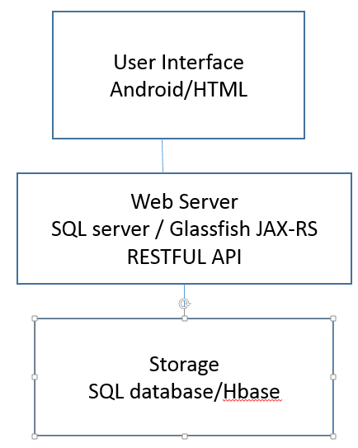

We are looking the possibility of both SQL database and Non-SQL database like Hbase for implementing our app.

SQL Vs No SQL:

1. Sql database depends on tables whereas no sql depends on key-value pairs.
2. Sql schema is pre-defined one and no sql scheme is dynamic.
3. Sql databse are doesn’t fit for hierarchical data storage whereas no sql databases do
4. No Sql database is not a best idea for complex queries where Sql is.

Our project Application is Android based. In our app GUI, it contains two main feature, one is categories, in which, we will separate each item based on the category for the convenience of the user and other is latest uploads. In this part, the most recent uploaded items will be displayed. A search bar is added in order to facilitate users to search the item they are interested in. Login and registration functions are implemented in order to maintain the details of users.

Considerations:

UI: Android

Server: SQL server works good as we handle less amount of data. Images of items will be stored in server directory. Images links are only stored in server.

SQL database tables:

User table: 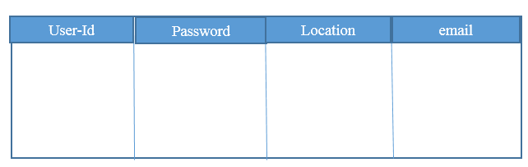

Items-Table: 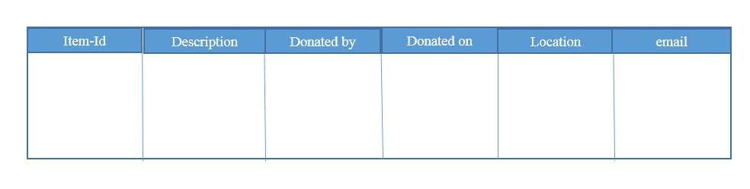

Class Diagram:

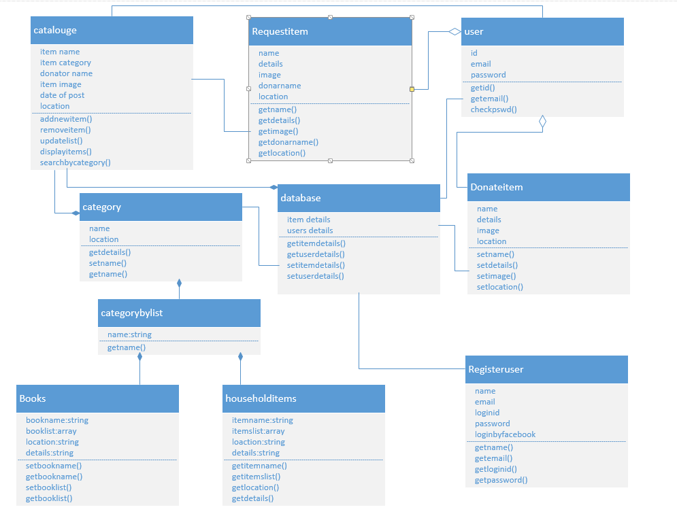

Acitvity Diagram:

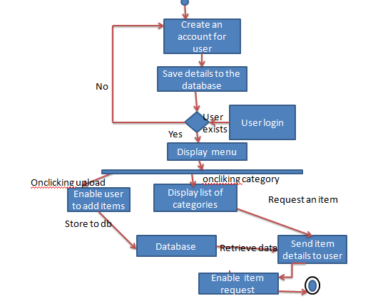

Sequence diagram:

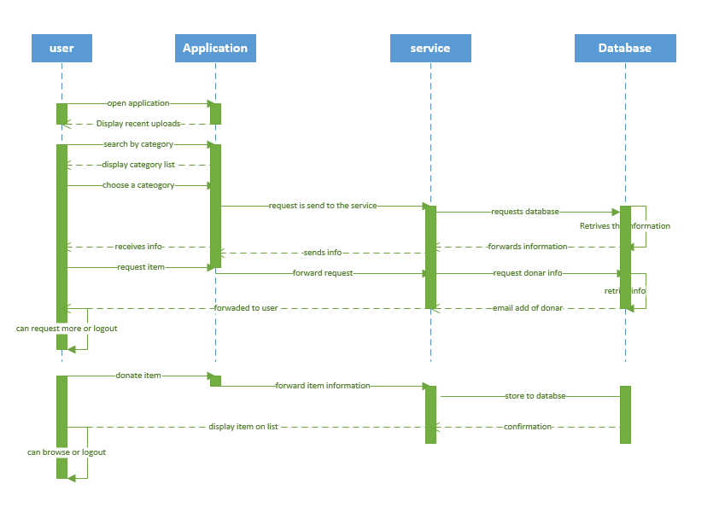

**Existing Services:**

1. Name: Google Maps API.

Description: Used to show items in that location

URL: <https://developers.google.com/maps/documentation/javascript/tutorial>

1. Name: Facebook API.

Description: Used to register a user through facebook.

URL: <https://developers.facebook.com/docs/reference/php/facebook-api>

**New Service to be constructed**

**Get Items by category:** This service provides items based on their category.

**Input:** Enter category

**Output:** list of items in that category

**Exception:** If entered category is not available in database, it replies no such category is found

Class Diagram:

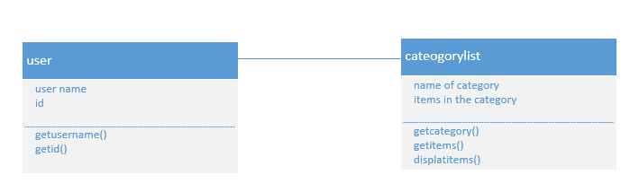

Sequence Diagram:

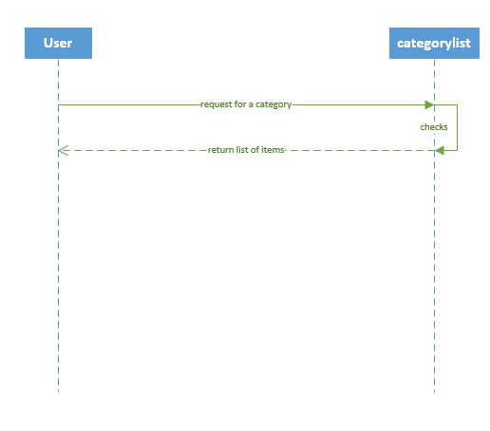

**Enable user upload items:** This service helps users to upload details of the item they want to donate

**Input:** upload a item

**Output:** database updated

Class Diagram

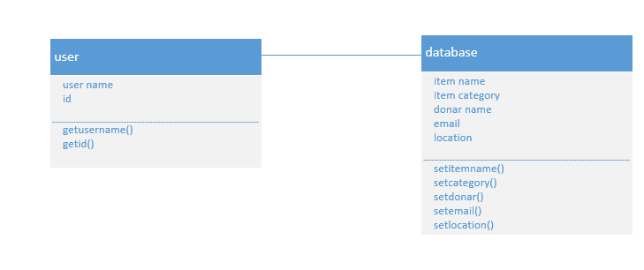

Sequence Diagram:

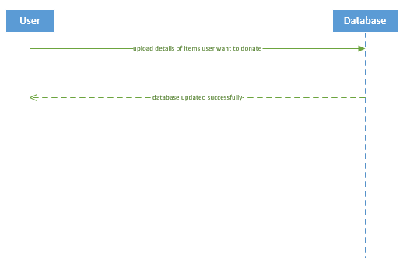

**Scrum do Link:**

Project Plan

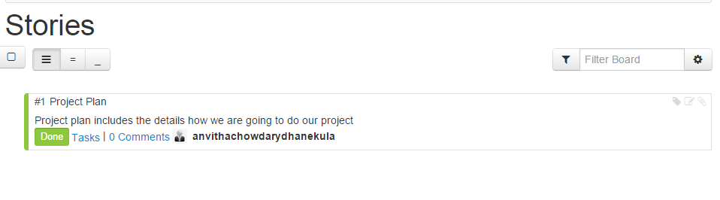

Increment 1

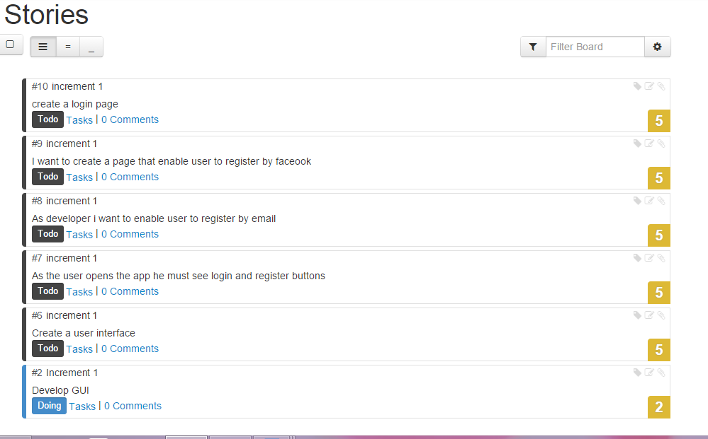

Increment 2

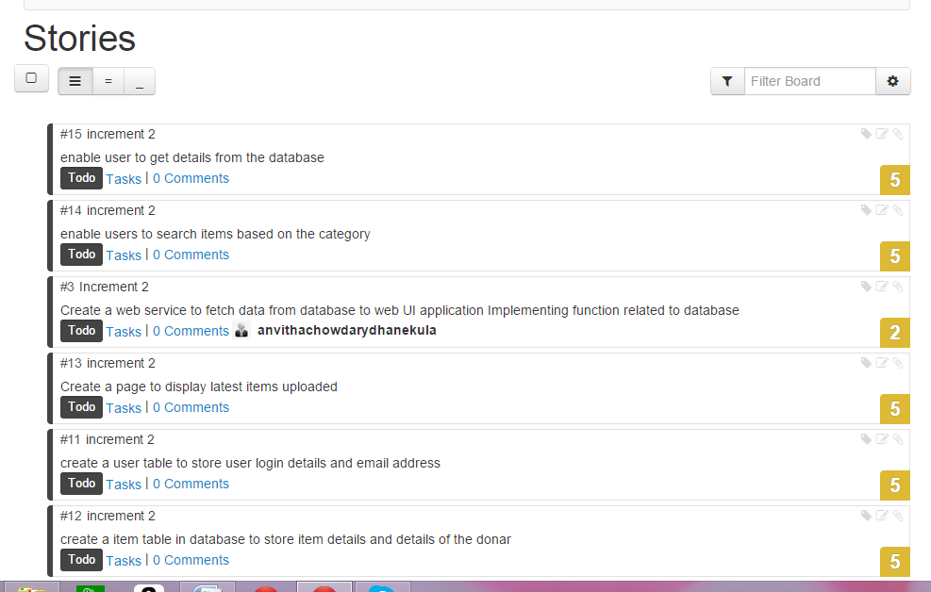

Increment 3 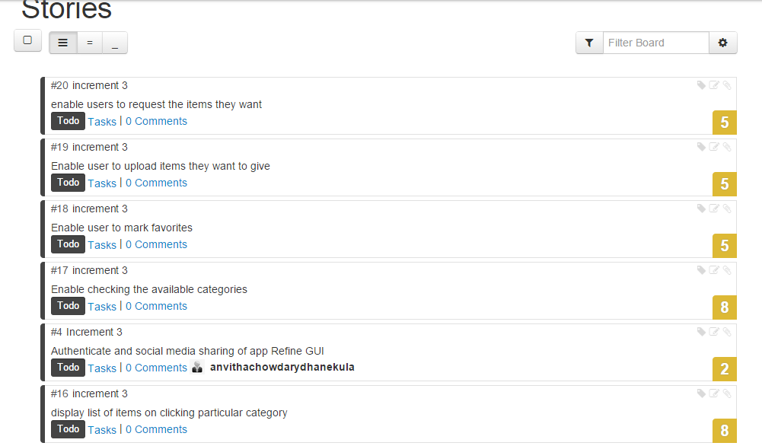

Increment 4

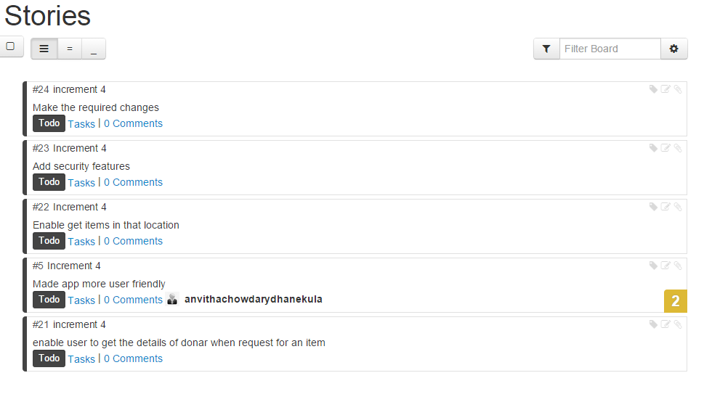

<https://www.scrumdo.com/projects/project/giveaway1/summary>

**Team Members:**

Anvitha Chowdary Dhanekula( Class Id 13)

Sasya Malireddy (Class Id 31)