SJF(preemptive)
#include<stdio.h>

int main()
{
int bt[20],rt[20],wt[20],tat[20];
int i,j,n,smallest,count=0,time;
float avgwt=0,avgtat=0;

printf("Enter number of processes: ");
scanf("%d",&n);

for(i=0;i<n;i++)
{
printf("Enter Burst Time for P%d: ",i+1);
scanf("%d",&bt[i]);
rt[i]=bt[i];
}

rt[19]=9999;

for(time=0;count!=n;time++)
{
smallest=19;

for(i=0;i<n;i++)
{
if(rt[i]<rt[smallest] && rt[i]>0)
smallest=i;
}

rt[smallest]--;

if(rt[smallest]==0)
{
count++;
wt[smallest]=time+1-bt[smallest];
}
}

printf("\nPID\tBT\tWT\tTAT\n");

for(i=0;i<n;i++)
{
tat[i]=bt[i]+wt[i];
avgwt+=wt[i];
avgtat+=tat[i];
printf("%d\t%d\t%d\t%d\n",i+1,bt[i],wt[i],tat[i]);
}

printf("\nAverage Waiting Time=%.2f",avgwt/n);
printf("\nAverage Turnaround Time=%.2f",avgtat/n);

return 0;
}
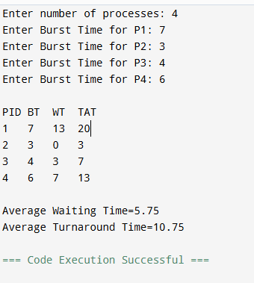

SJF(non-preemptive)
#include<stdio.h>

int main()
{
int n,i,j,temp;
int bt[20],wt[20],tat[20],p[20];

float avg_wt=0,avg_tat=0;

printf("Enter number of processes: ");
scanf("%d",&n);

for(i=0;i<n;i++)
{
printf("Enter Burst Time for P%d: ",i+1);
scanf("%d",&bt[i]);
p[i]=i+1;
}

for(i=0;i<n;i++)
{
for(j=i+1;j<n;j++)
{
if(bt[i]>bt[j])
{
temp=bt[i];
bt[i]=bt[j];
bt[j]=temp;

temp=p[i];
p[i]=p[j];
p[j]=temp;
}
}
}

wt[0]=0;

for(i=1;i<n;i++)
wt[i]=wt[i-1]+bt[i-1];

for(i=0;i<n;i++)
{
tat[i]=bt[i]+wt[i];
avg_wt+=wt[i];
avg_tat+=tat[i];
}

printf("\nP\tBT\tWT\tTAT\n");

for(i=0;i<n;i++)
printf("P%d\t%d\t%d\t%d\n",p[i],bt[i],wt[i],tat[i]);

printf("\nAverage Waiting Time = %.2f",avg_wt/n);
printf("\nAverage Turnaround Time = %.2f",avg_tat/n);

return 0;
}

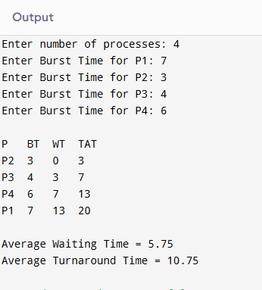

PRIORITY(preemtive)
#include<stdio.h>

int main()
{
int bt[20],pr[20],rt[20],wt[20],tat[20];
int i,n,time,smallest,count=0;
float avgwt=0,avgtat=0;

printf("Enter number of processes: ");
scanf("%d",&n);

for(i=0;i<n;i++)
{
printf("Enter Burst Time and Priority for P%d: ",i+1);
scanf("%d%d",&bt[i],&pr[i]);
rt[i]=bt[i];
}

pr[19]=9999;

for(time=0;count!=n;time++)
{
smallest=19;

for(i=0;i<n;i++)
{
if(pr[i]<pr[smallest] && rt[i]>0)
smallest=i;
}

rt[smallest]--;

if(rt[smallest]==0)
{
count++;
wt[smallest]=time+1-bt[smallest];
}
}

printf("\nPID\tBT\tPriority\tWT\tTAT\n");

for(i=0;i<n;i++)
{
tat[i]=bt[i]+wt[i];
avgwt+=wt[i];
avgtat+=tat[i];
printf("%d\t%d\t%d\t\t%d\t%d\n",i+1,bt[i],pr[i],wt[i],tat[i]);
}

printf("\nAverage WT=%.2f",avgwt/n);
printf("\nAverage TAT=%.2f",avgtat/n);

return 0;
}

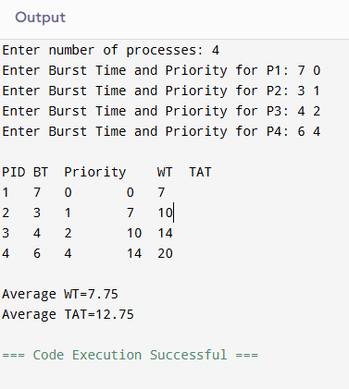

PRIORITY(preemtive)
#include<stdio.h>

int main()
{
int n,i,j;
int pid[20], bt[20], priority[20], wt[20], tat[20];
int temp;
float avgwt=0, avgtat=0;

printf("Enter number of processes: ");
scanf("%d",&n);

for(i=0;i<n;i++)
{
pid[i]=i+1;
printf("Enter Burst Time and Priority for P%d: ",i+1);
scanf("%d%d",&bt[i],&priority[i]);
}

for(i=0;i<n;i++)
{
for(j=i+1;j<n;j++)
{
if(priority[i] > priority[j])
{
temp = priority[i];
priority[i] = priority[j];
priority[j] = temp;

temp = bt[i];
bt[i] = bt[j];
bt[j] = temp;

temp = pid[i];
pid[i] = pid[j];
pid[j] = temp;
}
}
}

wt[0] = 0;

for(i=1;i<n;i++)
wt[i] = wt[i-1] + bt[i-1];

for(i=0;i<n;i++)
{
tat[i] = wt[i] + bt[i];
avgwt += wt[i];
avgtat += tat[i];
}

printf("\nPID\tPriority\tBT\tWT\tTAT\n");

for(i=0;i<n;i++)
printf("%d\t%d\t\t%d\t%d\t%d\n",pid[i],priority[i],bt[i],wt[i],tat[i]);

printf("\nAverage WT = %.2f",avgwt/n);
printf("\nAverage TAT = %.2f",avgtat/n);

return 0;
}
