RATE MONOTONIC SCHEDULING
#include <stdio.h>

struct Task {
int id, execution, period;
};

int main() {
int n, i, j, time = 0;
struct Task t[10], temp;

printf("Enter number of tasks: ");
scanf("%d", &n);

for(i = 0; i < n; i++) {
t[i].id = i + 1;
printf("Enter execution time and period for Task %d: ", i+1);
scanf("%d %d", &t[i].execution, &t[i].period);
}

// Sort by shortest period
for(i = 0; i < n-1; i++) {
for(j = i+1; j < n; j++) {
if(t[i].period > t[j].period) {
temp = t[i];
t[i] = t[j];
t[j] = temp;
}
}
}

printf("\nGantt Chart:\n|");
for(i = 0; i < n; i++) {
printf(" T%d |", t[i].id);
}

printf("\n0");
for(i = 0; i < n; i++) {
time += t[i].execution;
printf(" %d", time);
}

return 0;
}
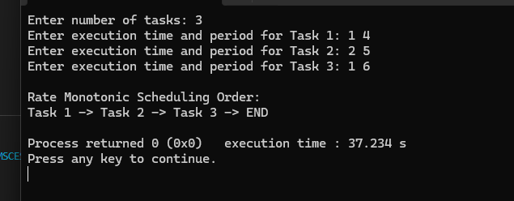Earliest Deadline First
#include <stdio.h>

struct Task {
int id, execution, deadline;
};

int main() {
int n, i, j, time = 0;
struct Task t[10], temp;

printf("Enter number of tasks: ");
scanf("%d", &n);

for(i = 0; i < n; i++) {
t[i].id = i + 1;
printf("Enter execution time and deadline for Task %d: ", i+1);
scanf("%d %d", &t[i].execution, &t[i].deadline);
}

// Sort by earliest deadline
for(i = 0; i < n-1; i++) {
for(j = i+1; j < n; j++) {
if(t[i].deadline > t[j].deadline) {
temp = t[i];
t[i] = t[j];
t[j] = temp;
}
}
}

printf("\nGantt Chart:\n|");
for(i = 0; i < n; i++) {
printf(" T%d |", t[i].id);
}

printf("\n0");
for(i = 0; i < n; i++) {
time += t[i].execution;
printf(" %d", time);
}

return 0;
}
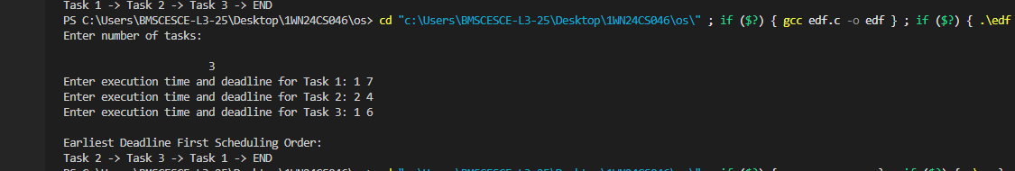
Proportional Scheduling
#include <stdio.h>

struct Task {
int id, execution, period;
float share;
};

int main() {
int n, i, totalTime = 10, allocated;
struct Task t[10];

printf("Enter number of tasks: ");
scanf("%d", &n);

for(i = 0; i < n; i++) {
t[i].id = i + 1;
printf("Enter execution time and period for Task %d: ", i+1);
scanf("%d %d", &t[i].execution, &t[i].period);

t[i].share = (float)t[i].execution / t[i].period;
}

printf("\nGantt Chart:\n|");
int current = 0;

for(i = 0; i < n; i++) {
allocated = (int)(t[i].share * totalTime);
printf(" T%d |", t[i].id);
}

printf("\n0");
for(i = 0; i < n; i++) {
allocated = (int)(t[i].share * totalTime);
current += allocated;
printf(" %d", current);
}

return 0;
}
