**COLLEGE OF ENGINEERING**



**Visualization**

**DAMG 6210 – FALL 2023 – DATA MANAGEMENT AND DATABASE DESIGN**

**GROUP 13**

**TEAM MEMBERS:**

**ANVITHA LAKSHMISHA 002965377**

**BHAVESH RAJA RAMPALLY 002776804**

**DIPEN MANOJ PATEL 002834112**

**SHREYA SARAVANAN 002760633**

1. Shows a detailed picture of the number of jobs each company has and the number of applicants for each company

* Uses the jobID and companyID to give the count of jobs by each company (bar graph)
* Uses companyID and applicationID to show the amount of application each company gets (line graph)

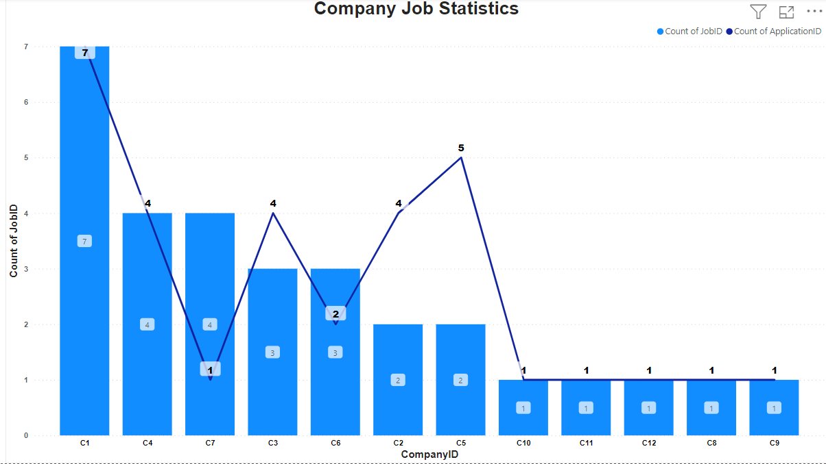

2. Gives a picture of the average salary of top 10 different job titles

* Uses jobTitle and salaryRange to get the top 10 job titles with the highest average salary (donut graph)

