**DAILY ONLINE ACTIVITIES SUMMARY**

|  |  |  |  |  |  |  |  |  |  |
| --- | --- | --- | --- | --- | --- | --- | --- | --- | --- |
| **Date:** | **24-06-2020** | | | | | **Name:** | | **Anvitha U** | |
| **Sem & Sec** | **6th  Sem ‘A’ Sec** | | | | | **USN:** | | **4AL17CS009** | |
| **Online Test Summary** | | | | | | | | | |
| **Subject** | | **JAVA and Data structures in C .** | | | | | | | |
| **Max. Marks** | | **JAVA Quiz1=5**  **JAVA Quiz2=5**  **DS Quiz1=6.** | | **Score** | | | | **JAVA Quiz1=5.**  **JAVA Quiz2=3.**  **DS Quiz1=4.** | |
| **Pre-Placement Training Summary** | | | | | | | | | |
| **Course** | **Workshop of JAVA and Data structures in C .** | | | | | | | | |
| **Faculty** | | | **Shilpa mam.**  **Venkatesh Sir.** | | | | **Duration** | | **4 hours** |
| **Coding Challenges** | | | | | | | | | |
| **Problem Statement:1.** Create a class named 'Shape' with a method to print "This is This is shape". Then create two other classes named 'Rectangle', 'Circle' inheriting the Shape class, both having a method to print "This is rectangular shape" and "This is circular shape" respectively. Create a subclass 'Square' of 'Rectangle' having a method to print "Square is a rectangle". Now call the method of 'Shape' and 'Rectangle' class by the object of 'Square' class. | | | | | | | | | |
| **Status: done** | | | | | | | | | |
| **Uploaded the report in Github** | | | | | **yes** | | | | |
| **If yes Repository name** | | | | | Daily Report =<https://github.com/anvithauppoor/online_coding_activity> | | | | |
| **Uploaded the report in slack** | | | | | **yes** | | | | |

**Class and Quiz Snapshots:**

**JAVA and Data structures in C :**

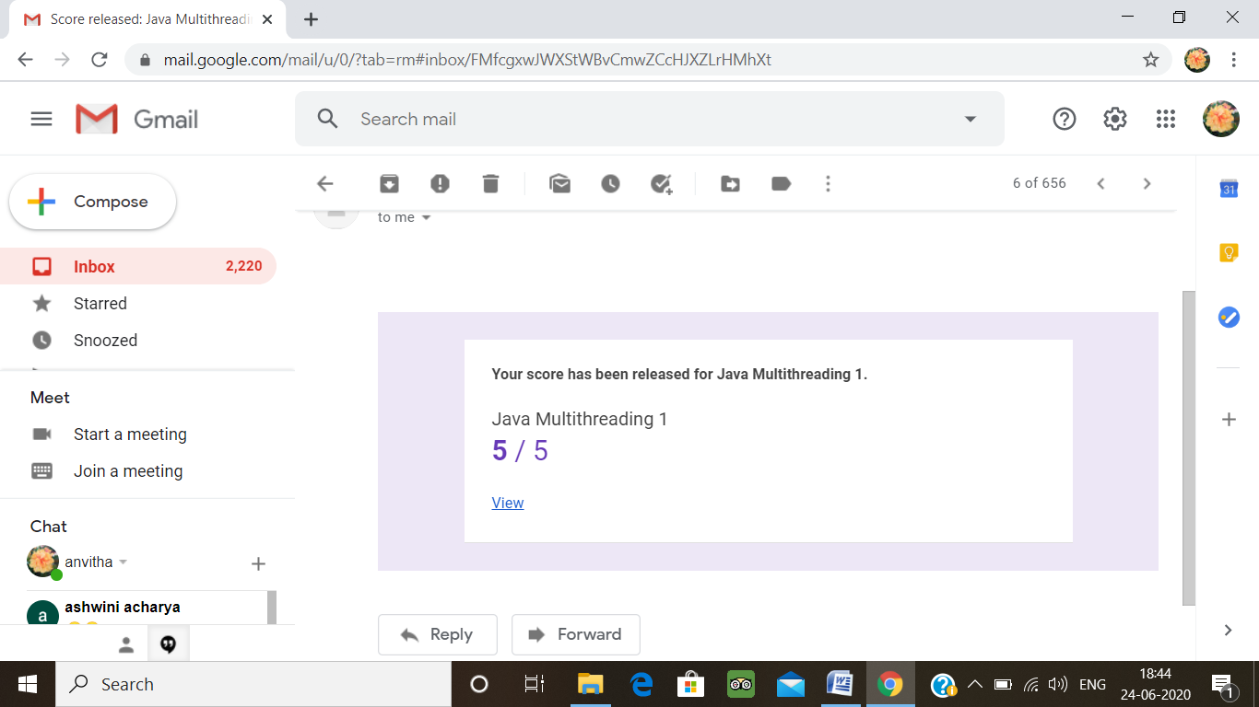

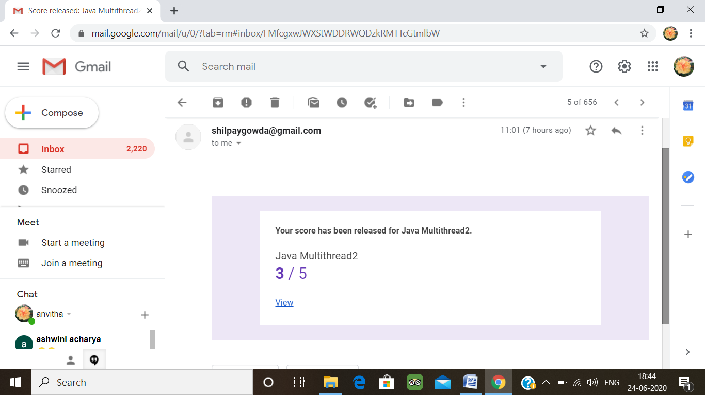

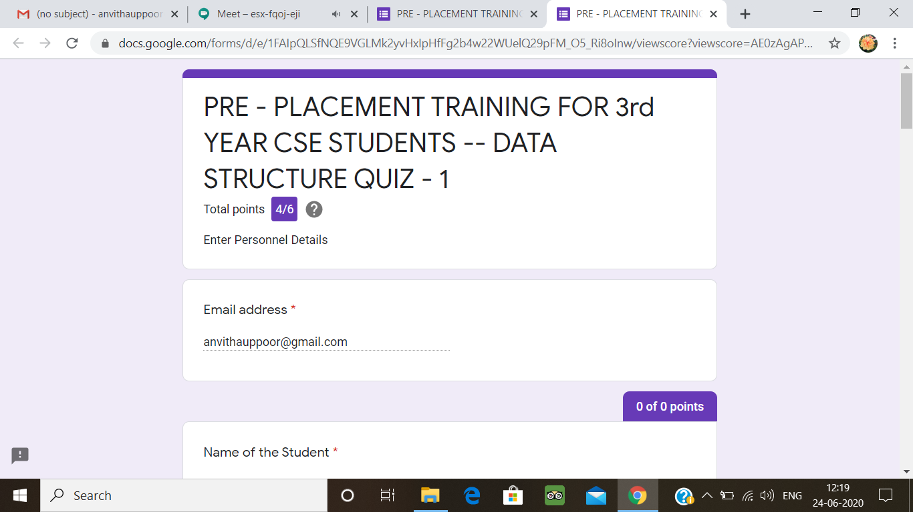

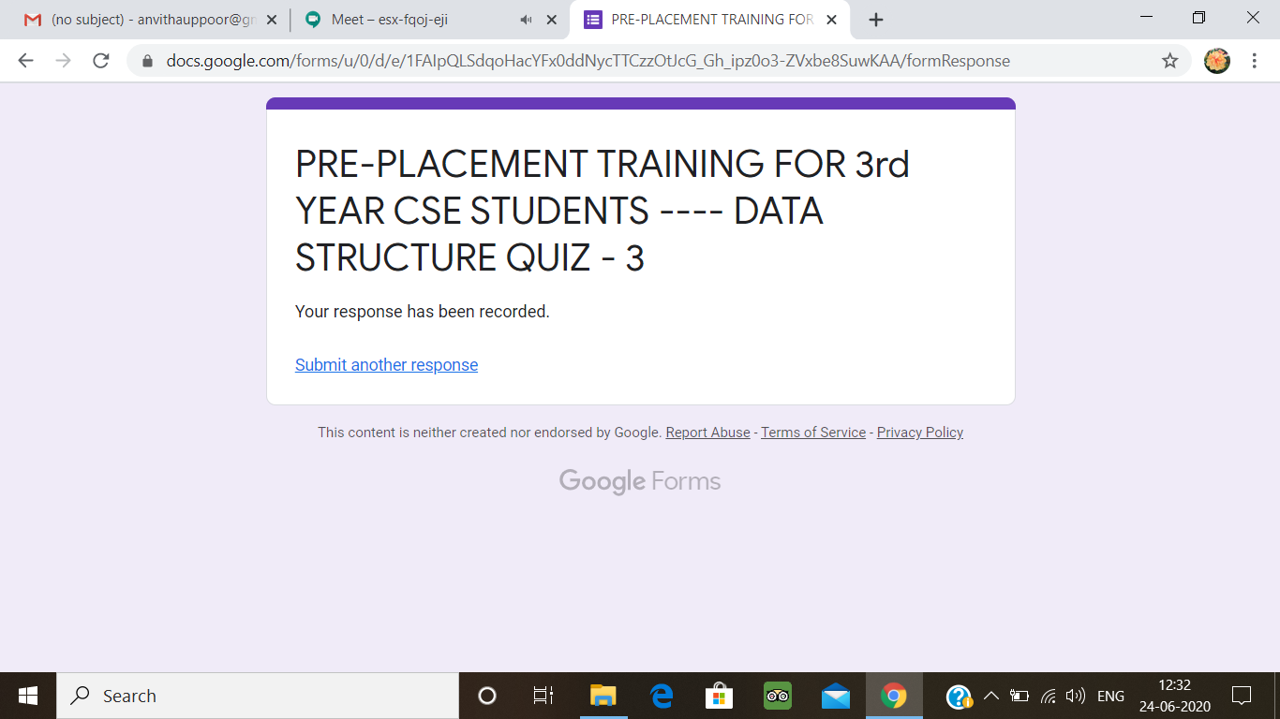

**Coding Challenge:**

1. Create a class named 'Shape' with a method to print "This is This is shape". Then create two other classes named 'Rectangle', 'Circle' inheriting the Shape class, both having a method to print "This is rectangular shape" and "This is circular shape" respectively. Create a subclass 'Square' of 'Rectangle' having a method to print "Square is a rectangle". Now call the method of 'Shape' and 'Rectangle' class by the object of 'Square' class.

class Shape{

public void print_shape(){

System.out.println("This is shape");

}

}

class Rectangle extends Shape{

public void print_rect(){

System.out.println("This is rectangular shape");

}

}

class Circle extends Shape{

public void print_circle(){

System.out.println("This is circular shape");

}

}

class Square extends Rectangle{

public void print_square(){

System.out.println("Square is a rectangle");

}

}

class Main{

public static void main(String[] args){

Square sq = new Square();

sq.print_shape();

sq.print_rect();

}

}

**Output:**

