Software Requirements Specification
AI-Based Resume Matching and Job Searching Platform Using Agentic AI
Team Member | SRN
Anvith Vegi | PES1UG24AM047
Ankitha Revadala | PES1UG24AM044
Anirudh N | PES1UG24AM041
Figure 1. UML use-case diagram for the platform.
SRS
Version 1.1 — Implemented Prototype
Prepared: 11 October 2026
Status: Implemented prototype (Sprint-2 freeze, 30 October 2026). Measured results are in docs/TEST_REPORT.md and docs/PERFORMANCE.md; differences from this specification are listed in docs/DEVIATIONS.md.

Document Control
Field | Value
Document ID | SRS-ARJ-001
Version | 1.1
Status | Implemented prototype (Sprint-2 freeze)
System status | Implemented (30 October 2026)
Primary audience | Course instructor, project team, developers, testers
Baseline stack | Python, FastAPI, SQLite, local job dataset; bounded tool-using agent workflow
Team name | the no name group
Team members / SRNs | Anvith Vegi — PES1UG24AM047; Ankitha Revadala — PES1UG24AM044; Anirudh N — PES1UG24AM041

Revision History
Version | Date | Change
1.0 | 11 October 2026 | Initial scope baseline and measurable requirements.
1.1 | 30 October 2026 | Implemented. Open decisions closed: plain HTML/JS frontend; PDF, DOCX, TXT up to 2 MB (pypdf, python-docx); JWT bearer login; no real LLM (mock provider behind consent gate). Deviations and unmet targets recorded in docs/DEVIATIONS.md.

1. Introduction

1.1 Purpose
This SRS specifies the proposed functional, non-functional, interface, data, and security requirements for an AI-based resume matching and job-search platform using a bounded Agentic AI workflow. It is the authoritative source for architecture decisions and test traceability.

1.2 Scope
The system enables job seekers to create an account, upload and review resume information, search a curated local job dataset, compare a resume with a job, inspect matched and missing skills, receive evidence-linked recommendations, bookmark jobs, and manually track applications. A controlled orchestrator coordinates approved tools. The initial prototype uses a Python FastAPI backend and SQLite.
Out of scope for Version 1.0: automatic job applications, guaranteed placement, unrestricted web scraping, integrations with multiple live job boards, recruiter hiring workflows, and autonomous modification of user data.

1.3 Intended Audience
- Project team and maintainers.
- Course instructor and evaluators.
- Testers validating requirements.
- Users reviewing privacy and system behavior.

1.4 Definitions, Acronyms, and Abbreviations
Term | Definition
Agentic AI | An AI-driven workflow that selects or coordinates approved tools across multiple steps toward a user goal.
FR | Functional Requirement: behavior the system shall provide.
NFR | Non-Functional Requirement: measurable quality or constraint.
SR / SO | Security Requirement / Security Objective.
Match score | A normalized indication of overlap between resume evidence and job criteria; not a guarantee of suitability.
Allowlisted tool | A registered operation the agent is permitted to invoke.
p95 | 95th percentile of measured response times.

1.5 References and Standards
- IEEE 29148:2018, Systems and software engineering — Life cycle processes — Requirements engineering (requirements-writing guidance).
- ISO/IEC/IEEE 29119 series, Software testing (test-process guidance).
- OWASP guidance for authentication, file upload handling, API security, and secure logging (implementation guidance).
- Course-provided IEEE templates and rubric take precedence for required section numbering and formatting.

1.6 Overview
Section 2 describes the system context. Section 3 specifies interfaces and constraints. Section 4 lists functional and quality requirements. Section 5 specifies security objectives and requirements. Section 6 provides the use-case model. Requirements use stable identifiers for cross-document traceability.

2. Overall Description

2.1 Product Perspective
The platform is a new modular web application. The client communicates with a FastAPI REST backend. Application services use SQLite for structured records and controlled file storage for resumes. A matching service computes scores and skill gaps. An agent orchestrator coordinates resume analysis, job retrieval, ranking, and explanation tools. An external LLM provider is optional and disabled unless configured; the core workflow must remain demonstrable without it.

2.2 Product Functions
- Account registration and authentication.
- Resume upload, parsing, review, and deletion.
- Job search over a curated dataset.
- Resume-job match scoring and skill-gap reporting.
- Tool-coordinated job recommendations with evidence-linked explanations.
- Bookmarks and manual application-status tracking.
- Administrative/import workflow for local job listings.
- Safe error handling, authorization, and security-event logging.

2.3 User Classes and Characteristics
User class | Description / privileges
Visitor | May access public landing/help content and register; cannot access private records.
Job seeker | May manage their own profile/resume, search jobs, view matches, bookmark jobs, and track their own applications.
Administrator/import operator | May manage the local job dataset through an authenticated, restricted administrative operation.
External service | Optional AI provider; receives only consented, minimized data and is not trusted as an authorization authority.

2.4 Operating Environment
- Python 3.12 or another pinned, supported Python 3.x release.
- FastAPI application served by a supported ASGI server.
- SQLite database for the student prototype.
- Local development on macOS, Windows, or Linux.
- Optional browser client; API endpoints use JSON over HTTP in development and HTTPS when deployed.

2.5 Design and Implementation Constraints
- The first release uses a curated local job dataset; no live job-board API is required.
- The agent may only use registered tools and schema-validated inputs.
- The system shall not submit applications autonomously.
- External AI use requires explicit configuration and appropriate user notice/consent.
- All requirement performance targets must be measured in a documented test environment.

2.6 Assumptions and Dependencies
- A sample job dataset with consistent fields (title, company, location, description, required skills, job type, and source) will be created or imported.
- Resume parsing quality depends on file format, document layout, and text quality.
- Optional LLM behavior depends on provider availability, credentials, and rate limits; deterministic matching must still work without it.
- The prototype is for educational demonstration and is not a production hiring decision system.

3. External Interface Requirements

3.1 User Interface
The interface shall provide registration/login, profile and resume upload/review, job search/results, match detail, bookmarks, application tracking, and safe error/empty states. Forms shall have labels and validation messages. Core journeys shall support keyboard operation.

3.2 Software Interfaces
Interface | Contract
Client ↔ FastAPI | JSON REST API; bearer/session authentication as selected in implementation; versioned API prefix such as /api/v1.
FastAPI ↔ SQLite | Parameterized queries through a data-access layer; schema migrations or documented initialization.
Resume parser | Internal service accepts validated file content and returns structured fields plus parsing warnings.
Matching engine | Internal service accepts normalized resume profile and job record; returns score, matched skills, missing skills, and score components.
Agent tools | Allowlisted typed operations for parsing, searching, matching, and ranking; no arbitrary shell, SQL, or network tool.
Optional AI provider | Provider adapter, explicit configuration, bounded timeout, minimized/consented data, and fallback on failure.

3.3 Communications Interfaces
Local development may use HTTP on localhost. Any deployment carrying credentials or personal data shall use HTTPS. Requests and responses shall use UTF-8 JSON except for multipart file-upload requests.

3.4 Data Requirements
Entity | Key fields / constraints
User | id, normalized_email (unique), password_hash, created_at
Resume | id, owner_user_id, storage_key, original_filename_safe, content_type, size_bytes, parsed_profile, created_at
Job | id, title, company, location, description, required_skills, employment_type, source, active
Bookmark | id, owner_user_id, job_id, created_at; unique owner/job pair
ApplicationRecord | id, owner_user_id, job_id, status, notes_optional, updated_at
ConsentSetting / AuditEvent | Consent decision and security event metadata; must not store secrets or raw resume text in audit messages.

4. System Requirements

4.1 Functional Requirements
ID | Name | Requirement statement | Acceptance criterion
FR-01 | Account registration | The system shall allow a visitor to create an account when all required fields are valid and the email address is not already registered. | Registration succeeds and a unique user record is created; invalid or duplicate registration is rejected.
FR-02 | Authentication | The system shall authenticate a registered user before granting access to protected endpoints. | Valid credentials establish a session/token; invalid credentials are rejected without revealing whether an account exists.
FR-03 | Resume upload | The system shall accept resume files in the configured supported formats and within the configured size limit. | A valid file is stored and linked to the authenticated owner; unsupported, malformed, or oversized files are rejected.
FR-04 | Resume parsing | The system shall extract supported fields, including skills, education, experience, and contact details where present, from an uploaded resume. | Extracted fields are shown to the user for review; missing or uncertain fields are not silently invented.
FR-05 | Job search | The system shall return job listings that satisfy the supplied supported search filters. | Returned listings satisfy the filters; an empty result set is presented as an empty state.
FR-06 | Resume-job matching | The system shall calculate a match score for a selected resume and job using the documented matching algorithm. | The response contains a score in the documented range and a breakdown of matching signals.
FR-07 | Skill gap analysis | The system shall identify job-required skills that are matched and skills not found in the parsed resume profile. | The response lists matched and missing skills based on normalized skill names.
FR-08 | Agent workflow | The agent orchestrator shall execute the configured job-recommendation workflow by invoking only registered, allowlisted tools. | A recommendation request invokes the required workflow steps and returns a structured result or a controlled failure.
FR-09 | Recommendation explanation | The system shall provide evidence-linked reasons for each recommended job. | Reasons refer to available job requirements and resume evidence; unsupported claims are omitted.
FR-10 | Bookmarks | The system shall allow an authenticated user to bookmark a job, remove a bookmark, and retrieve that user's bookmarks. | Changes persist and are visible only to the owning user.
FR-11 | Application tracking | The system shall allow a user to create and update a manual application record with a defined status. | Only supported status values are accepted and changes persist for the owning user.
FR-12 | Resource ownership | The system shall deny a user access to another user's private resume, bookmark, and application records. | Cross-user requests are denied and do not disclose protected record contents.
FR-13 | Controlled external actions | The system shall not submit job applications or transmit resume data to external services unless the user explicitly authorizes the specific action. | No external submission or transfer occurs in the default recommendation workflow.
FR-14 | Error handling | The system shall return a consistent error response for invalid input, unavailable dependencies, and failed parsing or AI operations. | Errors contain a safe message and correlation identifier where applicable, without stack traces or secrets.
FR-15 | Job dataset administration | The system shall allow an authorized administrator or controlled import process to add, update, and deactivate local job listings. | Only authorized operations change the dataset; invalid records are rejected.

4.2 Non-Functional Requirements
ID | Quality attribute | Measurable requirement
NFR-01 | Search performance | For a test dataset of up to 5,000 jobs and 20 concurrent users, at least 95% of local job-search requests shall complete within 2 seconds, measured at the API boundary.
NFR-02 | Matching performance | For supported resumes and jobs in the defined test environment, at least 95% of match requests shall complete within 10 seconds, excluding explicitly measured external-provider delays; the baseline workflow should not require an external LLM.
NFR-03 | Reliability | In 100 consecutive valid matching requests against a healthy local test environment, at least 99 shall return a valid result.
NFR-04 | Usability | In a task-based evaluation with five representative users, at least four shall complete resume upload and view a match result without facilitator assistance.
NFR-05 | Compatibility | The web client, if included, shall support the latest stable Chrome and Firefox versions available at test time. API endpoints shall conform to the documented JSON contract.
NFR-06 | Maintainability | The backend shall separate API routes, business services, data access, matching logic, and agent orchestration into distinct modules, with automated tests for core services.
NFR-07 | Data retention | The system shall provide an authenticated user-initiated way to delete their resume and associated extracted resume data; deletion behavior for backups/logs shall be documented before deployment.
NFR-08 | Accessibility | Core user journeys shall be operable using keyboard navigation in the web interface, and form fields shall have programmatic labels.
NFR-09 | Reproducibility | The project shall document dependency versions, environment variables, dataset schema, and setup/test commands so a reviewer can run the prototype from a clean environment.

4.3 Requirement Quality Rules
- Each requirement has a unique ID and uses one principal 'shall' statement.
- Requirements avoid vague terms such as fast, user-friendly, robust, or secure unless paired with a measurable criterion.
- Acceptance criteria are observable and testable; targets are not claimed as achieved until tests are run.
- Optional provider behavior is explicitly distinguished from the core offline-capable workflow.
- Changes to a requirement must be reflected in architecture, tests, and the traceability matrix.

5. Security

5.1 Security Objectives
ID | Objective
SO-01 | Confidentiality: protect credentials, resumes, profiles, bookmarks, and application records from unauthorized disclosure.
SO-02 | Integrity: prevent unauthorized creation, alteration, or deletion of user and job records.
SO-03 | Controlled autonomy: constrain the agent to approved tools and require explicit user authorization for consequential external actions.

5.2 Security Requirements
ID | Requirement
SR-01 | Authentication and authorization: All protected endpoints shall require authentication and enforce ownership checks at the service/data-access boundary.
SR-02 | Credential storage: Passwords shall be stored only as salted, computationally expensive password hashes using a maintained library; plaintext passwords shall never be persisted.
SR-03 | Upload validation: Uploads shall be checked against an allowlist of formats, configured size limits, and parser validation; filenames shall be generated by the application rather than trusted from the client.
SR-04 | Secret and error protection: API responses and logs shall not include passwords, tokens, API keys, raw stack traces, or resume contents unless explicitly required and access-controlled.
SR-05 | Agent tool controls: The agent shall invoke only allowlisted tools with schema-validated arguments; tool outputs shall be treated as untrusted data.
SR-06 | External transfer consent: Resume data shall not be sent to an external AI provider or job service unless the user is informed and the relevant data-transfer setting/consent is enabled.
SR-07 | Transport protection: Any deployed environment handling credentials or resumes shall use HTTPS; local development may use localhost and must be documented as development-only.
SR-08 | Audit events: Security-relevant events (authentication failures, access denials, administrative changes, and consent changes) shall be logged without logging secrets or resume contents.

5.3 Security Considerations
- Treat resume documents, job descriptions, and tool outputs as untrusted input; prompt injection within a resume or job listing must not change the agent's tool permissions.
- Use least privilege for database and file access. Resolve resume storage paths from server-generated identifiers, not user-supplied paths.
- Do not log credentials, access tokens, resume text, or unnecessary personal data.
- Use dependency pinning and review parser libraries; uploaded documents are a potential attack surface.
- The prototype must state its limitations and must not present match scores as objective or definitive employment decisions.

6. Use-Case Model

6.1 Actors
- Visitor: registers and logs in.
- Job seeker: uploads/reviews resume, searches jobs, requests recommendations, bookmarks jobs, tracks applications, and deletes resume data.
- Administrator/import operator: manages the curated job dataset.
- Optional external AI provider: performs only configured inference tasks after consent; it is not a user/authorization actor.

6.2 Use-Case Diagram
The diagram source below can be rendered using PlantUML. The Job Seeker is the primary actor; registration/login and all protected use cases are associated with that actor. Administrator actions are separate.
Figure 1. UML Use-Case Diagram
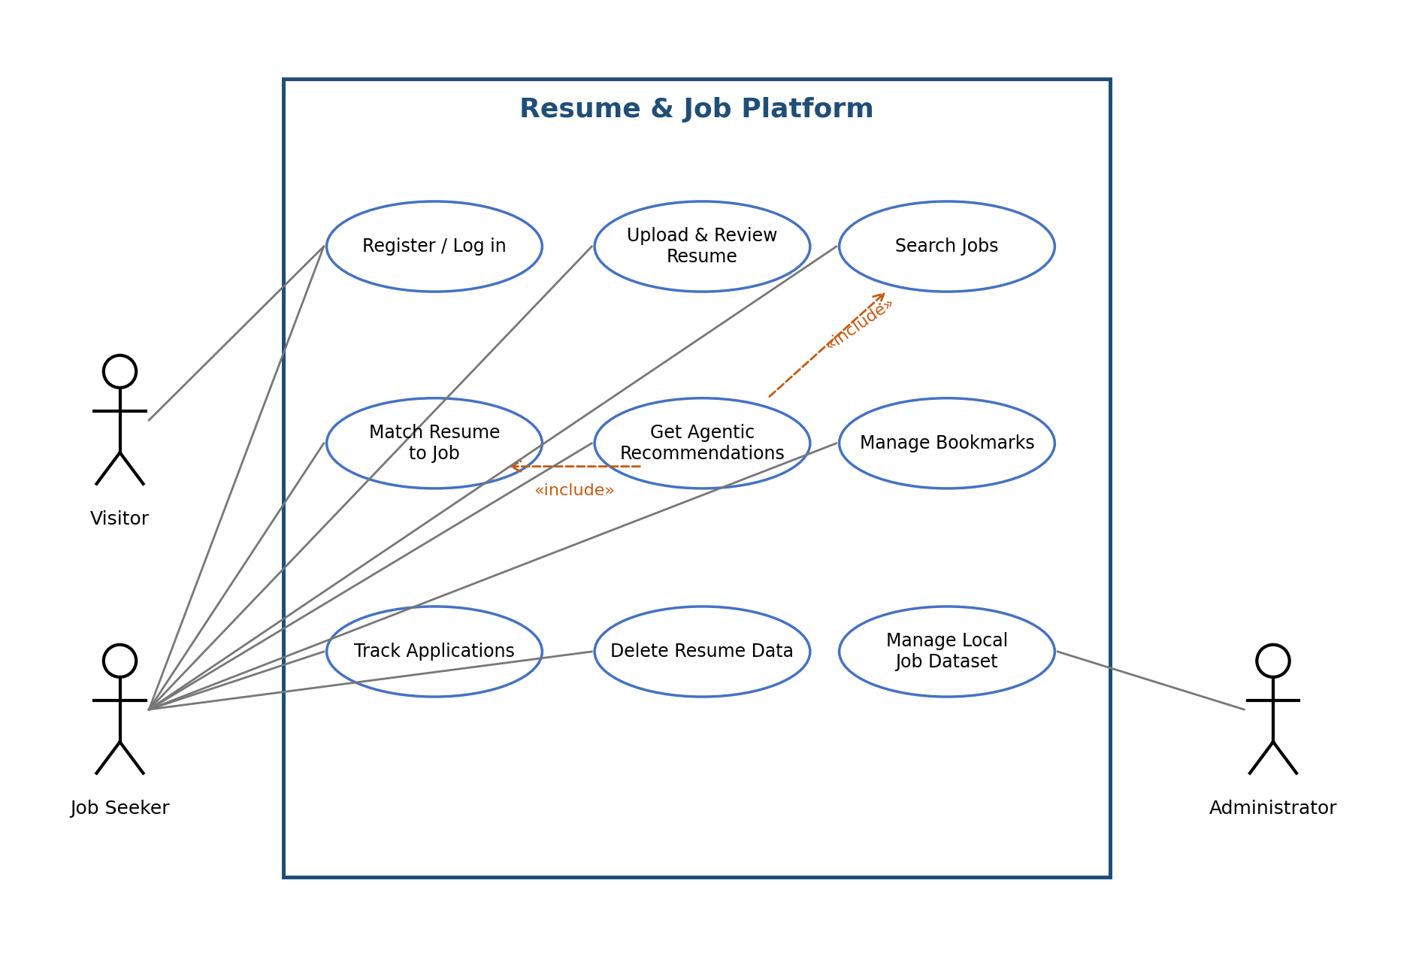

6.3 Primary Use-Case Description: Get Recommendations
Field | Description
Use case | UC-05 Get Agentic Recommendations
Primary actor | Authenticated Job Seeker
Preconditions | User is authenticated; a resume profile is available; local job dataset is initialized.
Trigger | User requests recommendations.
Main flow | 1. Validate request and ownership. 2. Agent invokes approved resume/profile tool. 3. Agent retrieves relevant local jobs. 4. Matching tool scores candidate jobs. 5. Ranking tool sorts results. 6. Explanation builder assembles evidence-linked reasons. 7. API returns recommendations.
Alternative flows | If no jobs match, return an empty result with guidance. If parsing/provider fails, return a controlled error or deterministic fallback where safe.
Postconditions | No application is submitted and no external resume transfer occurs by default; recommendation result is returned to the owner.

7. Appendices

7.1 Open Decisions / Change Control
- Confirm whether a browser frontend is required by the course; API-only backend is the minimum baseline until confirmed. — Decided (v1.1): plain HTML + JavaScript web client served by FastAPI.
- Select and pin a resume parser library after checking supported file types and license. — Decided (v1.1): pypdf for PDF, python-docx for DOCX, plain TXT; versions pinned in requirements.txt.
- Decide whether an external LLM is used; if yes, document provider, data transfer, consent, timeout, and fallback behavior. — Decided (v1.1): no external LLM; a mock provider behind the consent gate demonstrates FR-13/SR-06.
- All future changes should update this SRS and linked traceability records.
Team: the no name group

