Software Architecture and Design Specification
AI-Based Resume Matching and Job Searching Platform Using Agentic AI
Team Member | SRN
Anvith Vegi | PES1UG24AM047
Ankitha Revadala | PES1UG24AM044
Anirudh N | PES1UG24AM041
Figure 1. Components and dependencies in the proposed modular-monolith architecture.
Figure 2. Resume upload and parsing sequence.
Figure 3. Bounded agentic recommendation workflow.
Figure 4. Controlled fallback when an optional AI provider is unavailable.
Architecture & Design
Version 1.1 — Implemented Prototype
Prepared: 11 October 2026 · Updated: 30 October 2026
Status: Implemented prototype (30 October 2026). Measured results are recorded in docs/TEST_REPORT.md and docs/PERFORMANCE.md; differences from this design are listed in docs/DEVIATIONS.md.

Document Control
Field | Value
Document ID | SAD-ARJ-001
Version | 1.1
Status | Implemented (Sprint-2 freeze, 30 October 2026)
Requirements baseline | SRS-ARJ-001 v1.0
Test baseline | STP-ARJ-001 v1.0
Team name | the no name group
Team members / SRNs | Anvith Vegi — PES1UG24AM047; Ankitha Revadala — PES1UG24AM044; Anirudh N — PES1UG24AM041

1. Introduction

1.1 Purpose
This document describes the proposed software architecture and detailed design for the AI-based resume matching and job-search platform. It maps SRS requirements to components, interfaces, data flows, security controls, and verification.

1.2 Scope
The design covers a Python FastAPI modular monolith, SQLite persistence, local job data, controlled resume file storage, a matching engine, and an allowlisted agent orchestrator. External LLM integration is optional and must not be required for baseline matching.

1.3 Design Principles
- Small modules with explicit responsibilities and stable interfaces.
- Deterministic core matching so tests are reproducible.
- Least privilege and server-side ownership enforcement.
- Agent tools are typed, allowlisted, and limited to non-consequential actions by default.
- Traceability from SRS requirements to components and tests.
- Graceful degradation when optional external services fail.

2. Architecture Description

2.1 Architecture Pattern
Use a layered architecture implemented as a modular monolith. The presentation/API layer handles HTTP, schemas, and authentication dependencies; the application-service layer implements use cases; domain services contain matching and agent workflow logic; repository and storage adapters encapsulate SQLite and file storage. This avoids distributed-system overhead while keeping modules testable.

2.2 Component Diagram
Figure 1. UML Component Diagram
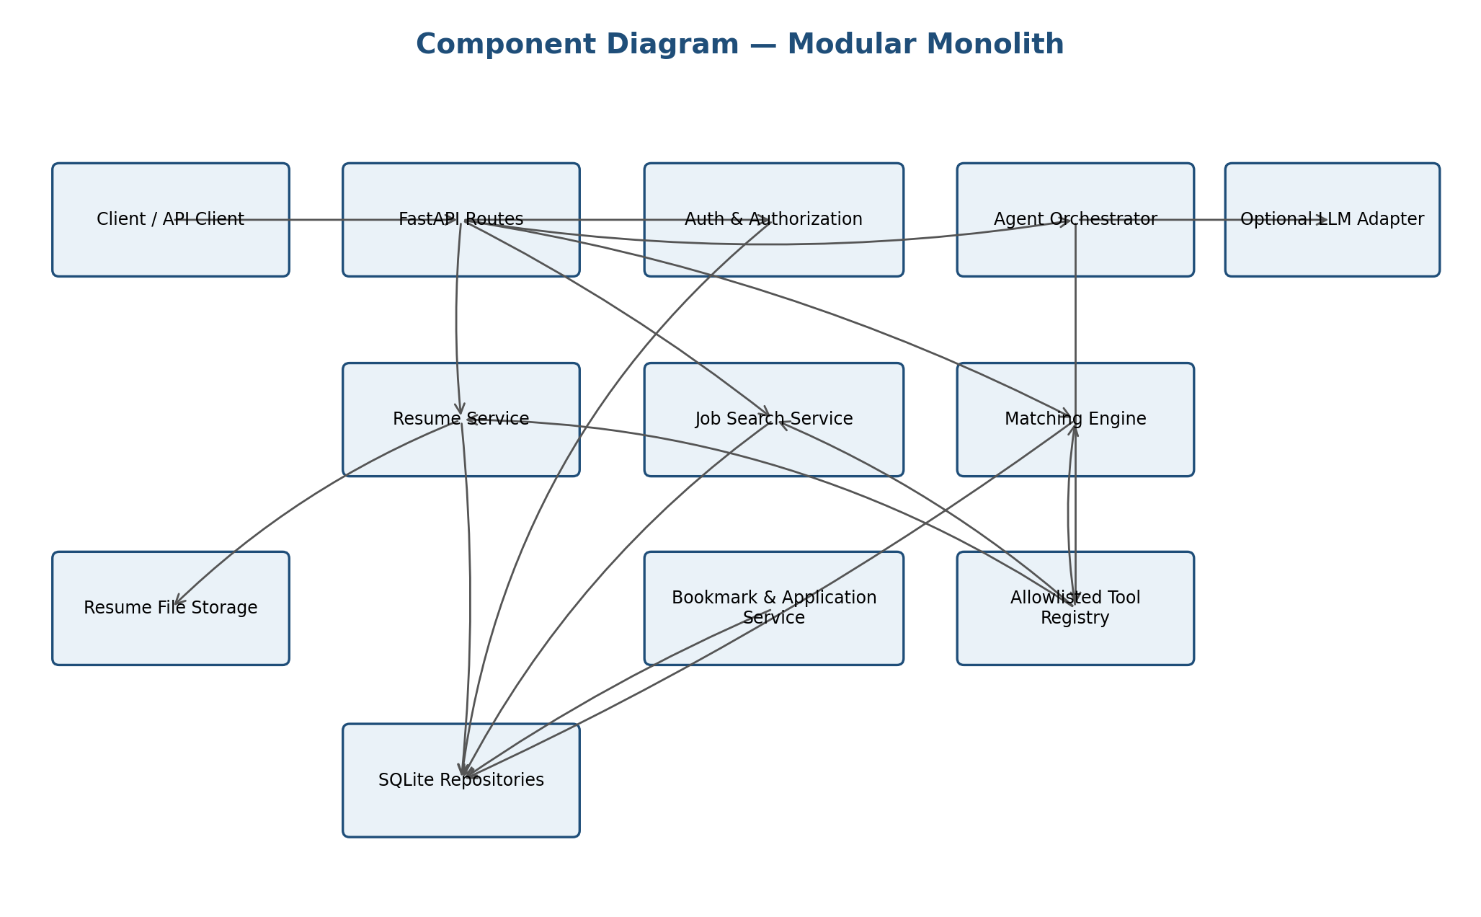

2.3 Component Descriptions
Component | Responsibilities | Key requirements
Web/API client | Collects inputs, presents results, and displays validation/empty/error states. A minimal API client may be used if a full frontend is out of scope. | FR-01 to FR-14, NFR-04, NFR-08
FastAPI routes | Defines versioned endpoints, validates request/response schemas, maps service errors to safe HTTP responses. | FR-01 to FR-15, FR-14
Authentication & authorization | Verifies credentials/tokens, checks resource ownership, and exposes current-user identity to services. | FR-02, FR-12, SR-01, SR-02
Resume service | Validates uploads, stores files under generated keys, parses supported formats, exposes reviewed structured profile, handles deletion. | FR-03, FR-04, FR-12, SR-03, SR-04, NFR-07
Job search service | Queries and filters the local job dataset; validates imported records. | FR-05, FR-15, NFR-01
Matching engine | Normalizes skills and job criteria, computes a documented score and skill gap, returns score components. | FR-06, FR-07, NFR-02, NFR-03
Agent orchestrator | Coordinates bounded steps and decides which registered tool to call within a fixed policy; builds evidence-linked recommendations. | FR-08, FR-09, FR-13, SR-05, SR-06
Tool registry | Provides only approved typed functions; validates arguments and outputs; rejects unknown operations. | FR-08, SR-05
Bookmark/application service | Creates and retrieves user-owned bookmarks and application status records. | FR-10, FR-11, FR-12
SQLite repositories | Persist structured records through a data-access layer and parameterized operations. | FR-01 to FR-15, NFR-06
File storage adapter | Stores resume files outside public static paths and resolves files by server-generated identifiers. | FR-03, FR-12, SR-03
Optional LLM provider adapter | Handles provider credentials, timeouts, consent, minimized input, and controlled fallback; never owns authorization. | FR-08, FR-09, FR-13, SR-04 to SR-06

2.4 Data Flow
- The client sends an authenticated request to the API layer.
- The API validates request syntax and obtains the authenticated user identity.
- The application service checks ownership and calls domain services/repositories.
- For recommendations, the orchestrator invokes allowlisted tools for job retrieval and matching.
- The matching engine returns scores and evidence; the explanation builder references those outputs.
- The API returns a schema-validated response. Security events are logged with minimized metadata.

2.5 Architecture Rationale and Trade-offs
Decision | Rationale | Trade-off / mitigation
Modular monolith | Simple to develop, run, and demonstrate as a student project. | Requires module boundaries and unit tests to avoid a monolithic code tangle.
SQLite | Low setup cost and reproducible local demo. | Not intended for high-concurrency production deployment; use a migration path if needed.
Curated local jobs | No API keys, scraping terms, or network dependency during tests. | Dataset freshness and coverage are limited; document this limitation.
Deterministic baseline matching | Repeatable and explainable tests. | Semantic nuance is limited; optional embeddings/LLM can be evaluated separately.
Bounded agent workflow | Demonstrates tool coordination while limiting unsafe autonomy. | Less open-ended than a fully autonomous agent; this is intentional for security and reproducibility.

3. Design Constraints and Traceability

3.1 Requirement-to-Component Traceability
Requirement IDs | Primary components | Verification
FR-01, FR-02, SR-01, SR-02 | API, Auth & Authorization, User Repository | TC-01, TC-02
FR-03, FR-04, SR-03, NFR-07 | Resume Service, File Storage, Parser | TC-03, TC-04; deletion regression check
FR-05, FR-15, NFR-01 | Job Search Service, Job Repository | TC-05; import validation test
FR-06, FR-07, FR-09, NFR-02, NFR-03 | Matching Engine, Skill Normalizer, Explanation Builder | TC-06, TC-07, TC-14; NFR-02 performance run
FR-08, FR-13, SR-05, SR-06 | Agent Orchestrator, Tool Registry, Provider Adapter | TC-08, TC-13
FR-10, FR-11, FR-12 | Tracking Services, Authorization, Repositories | TC-09, TC-10, TC-11
FR-14, SR-04, SR-08 | Exception Handler, Logging Filters, Audit Logger | TC-12; audit/log review
SR-07, NFR-05, NFR-08 | Deployment config, Client UI | Deployment HTTPS check; compatibility and usability checks
NFR-04, NFR-06, NFR-09 | UI, module boundaries, project configuration | TC-15; code review and clean setup run

4. Data Design

4.1 Logical Data Model
Entity | Relationships / constraints
User | One user owns zero or more resumes, bookmarks, and application records. Email is unique after normalization.
Resume | Belongs to one user; file is referenced by a generated storage key. Parsed fields are structured data and may be corrected by the user.
Job | Local listing; may be bookmarked by many users and referenced by many application records.
Bookmark | Join between User and Job; unique (owner_user_id, job_id).
ApplicationRecord | Belongs to User and Job; status restricted to a defined enumeration.
AuditEvent | Append-only metadata for security-relevant actions; excludes secrets and raw resume contents.

4.2 Matching Score Design
Version 1.0 should use a documented, deterministic scoring baseline. One candidate design is: skill_overlap = matched_required_skills / max(number_of_required_skills, 1); keyword_similarity = cosine similarity between normalized resume text and job description; score = 100 × (0.75 × skill_overlap + 0.25 × keyword_similarity), clamped to [0,100]. If a job has no required skills, the score must follow a documented fallback rather than divide by zero. The weights are initial design parameters and must be disclosed in the UI/report; they are not validated employment predictors.
Skill normalization shall handle case and common aliases through a curated mapping. The result shall include score components, matched skills, and missing skills. A score is an assistive relevance signal, not a hiring decision.
Implemented in v1.1 exactly as the candidate design above: weights 0.75 (skill overlap) and 0.25 (keyword similarity), result clamped to 0–100. Keyword similarity is a bag-of-words cosine similarity with a small stop-word list (no TF-IDF or embeddings, so results are repeatable). Fallback when a job lists no required skills: score = 100 × keyword_similarity. Skill normalization uses the curated alias map in app/services/skills.py (for example python3 → python, MySQL/PostgreSQL/SQLite → sql). Code: app/services/matching.py.

5. Interface and API Design

5.1 API Conventions
- Base path: /api/v1.
- JSON request/response bodies except multipart resume upload.
- Consistent error shape: {"error":{"code":"...","message":"...","request_id":"..."}}; never include stack traces.
- Use HTTP status codes consistently: 200/201 success, 400 invalid request, 401 unauthenticated, 403 unauthorized, 404 absent resource, 409 conflict, 413 upload too large, 415 unsupported media type, 422 schema validation, 429 rate limit if configured, 500 unexpected server error, 503 optional dependency unavailable.
- All private-resource routes derive the owner identity from the authenticated context; never trust a client-supplied owner ID.

5.2 Proposed Endpoints
Method / endpoint | Purpose | Auth | Requirements
POST /api/v1/auth/register | Create account | Public | FR-01
POST /api/v1/auth/login | Authenticate | Public | FR-02
GET /api/v1/me | Retrieve own profile | Required | FR-02, SR-01
POST /api/v1/resumes | Upload resume (multipart) | Required | FR-03, SR-03
GET /api/v1/resumes/{resume_id} | Retrieve own resume metadata/profile | Required + ownership | FR-04, FR-12
DELETE /api/v1/resumes/{resume_id} | Delete own resume and extracted data | Required + ownership | NFR-07
GET /api/v1/jobs | Search local job listings | Public (decided in v1.1) | FR-05
GET /api/v1/jobs/{job_id} | Retrieve job details | Public (decided in v1.1) | FR-05
POST /api/v1/matches | Score resume against job | Required + ownership | FR-06, FR-07
POST /api/v1/recommendations | Run bounded agent workflow | Required + ownership | FR-08, FR-09, FR-13
GET /api/v1/bookmarks | List own bookmarks | Required | FR-10, FR-12
POST /api/v1/bookmarks | Create bookmark | Required | FR-10
DELETE /api/v1/bookmarks/{job_id} | Remove own bookmark | Required | FR-10, FR-12
GET /api/v1/applications | List own application records | Required | FR-11, FR-12
POST /api/v1/applications | Create application-tracking record | Required | FR-11
PATCH /api/v1/applications/{record_id} | Update own record/status | Required + ownership | FR-11, FR-12
POST /api/v1/admin/jobs/import | Import validated local job records | Admin | FR-15
GET /api/v1/resumes | List own resumes (added in v1.1) | Required | FR-04, FR-12
PUT /api/v1/resumes/{resume_id}/profile | Correct own parsed profile (added in v1.1) | Required + ownership | FR-04
PATCH /api/v1/admin/jobs/{job_id} | Update or deactivate a job (added in v1.1) | Admin | FR-15
GET /api/v1/consent | Read own external-AI consent (added in v1.1) | Required | FR-13, SR-06
PUT /api/v1/consent | Change own external-AI consent; audited (added in v1.1) | Required | FR-13, SR-06, SR-08

5.3 Example Matching Request/Response
Request: {"resume_id":"res_123","job_id":"job_456"}
Response: {"score":78.5,"matched_skills":["python","sql"],"missing_skills":["docker"],"components":{"skill_overlap":0.67,"keyword_similarity":0.83},"explanation":["Resume lists Python and SQL, both required by this job.","Docker appears in the job requirements but was not found in the parsed resume."]}
Identifiers above are illustrative. Production-like responses must be based on actual stored records and should not expose another user's data.

6. UML Sequence Diagrams

6.1 Sequence A — Resume Upload and Parsing
Figure 2. UML Sequence Diagram — Resume Upload and Parsing
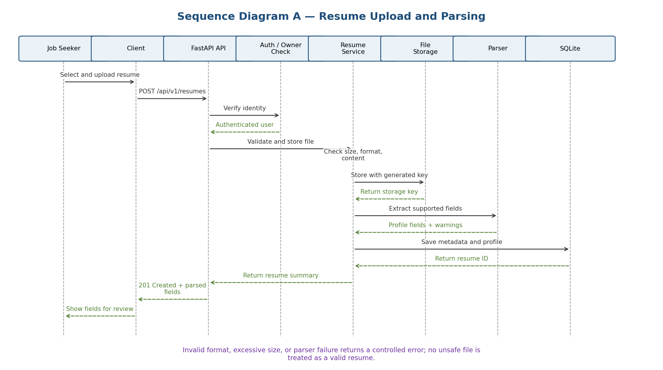

6.2 Sequence B — Agentic Job Recommendations
Figure 3. UML Sequence Diagram — Agentic Job Recommendations
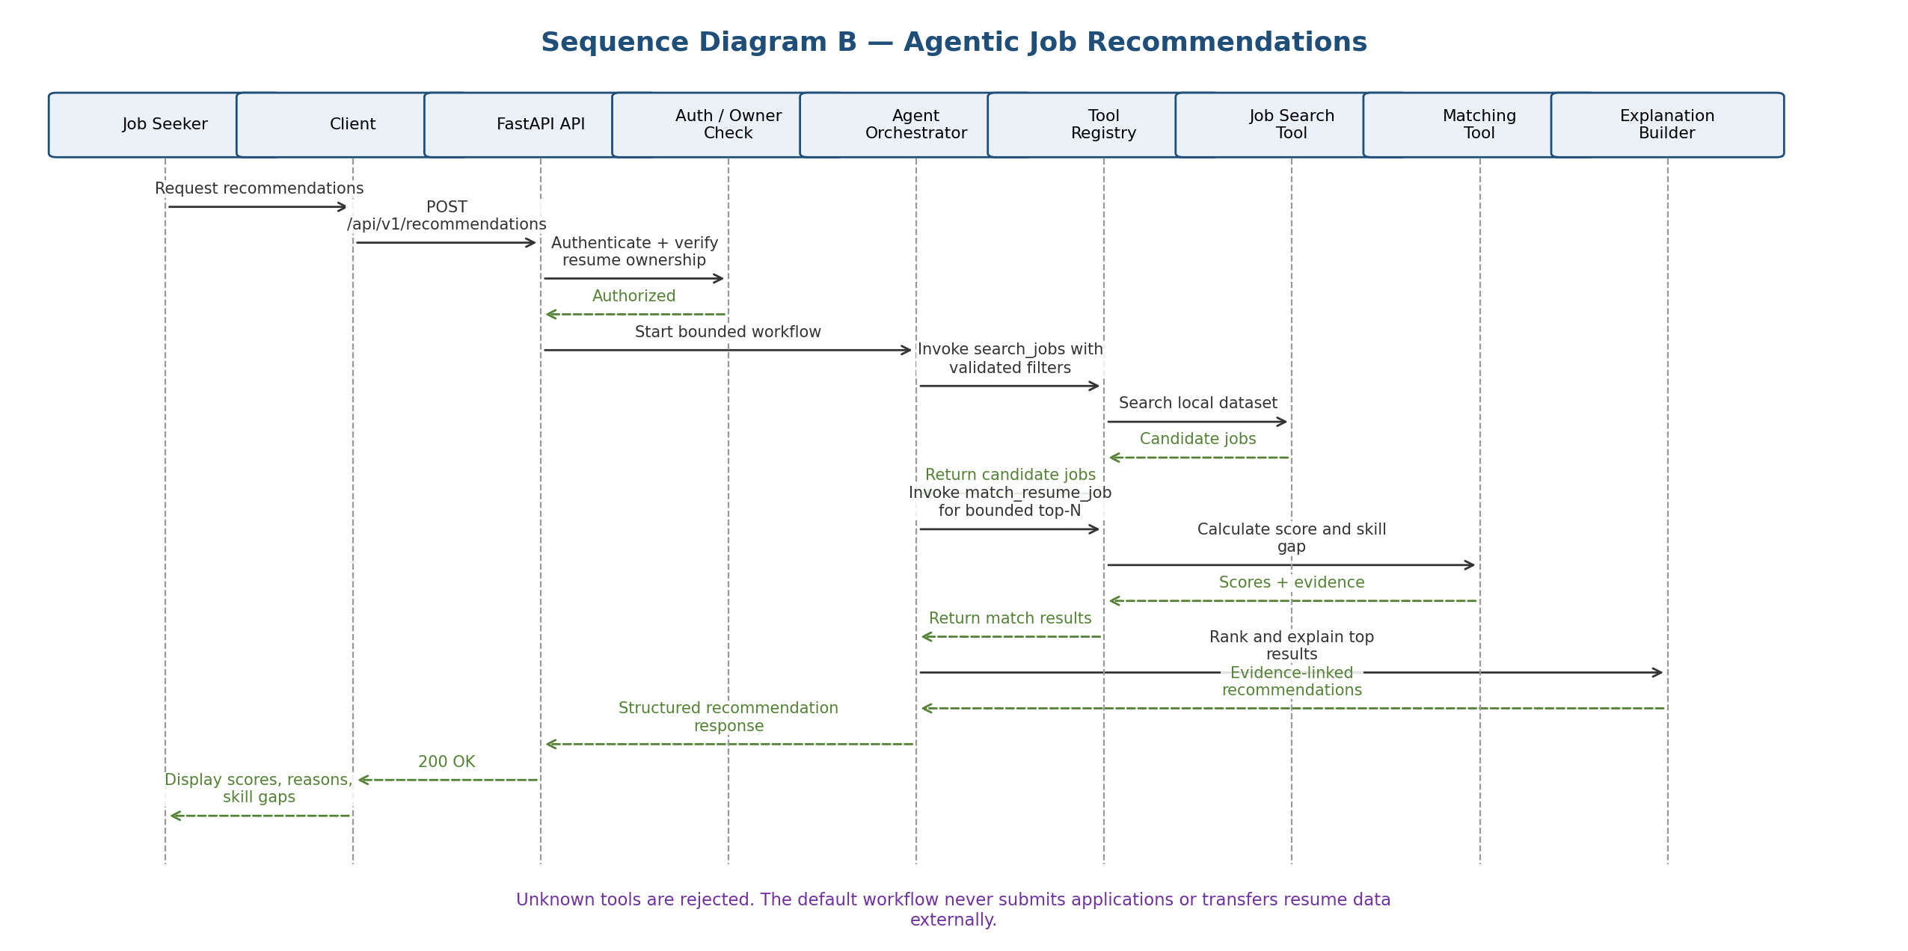
Implemented in v1.1 as a fixed-policy orchestrator (app/agent/orchestrator.py). It may call only four allowlisted tools, in this order: get_resume_profile → search_jobs → score_jobs → rank_results (app/agent/tools.py). Every tool argument is validated by a strict schema (unknown fields, wrong types and out-of-range values are rejected); unknown tool names are rejected and audited as agent_tool_rejected. Resume and job text is passed only as data to the matching engine, so instruction-like text cannot add tools. The response returns tool_trace (the tools actually run) and external_calls (0 by default). No tool can submit applications or contact external services.

6.3 Error Handling Sequence
Figure 4. UML Sequence Diagram — Optional AI Provider Failure
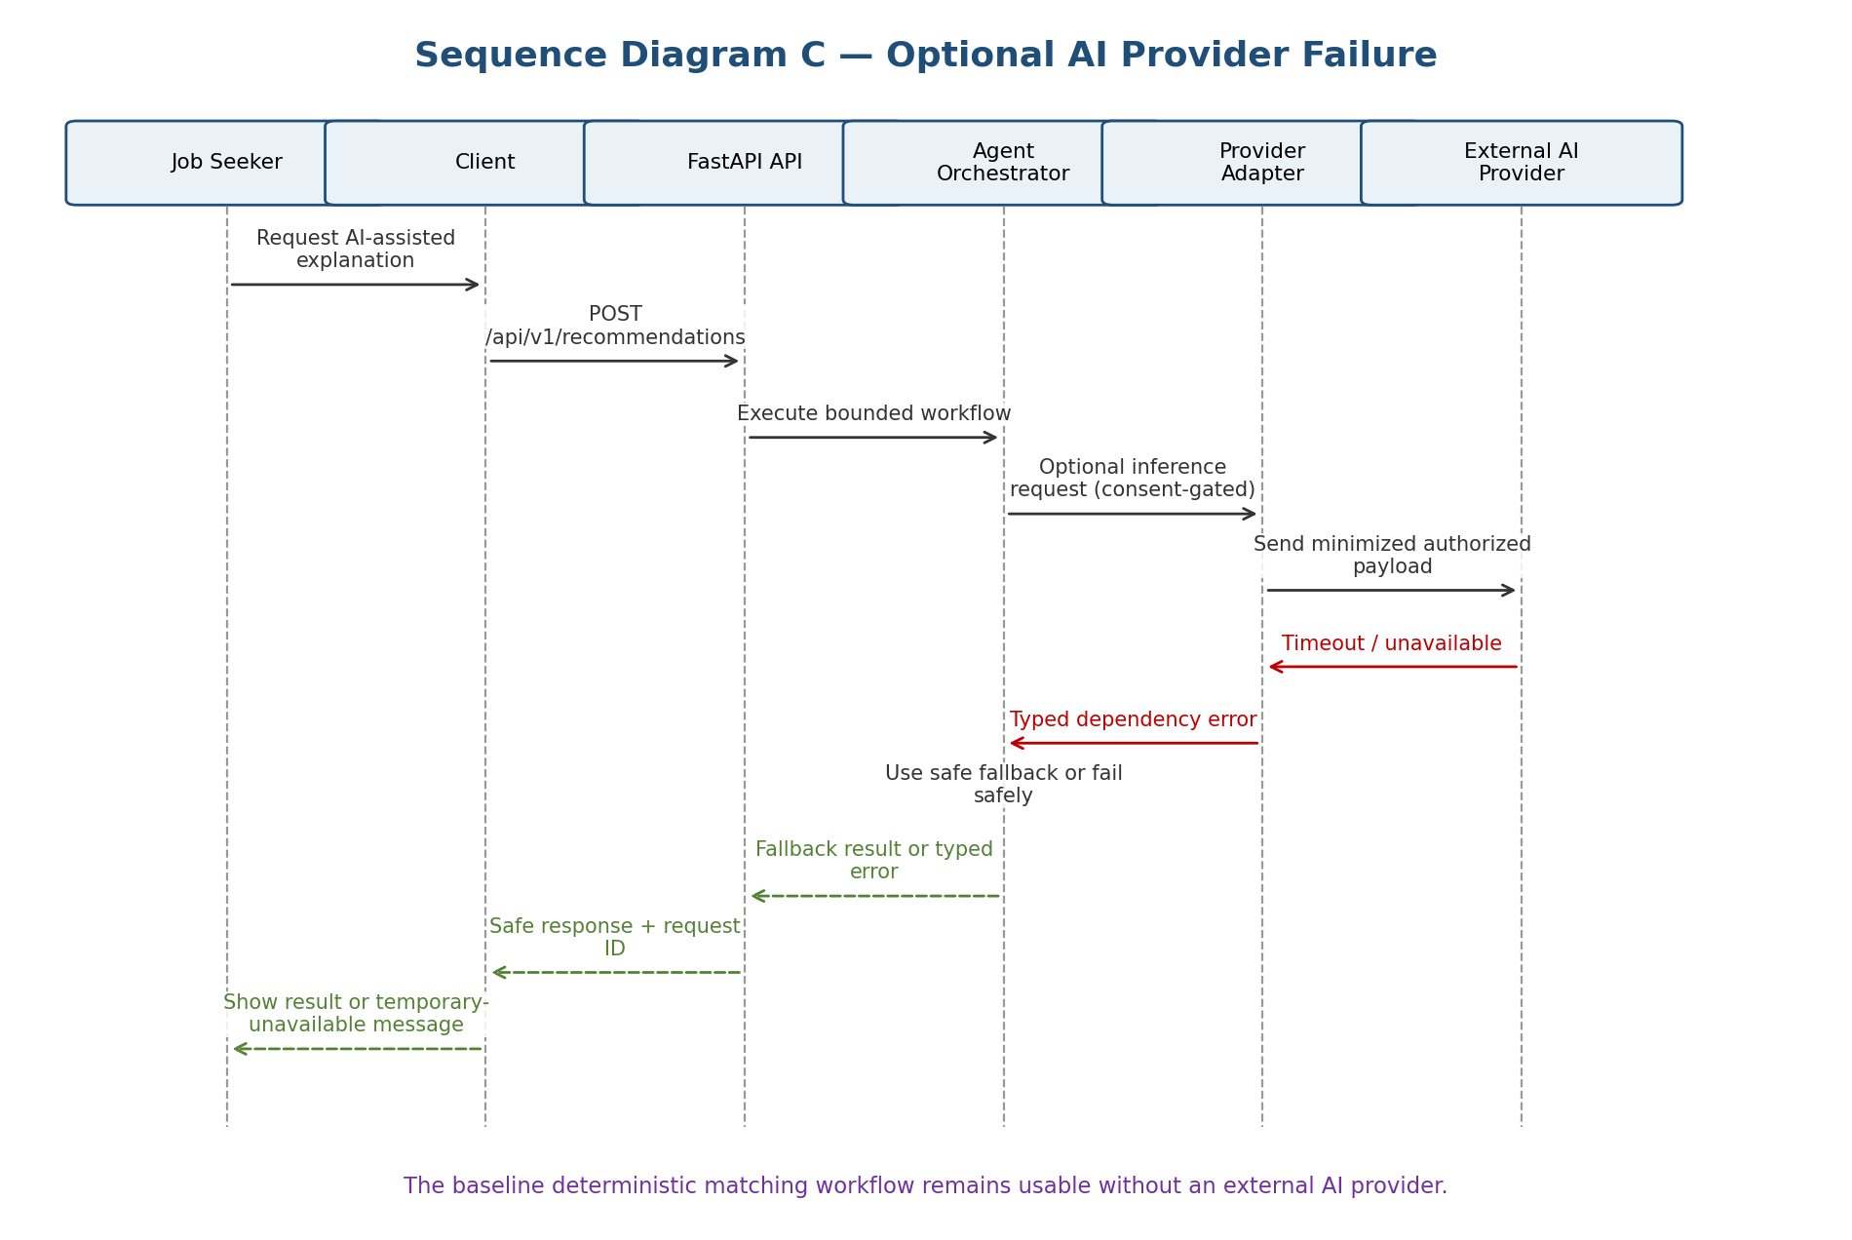

7. Error Handling and Observability

7.1 Error Categories
Category | Behavior
Validation error | Return 400/413/415/422 as appropriate with field-level safe detail; do not invoke parser/agent on invalid input.
Authentication failure | Return 401 with generic message; do not disclose account existence.
Authorization failure | Return 403 or a consistent 404 policy for private resources; never return protected contents.
Not found | Return 404 for nonexistent/inaccessible resources according to the chosen disclosure policy.
Parser failure | Return a controlled error or partial parse with explicit warnings; never fabricate fields.
Optional AI/provider failure | Timeout, retry only within a bounded policy if configured, then deterministic fallback or 503 response. v1.1: a mock provider is used (app/agent/provider.py); it runs only when EXTERNAL_AI_ENABLED=true and the user has consented, receives only job title and skill names, and any exception falls back to the deterministic explanation with a warning.
Unexpected failure | Return generic 500 and request ID; log sanitized diagnostic details server-side.

7.2 Logging
- Use structured logs with timestamp, request ID, route, status, duration, and safe user identifier where appropriate.
- Never log passwords, bearer tokens, API keys, raw resume text, or full request bodies containing personal data.
- Log security-relevant denials and admin changes; restrict log access and document retention.
- Expose health/readiness checks without returning environment variables or internal configuration.

8. Security Architecture
Threat / concern | Design control | Verification
Unauthorized record access | Authentication middleware plus ownership checks in service/repository calls. | TC-02, TC-09
Malicious or oversized upload | Allowlisted formats, size cap, generated storage keys, parser validation, non-public storage. | TC-03
Prompt injection in resume/job text | Treat retrieved text as data; do not let it change tool permissions; tool allowlist and argument schemas. | TC-08
Unapproved data transfer | External provider disabled by default; consent/configuration gate and minimized fields. | TC-13
Credential/secret leakage | Password hashing, secret environment configuration, response/log redaction. | TC-02, TC-12 and security review
Abuse or excessive requests | Consider request size limits, bounded candidate count, timeouts, and rate limiting for exposed deployments. | Performance/security checklist
Tampering with job import | Admin-only endpoint, schema validation, audit event. | FR-15 import test and SR-08 review

9. Deployment and Configuration
- Use a virtual environment and pinned dependencies; document exact install and run commands in README.
- Keep secrets in environment variables or a local untracked environment file; provide a sanitized example file.
- Initialize the SQLite schema and seed the job dataset through a repeatable command.
- Keep resume storage outside the public web root and apply least-privilege filesystem permissions.
- For deployment, configure HTTPS, secure cookies/token handling as applicable, and a non-debug server configuration.
- Document that SQLite/local file storage is a student-prototype deployment, not a production scaling recommendation.

10. Requirement and Test Traceability
SRS requirement(s) | Design section/component | Test evidence
FR-01, FR-02, SR-01, SR-02 | Auth service; API routes; §5.2 | TC-01, TC-02
FR-03, FR-04, SR-03, NFR-07 | Resume service/parser/storage; §4, §5.2 | TC-03, TC-04; deletion check
FR-05, FR-15, NFR-01 | Job search/import; §2.3, §5.2 | TC-05; import validation
FR-06, FR-07, FR-09, NFR-02, NFR-03 | Matching and explanation; §4.2 | TC-06, TC-07, TC-14; performance run
FR-08, FR-13, SR-05, SR-06 | Agent, tool registry, provider adapter; §6.2, §8 | TC-08, TC-13
FR-10, FR-11, FR-12 | Tracking services and ownership checks; §2.3 | TC-09, TC-10, TC-11
FR-14, SR-04, SR-08 | Error handler, logging; §7 | TC-12; audit review
SR-07, NFR-05, NFR-08 | Deployment and client; §9 | HTTPS/compatibility/accessibility checklist
NFR-04, NFR-06, NFR-09 | UI, module layout, project setup; §2, §9 | TC-15, code review, clean setup test

11. Open Decisions and Review Checklist
- Confirm whether a browser frontend is mandatory or an API-backed demo is acceptable. — Decided: plain HTML + JavaScript pages served by FastAPI.
- Choose resume parser package and supported file formats after a short technical spike. — Decided: PDF (pypdf), DOCX (python-docx) and TXT; 2 MB limit.
- Choose whether optional LLM integration is included; if included, document the provider and data consent UX. — Decided: no real LLM in v1.1; a mock provider behind the consent gate.
- Review matching-score weights with the team and instructor; treat them as transparent relevance signals. — Decided: 0.75 / 0.25 kept as documented in 4.2.
- Replace proposed targets only through documented agreement; do not report targets as achieved without test evidence.
- Apply the course-provided IEEE template/section numbering if it differs from this practical structure.
Team: the no name group

