Software Requirements
Specification
for
AI-Based Resume Matching and
Job Searching Platform
Using Agentic AI
Version 1.2 approved
Prepared by the no name group
Anvith Vegi (PES1UG24AM047)
Ankitha Revadala (PES1UG24AM044)
Anirudh N (PES1UG24AM041)
PES University
Department of Computer Science and Engineering (AI & ML)
31 October 2026

Table of Contents
Document Control 3
Revision History 3
1. Introduction 3
1.1 Purpose 3
1.2 Scope 4
1.3 Intended Audience and Reading Suggestions 4
1.4 Definitions, Acronyms, and Abbreviations 4
1.5 References and Standards 5
1.6 Overview 5
2. Overall Description 6
2.1 Product Perspective 6
2.2 Product Functions 8
2.3 User Classes and Characteristics 9
2.4 Operating Environment 9
2.5 Design and Implementation Constraints 10
2.6 Assumptions and Dependencies 10
3. External Interface Requirements 10
3.1 User Interfaces 10
3.2 Software Interfaces 11
3.3 Communications Interfaces 11
3.4 REST API Specification 11
3.5 Data Requirements 12
3.6 How the Agent Retrieves Data from SQL 13
4. System Requirements 14
4.1 Functional Requirements 14
4.2 Non-Functional Requirements 26
4.3 Performance Testing for the Agent / LLM Workflow 26
4.4 Requirement Quality Rules 27
5. Security 27
5.1 Security Objectives 27
5.2 Security Requirements 27
5.3 Threats and Countermeasures 27
5.4 Security Considerations 28
6. Use-Case Model 29
6.1 Actors 29
6.2 Use-Case Diagram 29
6.3 Use-Case Descriptions 29
6.4 Use Case ↔ Functional Requirement Mapping 31
6.5 Product Backlog Mapping 32
6.6 Supporting Behaviour Diagrams 33
7. Appendices 34
7.1 Open Decisions / Change Control 34
7.2 List of Diagrams 34

Document Control
Document ID | SRS-ARJ-001
Version | 1.2
Status | Implemented prototype; revised after the SRS review (31 October 2026)
Project | AI-Based Resume Matching and Job Searching Platform Using Agentic AI ("Resume Matcher")
Repository | github.com/anvithh-16/Resume_Matcher- (frozen at tag v1.0 for Sprint 2)
Baseline stack | Python 3.12/3.13, FastAPI, SQLAlchemy 2, SQLite, plain HTML + JavaScript client, bounded tool-using agent with an optional consent-gated AI provider
Team | the no name group — Anvith Vegi (PES1UG24AM047), Ankitha Revadala (PES1UG24AM044), Anirudh N (PES1UG24AM041)
Related documents | Architecture Design (SAD) v1.1, Test Plan v1.1, TraceabilityMatrix_v1.1.csv, docs/TEST_REPORT.md, docs/DEVIATIONS.md, docs/PERFORMANCE.md, docs/SECURITY_CHECKLIST.md

Revision History
Name | Date | Reason For Changes | Version
the no name group | 11 Oct 2026 | Initial scope baseline and measurable requirements. | 1.0
the no name group | 30 Oct 2026 | Implemented. Open decisions closed: plain HTML/JS frontend; PDF, DOCX, TXT up to 2 MB (pypdf, python-docx); JWT bearer login; no real LLM (mock provider behind consent gate). Deviations recorded in docs/DEVIATIONS.md. | 1.1
the no name group | 31 Oct 2026 | Revised after SRS review: IEEE cover page and contents; project introduction and project purpose; customer added to intended audience; overview, context, architecture, flow, DFD, ER, deployment, activity, state and screen-transition diagrams; Google Antigravity in operating environment; REST API specification; how the agent retrieves data from SQL; acceptance criteria, what to test and GUI screen for every functional requirement; acceptance and test method for every NFR and SR; agent/LLM performance requirement and testing (NFR-10); protection against sniffing, spoofing and man-in-the-middle attacks (SR-09 to SR-11); all nine use cases described and mapped to functional requirements. GUI screenshots and section 3.1 updated for the Sprint-3 Notion-style interface (5 Nov 2026). | 1.2

1. Introduction
Students and early-career job seekers usually apply to jobs by reading each posting and guessing whether their resume is a good fit. This is slow, and they rarely learn which skills are missing. Resume Matcher is a web application that reads a user's resume, searches a curated set of job listings, scores how well the resume fits each job, lists the matched and missing skills, and recommends the best jobs with a short, evidence-based reason for each one. A small "agentic" workflow coordinates these steps using only four approved tools, so it can help the user without ever acting on their behalf: it never applies to jobs and never sends resume data anywhere without consent.
The prototype was built in two sprints by a team of three (the no name group) using Python, FastAPI and SQLite, with a simple browser interface. It is an educational project and the scores are assistive signals, not hiring decisions.

1.1 Purpose
Purpose of the project. The project aims to:
- save job seekers time by finding relevant jobs from their own resume instead of manual reading;
- make the fit between a resume and a job measurable (a 0–100 score with a breakdown) and explainable (matched skills, missing skills and reasons);
- show a safe, bounded use of agentic AI: the agent follows a fixed plan, may only call allowlisted tools, and cannot submit applications or share data without consent;
- give users simple tools to keep track of bookmarked jobs and the status of their applications.
Purpose of this document. This SRS specifies the functional, non-functional, interface, data and security requirements of the platform. It is the reference for the architecture design, for testing (every requirement states its acceptance criteria and what to test) and for the traceability matrix. Version 1.2 describes the system as implemented at the Sprint-2 freeze and adds the material requested in the SRS review.

1.2 Scope
In scope: account registration and login; resume upload (PDF, DOCX, TXT, up to 2 MB), parsing, review, correction and deletion; search of a curated local job dataset; resume-to-job match score and skill-gap report; agent-based recommendations with explanations; bookmarks; manual application tracking; administrator job import/update; consent setting for an optional AI provider; consistent error handling and security audit logging.
Out of scope: automatic job applications, guaranteed placement, unrestricted web scraping, live job-board integrations, recruiter hiring workflows, and any autonomous change to user data.

1.3 Intended Audience and Reading Suggestions
Table 1. Intended audience
Reader | Why the SRS matters to them | Suggested sections
Customer / client — job seekers and students (end users), and a college placement cell that could offer the tool | Confirms what the product will and will not do, how their resume data is protected, and what each screen does | 1, 2.2, 3.1 (screens), 4.1, 5, 6
Course instructor and evaluators | Checks scope, measurable requirements, diagrams and traceability | All; 4, 5, 6.5
Developers (project team) | Exact behaviour, REST API, data model and agent rules to implement | 2, 3, 4, 5
Testers | Acceptance criteria and "what to test" for every requirement; GUI screens to validate | 3.4, 4, 5.2, 6
Administrator / import operator | How the job dataset is imported, updated and deactivated | 2.3, 3.4, FR-15
Maintainers / future teams | Operating environment, constraints, design decisions and open items | 2.4–2.6, 3, 7

1.4 Definitions, Acronyms, and Abbreviations
Table 2. Definitions
Term | Definition
Agentic AI | An AI-driven workflow that selects or coordinates approved tools across multiple steps toward a user goal.
Allowlisted tool | One of the four registered operations the agent may invoke: get_resume_profile, search_jobs, score_jobs, rank_results.
FR / NFR / SR / SO | Functional Requirement / Non-Functional Requirement / Security Requirement / Security Objective.
UC | Use case — a goal an actor achieves with the system (UC-01 to UC-09).
Match score | 0–100 value = 100 × (0.75 × skill overlap + 0.25 × keyword similarity); an assistive signal, not a decision.
REST / JSON | Representational State Transfer API style; JavaScript Object Notation data format.
JWT | JSON Web Token — signed bearer token proving who is logged in (HS256, 60-minute expiry).
ORM / SQL | Object-Relational Mapper (SQLAlchemy) / Structured Query Language used to read and write SQLite.
TLS / HTTPS | Transport Layer Security / HTTP over TLS — encrypts traffic and authenticates the server.
Sniffing | Passively capturing network traffic to read passwords, tokens or resume data.
Spoofing | Pretending to be another user or server, e.g. with a forged or stolen token.
MITM | Man-in-the-middle — an attacker who sits between browser and server to read or change traffic.
DFD / ER | Data Flow Diagram / Entity-Relationship diagram.
p95 | 95th percentile of measured response times.
Google Antigravity | AI-assisted code editor (IDE) used by the team for development.

1.5 References and Standards
- IEEE 29148:2018, Systems and software engineering — Requirements engineering.
- IEEE 830-1998 SRS template (section structure used for this document).
- ISO/IEC/IEEE 29119 series, Software testing.
- OWASP guidance: Authentication, File Upload, REST Security, Logging and Transport Layer Security cheat sheets.
- Project documents: SAD v1.1, Test Plan v1.1, TraceabilityMatrix_v1.1.csv, docs/TEST_REPORT.md, docs/DEVIATIONS.md.
- Course-provided templates and rubric take precedence for numbering and formatting.

1.6 Overview
Section 2 describes the product, its architecture, users and operating environment. Section 3 specifies the user interface screens, the REST API, the data model and how the agent retrieves data from SQL. Section 4 lists each functional requirement with its acceptance criteria, what to test and its GUI screen, followed by the non-functional requirements including agent/LLM performance. Section 5 covers security, including sniffing, spoofing and man-in-the-middle attacks. Section 6 gives the use-case model and the use case ↔ requirement mapping.
Overall picture. Figure 1 shows the system and everything it talks to. Figure 2 shows the overall flow a user follows through the product.
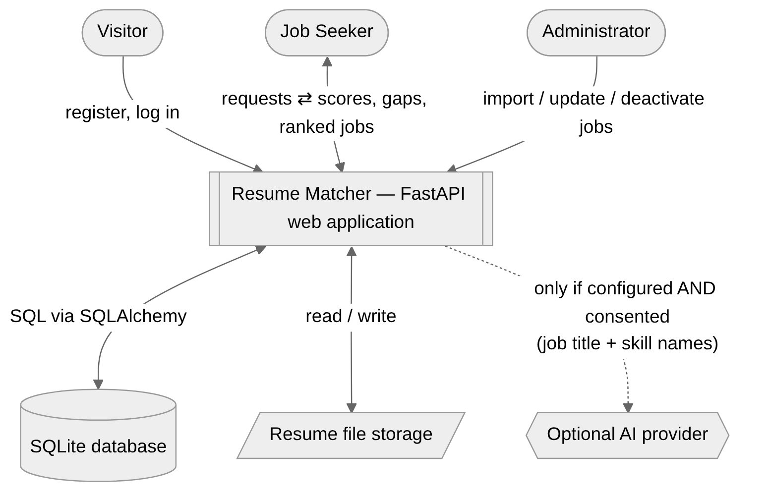
Figure 1. System context diagram — actors, data stores and the optional AI provider
Look and feel. Since Sprint 3 the interface follows a minimal, document-like style (similar to Notion): a left sidebar lists the pages (My resume, Find jobs, Match, Recommendations, Bookmarks, Applications) with the signed-in email and Log out at the bottom; each page opens with a large icon, a title and a one-line description. Data is shown in database-style views: jobs as a gallery of cards, recommendations as an expandable ranked list, applications as a status board. Skills and statuses appear as coloured tags, success and error messages as green and red callouts, and the match score as a large number with a progress bar. Light and dark mode follow the operating system. Every form field has a visible label, everything works with the keyboard alone, all pages pass an automated WCAG 2.1 AA check, and each result screen states that scores are assistive signals.
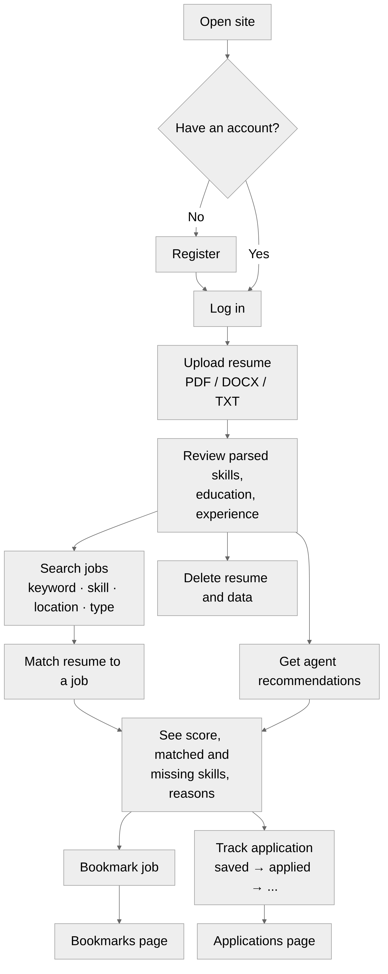
Figure 2. Overall user flow ("feel and flow" of the product)

2. Overall Description

2.1 Product Perspective
Resume Matcher is a new, self-contained web application. The browser loads seven static HTML pages served by the same FastAPI process and calls the JSON REST API under /api/v1 with a bearer token. Routers delegate to business services (parser, resume, job, matching, skills) which use SQLAlchemy to read and write SQLite; resume files are stored under server-generated names. The recommendation endpoint runs the agent orchestrator, which may only call the allowlisted tools. An external AI provider is optional, disabled by default, and used only with configuration and user consent; the core workflow runs fully offline.
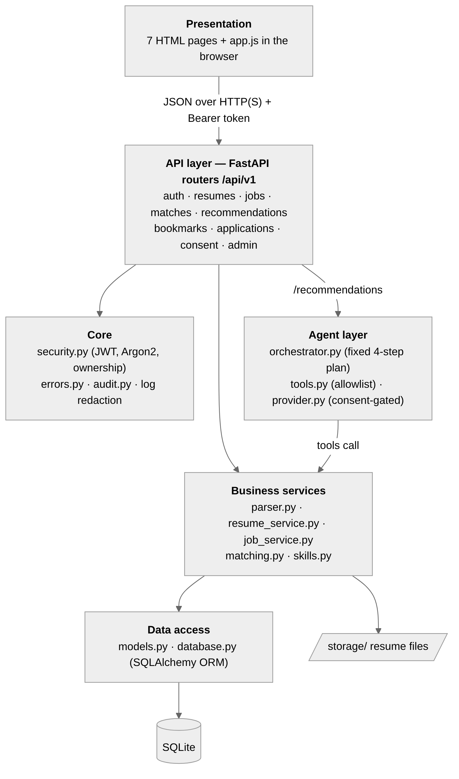
Figure 3. Layered architecture of the implemented system
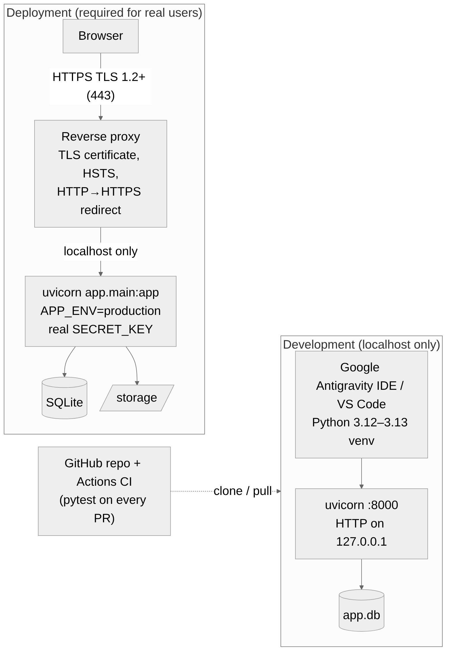
Figure 4. Development and deployment views

2.2 Product Functions
- Account registration and authentication (FR-01, FR-02).
- Resume upload, parsing, review, correction and deletion (FR-03, FR-04, NFR-07).
- Job search over a curated dataset by keyword, skill, location and job type (FR-05).
- Resume-to-job match score and skill-gap report with explanations (FR-06, FR-07, FR-09).
- Agent recommendations using allowlisted tools (FR-08).
- Bookmarks and manual application tracking (FR-10, FR-11).
- Owner-only access to private records (FR-12) and consent-controlled external transfer (FR-13).
- Consistent, safe error responses (FR-14) and administrator job import/update (FR-15).
Figure 5 shows how data moves between these functions and the data stores.
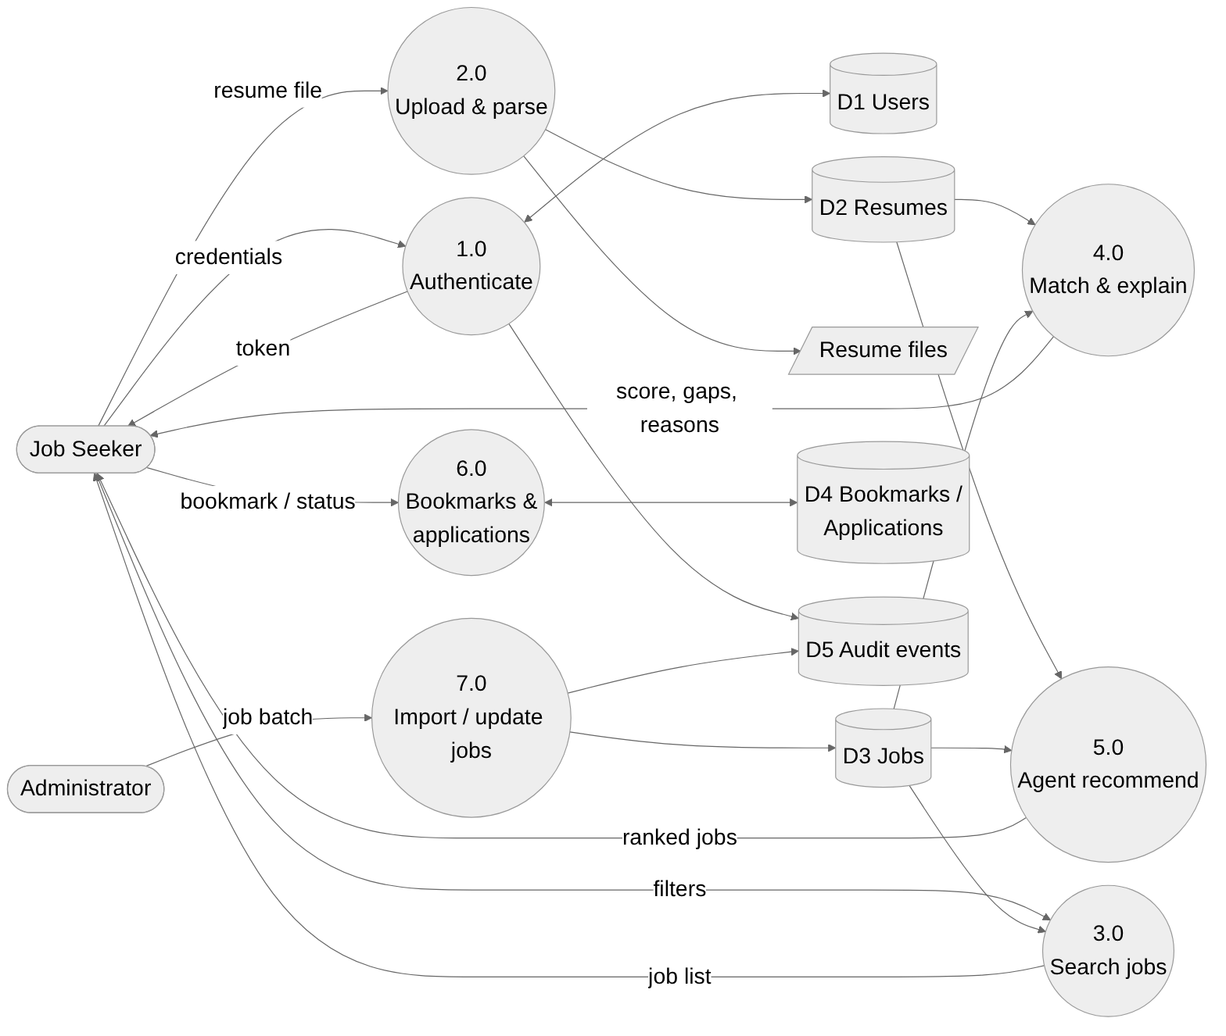
Figure 5. Data flow diagram (level 1)

2.3 User Classes and Characteristics
Table 3. User classes
User class | Description / privileges | Technical skill
Visitor | Views the login/registration page and registers; cannot access private records. | Basic web use
Job seeker | Manages own resumes, searches jobs, views matches and recommendations, bookmarks jobs, tracks own applications, sets AI consent. | Basic web use
Administrator / import operator | Imports, updates and deactivates job listings through authenticated admin endpoints (is_admin flag set with scripts/make_admin.py). | Can send JSON API requests
External AI provider (optional) | Receives only job title and skill names after configuration and consent; never an authorization authority. | System

2.4 Operating Environment
Table 4. Operating environment
Area | Environment
Client | Latest stable Google Chrome (tested) and Mozilla Firefox (target); any modern browser with JavaScript enabled.
Server runtime | Python 3.12 or 3.13 (3.14 not yet supported by pinned packages); FastAPI served by Uvicorn (ASGI).
Database / storage | SQLite file database through SQLAlchemy 2; resume files in a local storage/ folder.
Operating systems | Developed and tested on macOS (Anvith, Anirudh) and Windows 11 (Ankitha); Linux in GitHub Actions CI.
Development IDE | Google Antigravity (AI-assisted IDE) used by the team for coding, running and debugging; VS Code is an equivalent alternative.
Version control and CI | Git + GitHub (pull requests with review, protected main branch, GitHub Project board); GitHub Actions runs pytest on every push and pull request.
Testing tools | pytest, httpx/TestClient, pytest-cov (coverage), custom load scripts (scripts/perf_search.py, perf_match.py), Chrome Lighthouse.
Network | HTTP on localhost for development only; HTTPS (TLS 1.2+) required for any deployment carrying credentials or resumes.

2.5 Design and Implementation Constraints
- The first release uses a curated local job dataset; no live job-board API.
- The agent may only use registered tools with schema-validated inputs and a fixed plan.
- The system shall not submit applications autonomously.
- External AI use requires explicit configuration and user consent; only minimized data may be sent.
- Performance targets must be measured in a documented test environment.
- Dependencies are pinned in requirements.txt / requirements-lock.txt.

2.6 Assumptions and Dependencies
- A sample job dataset with consistent fields (title, company, location, description, required skills, job type, source) exists (data/jobs_seed.json).
- Resume parsing quality depends on file format, layout and text quality; scanned image-only PDFs are not supported.
- Optional AI behaviour depends on provider availability; deterministic matching always works without it.
- The prototype is for educational demonstration and is not a production hiring system.

3. External Interface Requirements

3.1 User Interfaces
The client has seven screens. Each screen and the requirements it serves are listed in Table 5; screenshots of every screen appear with the matching requirement in Section 4.1. Figure 6 is the screen transition diagram.
Table 5. User interface screens
Screen | File | Purpose | Requirements
Log in / Register | index.html | Create an account and log in | FR-01, FR-02, FR-14
My resume | resume.html | Upload, review, correct and delete resumes | FR-03, FR-04, NFR-07
Find jobs | jobs.html | Filter bar and gallery of job cards; bookmark or track | FR-05, FR-10, FR-11
Match | match.html | Score one resume against one job; matched/missing skills | FR-06, FR-07, FR-09
Recommendations | recommend.html | Ranked, expandable list with agent steps; AI consent switch | FR-08, FR-09, FR-13
Bookmarks | bookmarks.html | List and remove bookmarked jobs | FR-10
My applications | applications.html | Status board (saved → withdrawn); change status and notes | FR-11

UI rules: a sidebar on every page after login (a scrolling top bar on phones); labelled form fields; error messages in a red callout (role="alert") and success messages in a green callout (role="status"); empty results show a callout explaining what to do next; all controls reachable by keyboard with a visible focus ring; text contrast meets WCAG 2.1 AA in light and dark mode; a 401 response returns the user to the login page.
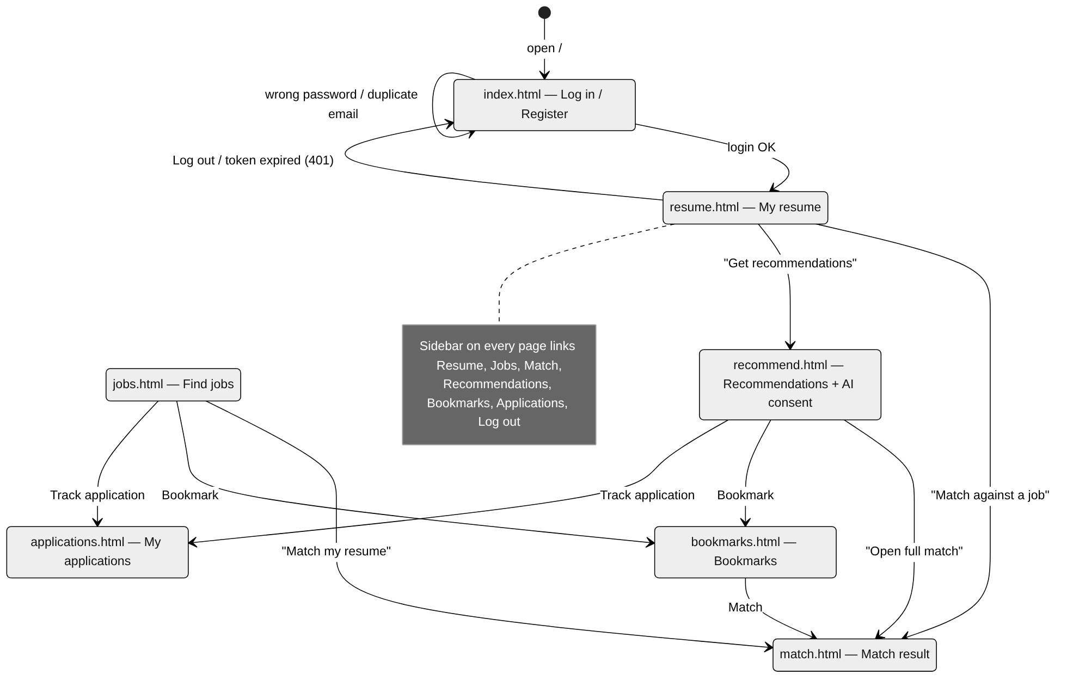
Figure 6. Screen transition diagram

3.2 Software Interfaces
Table 6. Software interfaces
Interface | Contract
Browser ↔ FastAPI | JSON REST API under /api/v1; bearer JWT in the Authorization header; multipart/form-data for resume upload.
FastAPI ↔ SQLite | SQLAlchemy ORM with bound parameters only (no string-built SQL); tables created at start-up (init_db).
Resume parser | pypdf (PDF), python-docx (DOCX), UTF-8 text; returns skills, education, experience, contact and warnings.
Matching engine | compute_match(profile, job) → score, skill_overlap, keyword_similarity, matched/missing skills, explanation.
Agent tools | Four allowlisted typed tools; strict pydantic arguments (unknown fields rejected); no shell, raw SQL or network tool.
Optional AI provider | Adapter with 5-second timeout; receives job title + skill names only; deterministic fallback on failure.

3.3 Communications Interfaces
Development uses HTTP on 127.0.0.1 only. Any deployment carrying credentials or resumes shall use HTTPS with TLS 1.2 or newer, terminate TLS at a reverse proxy, redirect HTTP to HTTPS and send HSTS (SR-07, SR-09, SR-11). Requests and responses use UTF-8 JSON except multipart resume uploads. In production (APP_ENV=production) the interactive API docs (/docs, /openapi.json) are disabled and the default secret key is refused.

3.4 REST API Specification
Base path: /api/v1. "Auth" = requires Authorization: Bearer <JWT>. All errors use the format defined in FR-14. The live interactive specification is available at /docs in development.
Table 7. REST API endpoints
Method and path | Auth | Request | Success response | Errors | Req.
POST /auth/register | No | {email, password ≥ 8} | 201 {id, email} | 409 email_taken, 422 | FR-01
POST /auth/login | No | {email, password} | 200 {access_token, token_type} | 401 invalid_credentials | FR-02
GET /me | Yes | — | 200 {id, email, is_admin} | 401 | FR-02
POST /resumes | Yes | multipart file (PDF/DOCX/TXT ≤ 2 MB) | 201 resume + parsed profile | 400, 413, 415, 422 | FR-03, FR-04
GET /resumes | Yes | — | 200 {resumes:[…]} (own only) | 401 | FR-04, FR-12
GET /resumes/{id} | Yes | — | 200 resume | 404 (not owner) | FR-12
PUT /resumes/{id}/profile | Yes | {skills, education, experience} | 200 corrected resume | 404, 422 | FR-04
DELETE /resumes/{id} | Yes | — | 204 | 404 | NFR-07
GET /jobs | No | ?q, skill (repeatable), location, employment_type, limit ≤ 100 | 200 {count, results} | 422 | FR-05
GET /jobs/{id} | No | — | 200 job | 404 | FR-05
POST /matches | Yes | {resume_id, job_id} | 200 {score, skill_overlap, keyword_similarity, matched_skills, missing_skills, explanation} | 404 | FR-06, FR-07, FR-09
POST /recommendations | Yes | {resume_id, location?, top_k 1–10} | 200 {recommendations, guidance, tool_trace, external_calls, note} | 400, 404 | FR-08, FR-09, FR-13
GET /bookmarks | Yes | — | 200 list (own only) | 401 | FR-10
POST /bookmarks | Yes | {job_id} | 201 | 404, 409 already_bookmarked | FR-10
DELETE /bookmarks/{job_id} | Yes | — | 204 | 404 | FR-10
GET /applications | Yes | — | 200 list (own only) | 401 | FR-11
POST /applications | Yes | {job_id, status?, notes?} | 201 | 404, 409, 422 | FR-11
PATCH /applications/{id} | Yes | {status?, notes?} | 200 | 404, 422 invalid_status | FR-11
GET /consent, PUT /consent | Yes | {external_ai_enabled} | 200 {external_ai_enabled, provider_configured, notice} | 401, 422 | FR-13
POST /admin/jobs/import | Admin | {jobs:[1–1000 job objects]} | 201 {imported} | 403, 422 invalid_jobs (nothing saved) | FR-15
PATCH /admin/jobs/{id} | Admin | {title?, description?, location?, required_skills?, employment_type?, active?} | 200 {id, active} | 403, 404, 422 | FR-15
GET /health | No | — | 200 {status: ok} | — | NFR-09

Example — request and response for POST /api/v1/matches:
POST /api/v1/matches Authorization: Bearer eyJhbGciOi...
{"resume_id": 1, "job_id": 4}

200 OK
{"job_id": 4, "score": 81.4, "skill_overlap": 1.0, "keyword_similarity": 0.26,
"matched_skills": ["fastapi", "git", "python", "sql"], "missing_skills": [],
"explanation": ["Your resume lists fastapi, git, python and sql, which this job requires."]}

3.5 Data Requirements
Figure 7 shows the database tables and relationships. Every private table has an owner column used for ownership checks.
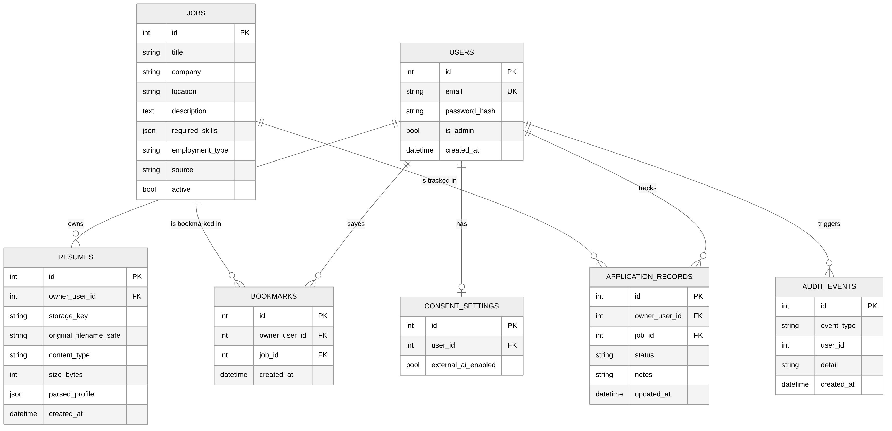
Figure 7. Entity-relationship diagram
Table 8. Data entities
Entity | Key fields / constraints
users | id, email (unique, lower-cased), password_hash (Argon2), is_admin, created_at
resumes | id, owner_user_id → users, storage_key (server-generated), original_filename_safe, content_type, size_bytes, parsed_profile (JSON), created_at
jobs | id, title, company, location, description, required_skills (JSON list of normalized names), employment_type ∈ {full-time, part-time, internship, contract}, source, active
bookmarks | id, owner_user_id, job_id, created_at; unique (owner, job)
application_records | id, owner_user_id, job_id, status ∈ {saved, applied, interviewing, offer, rejected, withdrawn}, notes ≤ 1000, updated_at
consent_settings | id, user_id (unique), external_ai_enabled (default false), updated_at
audit_events | id, event_type, user_id, detail (no secrets or resume text), created_at

3.6 How the Agent Retrieves Data from SQL
The agent never writes SQL and has no database or shell tool. It can only call the four allowlisted tools; each tool calls ordinary application code, and that code uses the SQLAlchemy ORM, which sends parameterized SQL to SQLite. This keeps data access inside the same ownership and validation rules as the rest of the API.
1. get_resume_profile(resume_id) loads the resume row by primary key and checks that owner_user_id equals the logged-in user (otherwise 404 and an access_denied audit event). It returns the parsed profile (skills, raw text).
2. search_jobs(skills, location, limit) calls job_service.search_jobs(). The ORM builds one SELECT on the jobs table: only active jobs, optional location filter, and the skills filter done in SQL — required_skills is stored as JSON text such as ["python", "sql"], so each wanted skill is matched with LIKE '%"python"%' (exact quoted name). Results are ordered by id and limited to at most 100 rows. Doing the filter in SQL keeps 5,000-job searches fast (NFR-01).
3. score_jobs(resume_id, job_ids) re-checks resume ownership, then loads each job by primary key and calls the matching engine (no SQL in the scoring itself).
4. rank_results(results, top_k) sorts in memory by score (ties by job id) and returns the top 1–10.
The SQL actually generated for skills = [python, sql] and location = Bengaluru (captured from SQLAlchemy):
SELECT jobs.id, jobs.title, jobs.company, jobs.location, jobs.description,
jobs.required_skills, jobs.employment_type, jobs.source, jobs.active
FROM jobs
WHERE jobs.active IS 1
AND lower(jobs.location) LIKE lower(?) -- '%Bengaluru%'
AND (CAST(jobs.required_skills AS VARCHAR) LIKE ? -- '%"python"%'
OR CAST(jobs.required_skills AS VARCHAR) LIKE ?) -- '%"sql"%'
ORDER BY jobs.id
LIMIT ? OFFSET ? -- 50, 0

Values are sent as bound parameters (?), never pasted into the SQL string, so text inside a resume (for example "'; DROP TABLE jobs; --") cannot change the query (SQL injection is prevented). Figure 8 shows the full sequence of one recommendation request.
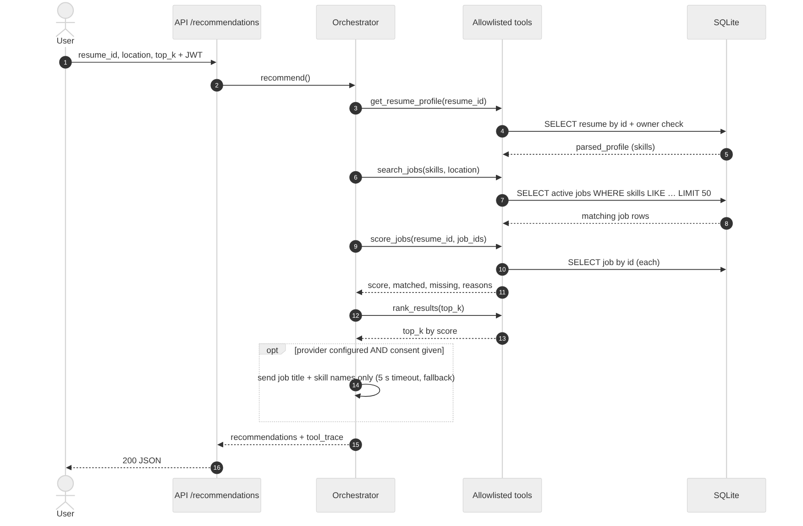
Figure 8. Sequence diagram — agent recommendation and its SQL queries

4. System Requirements

4.1 Functional Requirements
Each requirement below gives its statement, priority, acceptance criteria (Given / When / Then), what to test, the automated test that covers it, its result in Sprint-2 testing (docs/TEST_REPORT.md), and the GUI screen that shows it. Result values: Pass, Partial, Fail.

FR-01 Account registration
Requirement | The system shall allow a visitor to create an account when the email is valid, the password has at least 8 characters, and the email is not already registered.
Priority | High
Acceptance criteria | • Given a new valid email and password, when the visitor registers, then the response is 201 and one user record exists with a hashed password.  • Given an email that is already registered (any letter case), when registering, then the response is 409 with a safe message that does not reveal the account.  • Given an invalid email or a password under 8 characters, when registering, then the response is 422 and no user is created.
What to test | • Valid registration → 201 and "Account created" message  • Duplicate email (also different case) → 409  • Invalid email, short password, missing fields → 422  • Password stored as Argon2 hash, never plaintext (SR-02)
Test case / file | TC-01 · tests/test_auth.py
Sprint-2 result | Pass

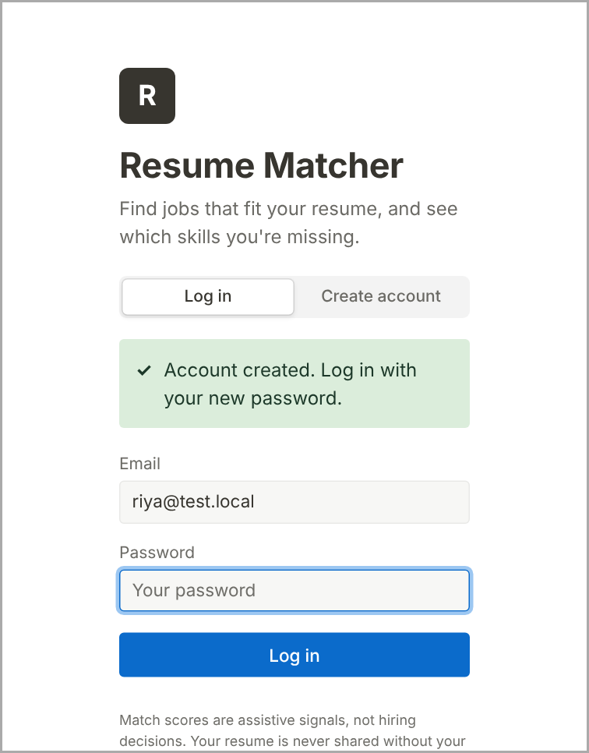
Figure 9. FR-01 GUI — Registration succeeded
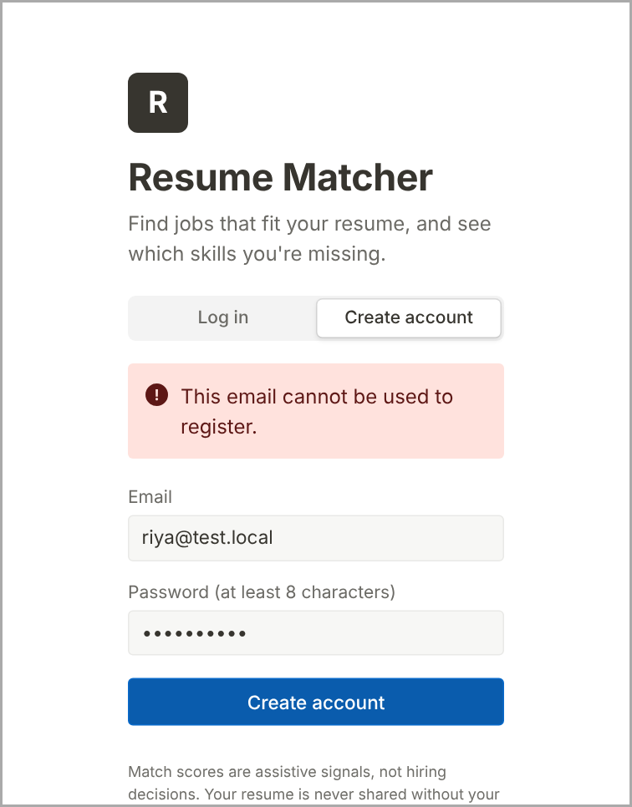
Figure 10. FR-01 GUI — Duplicate email rejected

FR-02 Authentication
Requirement | The system shall authenticate a registered user before granting access to protected endpoints.
Priority | High
Acceptance criteria | • Given correct credentials, when the user logs in, then a JWT (60-minute expiry) is returned and the user is taken to My resume.  • Given a wrong password or unknown email, when logging in, then the response is 401 with the same message for both cases and a login_failed audit event.  • Given no token, an expired token or a tampered token, when a protected endpoint is called, then the response is 401.
What to test | • Valid login returns token  • Wrong password and unknown email give identical 401  • Protected endpoint without/with forged token → 401  • login_failed audit event written without the password
Test case / file | TC-02 · tests/test_auth.py
Sprint-2 result | Pass

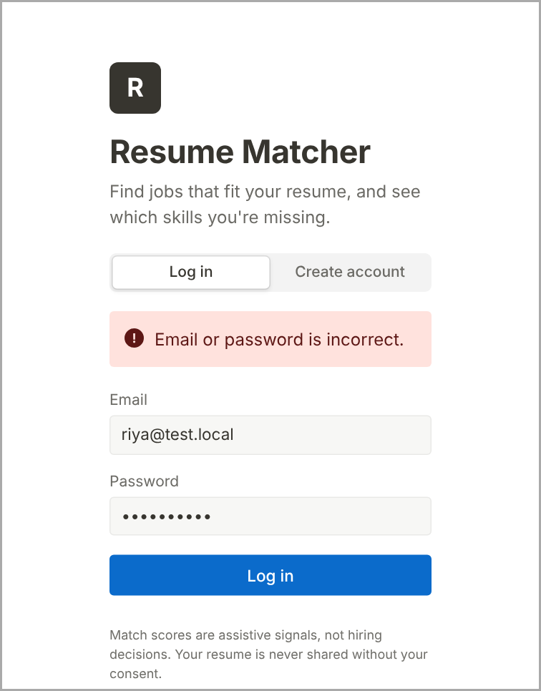
Figure 11. FR-02 GUI — Wrong password — generic error
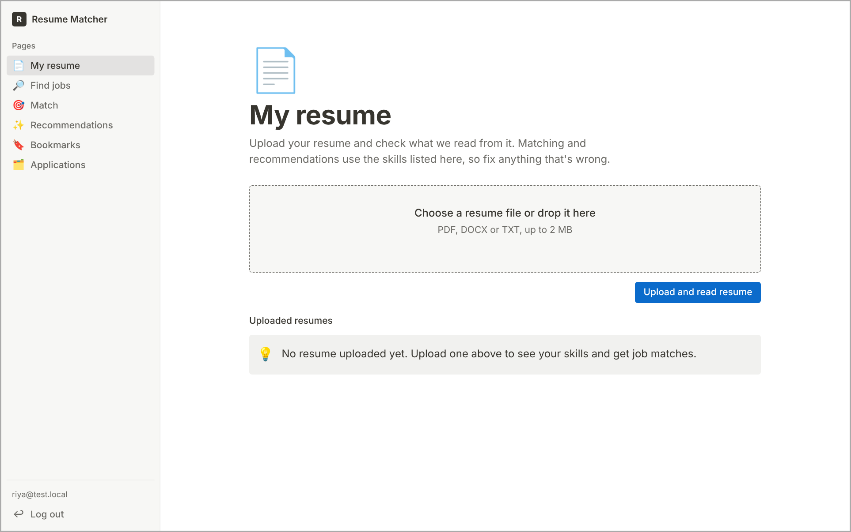
Figure 12. FR-02 GUI — After login — navigation bar and My resume

FR-03 Resume upload
Requirement | The system shall accept resume files in PDF, DOCX or TXT format up to 2 MB and link them to the authenticated owner.
Priority | High
Acceptance criteria | • Given a valid PDF, DOCX or TXT file ≤ 2 MB, when uploaded, then the response is 201 and the file is stored under a server-generated name linked to the owner.  • Given an unsupported extension, a file whose content does not match its type, an empty file or a file over 2 MB, when uploaded, then it is rejected (415, 415, 400, 413) and nothing is stored.
What to test | • Upload each supported type  • Upload .exe / renamed binary / empty / 2 MB + 1 byte  • Stored filename is not the client's filename  • Unauthenticated upload → 401
Test case / file | TC-03 · tests/test_resumes.py
Sprint-2 result | Pass

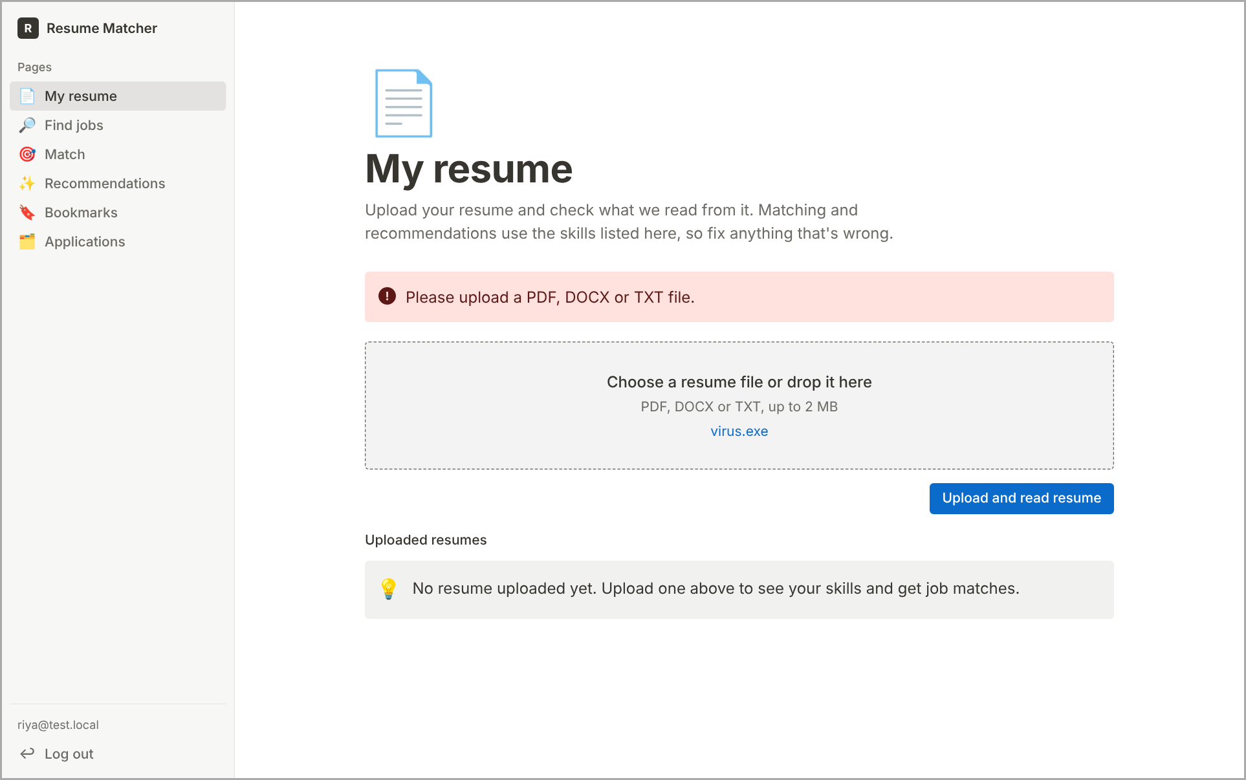
Figure 13. FR-03 GUI — Unsupported file rejected with a clear message

FR-04 Resume parsing and review
Requirement | The system shall extract skills, education, experience and contact details, where present, from an uploaded resume and show them to the user for review and correction.
Priority | High
Acceptance criteria | • Given a resume listing known skills, education and experience, when it is uploaded, then those fields are shown on My resume with skill names normalized (e.g. "Py" → python).  • Given a resume with missing sections, when parsed, then those fields are empty and a warning is shown — nothing is invented.  • Given the user corrects the skills list, when saved (PUT /resumes/{id}/profile), then the corrected profile is used for matching.
What to test | • Known fixture resume → expected skills/education/experience/email  • Resume without skills → empty list + warning  • Profile correction persists  • PDF, DOCX and TXT all parse
Test case / file | TC-04 · tests/test_resumes.py, tests/test_skills.py
Sprint-2 result | Pass

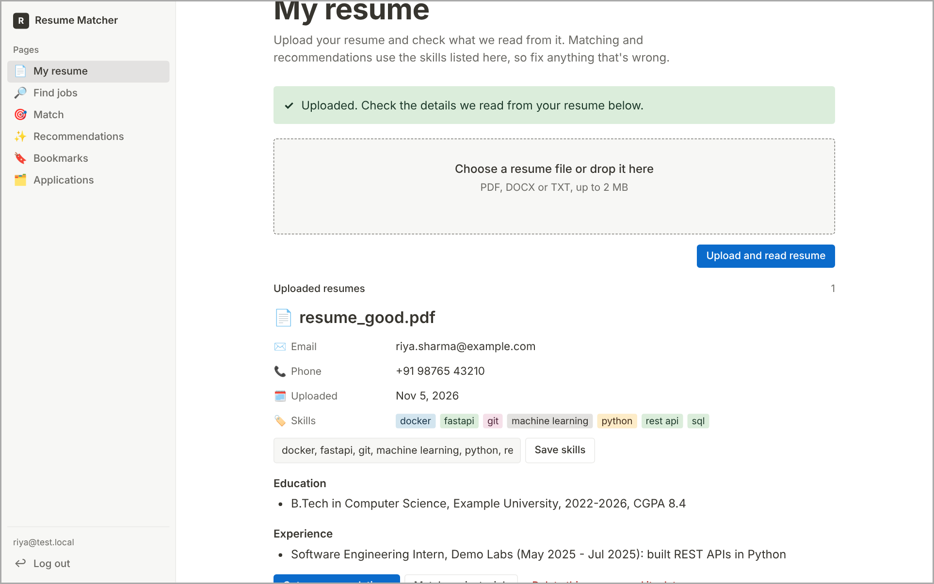
Figure 14. FR-04 GUI — Parsed resume fields shown for review

FR-05 Job search
Requirement | The system shall return active job listings that satisfy all supplied filters: keyword, skill(s), location and employment type.
Priority | High
Acceptance criteria | • Given filters, when the user searches, then every returned job matches all filters and inactive jobs never appear.  • Given filters that match nothing, when searching, then "0 jobs found" and guidance text are shown (empty state).
What to test | • Each filter alone and combined  • Skill alias (e.g. MySQL → sql) matches  • Inactive job excluded  • No-result search shows empty state  • Load test of NFR-01 (see 4.2)
Test case / file | TC-05 · tests/test_jobs.py
Sprint-2 result | Pass (functional); NFR-01 timing Fail

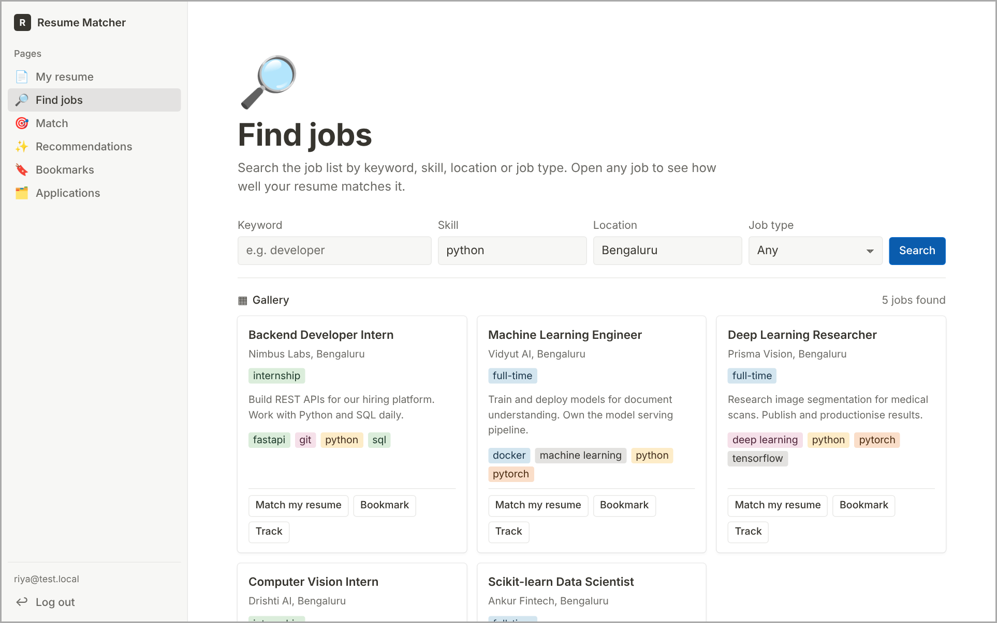
Figure 15. FR-05 GUI — Search results for skill = python, location = Bengaluru
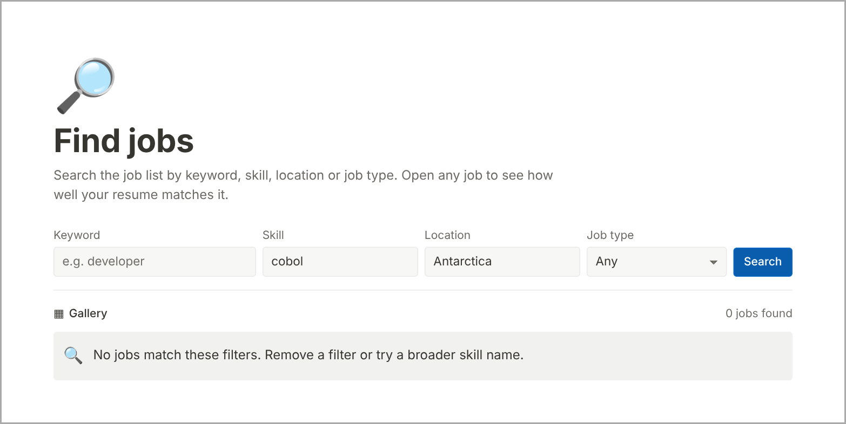
Figure 16. FR-05 GUI — Empty state

FR-06 Resume-job matching
Requirement | The system shall calculate a match score from 0 to 100 for a selected resume and job using score = 100 × (0.75 × skill overlap + 0.25 × keyword similarity), or 100 × keyword similarity when the job lists no skills.
Priority | High
Acceptance criteria | • Given an owned resume and an active job, when the user calculates a match, then a score in [0, 100] with skill overlap and keyword similarity is returned.  • Given the same inputs twice, when matched, then the score is identical (deterministic).
What to test | • Score range and formula on known cases  • Repeatability  • Job without required skills uses fallback (no division by zero)  • Non-owned resume → 404
Test case / file | TC-06 · tests/test_matching.py
Sprint-2 result | Pass

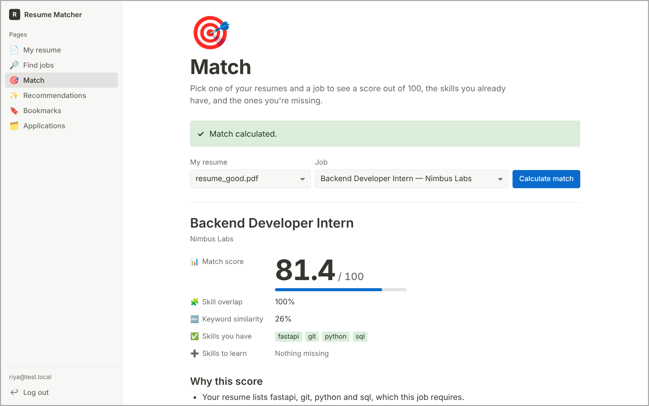
Figure 17. FR-06 GUI — Match result with score, breakdown, matched and missing skills

FR-07 Skill gap analysis
Requirement | The system shall list the job-required skills that are matched and those not found in the parsed resume, using normalized skill names.
Priority | High
Acceptance criteria | • Given a resume and a job, when matched, then matched_skills ∪ missing_skills equals the job's required skills and they do not overlap.
What to test | • Matched/missing lists correct for known fixtures  • Aliases count as matches  • No skill appears in both lists
Test case / file | TC-07 · tests/test_matching.py
Sprint-2 result | Pass

GUI screen: same screen as FR-06 above.

FR-08 Agent workflow
Requirement | The agent orchestrator shall execute the recommendation workflow by invoking only the allowlisted tools in the fixed order get_resume_profile → search_jobs → score_jobs → rank_results.
Priority | High
Acceptance criteria | • Given a resume with skills, when recommendations are requested, then tool_trace equals the four tools in order and up to top_k ranked jobs are returned.  • Given an unknown tool name or invalid tool arguments, when the agent tries to call it, then it is refused, an agent_tool_rejected audit event is written and a controlled 400 is returned.  • Given a resume with no skills or no matching jobs, when requested, then an empty list with guidance is returned.
What to test | • tool_trace order  • Unknown tool / extra argument refused and audited  • Prompt-injection text in resume does not change tools  • Empty-skills and no-match guidance
Test case / file | TC-08 · tests/test_agent.py
Sprint-2 result | Pass

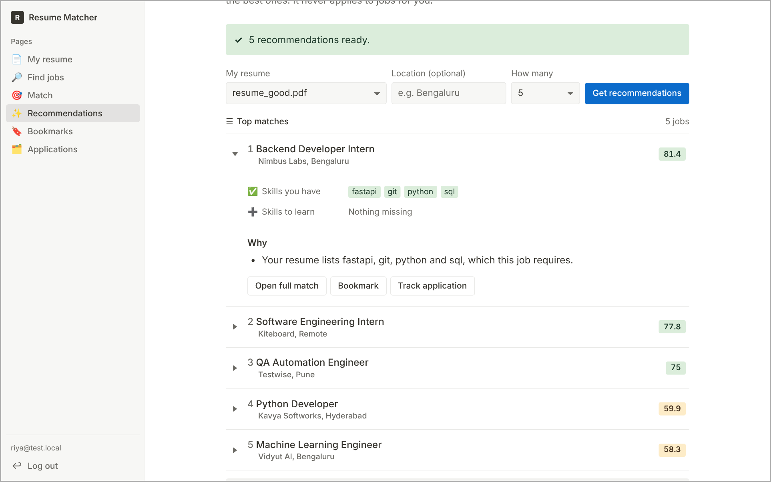
Figure 18. FR-08 GUI — Agent recommendations with reasons

FR-09 Recommendation explanation
Requirement | The system shall give evidence-linked reasons for each match and recommendation, mentioning only skills found in the job requirements or the parsed resume.
Priority | High
Acceptance criteria | • Given a match, when reasons are shown, then every skill named in a reason appears in matched_skills or missing_skills; no other claims are made.
What to test | • Each explanation sentence references only listed skills  • No-skill job states that text similarity was used
Test case / file | TC-07 · tests/test_matching.py
Sprint-2 result | Pass

GUI screen: same screen as FR-08 above.

FR-10 Bookmarks
Requirement | The system shall allow an authenticated user to bookmark a job, remove a bookmark and list their own bookmarks.
Priority | Medium
Acceptance criteria | • Given an active job, when bookmarked, then it appears on Bookmarks; bookmarking again returns 409.  • Given a bookmark, when removed, then it disappears; other users never see it.
What to test | • Add, list, duplicate 409, remove  • Bookmark of missing job → 404  • Second user cannot see first user's bookmarks
Test case / file | TC-10 · tests/test_bookmarks.py
Sprint-2 result | Pass

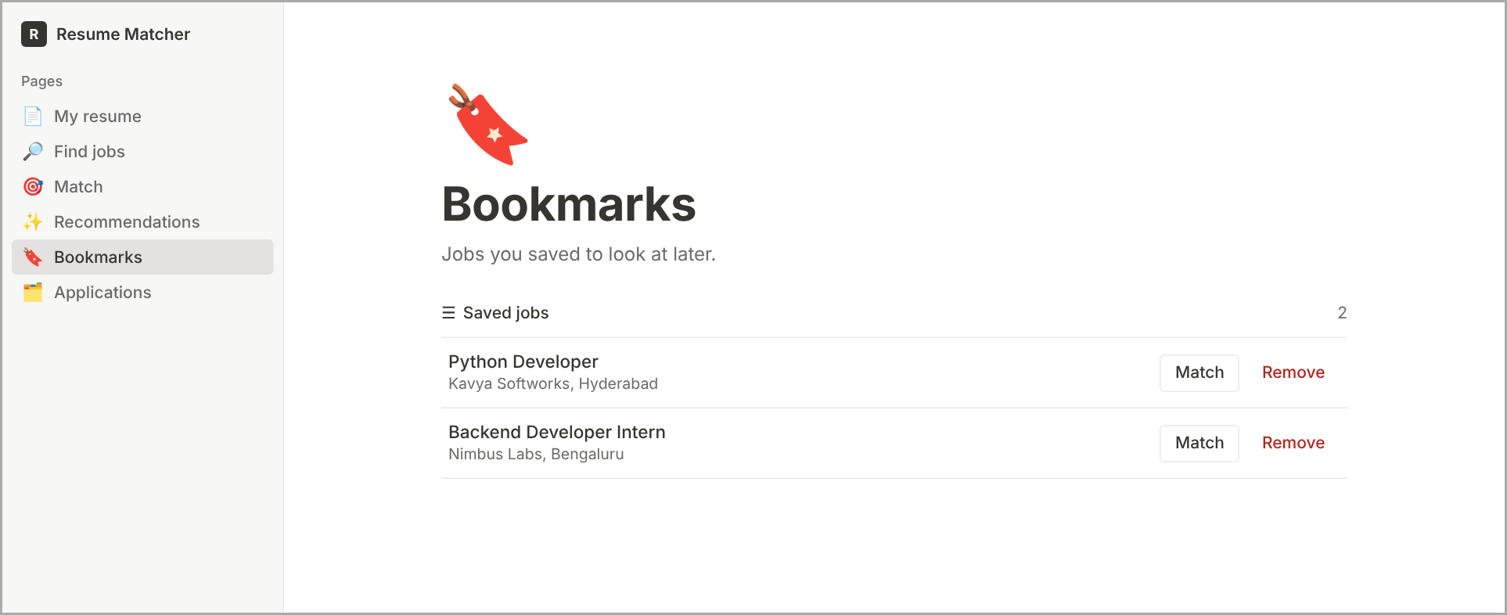
Figure 19. FR-10 GUI — Bookmarks page

FR-11 Application tracking
Requirement | The system shall allow a user to create and update a manual application record with one of the statuses saved, applied, interviewing, offer, rejected or withdrawn, plus optional notes.
Priority | Medium
Acceptance criteria | • Given a job, when the user tracks it, then a record with status saved (or the chosen status) is created; tracking it twice returns 409.  • Given a record, when the status is changed to a supported value, then it persists with a new updated time; any other value returns 422.
What to test | • Create, update status and notes  • Unsupported status → 422  • Notes > 1000 characters → 422  • Other user's record → 404
Test case / file | TC-11 · tests/test_applications.py
Sprint-2 result | Pass

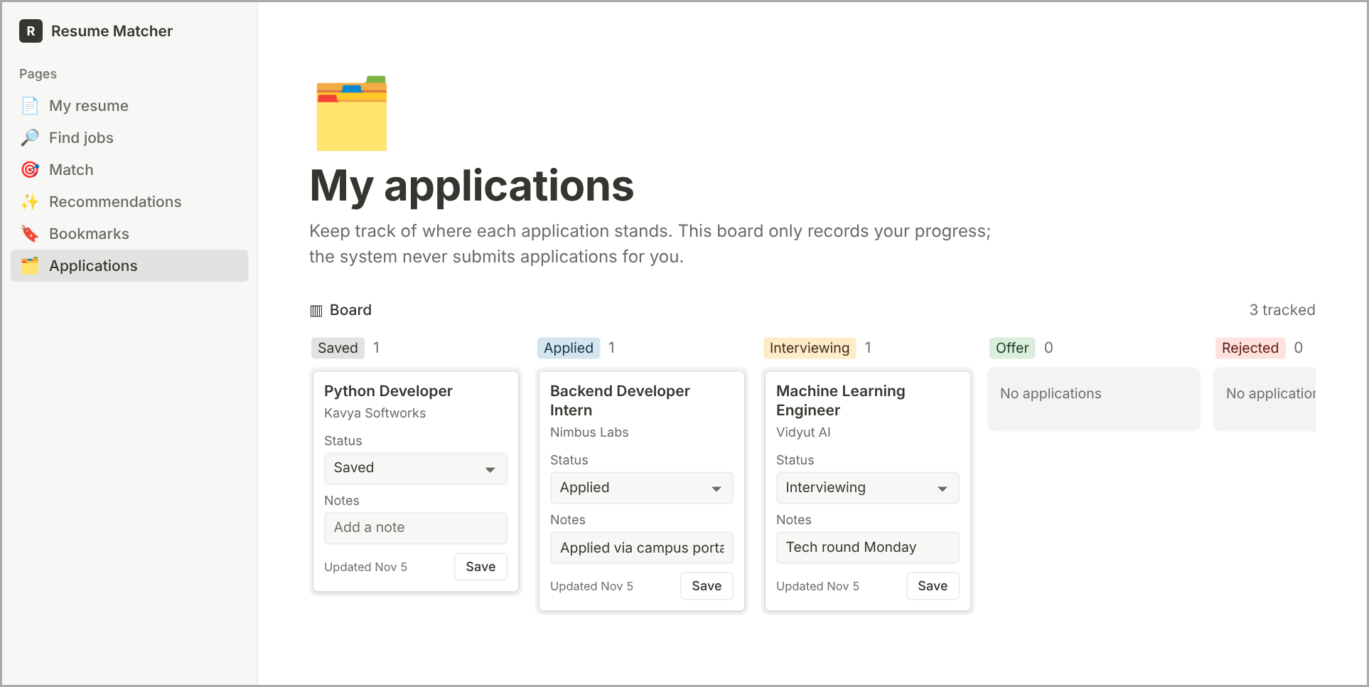
Figure 20. FR-11 GUI — My applications page

FR-12 Resource ownership
Requirement | The system shall deny a user access to another user's resumes, bookmarks, applications, matches and recommendations.
Priority | High
Acceptance criteria | • Given user B and a record owned by user A, when B requests it by id, then the response is 404 (record existence is not disclosed) and an access_denied audit event is written.
What to test | • Cross-user GET/PUT/DELETE resume, PATCH application, match and recommendation with A's resume id → 404  • Audit event written
Test case / file | TC-09 · tests/test_ownership.py
Sprint-2 result | Pass

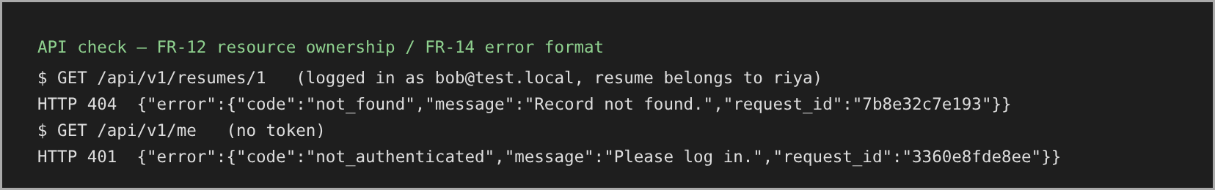
Figure 21. FR-12 GUI — API check — another user's resume returns 404; no token returns 401

FR-13 Controlled external actions
Requirement | The system shall not submit job applications or send resume data to an external service unless the provider is configured and the user has explicitly enabled consent.
Priority | High
Acceptance criteria | • Given default settings, when recommendations are produced, then external_calls = 0.  • Given provider configured and consent enabled, when recommendations are produced, then only job title and skill names are sent; resume text and contact details never are.  • Given the consent setting changes, then a consent_changed audit event is written.
What to test | • external_calls = 0 by default and with consent but no provider  • Payload contains only allowed keys  • Provider failure falls back to standard explanation  • Consent change audited
Test case / file | TC-13 · tests/test_agent.py
Sprint-2 result | Pass

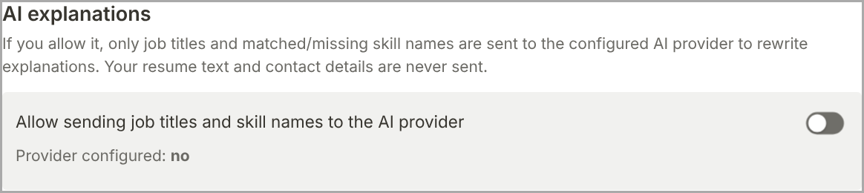
Figure 22. FR-13 GUI — AI consent panel on the Recommendations page

FR-14 Error handling
Requirement | The system shall return errors in one format {"error": {"code", "message", "request_id"}} for invalid input, missing records, parsing failures and unexpected failures.
Priority | Medium
Acceptance criteria | • Given any error, when it is returned, then it has the three fields and contains no stack trace, password, token or resume text.  • Given an unexpected exception, when it occurs, then the response is 500 with a request_id that matches the server log line.
What to test | • Validation, 401, 403, 404, 409, 413, 415, 422 and 500 all use the format  • No stack trace / secrets in body or logs
Test case / file | TC-12 · tests/test_errors.py
Sprint-2 result | Pass

GUI screen: same screen as FR-12 above.

FR-15 Job dataset administration
Requirement | The system shall allow only an administrator to import job listings (all-or-nothing) and to update or deactivate a listing.
Priority | Medium
Acceptance criteria | • Given a non-admin user, when calling an admin endpoint, then the response is 403 and an access_denied event is written.  • Given a batch containing any invalid row, when imported, then the response is 422 listing the rows and nothing is saved.  • Given a valid batch, when imported, then 201 {imported: n} is returned; a deactivated job disappears from search.
What to test | • Non-admin → 403  • Invalid batch → 422, zero rows saved  • Valid import, update, deactivate  • Skill names normalized
Test case / file | FR-15 · tests/test_admin.py
Sprint-2 result | Pass

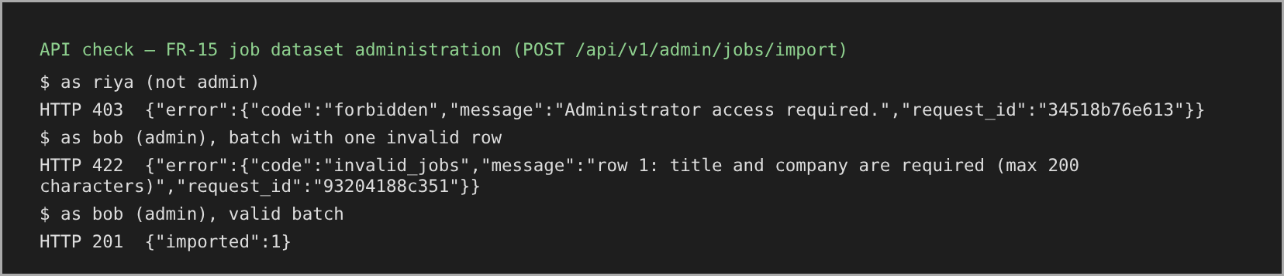
Figure 23. FR-15 GUI — Admin import via API (no GUI screen — operator uses the REST API)

4.2 Non-Functional Requirements
Table 9. Non-functional requirements
ID | Attribute | Requirement | Acceptance criterion / what to test | Sprint-2 result
NFR-01 | Search performance | For up to 5,000 jobs and 20 concurrent users, p95 of job-search requests ≤ 2 s at the API boundary. | Load test scripts/perf_search.py: 5,000 generated jobs, 20 users, ≥ 400 requests; pass if p95 ≤ 2 s. | Fail — p95 4.324 s on Windows laptop (PERFORMANCE.md)
NFR-02 | Matching performance | p95 of match requests ≤ 10 s without an external LLM. | scripts/perf_match.py; pass if p95 ≤ 10 s. | Pass — p95 1.334 s
NFR-03 | Reliability | ≥ 99 of 100 consecutive valid match requests return a valid result. | 100 sequential requests; count valid results. | Pass — 100/100
NFR-04 | Usability | ≥ 4 of 5 representative users upload a resume and view a match without help. | Task-based study with 5 users; record completion and help needed. | Partial — study not yet conducted
NFR-05 | Compatibility | Works in the latest stable Chrome and Firefox; API follows the documented JSON contract. | Run the core journey in both browsers; API contract tests. | Partial — Chrome tested; Firefox pending
NFR-06 | Maintainability | Routes, services, data access, matching and agent in separate modules with automated tests. | Module review; coverage report (pytest-cov). | Pass
NFR-07 | Data retention | User can delete a resume and its extracted data; log/backup behaviour documented. | Delete via UI/API; file and row gone; GET → 404. | Pass
NFR-08 | Accessibility | Core journeys operable by keyboard; all form fields labelled. | Keyboard-only walkthrough; Lighthouse accessibility audit. | Pass — Lighthouse 100 on 7 pages
NFR-09 | Reproducibility | Pinned versions, env variables, schema and setup/test commands documented. | Fresh clone → README steps → all tests pass. | Pass
NFR-10 | Agent / LLM performance | With the default (no external LLM) configuration, p95 of /recommendations ≤ 5 s for 20 concurrent users on 5,000 jobs; with a provider enabled, each provider call is bounded by a 5 s timeout and the request still completes with the standard explanation if the provider fails. | See 4.3: load test of /recommendations; provider latency, timeout and fallback tests. | Added in v1.2 — to be measured in Part-3 testing (2–6 Nov)

4.3 Performance Testing for the Agent / LLM Workflow
The recommendation feature is the "AI" part of the system, so its performance is tested separately from plain search and matching. In the delivered configuration the provider is a mock behind the consent gate, so the tests below measure the agent itself and the safety limits that will apply if a real LLM is connected.
Table 10. Agent / LLM performance tests
Metric | How it is measured | Pass criterion
End-to-end latency (p50, p95) | 20 concurrent users × 20 requests to POST /recommendations on a 5,000-job dataset (same method as scripts/perf_match.py) | p95 ≤ 5 s (NFR-10)
Tool-call budget | tool_trace of every response | Exactly 4 tool calls; never more
External calls | external_calls field with consent off, consent on + provider off, both on | 0, 0, ≤ top_k respectively
Provider timeout and fallback | Mock provider made to sleep > 5 s or raise an error | Request still returns 200 with standard explanation and a warning
Determinism / repeatability | Same resume and filters requested 10 times | Identical ranking and scores every time
Error rate under load | Non-200 responses during the load run | 0 % for valid requests
Explanation faithfulness (hallucination check) | Every skill named in an explanation is checked against matched/missing lists | 100 % of sentences supported
Payload minimization | Captured provider payload | Only job_title and skill names; no resume text or contact details

If a real LLM provider is added later, the same tests are repeated and two more metrics are recorded: provider response time per call and token usage per request. Results go in docs/PERFORMANCE.md.

4.4 Requirement Quality Rules
- Each requirement has a unique ID and one principal "shall" statement.
- Vague terms (fast, user-friendly, secure) are always paired with a measurable criterion.
- Acceptance criteria are observable; targets are not claimed as met until tests are run.
- Optional provider behaviour is kept separate from the offline core workflow.
- Any change to a requirement updates the architecture, tests and traceability matrix.

5. Security

5.1 Security Objectives
Table 11. Security objectives
ID | Objective
SO-01 | Confidentiality: protect credentials, resumes, profiles, bookmarks and application records from unauthorized disclosure.
SO-02 | Integrity: prevent unauthorized creation, alteration or deletion of user and job records.
SO-03 | Controlled autonomy: constrain the agent to approved tools and require explicit consent for external transfer.
SO-04 | Secure communication and identity: prevent traffic sniffing, identity spoofing and man-in-the-middle attacks.

5.2 Security Requirements
Table 12. Security requirements
ID | Requirement | Acceptance criterion / what to test | Status
SR-01 | All protected endpoints require authentication and ownership checks at the service/data-access boundary. | No token → 401; other user's record → 404 (TC-02, TC-09). | Implemented — Pass
SR-02 | Passwords stored only as salted Argon2 hashes; never plaintext. | Inspect users table: hash starts with $argon2; plaintext absent (SR-02 check). | Implemented — Pass
SR-03 | Uploads checked against extension allowlist, 2 MB limit and content signature; stored names generated by the server. | Bad type/size/signature rejected; stored name ≠ client name (TC-03). | Implemented — Pass
SR-04 | Responses and logs never contain passwords, tokens, keys, stack traces or resume text. | Error-format tests; log redaction test (TC-12, defect D-01 fixed). | Implemented — Pass
SR-05 | Agent calls only allowlisted tools with strict schema-validated arguments; tool output treated as data. | Unknown tool / extra field refused and audited (TC-08). | Implemented — Pass
SR-06 | Resume data not sent to an external service unless the provider is configured and the user consented. | external_calls = 0 by default; minimized payload (TC-13). | Implemented — Pass
SR-07 | Deployed environments use HTTPS; localhost HTTP is development-only; default secret key refused in production. | HTTPS check and default-secret check (evidence sr07_*.txt). | Implemented — Pass
SR-08 | Security events (login failures, access denials, admin changes, consent changes, rejected tool calls) are audited without secrets. | audit_events rows created by tests (TC-02, TC-09, FR-15, TC-13). | Implemented — Pass
SR-09 | Anti-sniffing: credentials, tokens and resume data shall travel only over TLS 1.2+ in deployment; HTTP shall redirect to HTTPS; tokens are sent in the Authorization header, never in URLs; the API sends no secrets in responses. | Plain HTTP to the TLS port is refused (sr07_https_check.txt); packet capture on deployment shows only TLS records; no token in any URL or log. | Implemented in app + deployment requirement
SR-10 | Anti-spoofing: every request is authenticated with an HS256-signed JWT using a secret ≥ 32 random characters (default refused in production), 60-minute expiry and server-side user lookup; login errors are generic to stop account enumeration. | Forged-signature, expired and "alg: none" tokens → 401; wrong password vs unknown email → identical 401. | Implemented — Pass (expiry/forgery tests to be added in Part 3)
SR-11 | Anti-man-in-the-middle: deployments shall use a valid CA-signed certificate, HSTS (max-age ≥ 6 months), no mixed HTTP content, and the server shall not be reachable except through the TLS proxy; the optional AI provider shall be called only over HTTPS with certificate verification on. | Browser shows valid certificate; response has Strict-Transport-Security; all page assets load over HTTPS; provider client uses verify=True. | Deployment requirement (prototype runs on localhost)

5.3 Threats and Countermeasures
Figure 24 shows where each network attack is stopped. Table 13 summarises the threats considered.
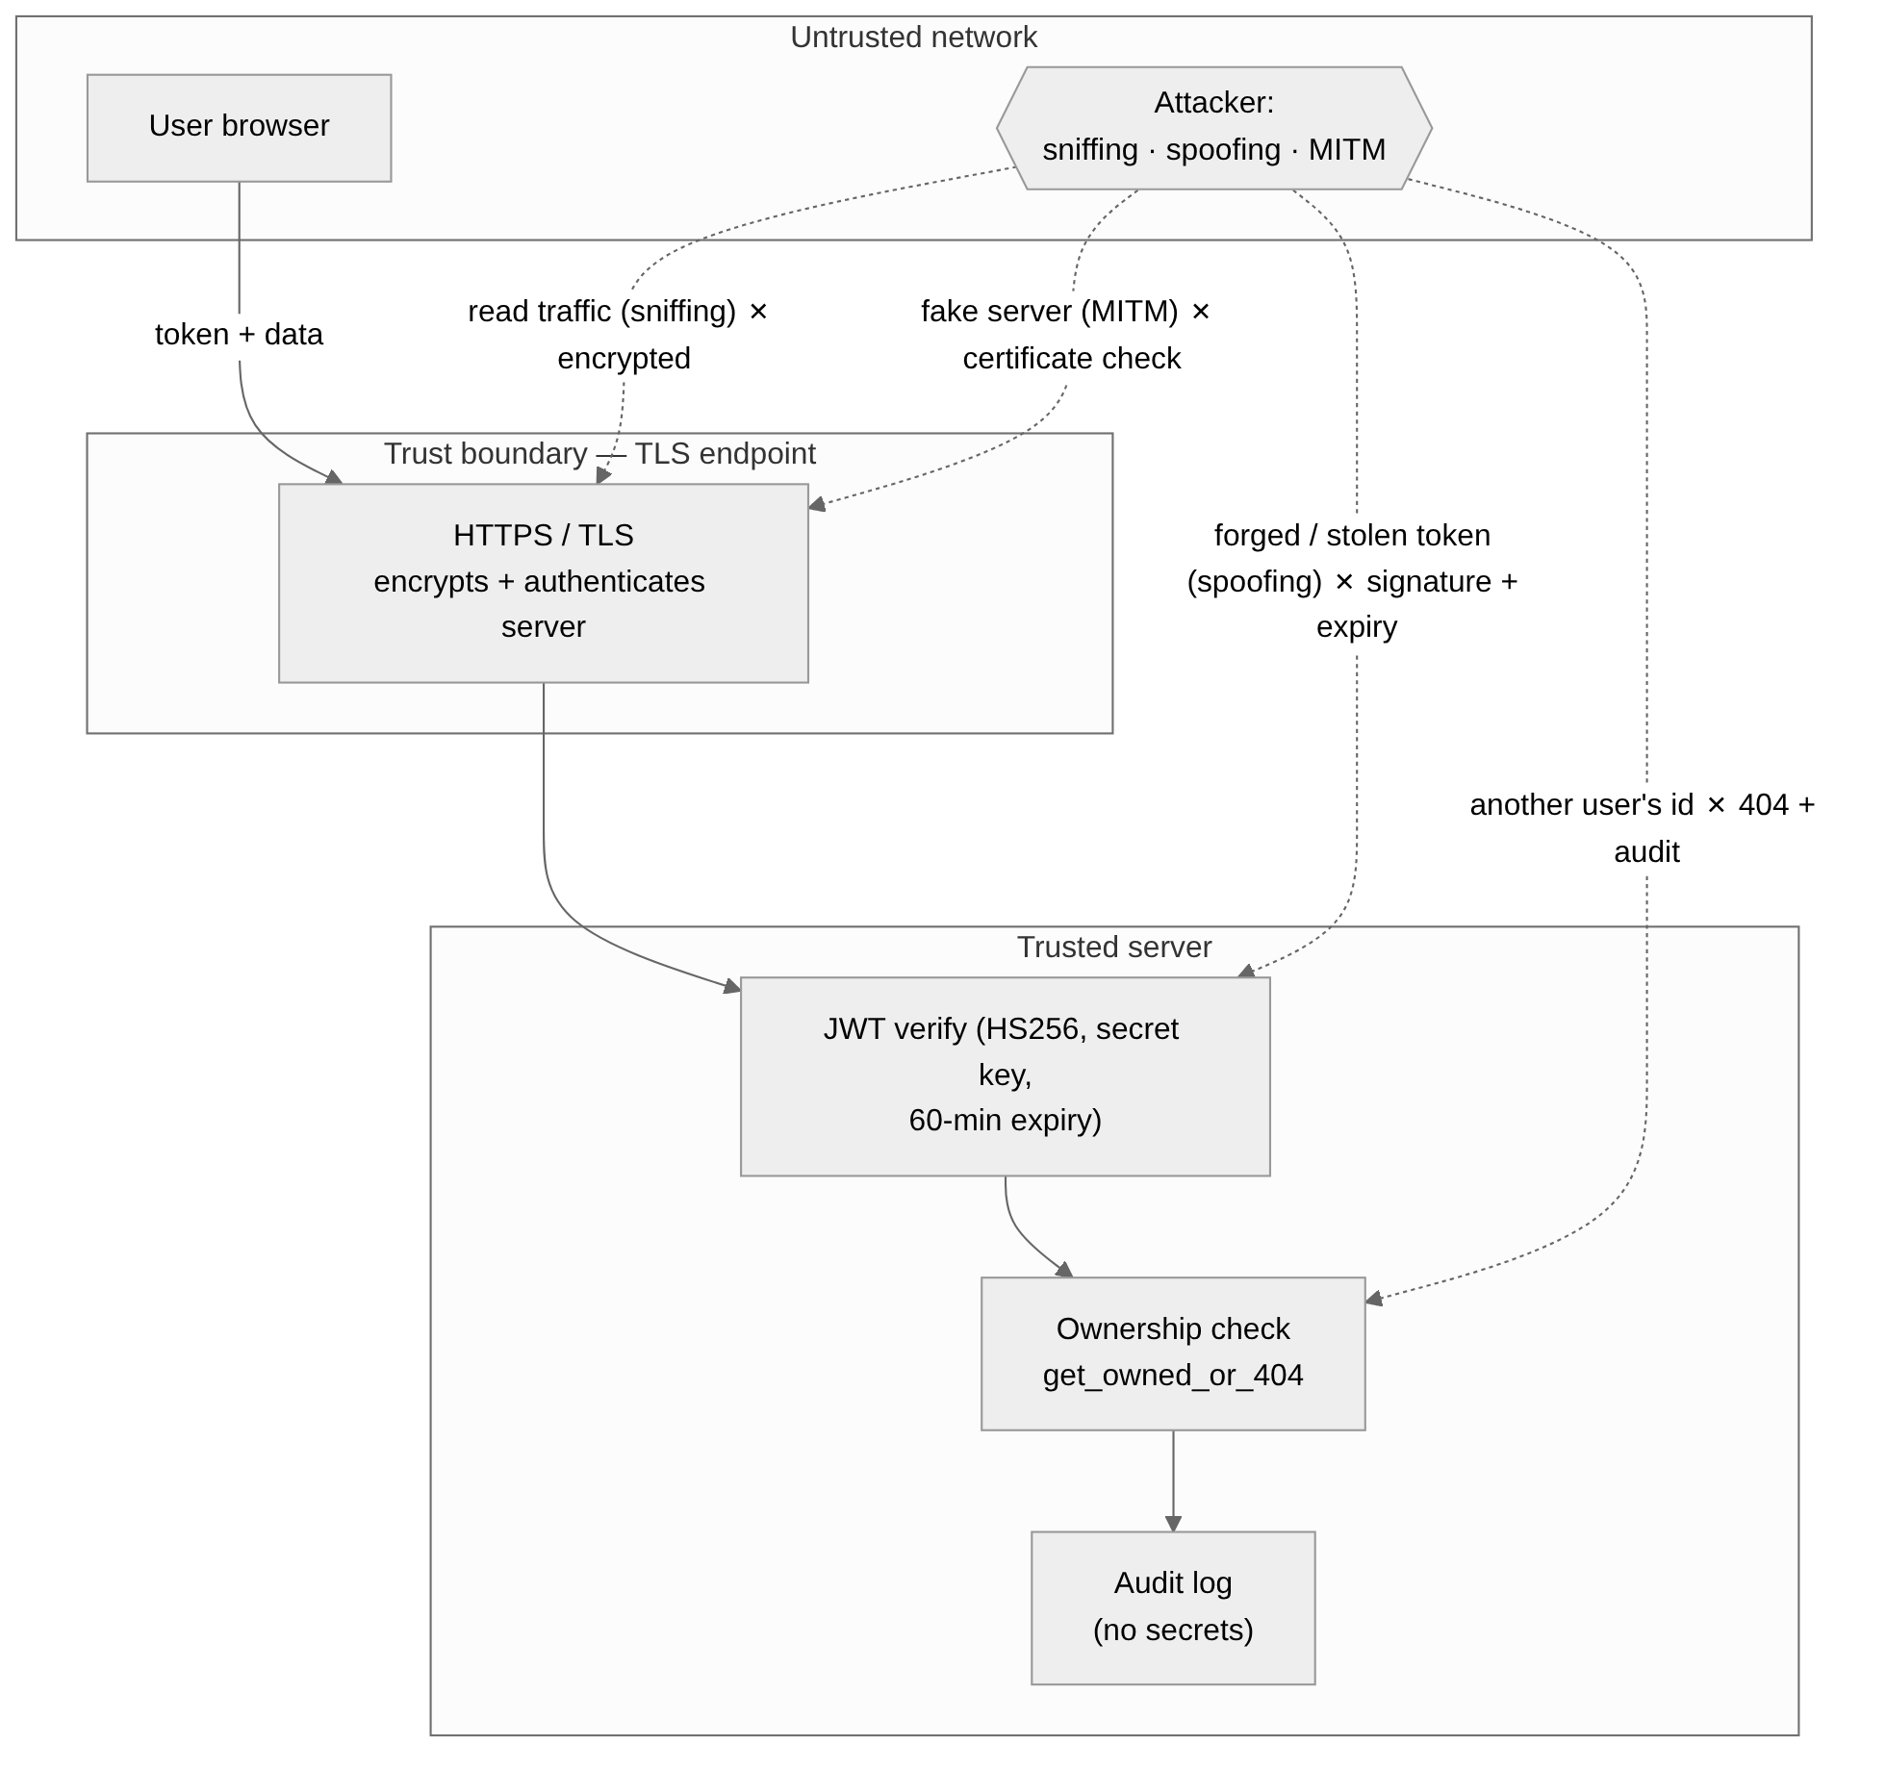
Figure 24. Trust boundaries and protection against sniffing, spoofing and MITM
Table 13. Threats and countermeasures
Threat | Example | Countermeasure | Req.
Sniffing (eavesdropping) | Attacker on campus Wi-Fi captures the login request | TLS encryption; HTTPS only; no secrets in URLs or logs | SR-09, SR-04
Spoofing — user identity | Forged or stolen JWT used to act as another user | HS256 signature with strong secret, 60-min expiry, owner checks on every record | SR-10, SR-01
Spoofing — server | Fake site imitating Resume Matcher | CA-signed certificate + HSTS so the browser rejects impostors | SR-11
Man-in-the-middle | Proxy that intercepts and alters traffic | TLS with certificate validation, HSTS, HTTP→HTTPS redirect, app bound to localhost behind proxy | SR-11
Brute-force / enumeration | Trying many passwords or emails | Argon2 slow hashing; identical login errors; login_failed audit events | SR-02, SR-08
Insecure direct object reference | Changing resume id in the URL | get_owned_or_404 → 404 + audit | SR-01, FR-12
SQL injection | Malicious text in a resume or search box | ORM bound parameters only; agent has no SQL tool | 3.6, SR-05
Prompt injection | Resume text telling the agent to email data | Fixed plan, allowlisted tools, text treated as data | SR-05
Malicious upload | Executable renamed to .pdf | Extension + signature + size checks; server-generated names | SR-03
Cross-site scripting | Job title containing <script> | All dynamic text escaped (esc()) before insertion into pages | SR-04

5.4 Security Considerations
- Resume documents, job descriptions and tool outputs are untrusted input.
- Least privilege for database and file access; storage paths come from server-generated identifiers.
- Dependencies are pinned and parser libraries reviewed; uploads are an attack surface.
- Match scores are presented as assistive signals, never as employment decisions.
- The prototype runs on localhost; SR-09 and SR-11 deployment controls must be in place before real users are served.

6. Use-Case Model

6.1 Actors
- Visitor — registers and logs in.
- Job seeker — uploads/reviews resumes, searches jobs, matches, requests recommendations, bookmarks, tracks applications, deletes resume data.
- Administrator — manages the curated job dataset.
- Optional external AI provider — performs configured explanation polishing after consent; not an authorization actor.

6.2 Use-Case Diagram
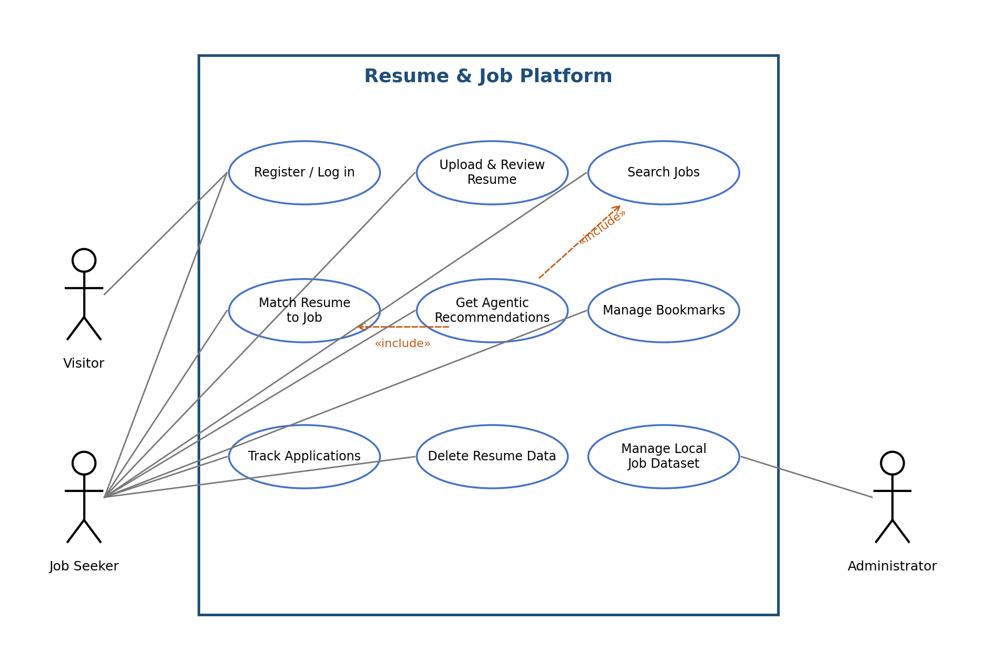
Figure 25. UML use-case diagram

6.3 Use-Case Descriptions

UC-01 Register / Log in
Primary actor | Visitor, Job seeker
Preconditions | None
Trigger | Visitor opens the site
Main flow | 1. Visitor enters email and password and registers. 2. System validates and creates the account. 3. User logs in. 4. System returns a token and opens My resume.
Alternative flows | Duplicate email → error; wrong password → generic error, user stays on page.
Postconditions | User is authenticated.
Requirements | FR-01, FR-02, FR-14

UC-02 Upload and review resume
Primary actor | Job seeker
Preconditions | Logged in
Trigger | User chooses a file and clicks Upload
Main flow | 1. System validates type, size and content. 2. Stores file. 3. Parses skills, education, experience, contact. 4. Shows fields. 5. User may correct the skills list.
Alternative flows | Invalid file → error, nothing stored; parse failure → error; missing sections → empty fields with warning.
Postconditions | Resume and parsed profile saved for the owner.
Requirements | FR-03, FR-04, FR-12, FR-14

UC-03 Search jobs
Primary actor | Job seeker (also public)
Preconditions | Job dataset loaded
Trigger | User enters filters and clicks Search
Main flow | 1. System queries active jobs with all filters. 2. Shows count and results with Match, Bookmark and Track buttons.
Alternative flows | No results → empty state with guidance.
Postconditions | Results displayed; nothing changed.
Requirements | FR-05

UC-04 Match resume to job
Primary actor | Job seeker
Preconditions | Logged in; resume uploaded
Trigger | User selects resume and job, clicks Calculate
Main flow | 1. System checks ownership. 2. Computes score, overlap and similarity. 3. Lists matched and missing skills. 4. Shows reasons.
Alternative flows | No resume → prompt to upload; job inactive → 404.
Postconditions | Match result shown.
Requirements | FR-06, FR-07, FR-09, FR-12

UC-05 Get agentic recommendations
Primary actor | Job seeker
Preconditions | Logged in; resume with skills; dataset loaded
Trigger | User clicks Get recommendations
Main flow | 1. Validate request and ownership. 2. get_resume_profile. 3. search_jobs (SQL). 4. score_jobs. 5. rank_results. 6. Optional consented polishing. 7. Return ranked jobs with reasons and tool trace.
Alternative flows | No skills or no jobs → empty list with guidance; tool refused → controlled error; provider failure → standard explanation.
Postconditions | Nothing submitted; no external transfer without consent.
Requirements | FR-08, FR-09, FR-13, FR-12

UC-06 Manage bookmarks
Primary actor | Job seeker
Preconditions | Logged in
Trigger | User clicks Bookmark or Remove
Main flow | 1. System adds or removes the bookmark. 2. Bookmarks page lists the user's bookmarks.
Alternative flows | Already bookmarked → 409 message.
Postconditions | Bookmarks updated for the owner only.
Requirements | FR-10, FR-12

UC-07 Track applications
Primary actor | Job seeker
Preconditions | Logged in
Trigger | User clicks Track application or changes a status
Main flow | 1. System creates a record (status saved) or updates status/notes. 2. Applications page shows the list.
Alternative flows | Unsupported status → 422; already tracked → 409.
Postconditions | Record saved; nothing is submitted to employers.
Requirements | FR-11, FR-12

UC-08 Delete resume data
Primary actor | Job seeker
Preconditions | Logged in; owns the resume
Trigger | User clicks Delete this resume and its data
Main flow | 1. System checks ownership. 2. Deletes the stored file and the database row with its parsed profile. 3. Audit event resume_deleted.
Alternative flows | Not owner → 404.
Postconditions | Resume and extracted data removed.
Requirements | NFR-07, FR-12

UC-09 Manage local job dataset
Primary actor | Administrator
Preconditions | Logged in as admin
Trigger | Admin sends an import or update request
Main flow | 1. System checks admin role. 2. Validates every row. 3. Saves all rows (or updates/deactivates one job). 4. Audit event.
Alternative flows | Not admin → 403; any invalid row → 422 and nothing saved.
Postconditions | Dataset changed only by the admin.
Requirements | FR-15, SR-08

6.4 Use Case ↔ Functional Requirement Mapping
Table 14. Use case to functional requirement matrix (column = FR number)
Use case | 01 | 02 | 03 | 04 | 05 | 06 | 07 | 08 | 09 | 10 | 11 | 12 | 13 | 14 | 15
UC-01 Register / Log in | ✓ | ✓ |  |  |  |  |  |  |  |  |  |  |  | ✓
UC-02 Upload and review resume |  |  | ✓ | ✓ |  |  |  |  |  |  |  | ✓ |  | ✓
UC-03 Search jobs |  |  |  |  | ✓
UC-04 Match resume to job |  |  |  |  |  | ✓ | ✓ |  | ✓ |  |  | ✓
UC-05 Get agentic recommendations |  |  |  |  |  |  |  | ✓ | ✓ |  |  | ✓ | ✓
UC-06 Manage bookmarks |  |  |  |  |  |  |  |  |  | ✓ |  | ✓
UC-07 Track applications |  |  |  |  |  |  |  |  |  |  | ✓ | ✓
UC-08 Delete resume data |  |  |  |  |  |  |  |  |  |  |  | ✓
UC-09 Manage local job dataset |  |  |  |  |  |  |  |  |  |  |  |  |  |  | ✓

Every functional requirement is covered by at least one use case. Reverse view:
Table 15. Functional requirement to use case and test case
FR | Use case(s) | Test case
FR-01 | UC-01 | TC-01
FR-02 | UC-01 | TC-02
FR-03 | UC-02 | TC-03
FR-04 | UC-02 | TC-04
FR-05 | UC-03 | TC-05
FR-06 | UC-04 | TC-06
FR-07 | UC-04 | TC-07
FR-08 | UC-05 | TC-08
FR-09 | UC-04, UC-05 | TC-07
FR-10 | UC-06 | TC-10
FR-11 | UC-07 | TC-11
FR-12 | UC-02, UC-04, UC-05, UC-06, UC-07, UC-08 | TC-09
FR-13 | UC-05 | TC-13
FR-14 | UC-01, UC-02 | TC-12
FR-15 | UC-09 | FR-15

6.5 Product Backlog Mapping
Every product backlog item on the GitHub Project board "Resume Matcher Board" (33 issues with story points, Sprint 1 and Sprint 2 iterations) is labelled with the functional requirement(s) it implements, and through Tables 14 and 15 with its use case. The full requirement → design → test → status mapping is kept in docs/TraceabilityMatrix_v1.1.csv.

6.6 Supporting Behaviour Diagrams
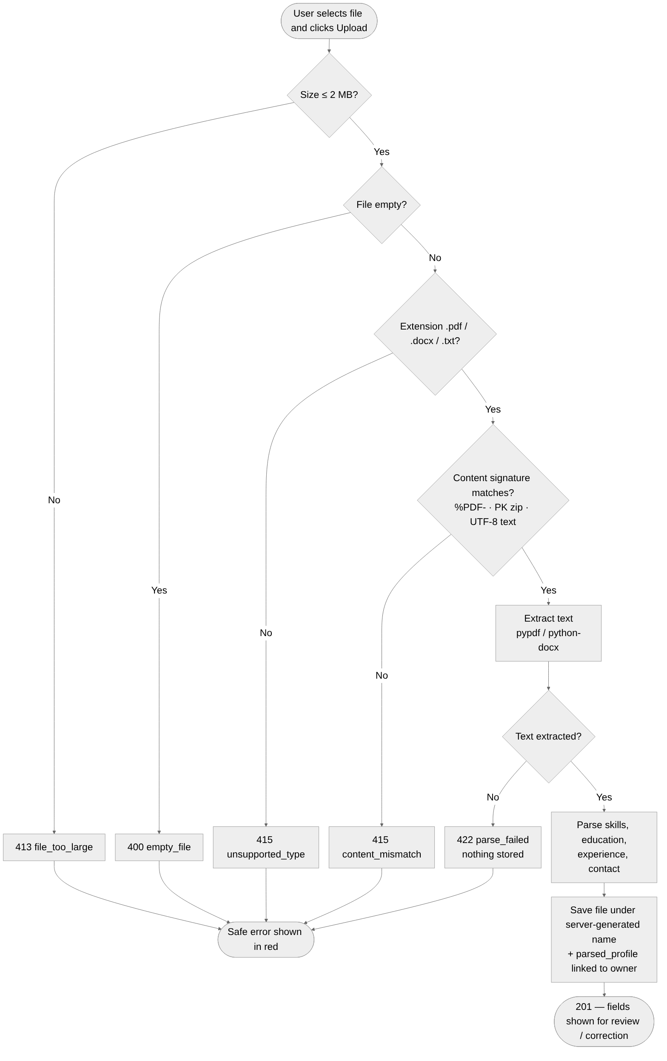
Figure 26. Activity diagram — resume upload and validation (UC-02)
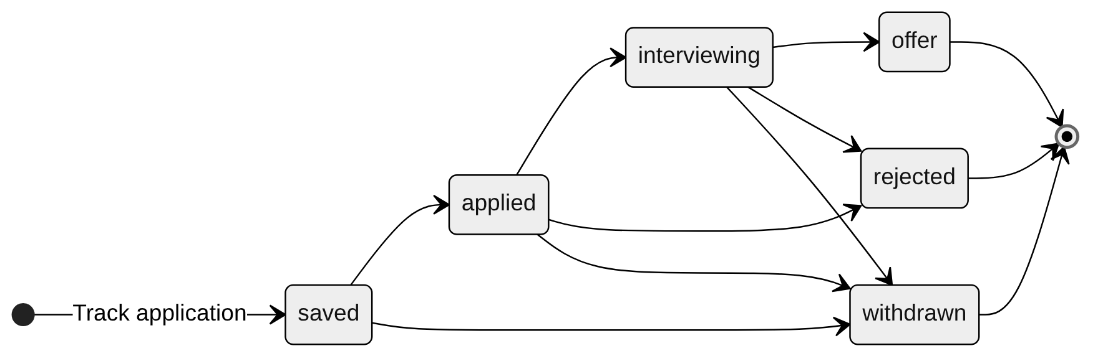
Figure 27. State diagram — typical application status flow (UC-07); the user may set any of the six statuses manually

7. Appendices

7.1 Open Decisions / Change Control
- Browser frontend — Decided (v1.1): plain HTML + JavaScript served by FastAPI.
- Resume parser — Decided (v1.1): pypdf, python-docx, plain TXT; versions pinned.
- External LLM — Decided (v1.1): none; mock provider behind the consent gate demonstrates FR-13/SR-06. NFR-10 defines the tests if one is added.
- Deployment hosting — Open: SR-09 and SR-11 apply when the prototype is deployed beyond localhost.
- All future changes update this SRS, the SAD, the Test Plan and the traceability matrix.

7.2 List of Diagrams
- System context (Fig. 1), user flow (Fig. 2), architecture (Fig. 3), deployment (Fig. 4), DFD (Fig. 5)
- Screen transition (Fig. 6), ER (Fig. 7), agent SQL sequence (Fig. 8), GUI screens for FR-01 to FR-15
- Threat / trust boundary, use-case, upload activity and application-status state diagrams

Team: the no name group

