Vietnam National University, HCMC

**UNIVERSITY OF ECONOMICS AND LAW**

Faculty of Information Systems

**AN HOSPITAL SYSTEM**

**SPECIFICATION**

*Môn học:* Thiết kế và lập trình web kinh doanh 1

*Giảng viên:* Th.S Trần Thị Ánh

*Nhóm:* DANT

*TP. Hồ Chí Minh, tháng 12 năm 2019.*

Contents

I. Overview 2

II. System analysis 3

1. DFD Context 3

2. DFD Mobile App 3

III. Details 5

1. Mobile Application 5

a. BPMN 6

b. Description 7

c. Validation 12

2. Check-in station 13

a. BPMN 13

b. Description 15

c. Validation 15

3. Test and Examination Center 16

a. BPMN 16

b. Description 16

c. Validation 16

4. Pharmacy Station 17

a. BPMN 17

b. Description 17

c. Validation 17

Figure contents

Figure II‑1 DFD Context 5

Figure II‑2 DFD Mobile app 6

Figure III‑1 BPMN Mobile app 8

Figure III‑2 Log in screen 9

Figure III‑3 Daily 9

Figure III‑4 Consultancy 10

Figure III‑5 Consultancy Result 10

Figure III‑6 Order prescription 11

Figure III‑7 Test prediction 11

Figure III‑8 Booking 12

Figure III‑9 Pharmacy 13

Figure III‑10 Profile 13

Figure III‑11 Anamnesis 13

Figure III‑12 Drug allergy 13

# Overview

Most of the hospital in cities are getting overloaded, which can be because of the slow and ineffective of the system as well as difficulties in interaction between humans. In the era of industry 4.0, we would like to make a revolutionary in hospital service by applying AI to all functions. This means people will find 90% of our workers are robots, along with that is a software system which is still being tested. Users will mostly experience their mobile phone app, and in many stations they also have to interact with our stations’ apps. In this specification, we focus on the mobile app, but let’s cover the whole system briefly.

The check-in app in the check-in station will check the user’s appointment if they have already had one and allow them to create if they haven’t. After that it will show what tests that user need to take and predict the disease based on tests’ results. Users will do necessary payments here, too, and cash is available.

In the test station, users should not step to “warning” room because the robots inside is currently not working. In each room, there will be a recognize sensor to recognize people and a screen to show what they need to do in the room. After that they can see the test result on the screen and also their mobile phone.

Patients after finishing test steps, they will come back to the check-in station to get the medical examination result. We will have a doctor here just to make sure the accuracy of the result. He/she will also the one who explain more about the result and answers any wonders from the patients. Receiving prescription, patients should pay for the medicine bill if they decide to get medicines from the pharmacy station. If not, they can still buy in other drug stores even it does not belongs to AN Hospital.

After corfirming the prescription, customers will wait in the waiting space until they receive a push notification from the application which says medicines are ready. After receiving medicines, they should sign in the pharmacy app or in their own app. If they do not receive medicines in 24 hours, order will be cancelled and payment will not be refund. In case there are people who want to buy medicines without using hospital examination service, they can still come to the station by fill in prescription ID, make payment and receive medicines.

In the mobile app, we provide several features. We call 5 main fragment in our app is “Daily”, “Consultancy”, “Booking”, “Pharmacy” and “Profile”. In the first one, we have pill reminder and health news. The second one providing health status and suggestions based on symptoms which are filled in by users. The third one simply book an appointment at the hospital. The information can be automatically filled in in some cases. The fourth one allows user to buy medicines, manage their orders and view history. The final one includes Anamnesis (history of consultancy and booking), family contact (save family’s information to use in emergency situation), drug allergy (know user’s allergy to avoid giving wrong drugs), master/visa card (save some vital information for payment), log out, support center and about us.

# System analysis

## DFD Context

This DFD show all the data stores and external entities that connect to the system.

Figure ‑ DFD Context

## DFD Mobile App

The DFD Mobile App shows actions, data stores and external entities in using mobile phone.

Figure ‑ DFD Mobile app

# Details

## Mobile Application

(next page)

### BPMN

Figure ‑ BPMN Mobile app

### Description

As in any other app, log in and sign up is the most casual features. In this app, users are not required to log in in the first step since this function only show up in certain cases that need users data to work well.

As you can see in most of the screen, the bottom navigation bar includes 5 features: “Daily”, “Consultancy”, “Booking”, “Pharmacy” and “Profile”. Their name may already tell you their functions.

Without log in, users can still use the “Daily” fragment but the pill reminder won’t appear. The weather feature uses google API but the suggestion belongs to our system. The news in this feature uses API from many health newspaper in order to provide both horizontal and vertical knowledge. If users tap to a link, it will get them directly to the newspapers’ website. If they are using pill reminder feature, they can see what drugs they have to take according to time and date. And the little cute “pacman” icon on the left tells you the number of pills. And if they took it, just tap the line to make red heart icon appear. For example, in the morning, December 16th, user need to take 3 type of drugs, including 1 pill of oxymetazolin. And the user took it so we can see the red heart on the right.

Figure ‑ Log in screen

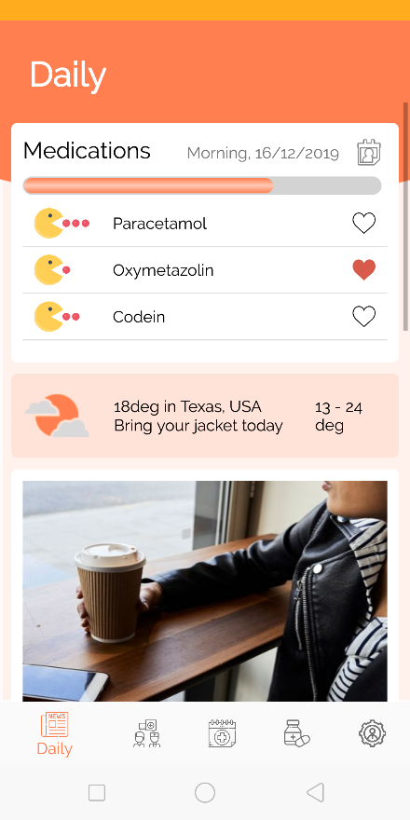

Figure ‑ Daily

Let’s move to the next fragment – consultancy. User can easily see the search bar since it stick to the scroll. Just think about a word to descript your symptoms and fill in only one word, the auto complete text view “What’s your symptom” will give you some helpful suggestion. Every symptoms that you filled in will appear in the list view below. We want to categorize these symptoms but we meet difficuties in building database and developing so it haven’t appear on the app. In case you chose wrong and want to delete a symptoms, long click on the line will help you to do that. Tap “consult” button when you finished.

The app now lead you to the “health status” screen. If the symptoms tell that your disease is not serious, we will tell you your health status as in the figure below. You can also find prescription, test prediction and book an appointment if you want to. But if the disease seems to be serious, we will not tell you anything except allow you to make an appointment at the hospital right away.

Figure ‑ Consultancy

Figure ‑ Consultancy Result

Our system connects to the national prescription database, which may include your previous prescription or at least a usually used prescription to cure your disease, but we will customize it to make sure you will not get drug allergy (this is the era of industry 4.0 so anything can happen). The prescription is a little bit academy so what you want to do may be print, buy medicines or ask for shipping service. Each of them will have different flow.

Figure ‑ Order prescription

What’s next, the test prediction features. You have a serious disease and want to see what you have to do if you go to the hospital? Use test prediction by paying a small amount of fee. Then we will show you tests that need for the medical examination. You may tap in each line to read explanation and some pre-test notes. But most of it using medical field terms, we are trying to make it more user friendly.

You can go back to your consultancy result anytime by tapping the “result” button.

Whether your disease is seriuos or not, you can always easily book an appointment at our hospital. If you tap “booking” button in the consultancy fragment, we can send all of consultancy data to the booking form. But if you tap “booking” in the bottom navigation bar, you may have to submit more information.

The booking function is still in developing period. But what it simply do is book you a room in our hospital. The waitlist is your waiting bookings, After booking successfully, you can see a mobile notification to confirm your booking.

Figure ‑ Test prediction

Figure ‑ Booking

The pharmacy fragment includes 4 small functions, help you to buy drugs, manage your orders, yours prescription and your history transactions.

The last fragment – profile has other less used features. The most significant feature is the Anamnesis. It will save all of transactions realting to health in the app. Family contact can save family’s information to use in emergency situation, Drug allergy allows user to tell us their drug’s allergy to avoid giving wrong drugs. Master/visa card saves some vital information for payment. Other features are log out, support center and about us.

Figure ‑ Pharmacy

Figure ‑ Profile

Figure ‑ Anamnesis

Figure ‑ Drug allergy

### Validation

## Check-in station

### BPMN

(next page)

### Description

### Validation

## Test and Examination Center

### BPMN

### Description

### Validation

## Pharmacy Station

### BPMN

### Description

### Validation