**Department of Computer Science and Engineering**

**Amrita School of Computing, Coimbatore**

**B.Tech/ III Year CSE/ V Semester**

**2023 -2024 Odd Semester**



**Small Office/Home Office (SOHO) Network**

**CASE STUDY REPORT**

**19CSE301 - COMPUTER NETWORKS**

|  |  |
| --- | --- |
| **Roll No** | **Name** |
| **CB.EN.U4CSE2105** | **ANWESHA BAIDYA** |
| **CB.EN.U4CSE2117** | **D MANVISH** |
| **CB.EN.U4CSE2138** | **SURYA NATUVA** |
| **CB.EN.U4CSE2148** | **R CHAITANYA** |

TABLE OF CONTENTS

* **Abstract.**
* **Introduction.**
* **Components used.**
* **Topology.**
* **Usecases.**
* **Configuration of end devices.**
* **Configuration of routers.**
* **Static routing of routers.**
* **Dns.**
* **Http.**
* **Email Server.**
* **Ftp.**
* **Dhcp.**
* **Images for cisco packet tracker file.**
* **Conclusion.**

**ABSTRACT**

This project delineates the design and deployment of a Cisco-based Small Office Home Office (SOHO) network for Company X's expanding branch of a robust and segregated network infrastructure in small towns. With a focus on simplicity and efficiency, the network is tailored to accommodate three distinct departments –

* Admin/IT
* Finance/HR
* Customer service/Reception.

The network architecture employs Cisco networking products, featuring a router and switch. VLANs are utilized to isolate each department, ensuring a secure and efficient operational environment. Subnetting and IP addressing are strategically applied to facilitate seamless communication within each department while maintaining autonomy.

The designed and implemented Small Office Home Office (SOHO) for Company X incorporates the following key features:

1. **VLAN Segmentation:** Isolates departments for security.
2. **Router Configuration:** Enables inter-VLAN routing and DHCP.
3. **Switch Configuration:** Utilizes VLANs and trunk ports.
4. **Wireless Connectivity:** Cisco Access Point with department-specific SSIDs.
5. **IP Addressing and Subnetting:** Efficient allocation of IPv4 addresses.
6. **DHCP Server:** Router dynamically assigns IP addresses.
7. **Testing and Verification:** Rigorous checks for functionality.
8. **Simplicity and Efficiency:** Tailored for a small branch office.
9. **Professional Documentation:** Clear configurations for future maintenance.

Here if we consider: Company X is a fast-growing company in India with more than 5 million customers. The company deals with selling and buying of items, which are basically operated from the headquarters. The company is intending to open a branch in small towns. The network is intended to operate separately from the HQ network.

Being a small network, the company has the following requirements during implementation:

* Router and switch to be used (all CISCO products).
* 3 departments (Admin/IT, Finance/HR and Customer service/Reception).
* Each department is required to be in different VIANS.
* Each department is required to have a wireless network for the users.
* Host devices in the network are required to obtain IPv4 address automatically.
* Devices in all the departments are required to communicate with each other.Top of Form

**INTRODUCTION**

SOHO, an acronym for Small Office Home Office, refers to a class of business environments characterized by their small scale, typically consisting of a few employees or a single individual working from a home office or a small office space. SOHO setups are commonly found in entrepreneurial ventures, freelancing, or businesses with limited personnel and infrastructure needs.

**Key Features:**

1. **Limited Scale:** Small size in terms of space and personnel.
2. **Cost-Efficiency:** Emphasis on budget-friendly solutions.
3. **Flexibility and Mobility:** Adaptable to varying work locations.
4. **Multi-Purpose Spaces:** Spaces serve multiple functions.
5. **Remote Work Capability:** Supports work from home.
6. **Simple Network Infrastructure:** Straightforward and easy to manage.
7. **Scalability:** Accommodates growth and changing needs.
8. **Integration of Home Technology:** Incorporates personal devices and home internet.
9. **Security Considerations:** Prioritizes data and network security.
10. **Entrepreneurial Spirit:** Reflects innovation and adaptability in business practices.

In an era characterized by dynamic shifts in work paradigms, Small Office Home Office (SOHO) environments have emerged as a transformative force, revolutionizing how individuals engage with their professional lives.

**SOHO Benefits for Common People:**

1. **Flexibility:** Enables a flexible work schedule for improved work-life balance.
2. **Reduced Commuting:** Eliminates commuting stress and associated costs.
3. **Cost Savings:** Minimizes overhead expenses for entrepreneurs and freelancers.
4. **Increased Productivity:** Offers a personalized and conducive workspace.
5. **Entrepreneurial Opportunities:** Facilitates the start and management of businesses.
6. **Global Access:** Provides access to job opportunities and collaborations worldwide.
7. **Customized Workspaces:** Allows individuals to create personalized home offices.
8. **Job Opportunities in Small Towns:** Brings employment opportunities to smaller communities.
9. **Technology Integration:** Utilizes personal devices and home internet for work.
10. **Enhanced Well-Being:** Contributes to improved health and well-being by reducing commuting and offering a comfortable work environment.

**COMPONENTS USED**

|  |  |
| --- | --- |
| **COMPONENTS** | **TYPE** |
| Servers | End Device |
| Laptop | End Device |
| PC | End Device |
| Switch | Network Device |
| Router | Network Device |
| Access Point | Wireless Network Device |
| Wires   * Copper straight Through * Serial DCE | Cables |

**TOPOLOGY**

This network design utilizes a Hybrid topology (Star and Mesh).

In a hybrid topology, different types of topologies are combined to form a more robust and scalable network.

This combination allows for flexibility in designing networks based on specific needs and requirements.

Here in our networking the following topologies are there:

**STAR TOPOLOGY**

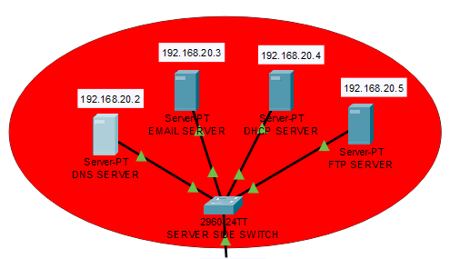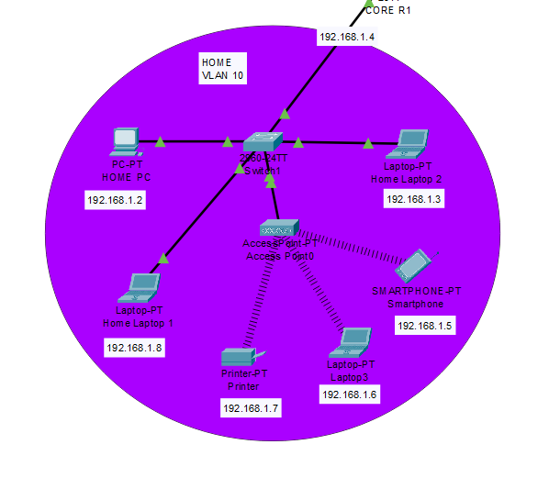

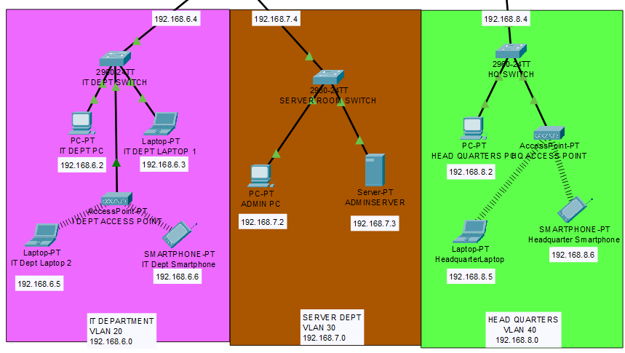

**MESH TOPOLOGY**

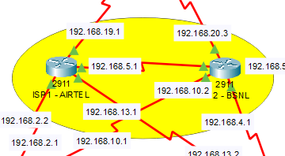

**Star Topology:**

* In a star topology, all devices (such as computers, printers, or other peripherals) are connected to a central hub or switch.
* The central hub acts as a repeater for data flow and facilitates communication between devices.
* If one device wants to communicate with another, it sends the data to the central hub, which then relays the data to the appropriate device.
* The failure of one cable or device does not affect the rest of the network (except the isolated device).

**Mesh Topology:**

* In a mesh topology, every device is connected to every other device in the network.
* This creates multiple paths for data to travel, providing redundancy and alternative routes in case one link fails.
* Mesh topologies can be either full mesh (every node is connected to every other node) or partial mesh (nodes are only connected to a subset of other nodes).
* While this redundancy is a strength in terms of fault tolerance, it can also lead to a large number of physical connections in a full mesh, making it impractical for large networks.

**Hybrid Topology:**

* Combination of Topologies: Hybrid topology integrates multiple network topologies within a single network infrastructure.
* Customization for Specific Needs: Tailored to meet specific organizational requirements, optimizing performance, scalability, and fault tolerance.
* Flexibility and Adaptability: Offers flexibility to adapt to changing organizational needs and diverse functionalities.
* Centralized and Decentralized Elements: Incorporates both centralized and decentralized elements based on the requirements of different network segments.
* Cost Optimization: Aims to optimize costs by employing cost-effective topologies where appropriate.

**Conclusion: So it’s a Hybrid Topology(Star and Mesh)**

**USECASES**

**Admin/IT Department:**

**Network Administration and Support**

* Manages the overall network infrastructure, including routers, switches, and access points.
* Provides technical support for employees regarding IT issues and network connectivity.
* Administers user accounts, permissions, and access controls to ensure network security.
* Monitors and troubleshoots any network-related problems.

**Finance/HR Department:**

**Financial Management and Human Resources**

* Manages financial transactions, budgeting, and financial reporting for the branch.
* Handles human resources functions, including employee payroll, benefits, and recruitment.
* Ensures compliance with financial regulations and company policies.
* Manages employee records and HR-related documentation.

**Customer Service/Reception Department:**

**Customer Interaction and Front Desk Operations**

* Provides customer support and assistance with inquiries related to products or services.
* Manages incoming calls, emails, and walk-in customers.
* Coordinates appointments, reservations, and customer service requests.
* Acts as the front desk for the branch, welcoming visitors and directing them to the appropriate departments.

Some Use Cases are as follows:

* **Separate traffic from different departments or offices:** By using VLANs, company X can isolate traffic from different departments, which can help to improve security and network performance. For example, traffic from the Admin/IT department will not be able to reach traffic from the Finance/HR department unless it is specifically allowed.
* **Segregate traffic from different users:** VLANs can also be used to segregate traffic from different types of users. For example, traffic from guest users can be segregated from traffic from employees. This can help to protect sensitive data from unauthorized access.
* **Allow different types of devices to coexist on the same networ:**VLANs can be used to allow different types of devices to coexist on the same network. For example, traffic from VoIP phones can be segregated from traffic from data devices. This can help to improve the quality of voice and data traffic.
* **Connect multiple switches together:** VLANs can be used to connect multiple switches together. This can be useful for creating a large, scalable network.
* **Protect against unauthorized access to sensitive:** systems VLANs can be used to protect against unauthorized access to sensitive systems. By isolating traffic from different departments, VLANs can make it more difficult for unauthorized users to gain access to sensitive data.

In addition to these use cases, VLANs can also be used to improve network performance by reducing broadcast traffic. Broadcast traffic is traffic that is sent to all devices on a network, regardless of whether or not they need to receive it. By using VLANs, company X can reduce the amount of broadcast traffic on its network, which can free up bandwidth for other types of traffic.

**CONFIGURATION OF END DEVICES**

|  |  |  |  |
| --- | --- | --- | --- |
| **End Devices** | **IPv4 Addresses** | **Subnet Mask** | **Class** |
| HOME PC | 192.168.1.2 | 255.255. 255.0 | C |
| Laptop1 | 192.168.1.8 | 255.255. 255.0 | C |
| Printer1 | 192.168.1.7 | 255.255. 255.0 | C |
| Laptop 3 | 192.168.1.6 | 255.255. 255.0 | C |
| Smartphone 1 | 192.168.1.5 | 255.255. 255.0 | C |
| Laptop 2 | 192.168.1.3 | 255.255. 255.0 | C |
| IT DEPT PC | 192.168.6.2 | 255.255. 255.0 | C |
| IT DEPT LAPTOP 1 | 192.168.6.3 | 255.255. 255.0 | C |
| IT Dept Laptop 2 | 192.168.6.5 | 255.255. 255.0 | C |
| IT Dept Smartphone | 192.168.6.6 | 255.255. 255.0 | C |
| HEAD QUARTERS PC | 192.168.8.2 | 255.255. 255.0 | C |
| Headquarter Laptop | 192.168.8.5 | 255.255. 255.0 | C |
| Head quarter Smartphone | 192.168.8.6 | 255.255. 255.0 | C |
| ADMIN PC | 192.168.7.2 | 255.255. 255.0 | C |
| ADMIN SERVER | 192.168.7.3 | 255.255. 255.0 | C |
| DHCP SERVER | 192.168.20.4 | 255.255. 255.0 | C |
| FTP Server | 192.168.20.5 | 255.255. 255.0 | C |

**CONFIGURATION OF ROUTERS**

Here in the network router 2911 is used to build the connection. The the key port for the Cisco 2911 router:

1. **GigabitEthernet Ports:**
   * GigabitEthernet 0/0
   * GigabitEthernet 0/1
   * GigabitEthernet 0/2
2. **WAN Interfaces:**
   * Serial0/2/0
   * Serial0/2/1
   * Serial0/3/0
   * Serial0/3/1
3. **Service Module Slots:**

* Labeled Service-Module0/0

The Cisco 2911 Integrated Services Router (ISR) delivers highly secure data, voice, video, and application service. Key features include:

* 3 integrated 10/100/1000 Ethernet ports (RJ-45 only)
* 1 service module slot
* 4 enhanced high-speed WAN interface card slots
* 2 onboard digital signal processor (DSP) slots
* 1 Internal Service Module slot for application services
* Fully integrated power distribution to modules supporting 802.3af Power over Ethernet (PoE) and Cisco Enhanced PoE.

**RPI ROUTING OF ROUTERS**

**CORE R1**

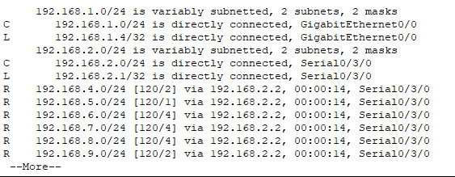

**ISP AIRTEL**

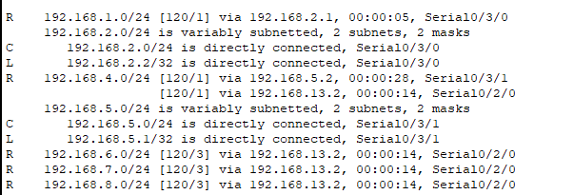

**ISP BSNL**

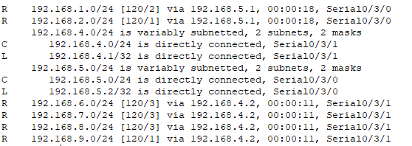

**SERVER SIDE ROUTER**

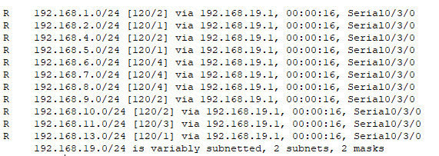

**CORE R2**

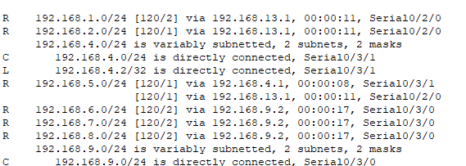

**COMPANY SIDE**

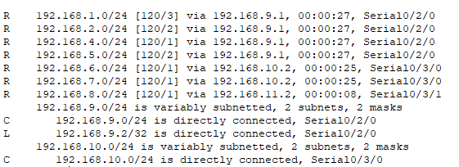

**COMPANY R1**

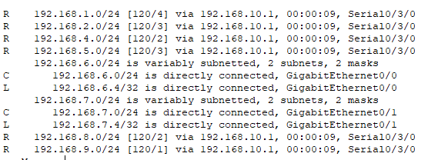

**COMPANY R2**

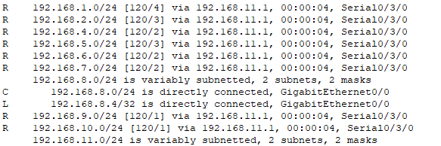

**DNS**

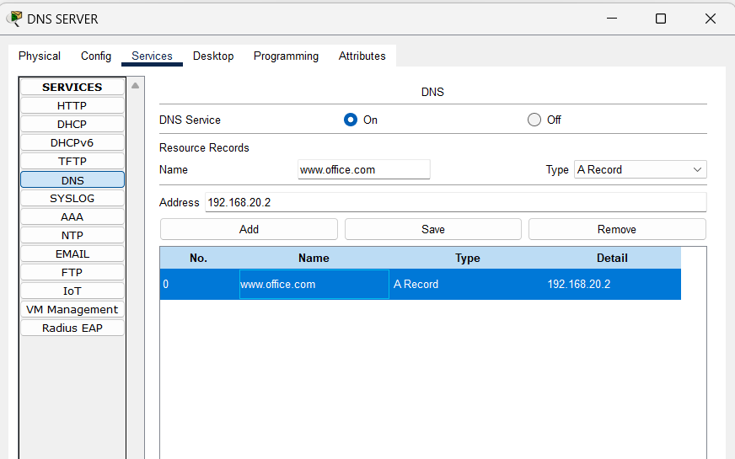

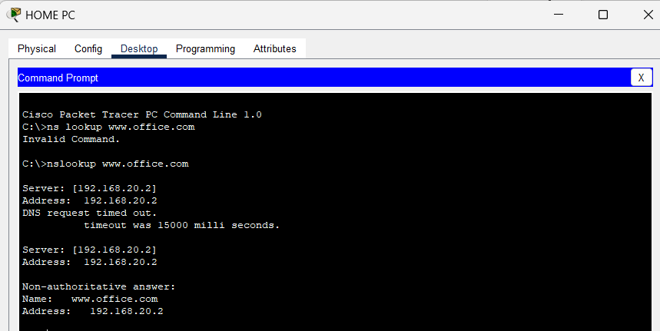

**DNS SERVER CONNECTED WITH END DEVICES**

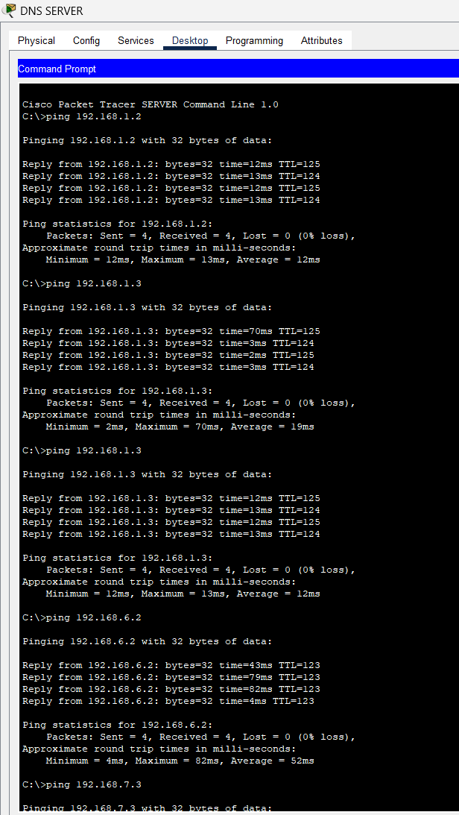

**HTTP**

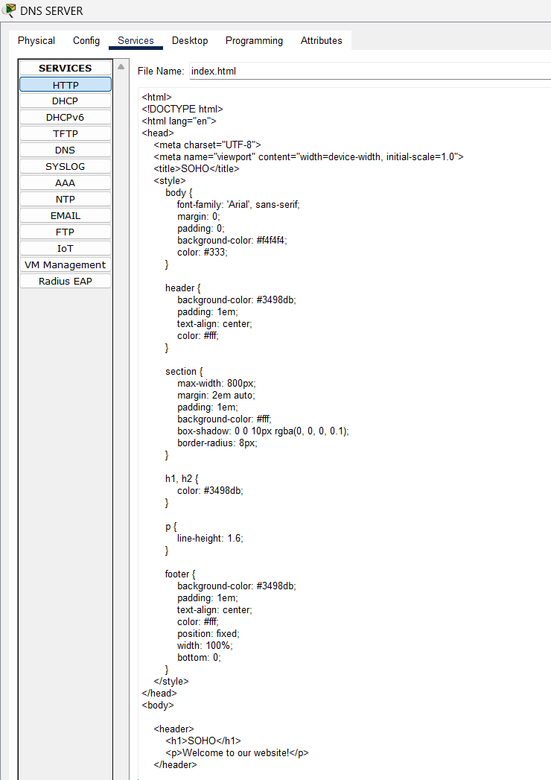

**WEB PAGE FOR DOMAIN NAME**

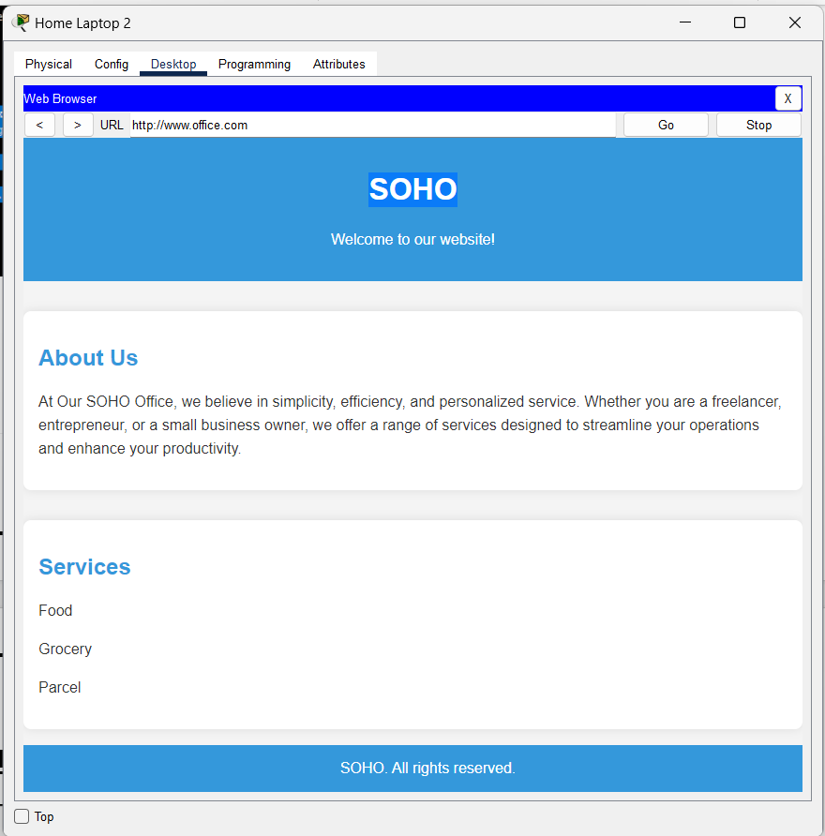

**EMAIL SERVER**

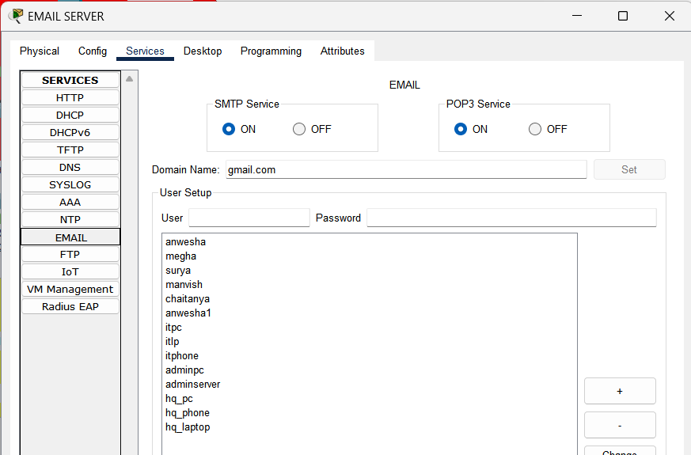

**HOME PC** 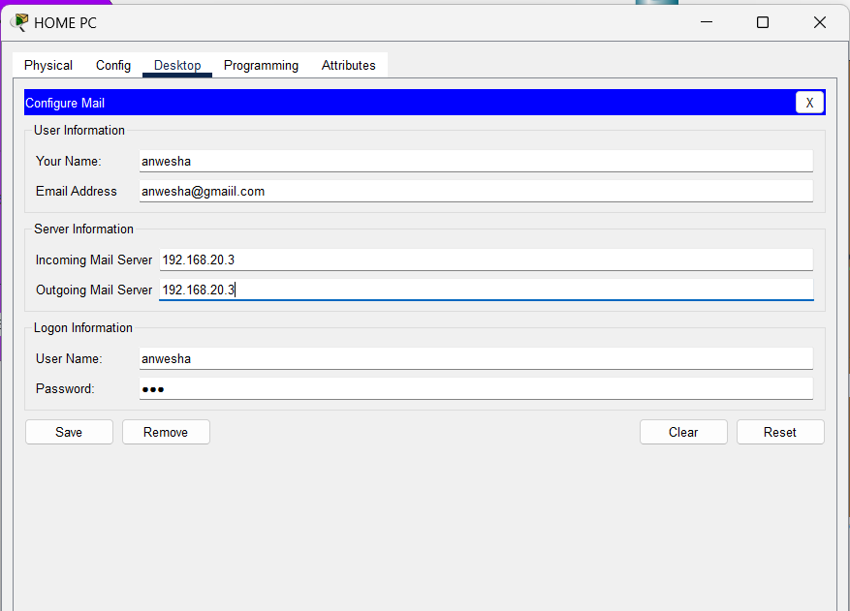

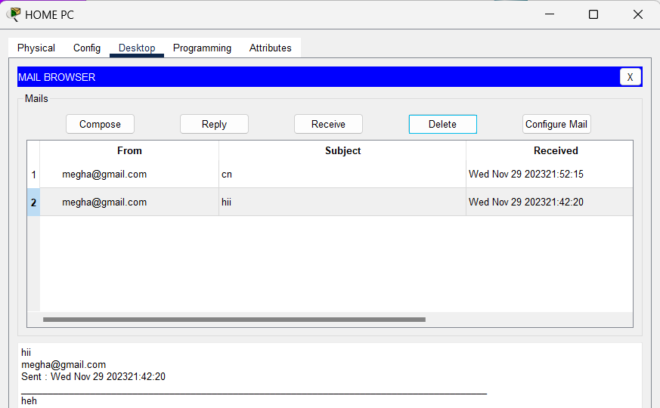

**IT DEPT LAPTOP**

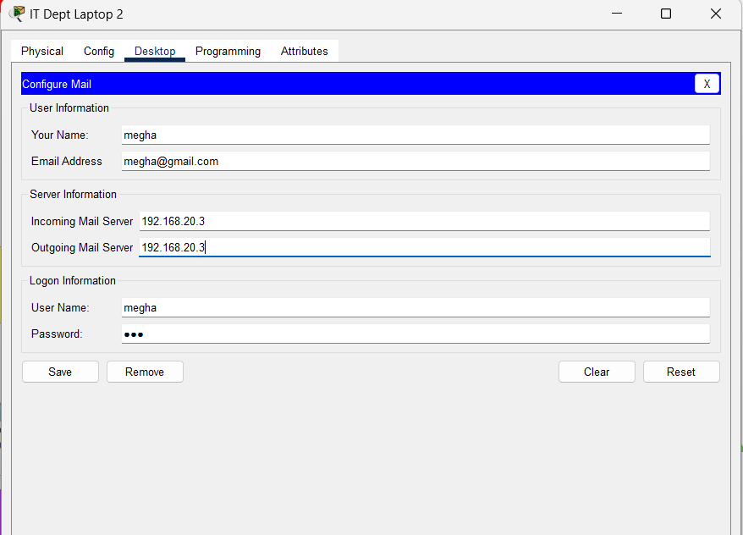

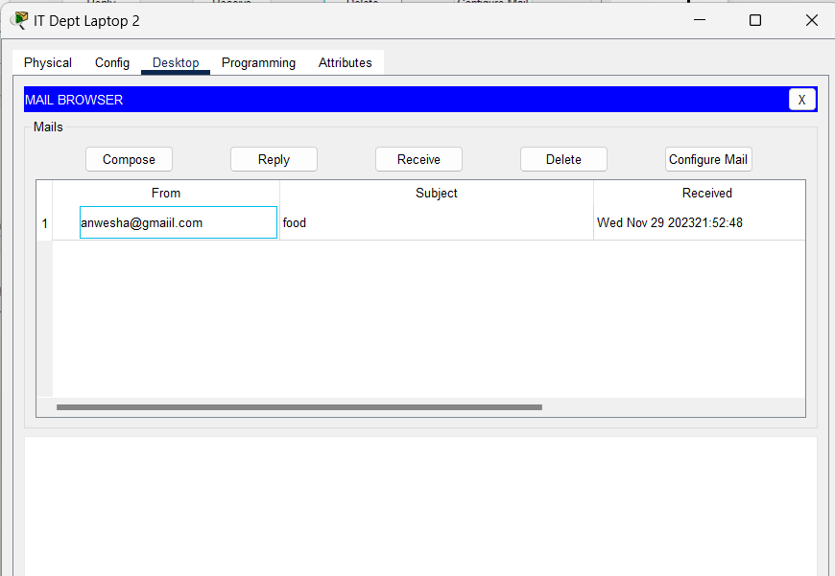

**FTP**

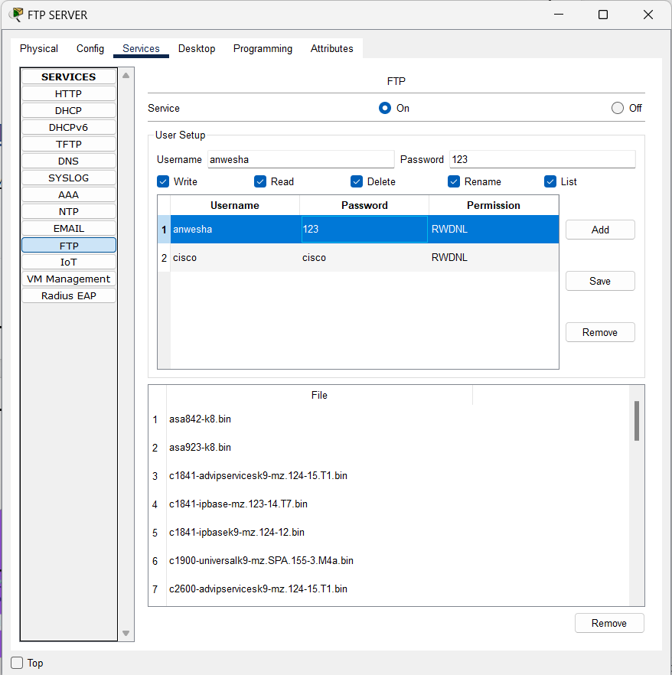

**HOME PC**

**FTP SERVER CONNECTED** 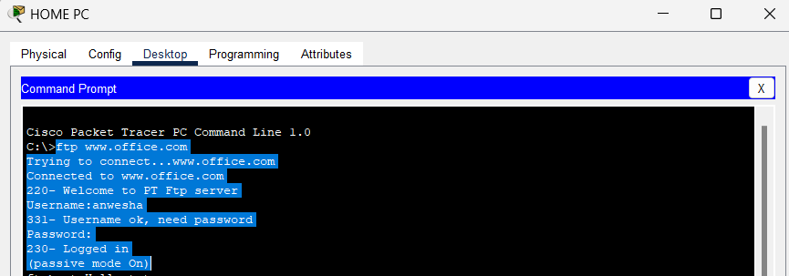

**FILE TRANSFERRED FROM CURRENT NODE TO SERVER NODE**

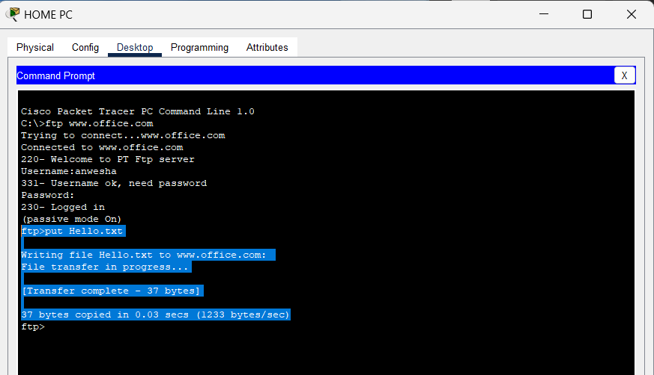

**FILE LISTED/UPLOADED**

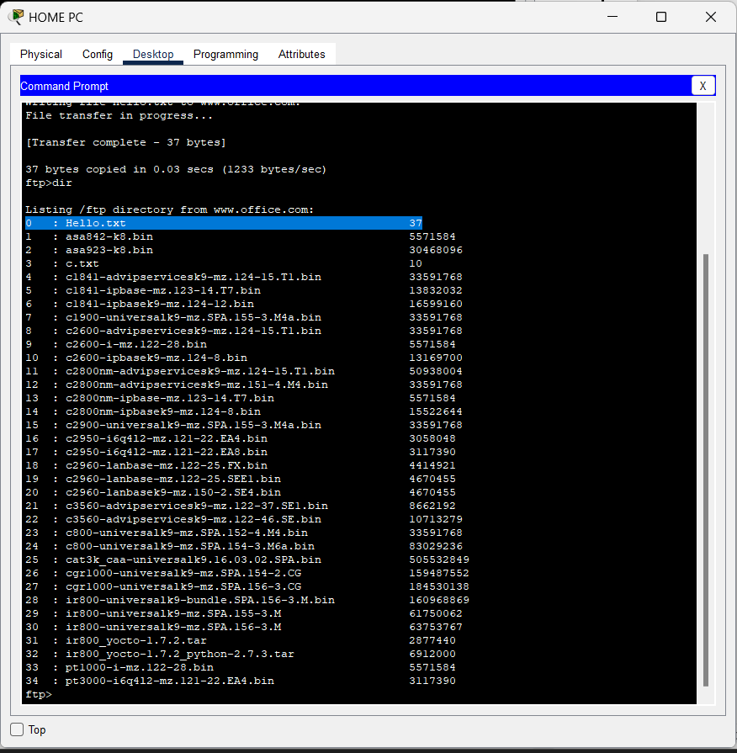

**LAPTOP 2**

**FTP SERVER CONNECTED**

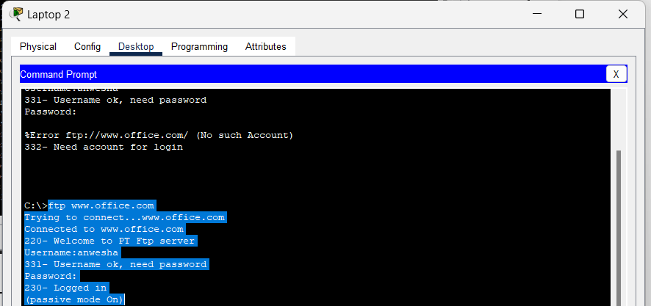

**DOWNLOADING THE FILE**

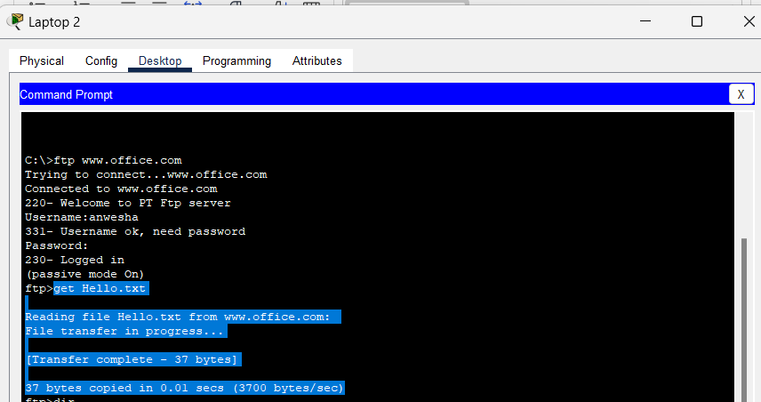

**FILE LISTED**

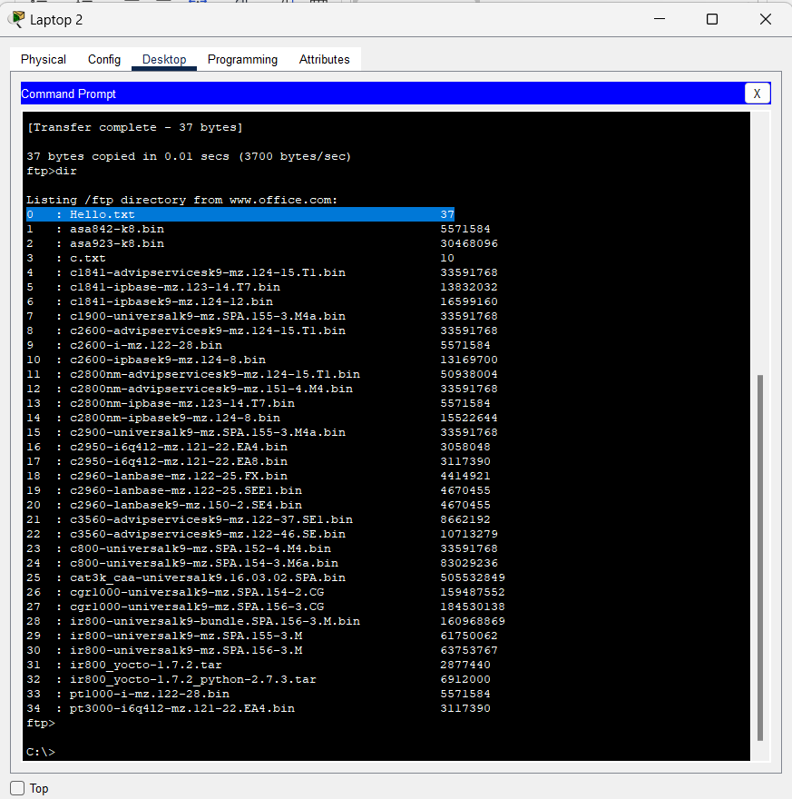

**DHCP**

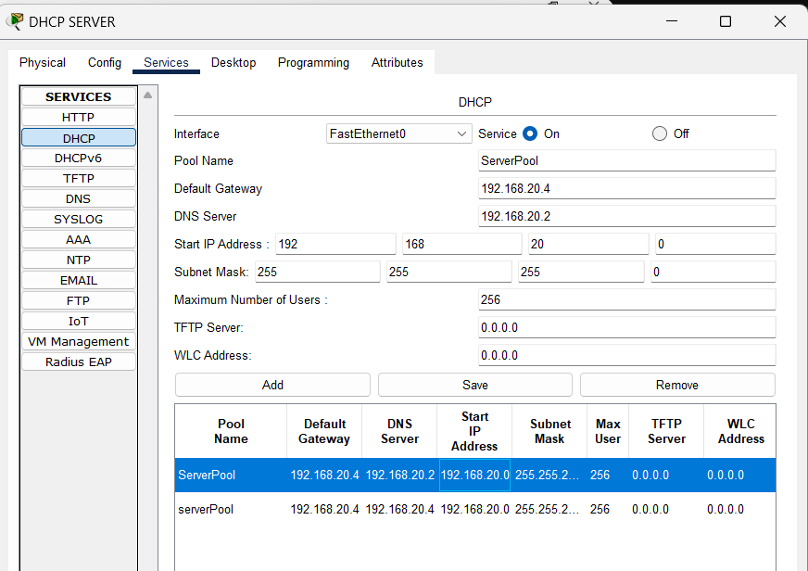

**IMAGES FOR CISCO PACKET TRACKER FILE**

**HOME COMMUNITY**

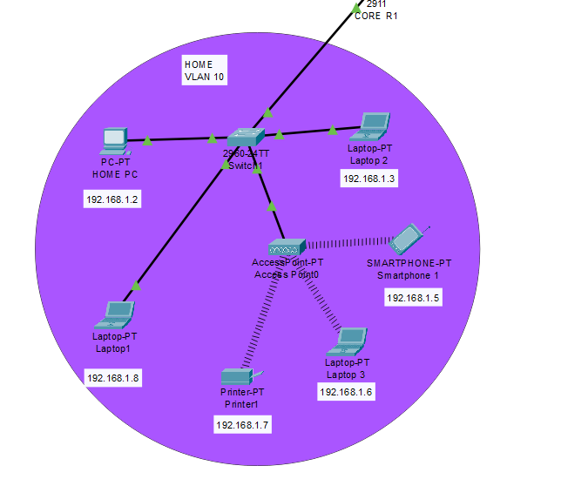

**ADMIN OFFICE HIERARCHY**

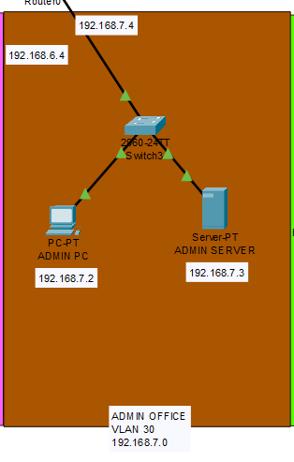

**IT DEPARTMENT HIERARCHY**

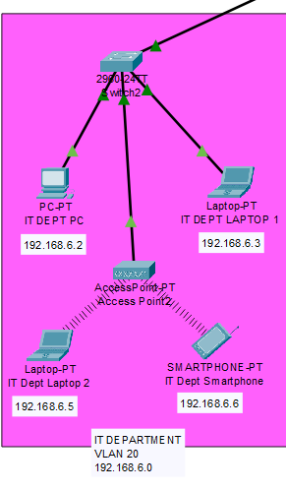

**HEAD QUARTER HIERARCHY**

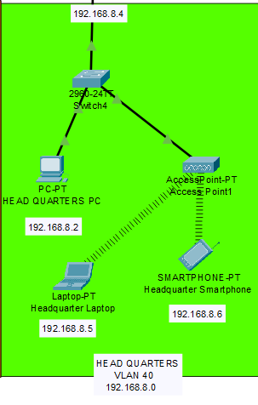

**SCREENSHOT OF SUCCESSFUL PUSH FROM CLIENT TO SERVER**

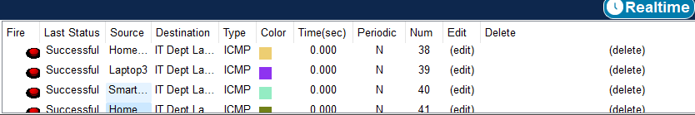

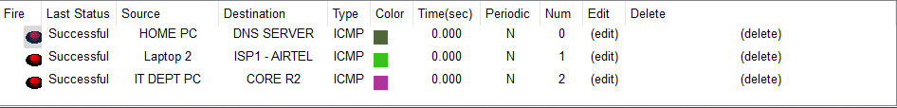

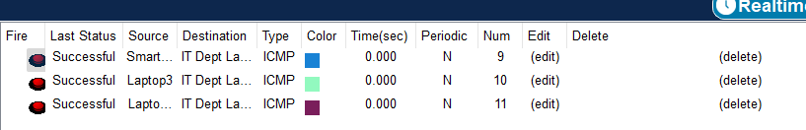

**SCREENSHOT OF FAILED TRANSFER**

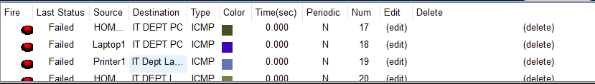

**UPPER HIERARCHY**

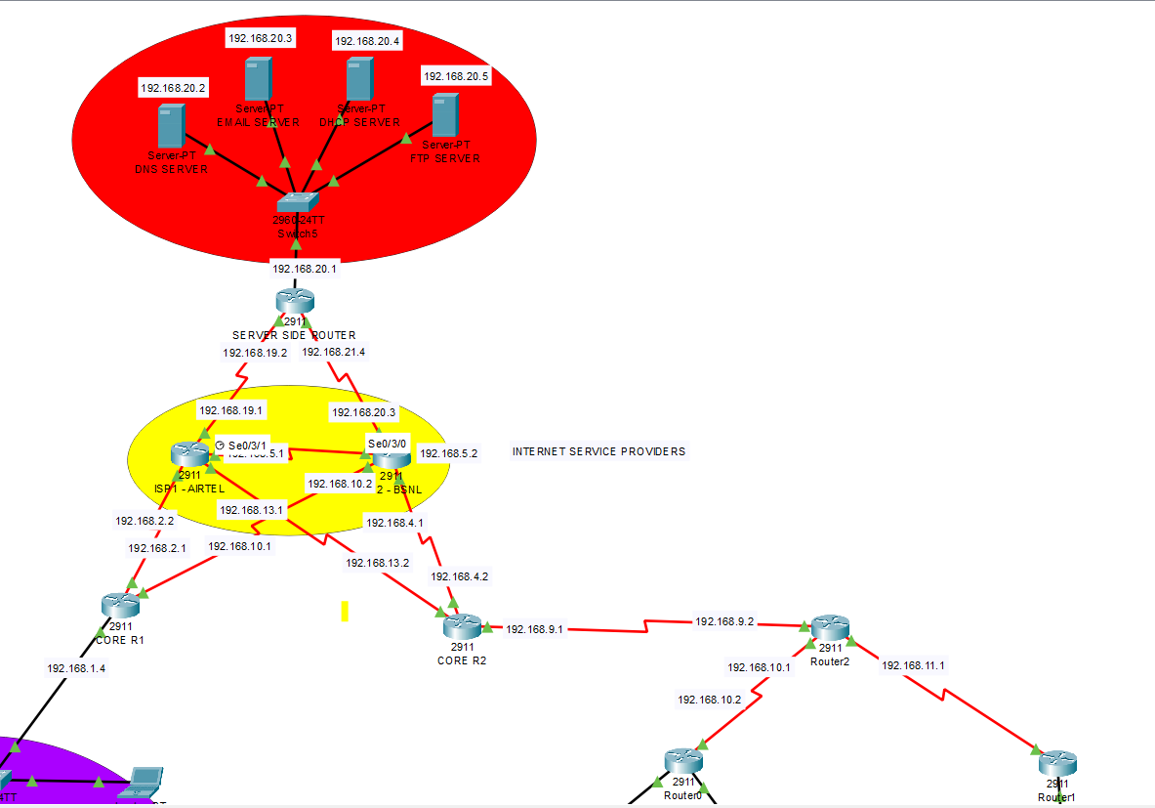

**COMPLETE NETWORK**

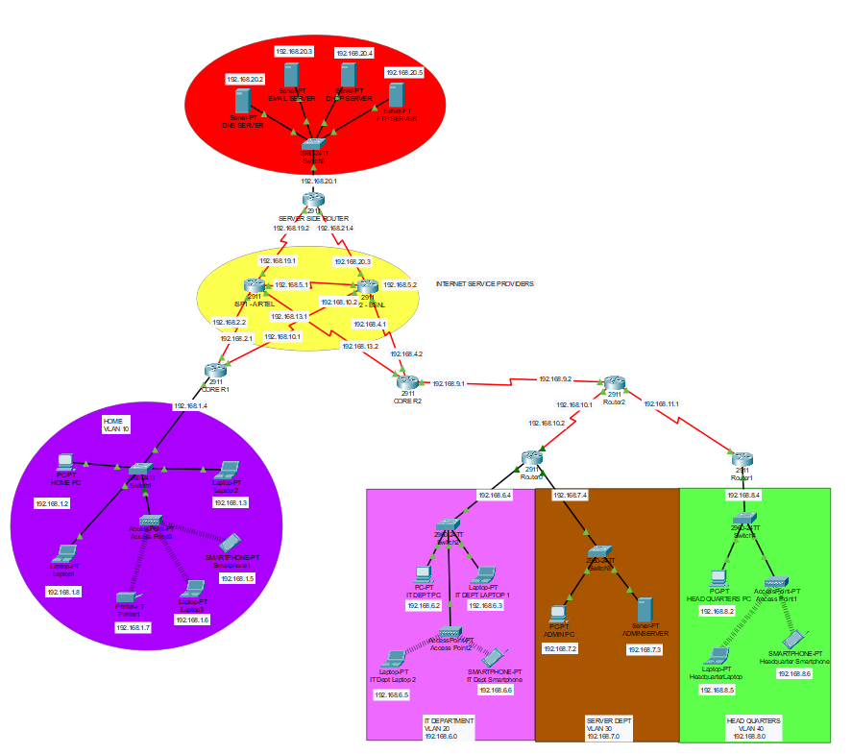

**CONCLUSION**

The implementation of the network for Company X's new branch in the small town involved the use of Cisco networking products and various technologies to meet the specific requirements. The key components of the network design included a router, a switch, VLANs, subnetting, IP addressing, inter-VLAN routing, DHCP server configuration, and the integration of wireless networks using Cisco Access Points.

From this Project We Learned :

* How to design and implement a simple network
* How to configure Cisco routers and switches
* How to create and manage VLANs
* How to configure DHCP servers
* How to configure wireless networks
* How to test and verify network connectivity.

The meticulous design and deployment of Company X's small-town branch network underscore the efficacy of utilizing industry-standard Cisco networking products. The incorporation of VLANs, subnetting, inter-VLAN routing, DHCP services, and wireless connectivity through Cisco Access Points reflects a nuanced approach to fulfilling the company's distinct operational requirements.