Cloud Front

1. Resolved latency problems
2. Securely delivers content to the end users with high transfer speed and low latency.

Benefits

1. Cost effective
2. Time saving (easily implemented)
3. Content-Privacy (content is secure)
4. Highly programmable
5. Target specific Geo-targeting
6. Quickly delivers content.

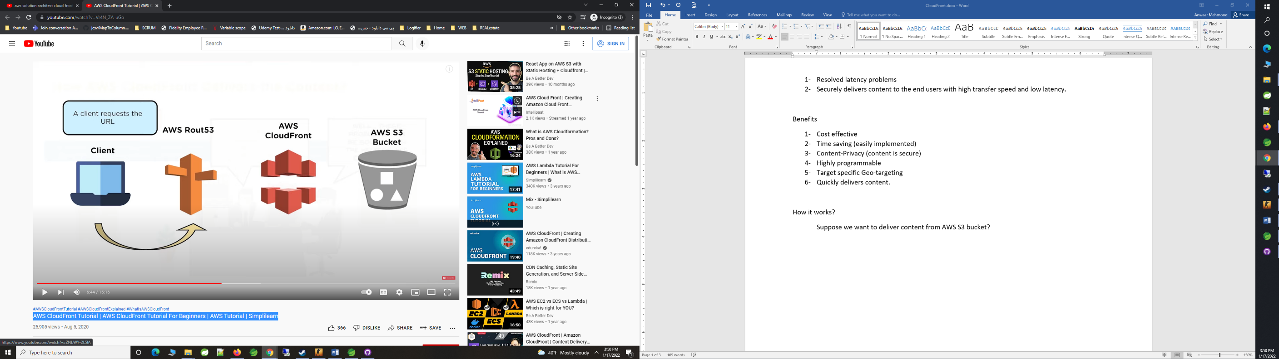

How it works?

Suppose we want to deliver content from AWS S3 bucket?

What we need?

1. A domain URL
   1. Please update nameservers generated in Step 2 (a) iii
2. Route 53 Service
   1. Create hosted zone
      1. Put domain name
      2. Mark as Public Hosted Zone
      3. 4 Nameservers will be provided
      4. Create Record
         1. Create Routing Policy
            1. Simple Routing
            2. Create Simple Record

Record name

Value/Route traffic to

Select Alias to CloudFront distribution

US East

Provide cloudfront distribution url (Domain name)

1. Create Cloud Front distribution
2. Cloud Front distribution will be linked with S3 Bucket.
   1. Create Bucket

Cloud Front Delivery Method

1. Web
   1. User stores files in an origin either S3 Bucket, or a Webserver, after you create distribution you can add more origins.
   2. Distribute media files using HTTP, HTTPS
   3. Use live streaming to stream an event in real time.
   4. CRUD data and web forms.
2. RTMP
   1. Real-Time Messaging Protocol
      1. For Audio, Video etc.

Notes:

Edge Locations

1. These are locations which caches the content.
2. CloudFront contacts nearest Edge location to deliver content.
   1. If the data is not available, it request actual server.

AWS CloudFront Tutorial | AWS CloudFront Tutorial For Beginners | AWS Tutorial | Simplilearn

<https://www.youtube.com/watch?v=Vr4N_ZA-uGo>

Best Tutorials

Amazon CloudFront CDN Part 1| Cost Effective Website | AWS Certified Solutions Architect

<https://www.youtube.com/watch?v=2k6UGBwmlXs>

Amazon CloudFront CDN Part 2| GEO Restrictions| AWS Certifications <https://www.youtube.com/watch?v=PFs_kIVHqoQ>