* S3
* EBS
* EFS
* Glaciar
* Storage Gateway

Block Storage

1. EBS
2. Fast read/write operations as change
3. Connected/Attached to an instance

Object Storage

1. S3
2. Write once and Read many times, Object Storage is better
3. If read/write happening at the same time, then it’s not feasible.
4. Cannot install anything in it.

S3

1. Bucket name should be unique globally.
2. Object Storage
3. Replicated within AZ and could be mounted to one EC2 in the AZ.
4. Dump operations
5. Scalable, size not be planned
6. Writing continuously such as
   1. Log files ingestion
   2. Static web content deliver
7. Not Suitable
   1. Hosting OS
   2. Database
8. 5 TB is max file size.
9. Beneftis
   1. Durability
      1. If we store data, it’s not getting lost.
   2. Availability
      1. If we want the data now, we have 99.99 availability.
   3. Simple data transfer
   4. Secure
   5. Low cost
10. When you upload data to bucket, you need to specify region.

How S3 works

1. When files are uploaded to the bucket, user will specify type of s3 storage class to be used for those specific objects.
   1. Storage Classes
      1. Default (S3 Standard)
      2. S3 Glacier
         1. Ex student’s old record, which is not required on daily basis.
         2. Even low latency is not needed.
      3. S3 Standard frequent data access.
         1. Like Student Attendance, which should be retrieved quickly
      4. S3 Standard Infrequent data access.
         1. Student Academic record
      5. One Zone – IA Storage class
         1. Data is infrequently accessed and stored in a single region.
         2. Student report card is not used on daily basis and stored in a single availability region (i.e. school)
      6. AWS S3 : Standard Reduced Redundancy storage:
         1. Where data is not critical and can be reproduced quickly
         2. Books in the library are non-critical data and be replaced if lost.
2. We can later specify features to the bucket policy such as lifecycle policies, version control etc.

Object : Is actual data and reference to the location of data, type of file, size etc.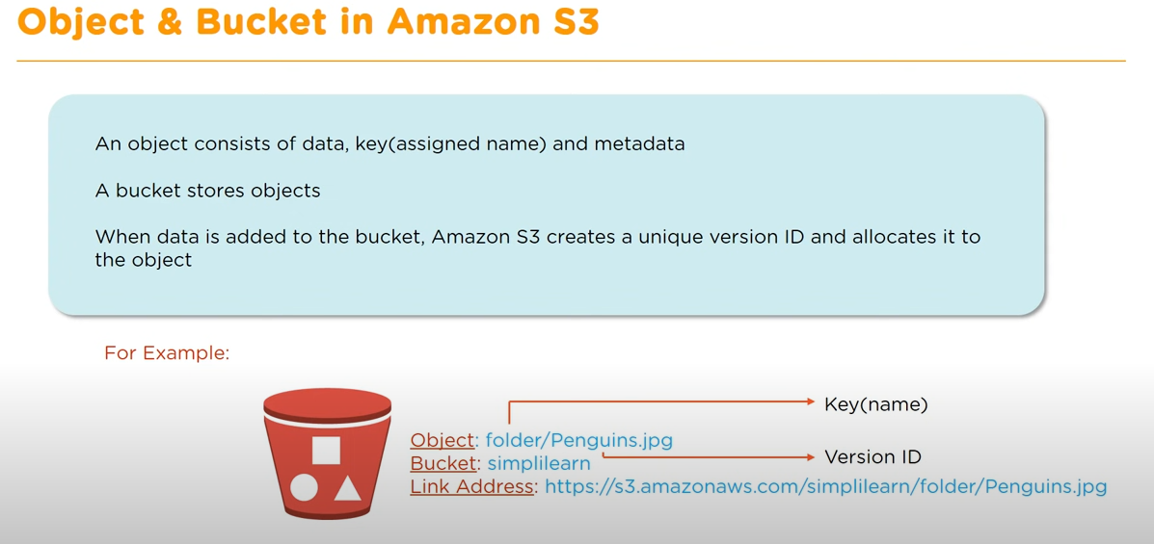

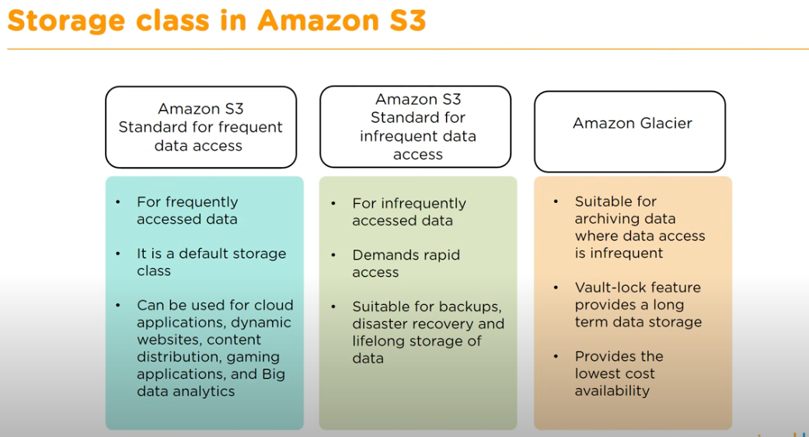

**S3 Lifecycle Management**

Set of rules that defines action to a group of objects.

1. Transition Actions
   1. It helps to automatically migrate your data to lower cost storage as your data ages.
   2. We can move the data to another storage class on a defined scheduled.
   3. S3 Standard to S3 infrequent Access to Glacier
      1. Suppose you have not used files frequently for 30 days, then it will be moved to infrequent access.
      2. After 60 days it is moved Glacier.
2. Expiration Actions
   1. WE can setup lifecycle management to expire data after specific date automatically.

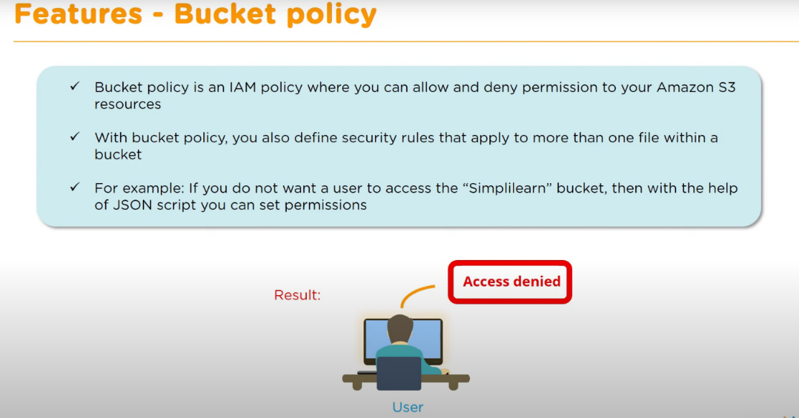

**S3 Bucket Policy**

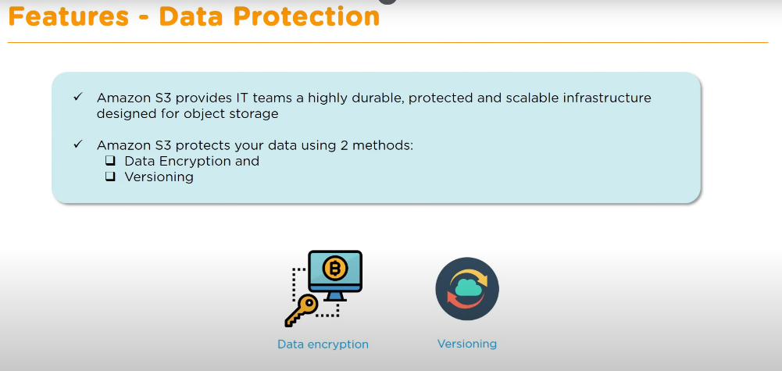**S3 Data Protected.**

Enabled at bucket level.

1. Encryption
   1. Cannot access data without encryption key.
   2. Two ways
      1. Client-side
      2. Server-side
2. Versioning
   1. Multiple copies of data.
   2. We can rollback changes to previous version in case of unwanted changes.

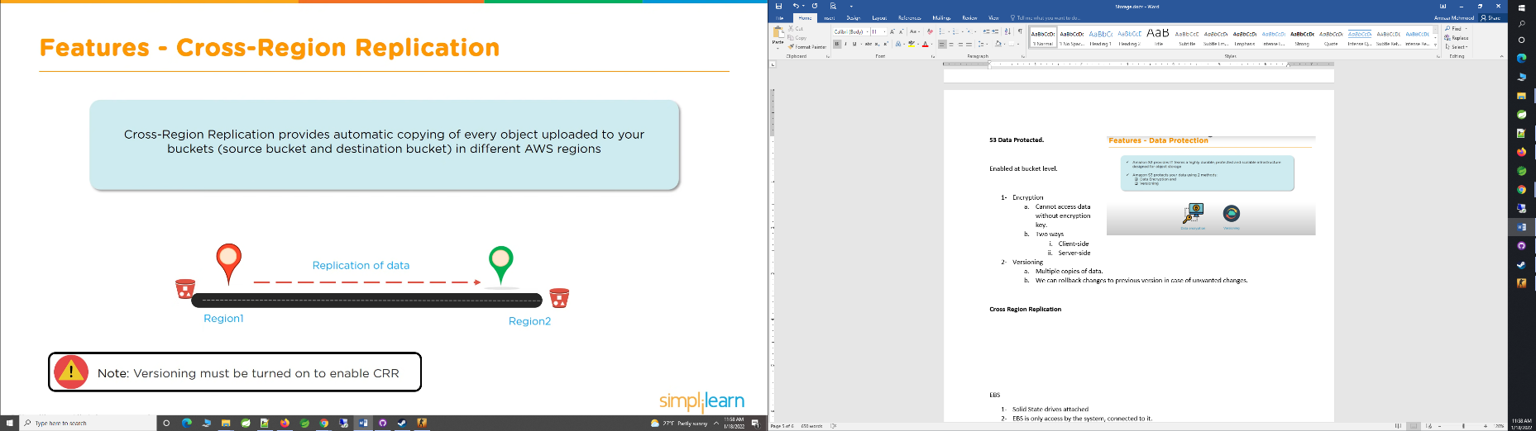

**Cross Region Replication**

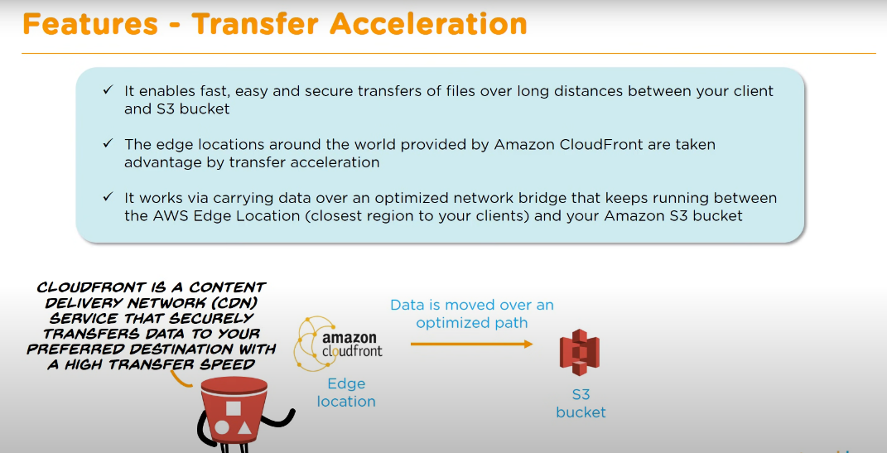**Transfer Acceleration**

Instead of copying data to client environment/destination bucket.

It copies data to cloud front distribution, then it

Transfer Acceleration takes advantage of the globally distributed edge locations in Amazon CloudFront.

**You can take help form online tool**

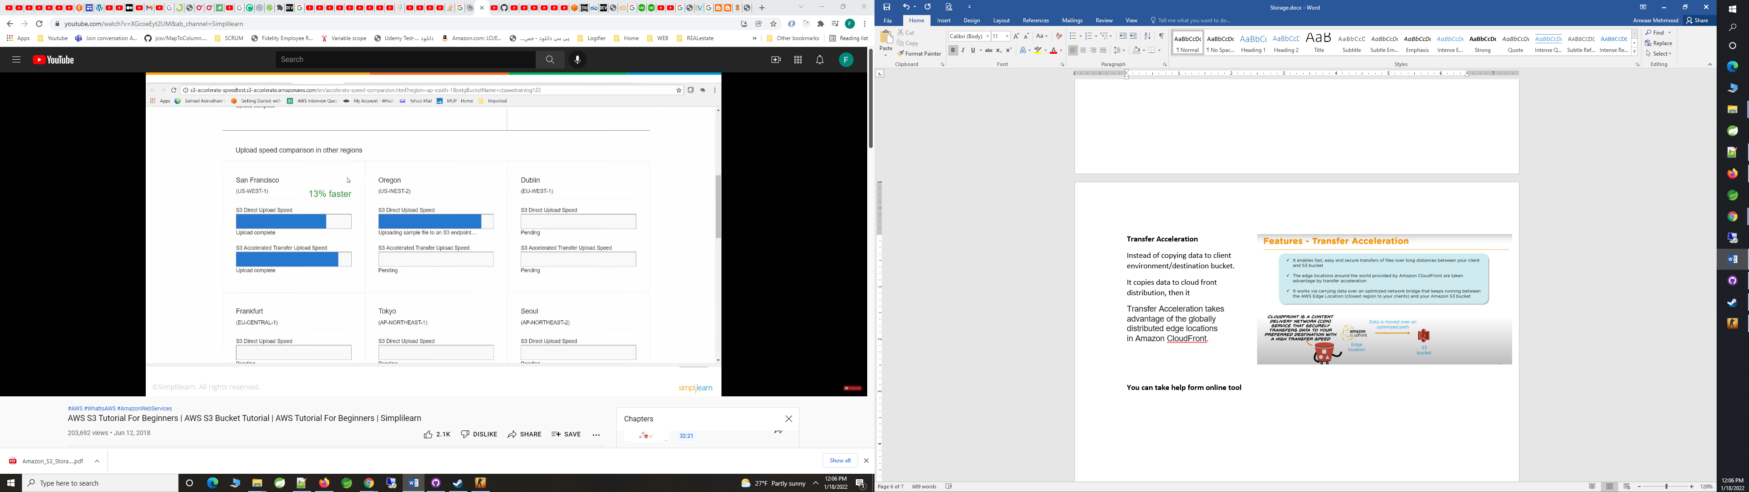

EBS

1. Solid State drives attached
2. EBS is only access by the system, connected to it.

EFS

1. Shared File System, Can be access by inside AWS and external/on site premise systems.
2. Replicated across AZ in a region
3. Could be mounted to on premise server as well (over VPN or Direct Connect)
4. Can be mounted to multiple EC2 at the same time
5. No sizing to be done (unlike EBS), its same as S3 in scaling and sizing

Glacier

1. Low cost Archival of huge data.

Storage Gateway

Used to Safely move my data from local environment to cloud.

Keep a copy of the local data

Snowball

Data import/export system

Snowball Edge

Hardware which is ship to our premises, where we can copy the data from amazon and ship it back.

Snowmobile

1. Really Huge Data
2. Datacenter on a truck, loaded with data center,
3. Lot of storage, compute, electric capacity.