CISCO NETWORKING PROJECT
SMALL ENTERPRISE NETWORK
VLAN SEGMENTATION & INTER-VLAN ROUTING
Cisco Packet Tracer Implementation

PROJECT TYPE
Networking/Network Engineering
TECHNOLOGIES IMPLEMENTED
IPv4 Addressing • VLANs • 802.1Q Trunking
Router-on-a-Stick • Inter-VLAN Routing
Network Verification • Troubleshooting

PREPARED BY
Anwar Ul Haq
TOOL USED
1Cisco Packet Tracer
PROJECT
Project 01
DATE
September 2026

TABLE OF CONTENT
1. PROJECT OVERVIEW 5
2. PROJECT OBJECTIVES 6
Specific Objectives 6
3. NETWORK SCENARIO 7
Department and VLAN Structure 7
Network Architecture 7
4. NETWORK TOPOLOGY 8
5. IP ADDRESSING & VLAN DESIGN 9
5.1 VLAN Design 9
5.2 IP Addressing Plan 9
5.3 VLAN-to-Port Assignment 9
6. CONFIGURATION 10
6.1 VLAN Configuration 10
6.2 Access Port Configuration 10
6.3 Trunk Configuration 10
6.4 Router-on-a-Stick Configuration 10
6.5 Configuration Summary 11
7. VERIFICATION & TESTING 12
7.1 VLAN Verification 12
7.2 Trunk Verification 12
7.3 Router Interface Verification 14
7.4 Same-VLAN Connectivity Test 14
7.5 Inter-VLAN Connectivity Test 15
8. TROUBLESHOOTING CASE STUDY 16
8.1 Problem Introduction 16
8.2 Incorrect Configuration 16
8.3 Connectivity Failure 17
8.4 Configuration Correction 17
8.5 Verification After Correction 18
8.6 Root Cause Analysis 19
9. RESULTS 20
10. FUTURE IMPROVEMENTS 21
10.1 Dynamic Host Configuration Protocol (DHCP) 21
10.2 Dynamic Routing 21
10.3 Network Security 21
10.4 Network Address Translation 21
10.5 Network Redundancy 21
10.6 Network Automation 21
10.7 Cloud Networking 21

LIST OF FIGURES
Figure 1 Small Enterprise Network Topology 8
Figure 2 VLAN Configuration Verification 12
Figure 3 Trunk Link Verification 13
Figure 4 Router Interface Verification 14
Figure 5 Same-VLAN Connectivity Test 15
Figure 6 InterVLAN Connectivity Test 15
Figure 7 Incorrect VLAN Encapsulation Configuration 16
Figure 8 Failed Inter-VLAN Connectivity Test 17
Figure 9 Correction of VLAN Encapsulation Configuration 18
Figure 10 Successful Inter-VLAN Connectivity After Correction 18

1. PROJECT OVERVIEW
This project presents the design and implementation of a small enterprise network using Cisco Packet Tracer. The network is designed to demonstrate how VLAN segmentation and inter-VLAN routing can be used to organize departments within an enterprise network while allowing controlled communication between different VLANs.
The network consists of a Cisco router, a managed Cisco switch, and six end devices representing three different departments: Human Resources (HR), Information Technology (IT), and Finance. Each department is assigned to a separate VLAN to logically divide the network into independent broadcast domains.
802.1Q trunking is configured between the switch and router to carry traffic from multiple VLANs over a single physical connection. Router-on-a-Stick is then implemented using router subinterfaces to provide gateway services and enable communication between the different VLANs.
The project also includes network verification and a troubleshooting scenario in which an incorrect VLAN encapsulation configuration is introduced, identified, corrected, and tested. This demonstrates practical configuration, verification, and troubleshooting skills in a simulated enterprise networking environment.

2. PROJECT OBJECTIVES
The main objectives of this project are to design and configure a small enterprise network that demonstrates fundamental networking concepts and practical Cisco configuration skills.

Specific Objectives
- Implement VLAN Segmentation
Create separate VLANs for the HR, IT, and Finance departments to logically segment the enterprise network.
- Configure Access Ports
Assign end devices to their appropriate VLANs through correctly configured switch access ports.
- Implement 802.1Q Trunking
Configure a trunk link between the Cisco switch and router to carry traffic from multiple VLANs over a single physical connection.
- Configure Router-on-a-Stick
Configure router subinterfaces and IEEE 802.1Q encapsulation to provide gateway connectivity for each VLAN.
- Enable Inter-VLAN Routing
Allow devices in different VLANs to communicate through the router while maintaining logical network segmentation.
- Verify Network Connectivity
Use Cisco IOS verification commands and end-device ping tests to confirm that the network is functioning correctly.
- Develop Troubleshooting Skills
Identify and resolve a deliberately introduced VLAN encapsulation error and verify that connectivity is restored after the correction.

3. NETWORK SCENARIO
The network is designed for a small enterprise organization consisting of three departments: Human Resources (HR), Information Technology (IT), and Finance. Each department contains two end devices and is assigned to a separate VLAN to provide logical network segmentation.
A Cisco 2960 Layer 2 switch is used to connect the end devices, while a Cisco 2911 router provides Layer 3 gateway functionality and enables communication between the different VLANs. The switch and router are connected through a single trunk link configured using IEEE 802.1Q encapsulation.

Department and VLAN Structure
Department | VLAN | Network Address | Default Gateway | Devices
Human Resources (HR) | 10 | 192.168.10.0/24 | 192.168.10.1 | PC1, PC2
Information Technology (IT) | 20 | 192.168.20.0/24 | 192.168.20.1 | PC3, PC4
Finance | 30 | 192.168.30.0/24 | 192.168.30.1 | PC5, PC6

Network Architecture
The network follows a centralized design in which the Cisco switch provides connectivity for all six end devices. The router is connected to the switch using a trunk link and uses separate subinterfaces for VLAN 10, VLAN 20, and VLAN 30.
Each VLAN represents a separate broadcast domain. Devices within the same VLAN can communicate directly through the switch, while communication between different VLANs is handled by the router through Router-on-a-Stick configuration.
The design provides a simple and scalable foundation for an enterprise network while demonstrating essential concepts including VLAN segmentation, access ports, trunking, router subinterfaces, and inter-VLAN routing.

4. NETWORK TOPOLOGY
The network topology was implemented in Cisco Packet Tracer using one Cisco 2911 router, one Cisco 2960 switch, and six end devices. The six PCs are divided into three departments: Human Resources (HR), Information Technology (IT), and Finance.
The switch provides Layer 2 connectivity for all end devices. The connection between the switch and router is configured as an IEEE 802.1Q trunk, allowing traffic from VLAN 10, VLAN 20, and VLAN 30 to traverse a single physical link.
The router uses Router-on-a-Stick configuration, with separate subinterfaces assigned to each VLAN. These subinterfaces provide the default gateways required for communication between different VLANs.
Figure 1 shows the complete network topology implemented for this project.
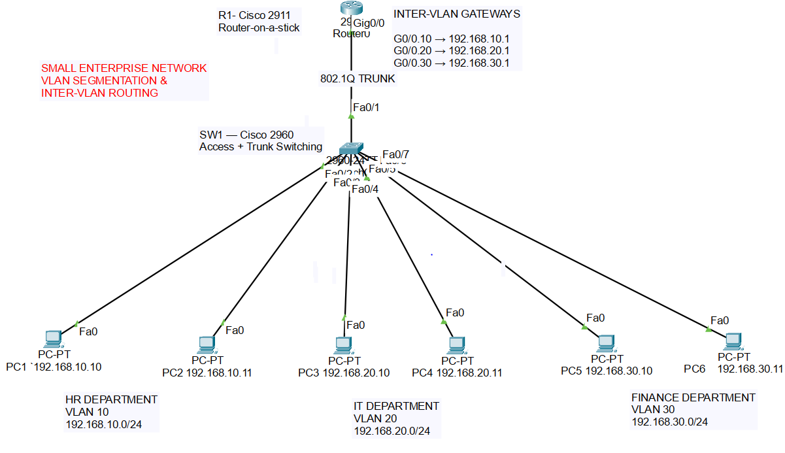
Figure 1 Small Enterprise Network Topology
Topology Components
• R1: Cisco 2911 Router — Provides inter-VLAN routing through router subinterfaces.
• SW1: Cisco 2960 Switch — Provides VLAN segmentation and Layer 2 connectivity.
• PC1–PC2: HR department — VLAN 10.
• PC3–PC4: IT department — VLAN 20.
• PC5–PC6: Finance department — VLAN 30.
• Fa0/1: Trunk link between SW1 and R1.

Figure 1 Small Enterprise Network TopologyFigure 1Figure 1Figure 1Figure 1Figure 1

5. IP ADDRESSING & VLAN DESIGN
VLAN segmentation was implemented to logically separate the three departments within the enterprise network. Each department was assigned a unique VLAN and IPv4 subnet. This design creates separate broadcast domains while allowing communication between departments through the router.

5.1 VLAN Design
Three VLANs were created on the Cisco 2960 switch. VLAN 10 was assigned to the Human Resources department, VLAN 20 to the Information Technology department, and VLAN 30 to the Finance department.
VLAN ID | VLAN Name | Department | Network
10 | HR | Human Resources | 192.168.10.0/24
20 | IT | Information Technology | 192.168.20.0/24
30 | FINANCE | Finance | 192.168.30.0/24

5.2 IP Addressing Plan
Each end device was assigned a unique IPv4 address within its department's subnet. The router subinterface for each VLAN was configured as the default gateway for devices in that VLAN.
Device | Department | VLAN | IP Address | Subnet Mask | Default Gateway
PC1 | HR | 10 | 192.168.10.10 | 255.255.255.0 | 192.168.10.1
PC2 | HR | 10 | 192.168.10.11 | 255.255.255.0 | 192.168.10.1
PC3 | IT | 20 | 192.168.20.10 | 255.255.255.0 | 192.168.20.1
PC4 | IT | 20 | 192.168.20.11 | 255.255.255.0 | 192.168.20.1
PC5 | Finance | 30 | 192.168.30.10 | 255.255.255.0 | 192.168.30.1
PC6 | Finance | 30 | 192.168.30.11 | 255.255.255.0 | 192.168.30.1

5.3 VLAN-to-Port Assignment
The switch access ports were assigned according to the department structure. Each department's two PCs are connected to access ports belonging to the same VLAN.
Switch Port | Connected Device | VLAN | Mode
Fa0/2 | PC1 | 10 | Access
Fa0/3 | PC2 | 10 | Access
Fa0/4 | PC3 | 20 | Access
Fa0/5 | PC4 | 20 | Access
Fa0/6 | PC5 | 30 | Access
Fa0/7 | PC6 | 30 | Access
Fa0/1 | R1 G0/0 | 10, 20, 30 | Trunk

6. CONFIGURATION
The network devices were configured using the Cisco IOS command-line interface in Cisco Packet Tracer. The configuration process involved creating the required VLANs, assigning switch access ports, configuring the trunk connection, and implementing Router-on-a-Stick for inter-VLAN routing.

6.1 VLAN Configuration
Three VLANs were created on the Cisco 2960 switch to provide logical separation between the three departments.
vlan 10
name HR

vlan 20
name IT

vlan 30
name FINANCE

6.2 Access Port Configuration
The six PCs were connected to access ports and assigned to their respective VLANs.
interface range fa0/2-3
switchport mode access
switchport access vlan 10

interface range fa0/4-5
switchport mode access
switchport access vlan 20

interface range fa0/6-7
switchport mode access
switchport access vlan 30

6.3 Trunk Configuration
The connection between SW1 Fa0/1 and R1 G0/0 was configured as an IEEE 802.1Q trunk. This allows traffic from multiple VLANs to travel through the same physical link.
interface fa0/1
switchport mode trunk

6.4 Router-on-a-Stick Configuration
Router subinterfaces were configured on R1 to provide default gateways for the three VLANs and enable inter-VLAN routing.
interface g0/0
no shutdown

interface g0/0.10
encapsulation dot1Q 10
ip address 192.168.10.1 255.255.255.0

interface g0/0.20
encapsulation dot1Q 20
ip address 192.168.20.1 255.255.255.0

interface g0/0.30
encapsulation dot1Q 30
ip address 192.168.30.1 255.255.255.0

6.5 Configuration Summary
The completed configuration establishes three separate VLANs, assigns the appropriate end devices to each VLAN, carries VLAN traffic through the trunk link, and provides gateway services through router subinterfaces. This configuration enables communication between devices in different VLANs while maintaining logical network segmentation.
The complete router and switch configurations are also provided separately in the project Configuration folder.

7. VERIFICATION & TESTING
After completing the network configuration, verification commands and connectivity tests were performed in Cisco Packet Tracer. The purpose of verification was to confirm that the VLANs, trunk link, router subinterfaces, and inter-VLAN communication were operating correctly.

7.1 VLAN Verification
The show vlan brief command was used on SW1 to verify that VLAN 10, VLAN 20, and VLAN 30 were successfully created and that the appropriate switch ports were assigned to each VLAN.
Figure 2. VLAN Configuration Verification
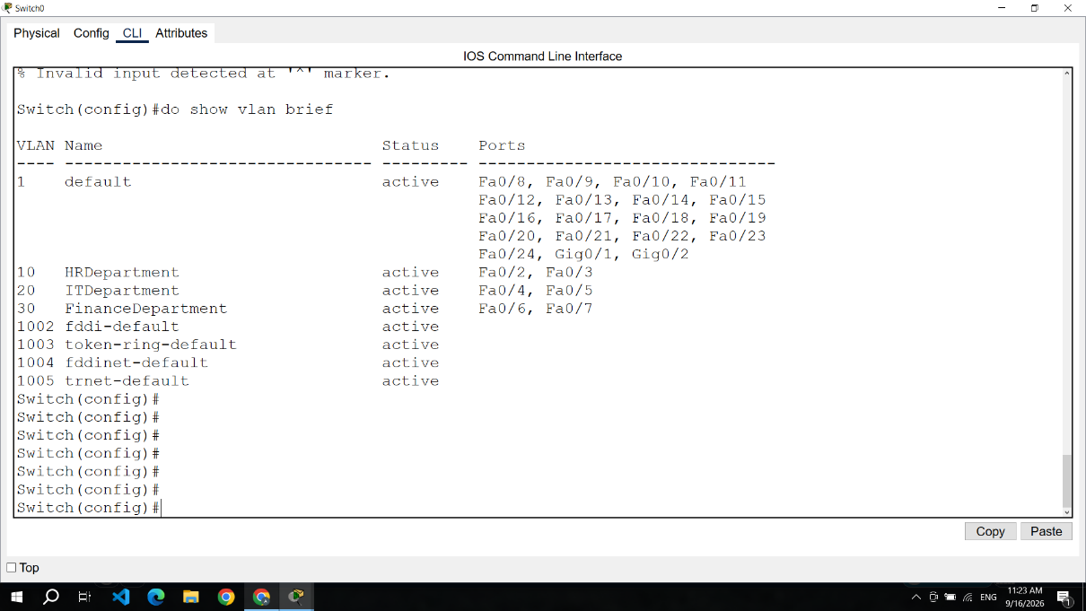
Figure 2 VLAN Configuration Verification
The verification output confirms that the required VLANs are present and that the end-device ports are assigned to their corresponding VLANs.

7.2 Trunk Verification
The show interfaces trunk command was used to verify the trunk connection between SW1 Fa0/1 and R1 G0/0.

Figure 3. Trunk Link Verification
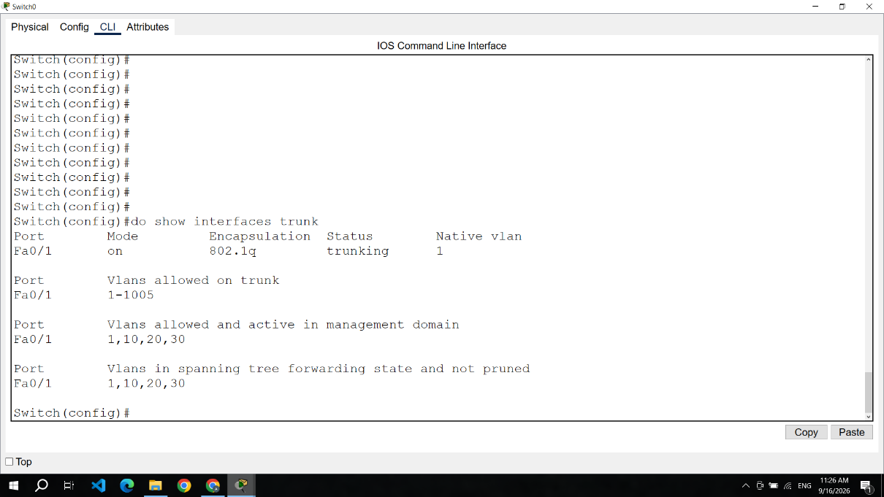
Figure 3 Trunk Link Verification
The output confirms that Fa0/1 is operating in trunking mode using IEEE 802.1Q encapsulation and that VLANs 10, 20, and 30 are active on the trunk.

7.3 Router Interface Verification
The show ip interface brief command was used on R1 to verify the operational status of the router's physical interface and VLAN subinterfaces. The verification confirms that the configured interfaces are operational and available for inter-VLAN routing.
Figure 4 Router Interface Verification
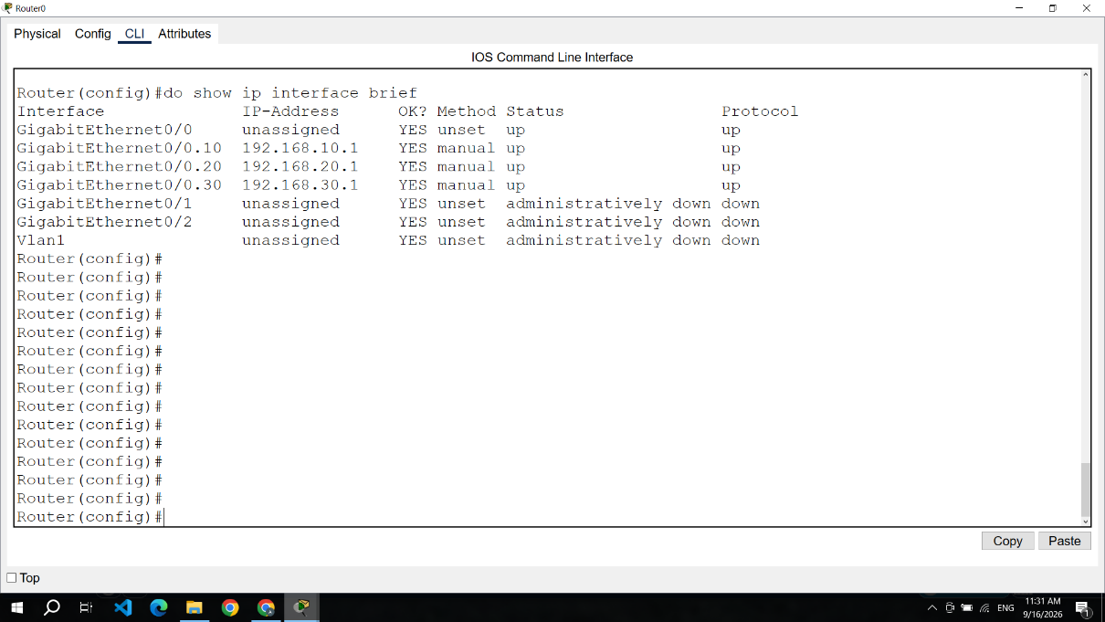
Figure 4 Router Interface Verification
The output shows that the router subinterfaces for VLAN 10, VLAN 20, and VLAN 30 are configured with the correct gateway addresses and are operational.

7.4 Same-VLAN Connectivity Test
A connectivity test was performed between PC1 and PC2, which are both members of VLAN 10 (HR). The test verifies communication between devices within the same VLAN.
Figure 5 Same-VLAN Connectivity Test
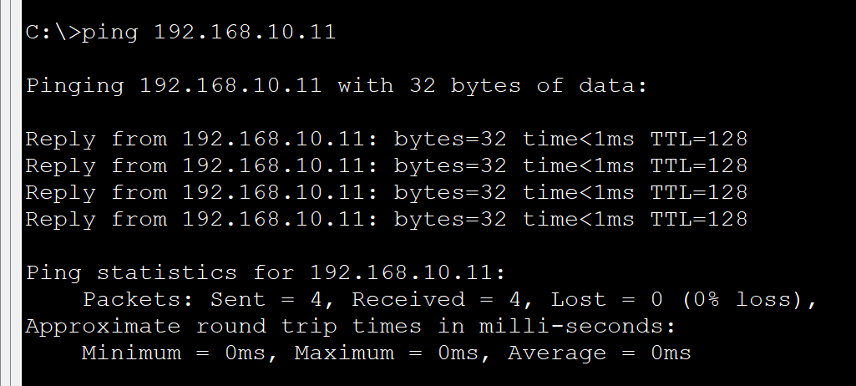
Figure 5 Same-VLAN Connectivity Test
The successful ping responses confirm that PC1 and PC2 can communicate within VLAN 10.

7.5 Inter-VLAN Connectivity Test
Inter-VLAN connectivity was tested by sending ICMP ping traffic between devices belonging to different VLANs. For example, PC1 in VLAN 10 was tested against PC3 in VLAN 20 and PC5 in VLAN 30.
Figure 6 Inter-VLAN Connectivity Test
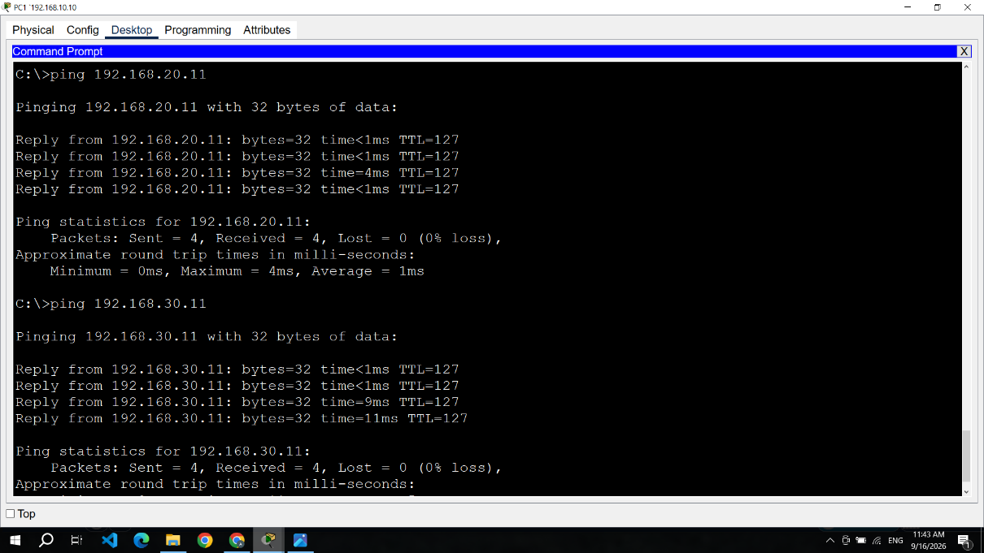
Figure 6 InterVLAN Connectivity Test
The successful ping responses demonstrate that traffic can be routed between VLAN 10, VLAN 20, and VLAN 30 through the Router-on-a-Stick configuration.

8. TROUBLESHOOTING CASE STUDY
A deliberate configuration error was introduced into the network to simulate a real-world troubleshooting situation. The purpose of this exercise was to identify the cause of an inter-VLAN connectivity failure, correct the configuration, and verify that normal communication was restored.

8.1 Problem Introduction
The router subinterface for VLAN 20 was originally configured with the correct IEEE 802.1Q VLAN ID of 20. During the troubleshooting exercise, the encapsulation VLAN ID was deliberately changed from 20 to 25.
The IP address of the VLAN 20 gateway remained unchanged at 192.168.20.1; however, the router was no longer using the correct VLAN tag for traffic belonging to VLAN 20.

8.2 Incorrect Configuration
The following incorrect configuration was introduced on R1:
interface g0/0.20
encapsulation dot1Q 25
ip address 192.168.20.1 255.255.255.0
Figure 7 Incorrect VLAN Encapsulation Configuration
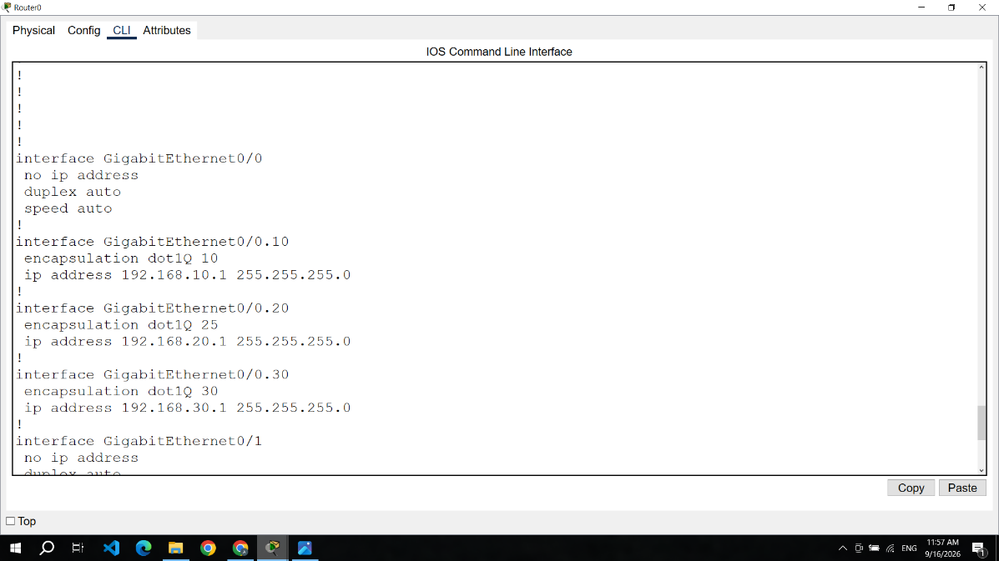
Figure 7 Incorrect VLAN Encapsulation Configuration
The configuration shows that subinterface G0/0.20 was incorrectly associated with VLAN ID 25 instead of VLAN ID 20.

8.3 Connectivity Failure
After introducing the incorrect encapsulation, a ping was performed from PC1 in VLAN 10 to PC3 in VLAN 20. The connectivity test failed because the router was not correctly processing traffic for VLAN 20.
Figure 8Figure 8. Failed Inter-VLAN Connectivity Test
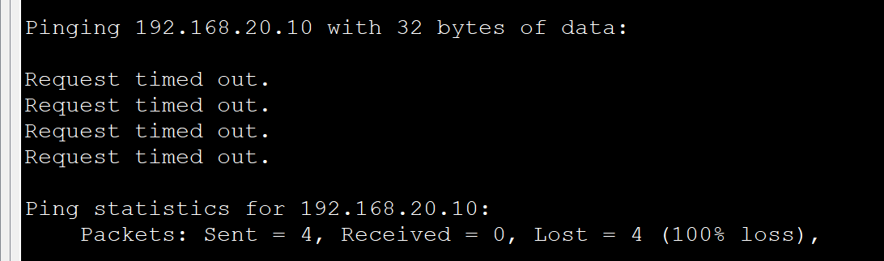
Figure 8 Failed Inter-VLAN Connectivity Test

8.4 Configuration Correction
The configuration was reviewed to identify the cause of the connectivity failure. The VLAN 20 subinterface was found to contain an incorrect IEEE 802.1Q encapsulation value. The VLAN ID was corrected from 25 to 20.
The following commands were used to correct the configuration:
enable
configure terminal
interface g0/0.20
encapsulation dot1Q 20
end
Figure 9. Correction of VLAN Encapsulation Configuration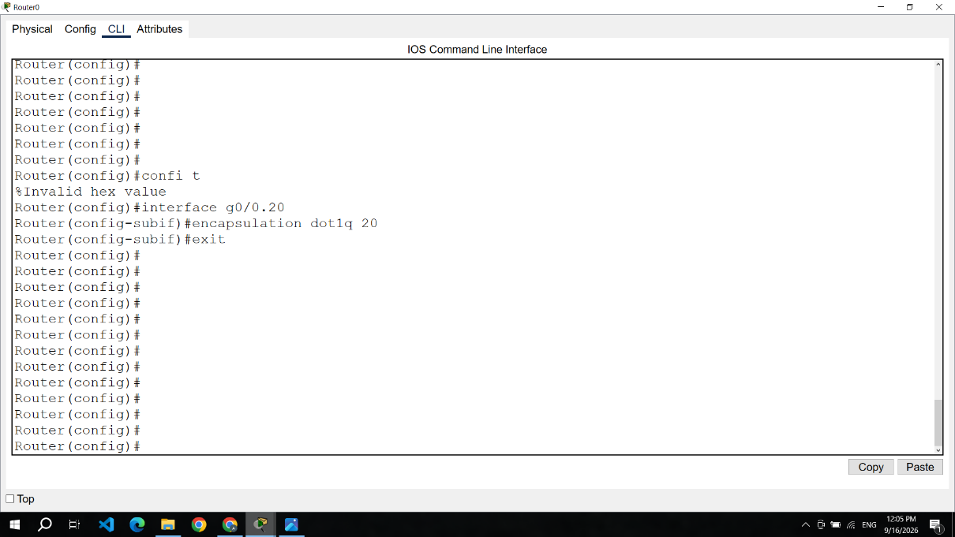
Figure 9 Correction of VLAN Encapsulation Configuration
The corrected configuration restores the association between router subinterface G0/0.20 and VLAN 20.

8.5 Verification After Correction
After correcting the encapsulation configuration, the connectivity test was repeated from PC1 in VLAN 10 to PC3 in VLAN 20.
Figure 10. Successful Inter-VLAN Connectivity After Correction
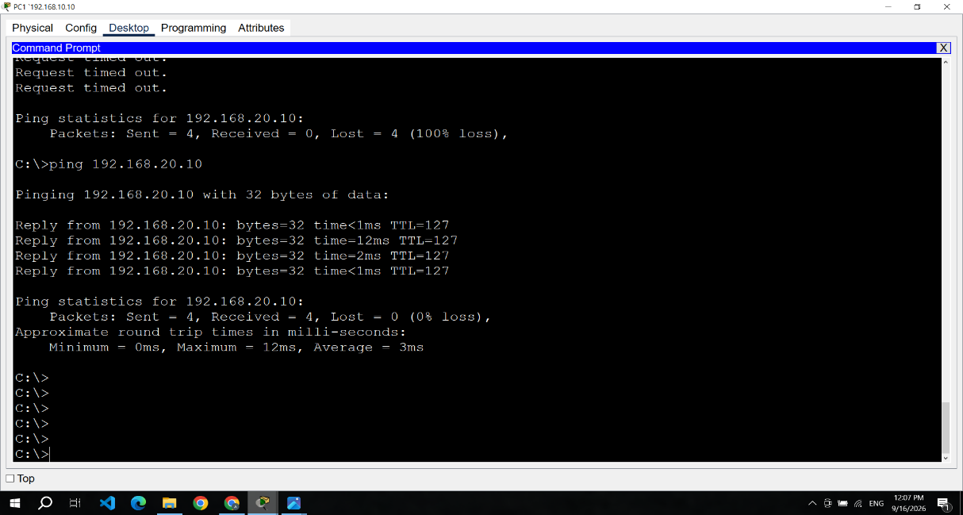
Figure 10 Successful Inter-VLAN Connectivity After Correction
The successful ping responses confirm that inter-VLAN connectivity was restored after correcting the VLAN encapsulation.

8.6 Root Cause Analysis
The root cause of the connectivity failure was an incorrect VLAN ID configured on router subinterface G0/0.20. The subinterface was configured with VLAN ID 25 while the corresponding switch VLAN was VLAN 20.
Because the VLAN tags did not match, traffic belonging to VLAN 20 could not be correctly processed by the router. Correcting the encapsulation to dot1Q 20 restored proper VLAN identification and inter-VLAN communication.
This troubleshooting exercise demonstrates the importance of checking VLAN IDs, trunk configuration, router subinterfaces, and connectivity tests when diagnosing inter-VLAN routing problems.

9. RESULTS
The small enterprise network was successfully designed and implemented in Cisco Packet Tracer. The completed configuration achieved the intended network segmentation and communication requirements defined for the project.
The following results were achieved:
- Successful VLAN Segmentation
Three VLANs were successfully created for the HR, IT, and Finance departments. Each department was assigned to a separate broadcast domain.
- Successful Access Port Assignment
All six PCs were connected to the appropriate switch access ports and assigned to their corresponding VLANs.
- Successful Trunk Configuration
The link between SW1 Fa0/1 and R1 G0/0 was successfully configured as an IEEE 802.1Q trunk, allowing traffic from multiple VLANs to traverse the connection.
- Successful Router-on-a-Stick Implementation
Router subinterfaces were configured for VLAN 10, VLAN 20, and VLAN 30, providing the required default gateways.
- Successful Inter-VLAN Communication
Devices belonging to different VLANs were able to communicate successfully through the router after the configuration was completed.
- Successful Troubleshooting
A deliberate VLAN encapsulation error was identified and corrected. Connectivity was successfully restored after changing the incorrect VLAN ID from 25 to 20.
Overall, the project successfully demonstrates the practical implementation of VLAN segmentation, 802.1Q trunking, Router-on-a-Stick, inter-VLAN routing, network verification, and basic troubleshooting in a simulated enterprise environment.

10. FUTURE IMPROVEMENTS
The current project provides a foundation in enterprise networking and can be expanded in future projects by introducing additional networking, network security, automation, and cloud technologies.

10.1 Dynamic Host Configuration Protocol (DHCP)
DHCP can be implemented to automatically assign IP addresses, subnet masks, default gateways, and other network parameters to end devices.

10.2 Dynamic Routing
A dynamic routing protocol such as OSPF can be introduced in a multi-router topology to provide automatic route discovery and improve network scalability.

10.3 Network Security
Future projects can introduce network security technologies such as Access Control Lists (ACLs), firewalls, secure management using SSH, VPNs, network segmentation, and basic intrusion detection concepts.

10.4 Network Address Translation
NAT can be implemented to allow internal private IP addresses to communicate with external networks through a router.

10.5 Network Redundancy
Additional switches, routers, and redundant links can be introduced to explore network availability, redundancy, and protocols such as Spanning Tree Protocol (STP) and EtherChannel.

10.6 Network Automation
Python and network automation tools can be introduced to automate repetitive configuration, monitoring, and network management tasks.

10.7 Cloud Networking
Cloud networking concepts such as virtual networks, subnets, routing tables, VPN connectivity, load balancing, and cloud security controls can be explored to extend the project toward modern enterprise network environments.
These improvements provide a pathway from fundamental networking concepts toward more advanced areas including enterprise networking, network security, network automation, and cloud networking.

