1. Give the output for the following commands:
a. echo “hello world”
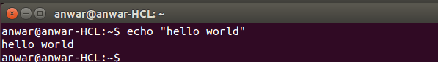

b. List all the files(hidden included) present in the current directory in long format
displaying files in reverse order , sorted based on the modification time .
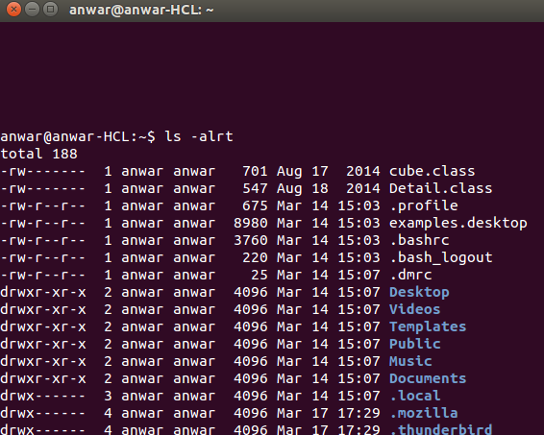

c. Change your current password.
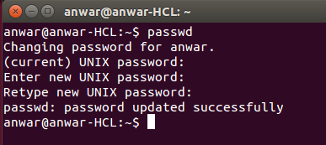

d. How to get the current date
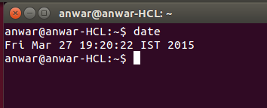

e. How to get the current logged in user
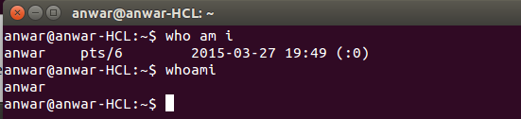

f. How to get the current working directory.
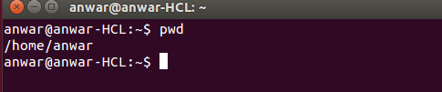

g. How to get the list of all commands that you have typed so far
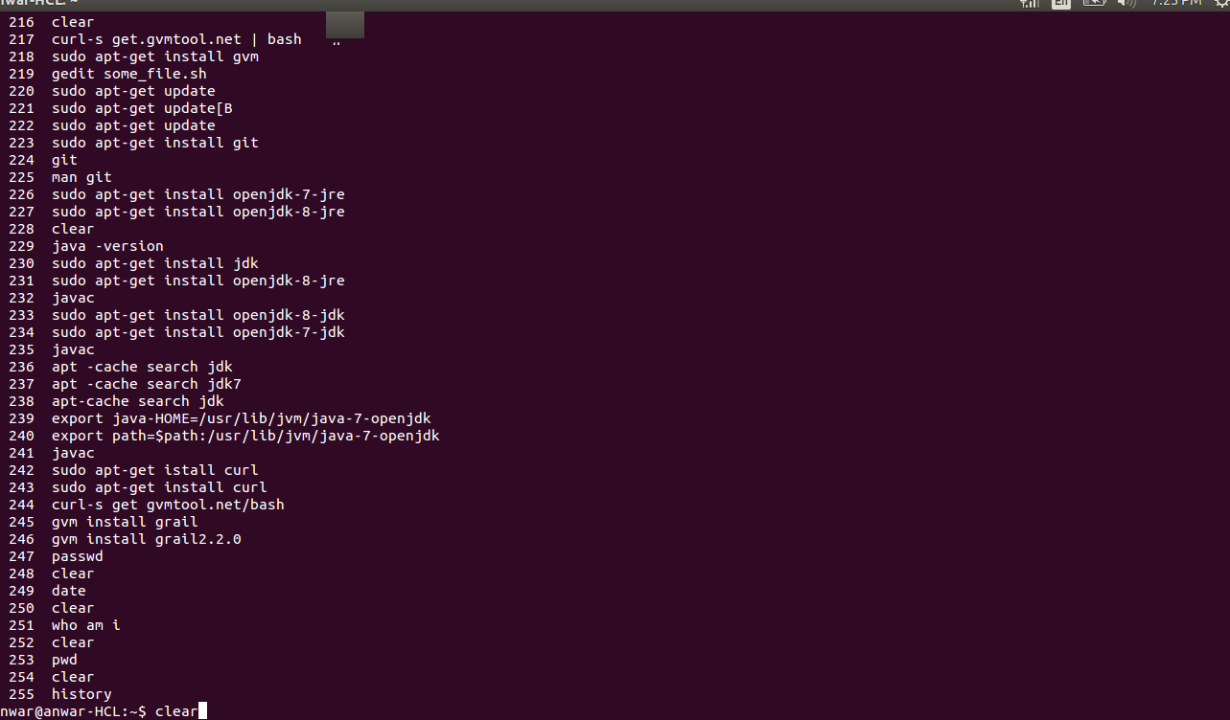

h. To get the information on the tcp ports
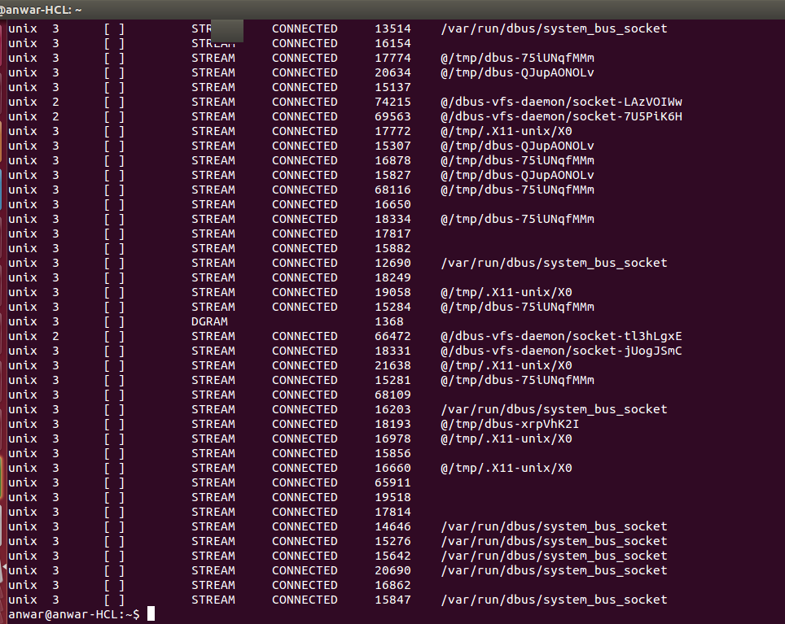

i. To get the information about the running processes.
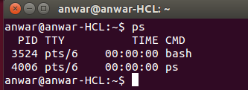

j. Search for a word in a file. (Hint grep)
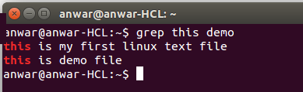

k. Search for a specific process. (Hint use | with ps )
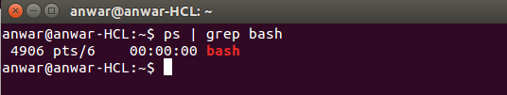

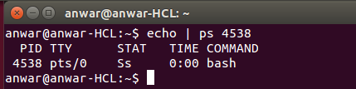

2. Create a directory “exercises” inside your home directory.​cd to this new directory.
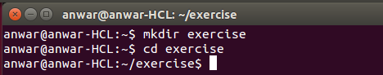

3. Create 3 empty files , file1.txt,file2.txt,file3.txt in current directory (exercises).
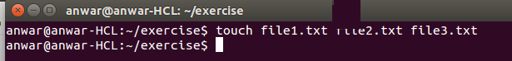

4. Add some text to file1.txt and copy this to ~/exercises/files.

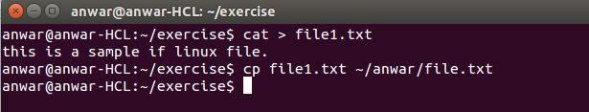

5. Copy the entire ​exercise​ directory to this files​ directory.
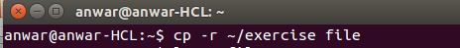

6. Create a symlink “testlink” in your home directory that points to this file1.txt i.e.
~/exercises/files/file1.txt.
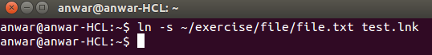

7. Try creating a hard link in your home directory that points to “ files” directory .
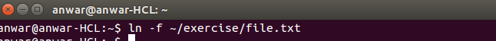

8. Difference between soft and hard link.
HARD LINKS
a) Hard link cannot be created for directories (folders). Hard link can only be created for a file.
b) Removing the original file that your hard link points to does not remove the hard link itself; the hard link still provides the content of the underlying file.
c) If you remove the hard link itself, the original file will stay intact.
SOFT LINKS
a) Symbolic links or symlinks can link to a directory (folder).
b) Removing the original file does not remove the attached symbolic link or symbolic link, but without the original file, the symbolic link is useless (the same concept like Windows shortcut).
c) If you remove the symbolic link itself, the original file will stay intact.

9.Change permissions for files directory such that nobody other than the user who created the directory, can write/update anything in that directory.
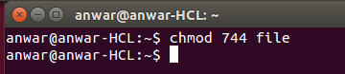

10. Create a new user “test”.
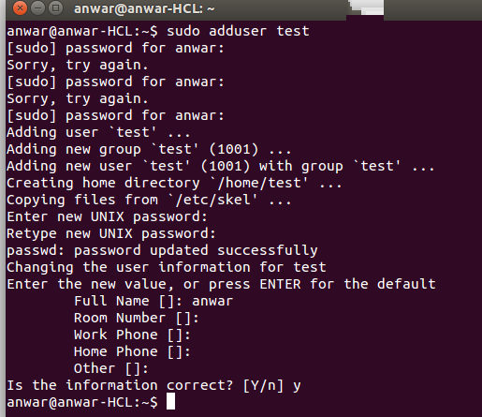
11. Change the owner of​ file1.txt to test
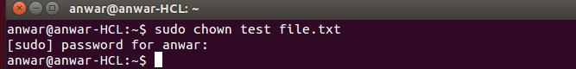

12. create following directory structure with single command
home
|john
|work
|scripts
|bash

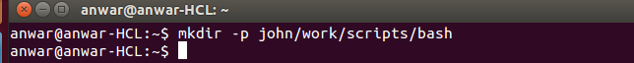

Assume that you are currently in ‘home’ directory.
13. Try deleting the ~/exercises/files/exercises directory. See what happens.
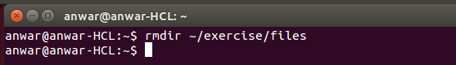

14. A file named employees.odt has a mode of rwr r . If John is not the file's owner but is
a member of the group that owns this file, what can he do with it?

Ans:-He can only Read the File.

15. Create an alias for clearing the screen.

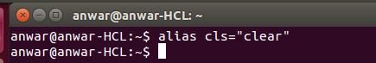

16. Create a tar archive of all the files in the current directory.
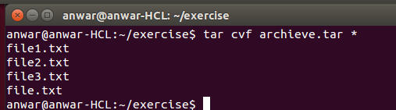

17. How to find if a jar file contains a particular class file?
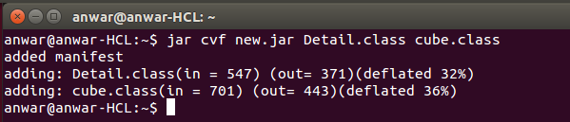

18. How to find all jars with given classname.
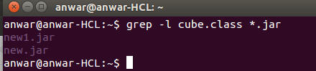

19. How to find files greater than a certain size 50. How do u add and remove a variable in the shell environment.
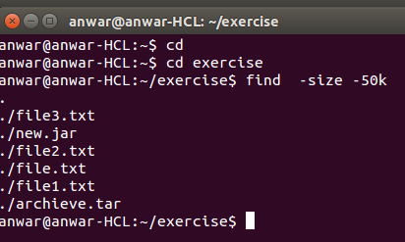

20. How do u add and remove a variable in the shell environment

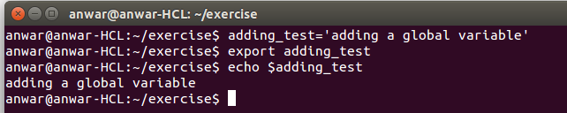

21. Install opensshserver on your system
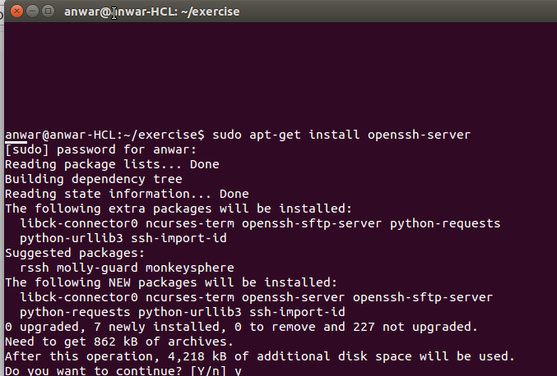
22. try remote login to your friend’s machine using ssh.
23. Copy some files from your machine to your friend’s machine. (Hint scp)

