HTML and CSS EXERCISE
Solution 1.
<html>
<head>
<title>data item list</title>
<style>
table, th, td
{

border-collapse:collapse;
font-size: 50px;
}
.forground1
{
background-color:#0000FF;
}
.forground2
{
background-color: #6495ed;
}
.forground3
{
background-color: #b0c4de;
}
</style>
</head>

<body>
<div>
<center>
<table>
<tr class=forground1>
<th>Item Name</th>
<th>Price</th>
</tr>
<tr class=forground2>
<td>Laptop</td>
<td>22,000</td>
</tr>
<tr class=forground3>
<td>Monitor</td>
<td>10,200</td>
</tr>
<tr class=forground2>
<td>Printer</td>
<td>7,100</td>
</tr>
<tr class=forground3>
<td><br></td>
<td><br></td>
</tr>
</table>
</center>
</div>
</body>
</html>

OUTPUT:-
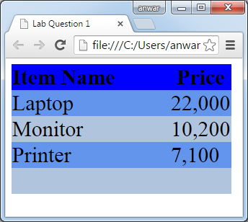

Solution 2:-
<html>
<head>
<title> Lab Question 2</title>

</head>
<body>
<div>
<ul type=disc>
<li>Comedies</li>
<ul type=circle>
<li><a href="#">As You Like It</a></li>
<li>All's Well That Ends Well</li>
<li>A Midsummer Night's dream</li>
<li>Twelfth Night</li>
</ul>
<li>Tragedies</li>
<ul type="circle">
<li><a href="#">Hamlet</a></li>
<li>Macbeth</li>
<li>Romeo and Juliet</li>
</ul>
<li>Histories</li>
<ul type=circle>
<li>Henry IV(<a href="#">email</a>)
<ul type=square>
<li>Part I</li>
<li>Part II</li>
</ul>
<li><a href="#">Henry V</a></li>
<li>Richard II</li>
</ul>
</ul>
</div>
</body>
</html>
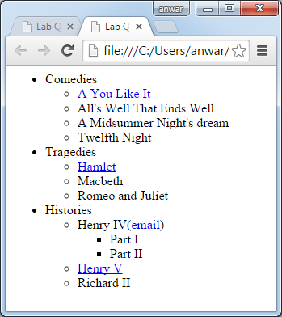

Solution 3:-
<html>
<head>
<style>
.align
{
float:left;
width:150px;
}
.lalign
{
clear:both;
}
</style>
</head>
<body>
<div class="lalign">
<div class="align">
<img src="coke.jpg" width=70% height=15%>
</div>
<div class="align">Coke<br>
200ml<br>
10% sugar<br>
newly launched<br>
</div>
</div>
<div class="lalign">
<div class="align">
<img src="pepsi.jpg" width=70% height=15%>
</div>
<div class="align">Pepsi<br>
200ml<br>
20% sugar<br>
Comming Soon<br>
</div>
</div>
<div class="lalign">
<div class="align">
<img src="lays.jpg" width=70% height=15%>
</div>
<div class="align">LAYS<br>
100mg<br>
Good Taste<br>
Launched<br>
</div>
</div>
</body>
</html>
OUTPUT:-
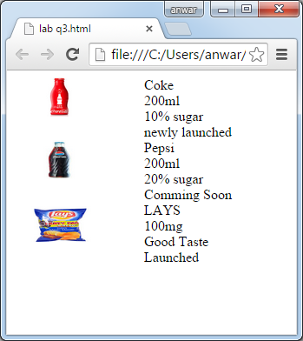

Solution 4:-
<html>
<head>
</head>
<body>
<div>
<form action="lab q1.html" method=post>
Name:<input type="text"><br/><br/>
Email:<input type="text"><br/><br/>
<input type="checkbox" checked>Subscribe to the News letter<br/><br/>
Format of the Email<br/><br/>
<input type="radio" name=g1 checked>HTML<br/><br/>
<input type="radio" name=g1>Plain Text
<br><br/>
Type of Subscription you want<br><br/>
<select>
<option>Standard-Free</option>
<option>Premium</option>
</select>
<br/><br/>
Comment to the Editor<br/>
<textarea rows="10" cols=30></textarea>
<br/><br/>
<input type=submit value=submit>
</div>
</body></html>
OUTPUT:-
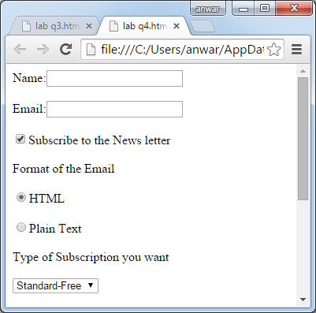

Solution 5 : -
<html>
<head>
<style>
.box1{
background-color:yellow;
position:absolute;
left: 50px;
top: 10px;
width:100px;
height:100px;
z-index:99;
}
.box2{
opacity:0.5;
background-color:blue;
position:absolute;
left: 80px;
top: 70px;
width:100px;
height:100px;
z-index :100;
}
</style>
</head>
<body>
<div>
<div class="box1"></div>
<div class="box2">TEXT</div>
</div>
</body>
</html>
OUTPUT:-
