git init (this is to initialize the .git folder in local system)

git add file name(to add the file name)

git status(to check the status)

git commit -m ""(to commit the code)

git push origin main/master (to push the code to repo)

git log

vi file name to create a new file ,you can add in this file, I to insert some data

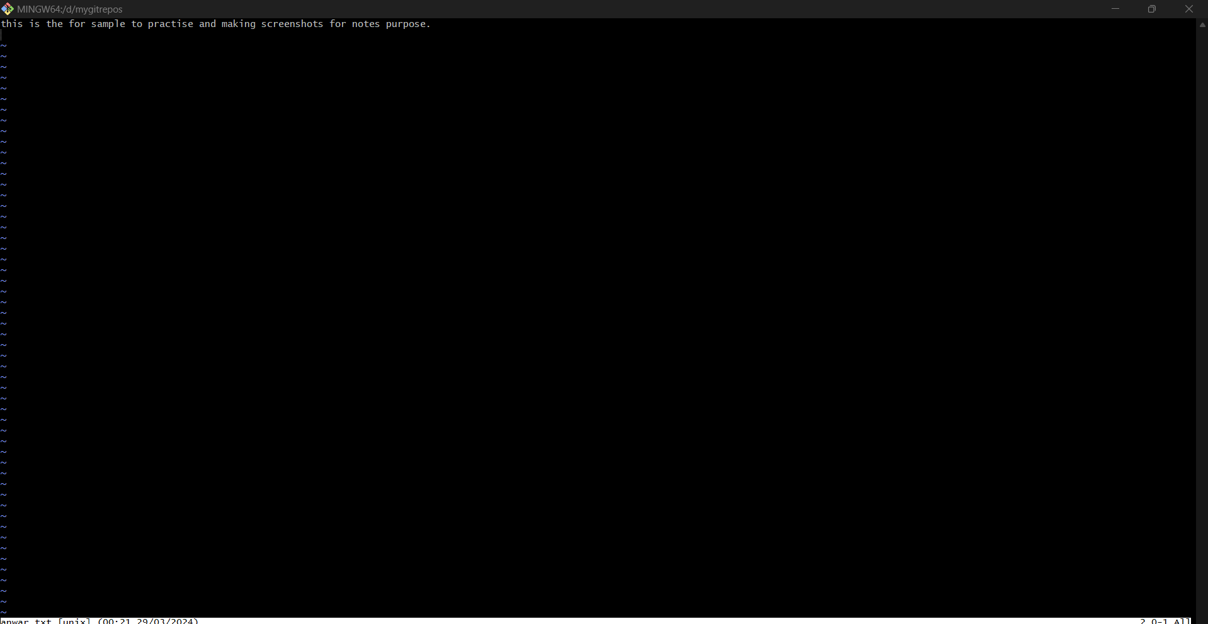

To save and exit esc and :wq enter

touch file name (to create a empty file)

touch file name(to check what is inside the file)

====================================================================

if you are moivng already cloned code from git make sure there should not be git init ,it will acuses error to commit and push code

refer this:

here I have cloned code from some other repos ,so it will be with .git which is not visble

