SAS Application – Functional and Access Overview

# 1. Overview

This document provides a high-level overview of the SAS application currently hosted on-premises in the Chennai data center. This SAS environment is classified as an End User Computing (EUC) application. It is actively used by multiple business teams to process, analyze, and manage large datasets critical for operational and regulatory needs.

# 2. Purpose and Core Functionality

The on-prem SAS server supports high-volume data operations such as:

* - Import/export of large flat files (greater than 10 GB)  
  - Data transformation using SAS macros and procedures  
  - Generation of reports and campaign analytics  
  - Regulatory data preparation and downstream sharing  
  - Secure access and control via static Unix logins (a-prefixed IDs)

# 3. Access Mechanisms

There are currently two access pathways available to users for interacting with the SAS backend server:

a. Desktop SAS:  
 - Users initiate remote submit sessions via Unix login from their personal laptops  
 - Large flat files are processed offline  
 - Data is downloaded locally after execution

b. SAS Viya:  
 - Users log in through a browser with MFA  
 - Remote submit of jobs and file operations to/from the SAS backend server  
 - Data is processed and downloaded via the Viya interface

# 4. Transition to SAS Viya Access Only

Currently, both Desktop SAS and SAS Viya access methods are active. However, from August onward, Desktop SAS access is expected to be deprecated. Post this transition, SAS Viya will remain the sole interface for accessing the SAS backend server, enhancing central governance, user tracking, and scalability.

# 5. Architecture Diagram

Refer to the diagram below for a visual representation of the current SAS setup and user interaction flows:

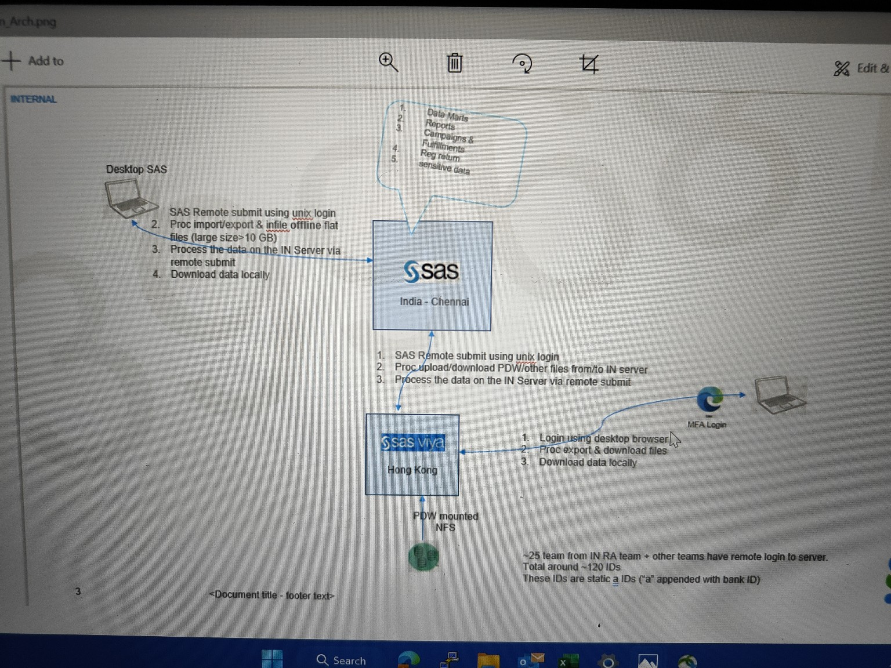

# 6. User Base and Access Details

Approximately 25 teams from the IN RA function and other units access the SAS backend. The total user base is around 120 IDs. All access is provisioned via static Unix accounts that are prefixed with 'a' followed by the Bank ID.