**Path2Week2**

**Our task is to design an algorithm to help with social distancing**

I am going to do flowcharts figure (1,2) that will explain how our design will work As we assume that each user holds a phone with an app to send data to a database or a robot, after that we required this because we need to store a number that gets incremented or decremented depending on the number of users in range of the Bluetooth beacon in a specific area

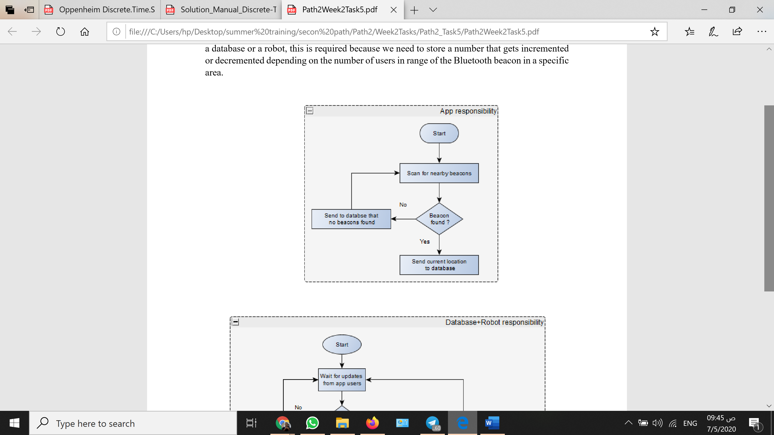

Figure (1)

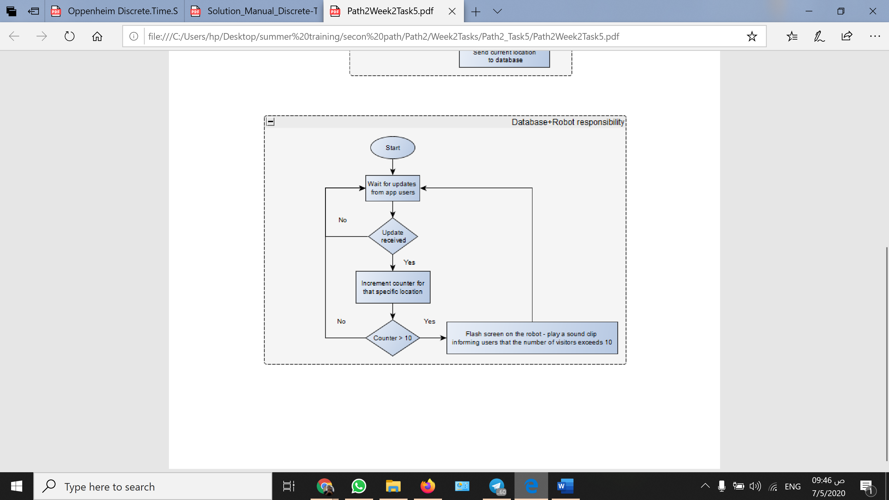

Figure (2)