Anwar
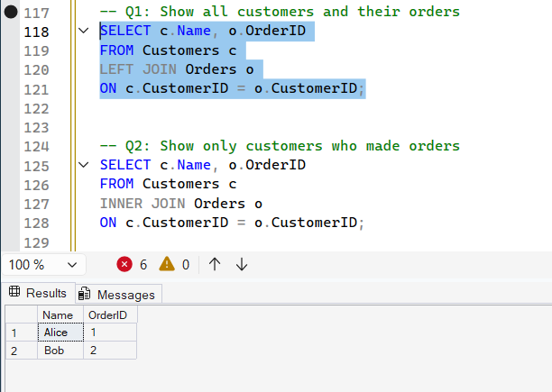
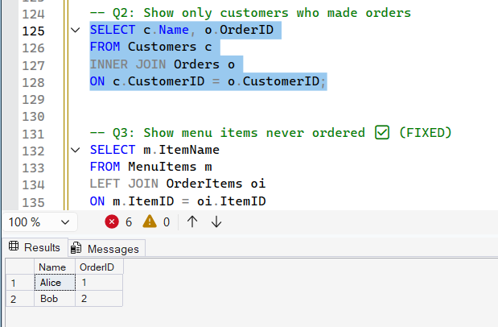
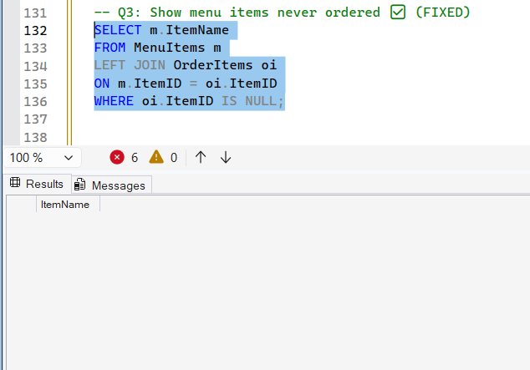
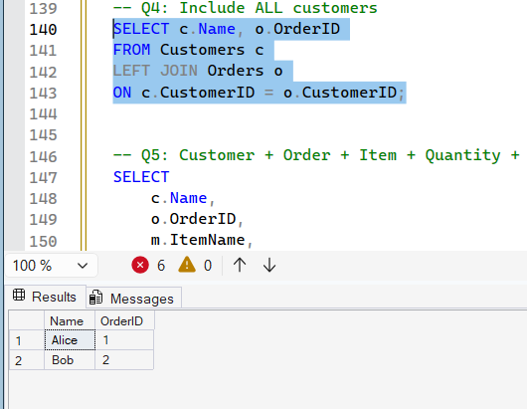
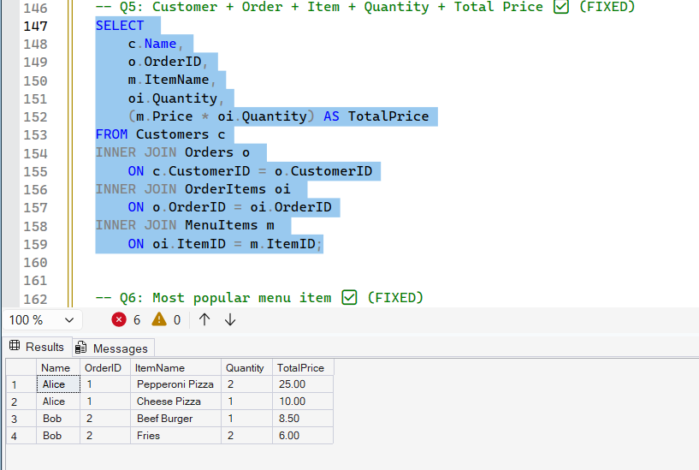
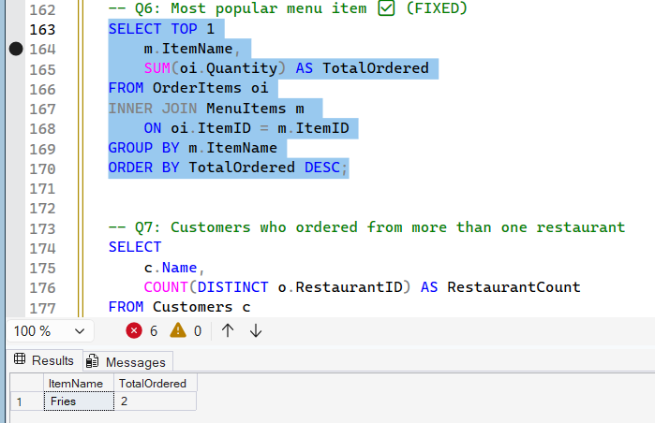
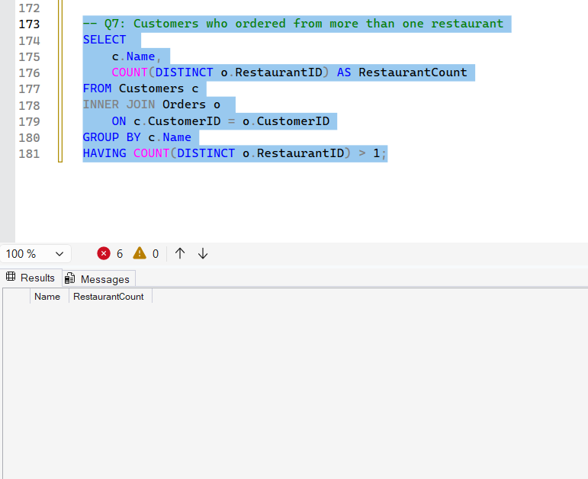
# food
-- Create Database
CREATE DATABASE FoodDeliveryDB;

-- =========================
-- Create Tables
-- =========================

CREATE TABLE Customers (
CustomerID INT PRIMARY KEY IDENTITY(1,1),
Name VARCHAR(100),
Email VARCHAR(100),
Phone VARCHAR(20)
);

CREATE TABLE Restaurants (
RestaurantID INT PRIMARY KEY IDENTITY(1,1),
Name VARCHAR(100),
Location VARCHAR(100)
);

CREATE TABLE MenuItems (
ItemID INT PRIMARY KEY IDENTITY(1,1),
RestaurantID INT,
ItemName VARCHAR(100),
Price DECIMAL(10,2),
FOREIGN KEY (RestaurantID) REFERENCES Restaurants(RestaurantID)
);

CREATE TABLE Orders (
OrderID INT PRIMARY KEY IDENTITY(1,1),
CustomerID INT,
RestaurantID INT,
OrderDate DATETIME DEFAULT GETDATE(),
FOREIGN KEY (CustomerID) REFERENCES Customers(CustomerID),
FOREIGN KEY (RestaurantID) REFERENCES Restaurants(RestaurantID)
);

CREATE TABLE OrderItems (
OrderItemID INT PRIMARY KEY IDENTITY(1,1),
OrderID INT,
ItemID INT,
Quantity INT,
FOREIGN KEY (OrderID) REFERENCES Orders(OrderID),
FOREIGN KEY (ItemID) REFERENCES MenuItems(ItemID)
);

-- =========================
-- Insert Sample Data
-- =========================

INSERT INTO Customers (Name, Email, Phone)
VALUES
('Alice', 'alice@email.com', '123456789'),
('Bob', 'bob@email.com', '987654321');

INSERT INTO Restaurants (Name, Location)
VALUES
('Pizza Place', 'New York'),
('Burger House', 'Chicago');

INSERT INTO MenuItems (RestaurantID, ItemName, Price)
VALUES
(1, 'Pepperoni Pizza', 12.50),
(1, 'Cheese Pizza', 10.00),
(2, 'Beef Burger', 8.50),
(2, 'Fries', 3.00);

INSERT INTO Orders (CustomerID, RestaurantID)
VALUES
(1, 1),
(2, 2);

INSERT INTO OrderItems (OrderID, ItemID, Quantity)
VALUES
(1, 1, 2),
(1, 2, 1),
(2, 3, 1),
(2, 4, 2);

-- =========================
-- Queries
-- =========================

-- 1. Orders with customer names
SELECT
o.OrderID,
c.Name AS CustomerName,
r.Name AS RestaurantName,
o.OrderDate
FROM Orders o
JOIN Customers c ON o.CustomerID = c.CustomerID
JOIN Restaurants r ON o.RestaurantID = r.RestaurantID;

-- 2. Items in each order
SELECT
o.OrderID,
m.ItemName,
oi.Quantity,
m.Price,
(oi.Quantity * m.Price) AS TotalPrice
FROM OrderItems oi
JOIN Orders o ON oi.OrderID = o.OrderID
JOIN MenuItems m ON oi.ItemID = m.ItemID
ORDER BY o.OrderID;

-- 3. Total price per order
SELECT
o.OrderID,
SUM(oi.Quantity * m.Price) AS OrderTotal
FROM OrderItems oi
JOIN Orders o ON oi.OrderID = o.OrderID
JOIN MenuItems m ON oi.ItemID = m.ItemID
GROUP BY o.OrderID;

-- Q1: Show all customers and their orders
SELECT c.Name, o.OrderID
FROM Customers c
LEFT JOIN Orders o
ON c.CustomerID = o.CustomerID;

-- Q2: Show only customers who made orders
SELECT c.Name, o.OrderID
FROM Customers c
INNER JOIN Orders o
ON c.CustomerID = o.CustomerID;

-- Q3: Show menu items never ordered ✅ (FIXED)
SELECT m.ItemName
FROM MenuItems m
LEFT JOIN OrderItems oi
ON m.ItemID = oi.ItemID
WHERE oi.ItemID IS NULL;

-- Q4: Include ALL customers
SELECT c.Name, o.OrderID
FROM Customers c
LEFT JOIN Orders o
ON c.CustomerID = o.CustomerID;

-- Q5: Customer + Order + Item + Quantity + Total Price ✅ (FIXED)
SELECT
c.Name,
o.OrderID,
m.ItemName,
oi.Quantity,
(m.Price * oi.Quantity) AS TotalPrice
FROM Customers c
INNER JOIN Orders o
ON c.CustomerID = o.CustomerID
INNER JOIN OrderItems oi
ON o.OrderID = oi.OrderID
INNER JOIN MenuItems m
ON oi.ItemID = m.ItemID;

-- Q6: Most popular menu item ✅ (FIXED)
SELECT TOP 1
m.ItemName,
SUM(oi.Quantity) AS TotalOrdered
FROM OrderItems oi
INNER JOIN MenuItems m
ON oi.ItemID = m.ItemID
GROUP BY m.ItemName
ORDER BY TotalOrdered DESC;

-- Q7: Customers who ordered from more than one restaurant
SELECT
c.Name,
COUNT(DISTINCT o.RestaurantID) AS RestaurantCount
FROM Customers c
INNER JOIN Orders o
ON c.CustomerID = o.CustomerID
GROUP BY c.Name
HAVING COUNT(DISTINCT o.RestaurantID) > 1;

