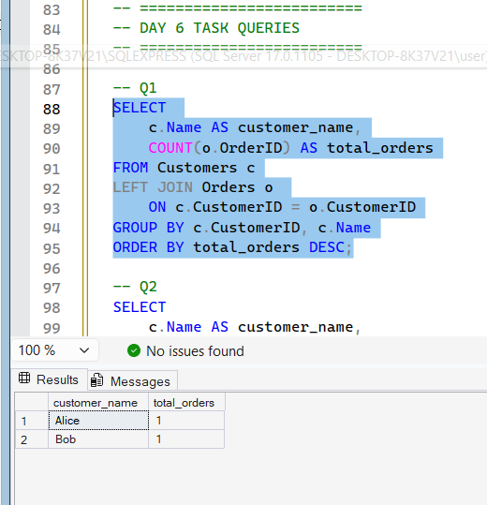
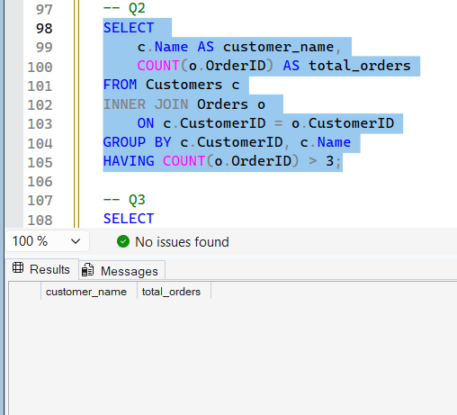
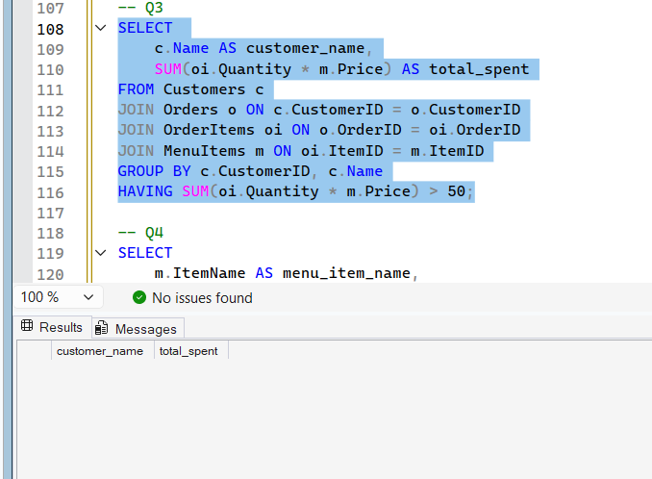
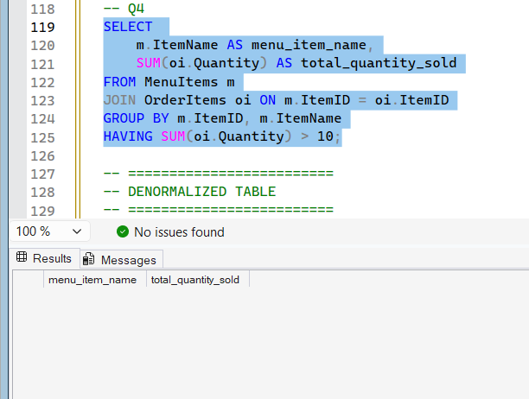
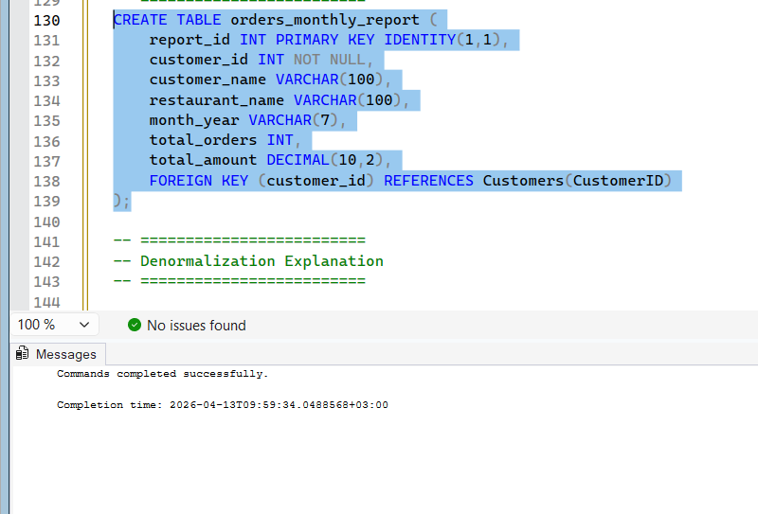

USE FoodDeliveryDB;

-- =========================
-- DAY 6 TASK QUERIES
-- =========================

-- Q1
SELECT
c.Name AS customer_name,
COUNT(o.OrderID) AS total_orders
FROM Customers c
LEFT JOIN Orders o
ON c.CustomerID = o.CustomerID
GROUP BY c.CustomerID, c.Name
ORDER BY total_orders DESC;

-- Q2
SELECT
c.Name AS customer_name,
COUNT(o.OrderID) AS total_orders
FROM Customers c
INNER JOIN Orders o
ON c.CustomerID = o.CustomerID
GROUP BY c.CustomerID, c.Name
HAVING COUNT(o.OrderID) > 3;

-- Q3
SELECT
c.Name AS customer_name,
SUM(oi.Quantity * m.Price) AS total_spent
FROM Customers c
JOIN Orders o ON c.CustomerID = o.CustomerID
JOIN OrderItems oi ON o.OrderID = oi.OrderID
JOIN MenuItems m ON oi.ItemID = m.ItemID
GROUP BY c.CustomerID, c.Name
HAVING SUM(oi.Quantity * m.Price) > 50;

-- Q4
SELECT
m.ItemName AS menu_item_name,
SUM(oi.Quantity) AS total_quantity_sold
FROM MenuItems m
JOIN OrderItems oi ON m.ItemID = oi.ItemID
GROUP BY m.ItemID, m.ItemName
HAVING SUM(oi.Quantity) > 10;

-- =========================
-- DENORMALIZED TABLE
-- =========================
CREATE TABLE orders_monthly_report (
report_id INT PRIMARY KEY IDENTITY(1,1),
customer_id INT NOT NULL,
customer_name VARCHAR(100),
restaurant_name VARCHAR(100),
month_year VARCHAR(7),
total_orders INT,
total_amount DECIMAL(10,2),
FOREIGN KEY (customer_id) REFERENCES Customers(CustomerID)
);

-- =========================
-- Denormalization Explanation
-- =========================

-- Why is this table denormalized?
-- This table is denormalized because it stores precomputed and duplicated data
-- (such as customer_name, restaurant_name, total_orders, and total_amount)
-- instead of retrieving it using JOINs and aggregations from multiple tables.
-- It combines data from Customers, Restaurants, Orders, and OrderItems into one table.

-- Which columns here are redundant with other tables?
-- The following columns already exist or can be derived from other tables:
-- customer_name -> موجود في جدول Customers
-- restaurant_name -> موجود في جدول Restaurants
-- total_orders -> يمكن حسابه من جدول Orders
-- total_amount -> يمكن حسابه من OrderItems + MenuItems

-- What is the main advantage of this table for reports?
-- The main advantage is performance (speed).
-- Reports and dashboards can read data directly from this table
-- without using complex JOINs, GROUP BY, or SUM operations,
-- which makes queries much faster.

-- What is the main disadvantage and how should it be kept up-to-date?
-- The main disadvantage is data inconsistency (data may become outdated or incorrect).
-- Since the data is duplicated, any change in the original tables
-- will not automatically reflect here.

-- To keep it updated:
-- 1. Batch Jobs:
-- Run scheduled jobs (daily/monthly) to recalculate and refresh the table.

-- 2. Triggers:
-- Automatically update the table when INSERT/UPDATE/DELETE happens.
-- Provides real-time accuracy but may slow down transactions.

-- 3. Stored Procedures:
-- Recalculate and update data when manually or programmatically executed.
-- Often used together with scheduled jobs.

