Nama : Muhammad Anwar Firdaus

NIK : 0524873

Task : Latihan Level 2 IDP PostgreSQL

1. **Level 1 - 7 Insert Tabel**

1. **Level 1 - 8 Update Tabel**

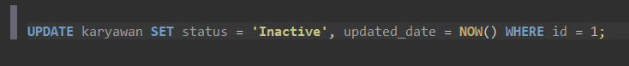

1. **Level 1 - 9 Delete Tabel**



1. **Level 1 - 10 Alter table**



1. **Level 1 - 11 Drop Tabel**



1. **Level 1 - 12 Truncate Tabel**

1. **Level 2 - 1 Select**



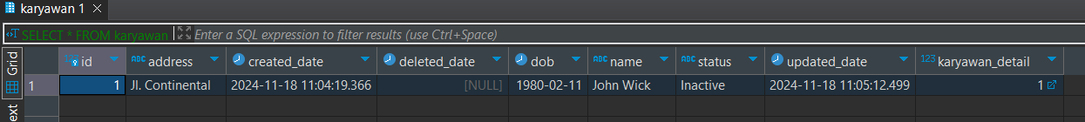

1. **Level 2 - 2 Alias , Where dan Order By**

1. **Level 2 - 3 Limit dan Offset**



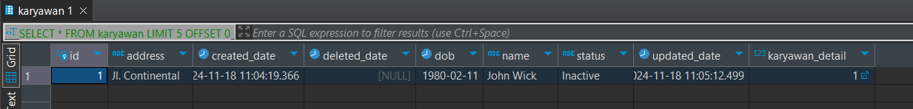

1. **Level 2 - 4 Union**

1. **Level 2 - 5 Union All**

1. **Level 2 - 6 Inner Join**

****

1. **Level 2 - 7 Left Join**

1. **Level 2 - 8 Right Join**

1. **Level 2 - 9 Full Join**

1. **Level 2 - 10 Fungsi Skalar**



1. **Level 2 - 11 Fungsi Text**



1. **Level 2 - 12 Fungsi Agregate**



1. **Level 2 - 13 Subquery**



1. **Level 2 - 14 Group By**



1. **Level 2 - 15 Group By & Having**

1. **Level 2 - 16 Operator Perbandingan**





1. **Level 2 - 17 Operator Logika**



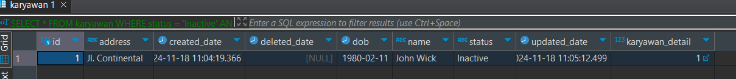

1. **Level 2 - 18 Level 2 - 1IN**

1. **Level 2 - 19 Like**



1. **Level 2 - 20 Between**



1. **Level 2 - 21 Case When**

