Login and Signup:

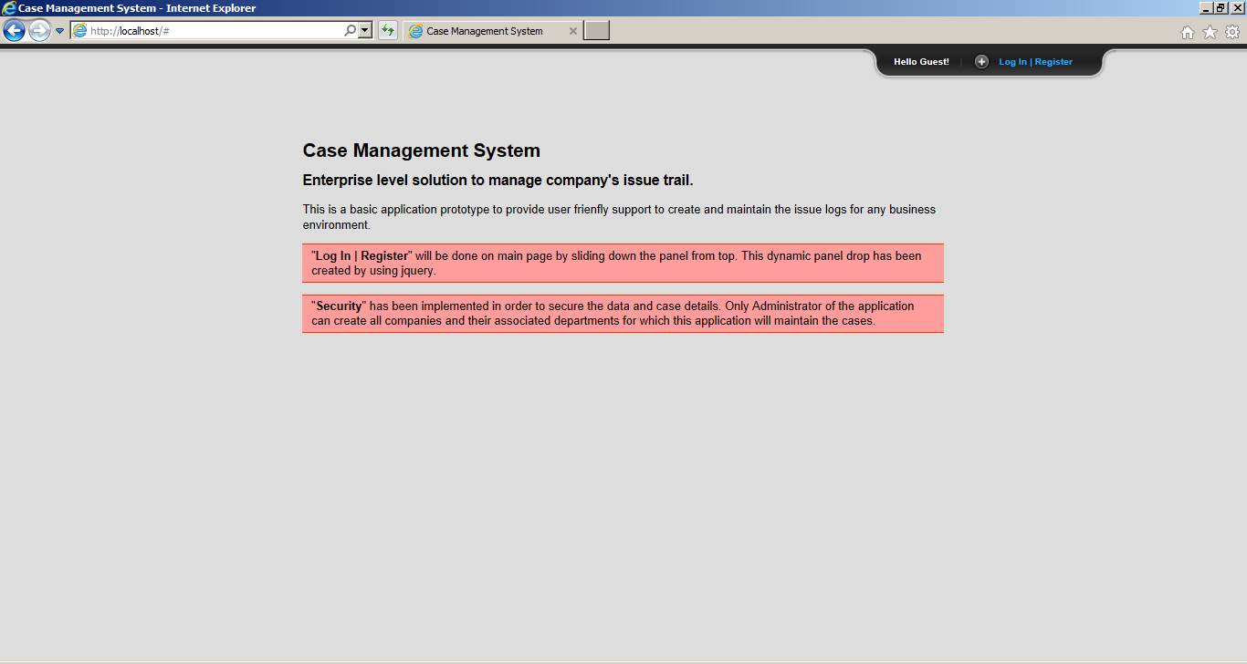

Click on login | Register on top right cornet to slide down the panel for action:

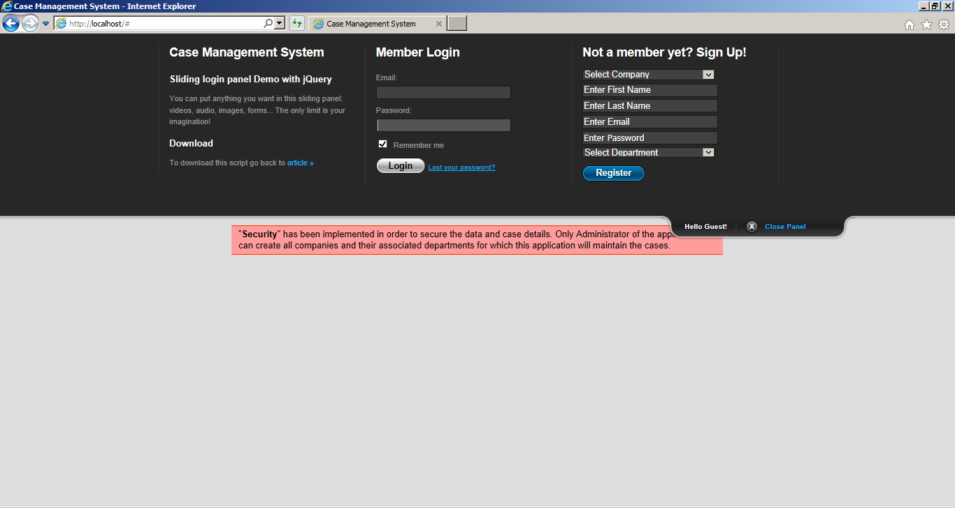

Administrator Login:

Login ID: [admin@anwarhaq.biz](mailto:admin@anwarhaq.biz)

Password: admin

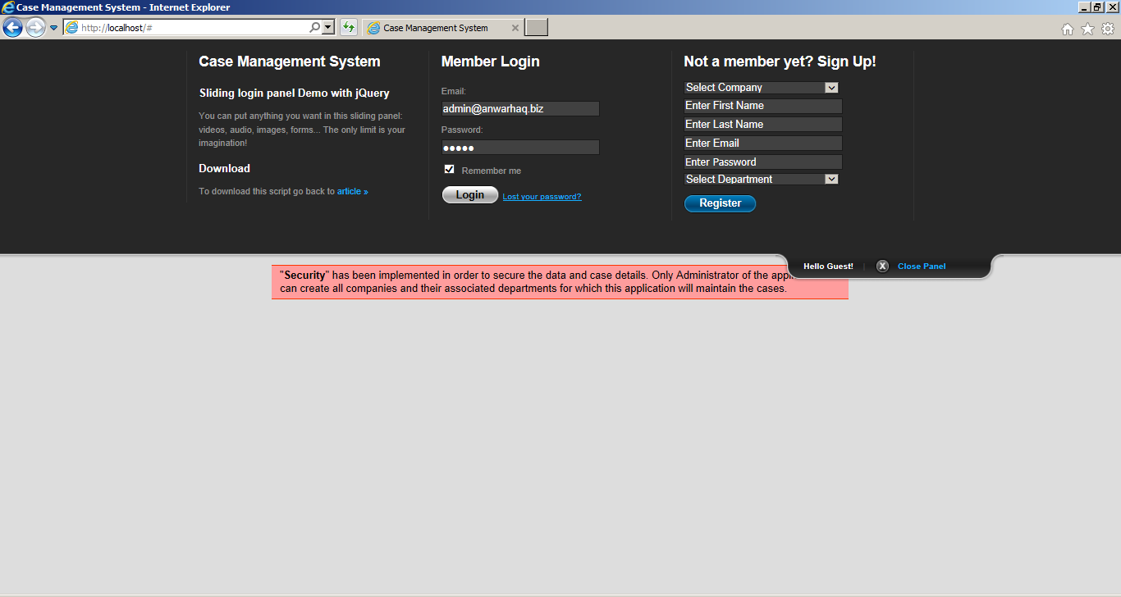

When login you will see list op options available for Administrator:

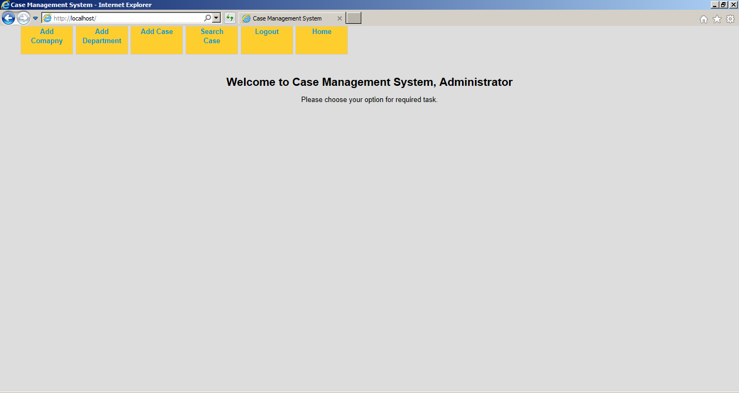

To Add a new company for which cases will be maintained:

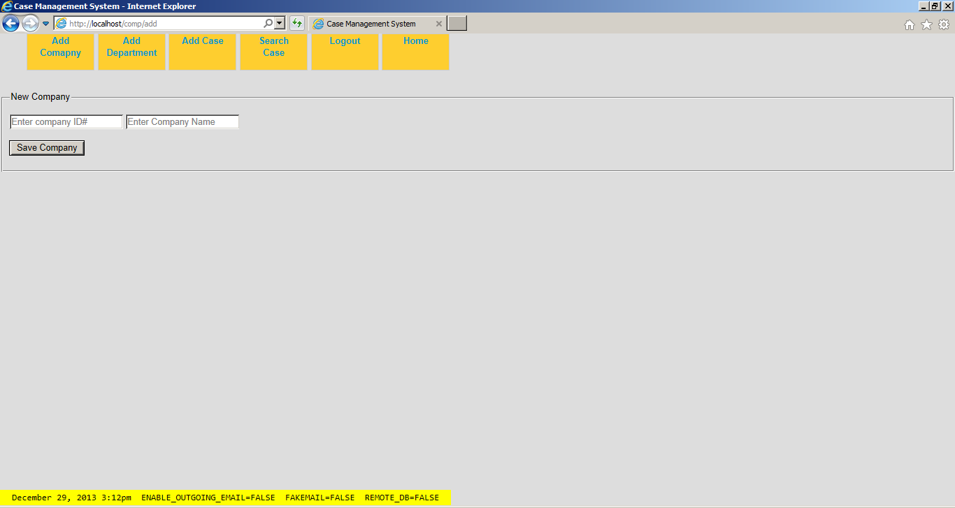

To add department for companies:

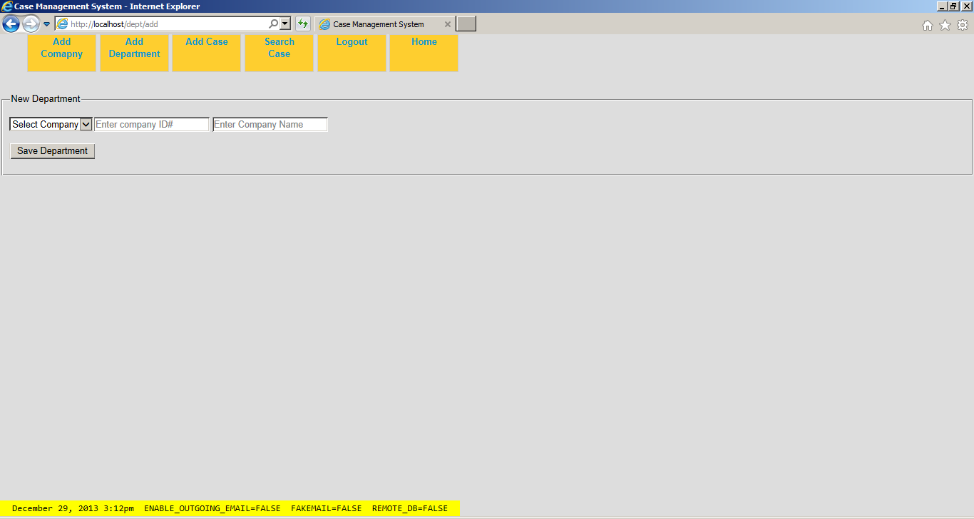

To add a new case for department of the company:

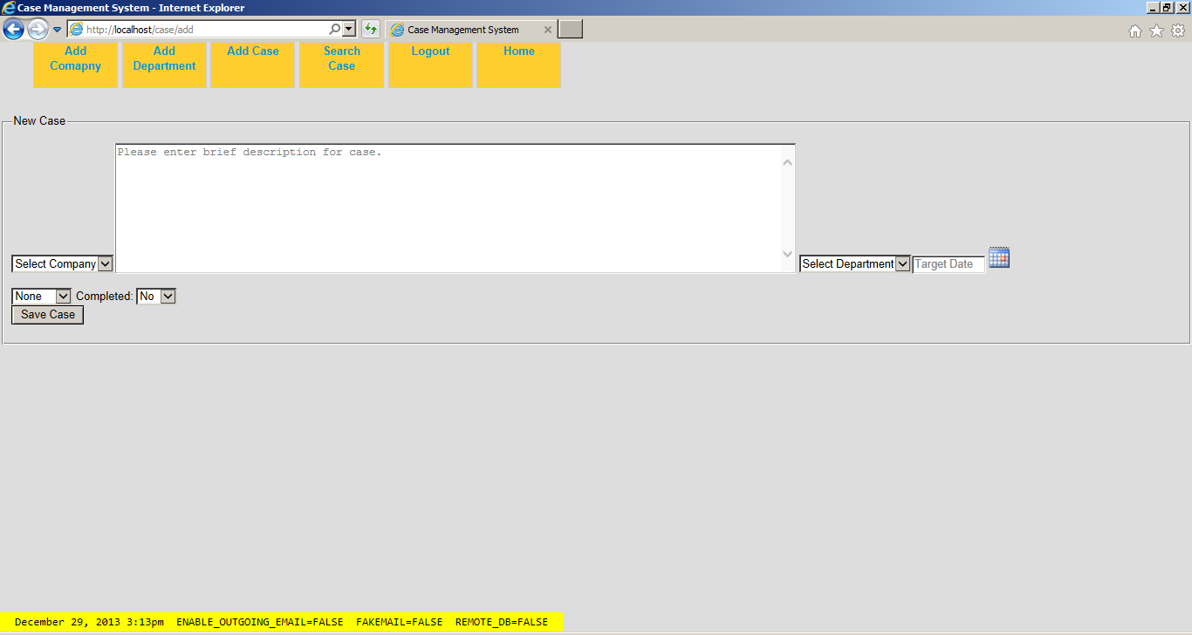

Search for Department’s/Company’s cases:

