LOVELY PROFESSIONAL UNIVERSITY
School of Computer Science and Engineering
CSE570 – Machine Learning with Python
Academic Task 2 – Skill Based Assignment

AI-Based Smart Traffic Management and Congestion Prediction System Using Machine Learning
End-to-End Machine Learning Solution for a Real-World Problem
Submitted by: Anwar Husain
Registration No.: 12626187
Roll No.: 13
Section: ____________________
Submitted to: ____________________
Date of submission: 8 November 2026

GitHub: https://github.com/anwarhusain150/Smart-Traffic-Management-System
Live dashboard: https://anwarhusain150-smart-traffic-management-system-appapp-h521pm.streamlit.app/
LinkedIn post: ____________________

Abstract
Road congestion wastes time and fuel and increases pollution, yet most traffic control is reactive. This project builds an end-to-end machine-learning system that uses six years of historical hourly traffic and weather data from the I-94 interstate (Minneapolis–St Paul, USA) to (1) predict hourly traffic volume (regression) and (2) classify the congestion level of an hour as Low, Medium or High (classification). After cleaning 48,204 raw records into 40,564 unique hours, exploratory analysis and statistical tests showed that time of day and working-day status dominate traffic, while weather has a significant but much smaller effect. Using a strictly future test year (Oct 2017 – Sep 2018), leakage-free preprocessing pipelines and time-series cross-validation, eight regression and seven classification models were compared. A Random Forest achieved the best results in both modules: R² = 0.960 (MAE = 235 vehicles/hour) for volume prediction and macro F1 = 0.913, ROC-AUC = 0.982 for congestion classification. Both models are deployed in an interactive Streamlit dashboard that gives a 24-hour forecast and simple traffic-management suggestions.

Contents
1. Problem Statement
2. Objectives and Success Criteria
3. Dataset Description
4. Methodology and Workflow
5. Data Cleaning and Visualization
6. Exploratory Data Analysis and Statistical Analysis
7. Model Development
8. Results and Model Comparison
9. Streamlit Dashboard
10. Conclusion
11. Limitations and Future Work
12. References
13. Project Links

1. Problem Statement
Context. Urban highways experience recurring congestion during commuting hours. Traffic control rooms need to know in advance how busy a road will be so they can adjust signal timings, publish diversions and deploy traffic police before queues form. This project uses historical data (not live cameras or sensors) to learn the patterns of traffic and forecast it from information known in advance: date, hour, holiday and expected weather.
Table 1: Machine-learning formulation
Item | Module 1 | Module 2
Task | Regression | Multi-class classification
Target variable | traffic_volume (vehicles/hour) | congestion_level: Low / Medium / High
Class rule | – | Low < 2000; Medium 2000–4499; High ≥ 4500
Inputs | Time, calendar and weather features | Same features (traffic_volume excluded)

Intended users and impact. Traffic control rooms (signal timing, police deployment), city planners (identifying recurring bottleneck hours) and commuters (choosing low-congestion travel times).
Key assumptions and constraints.
- Only historical hourly data from one road segment (I-94 westbound) is available; no live feed.
- Weather for the forecast hour is assumed to be known (e.g. from a weather forecast).
- Congestion thresholds (2000 / 4500) are defined from this road's volume distribution, not an official standard.
- The project must use classical ML methods from the course syllabus and run on a normal laptop.

2. Objectives and Success Criteria
- Clean and prepare the dataset without data leakage.
- Identify the main drivers of traffic using EDA and statistical tests.
- Build and tune at least three models per module against a simple baseline.
- Module 1 success criterion: R² ≥ 0.90 on the unseen test year and MAE far below the baseline.
- Module 2 success criterion: macro F1 ≥ 0.85 and recall of the High class ≥ 0.85 (missing a real congestion hour is the costliest error).
- Deploy the final models in an easy-to-use Streamlit dashboard.

3. Dataset Description
Source: Metro Interstate Traffic Volume, UCI Machine Learning Repository (ID 492), donated by John Hogue (2019). https://archive.ics.uci.edu/dataset/492/metro+interstate+traffic+volume. Hourly westbound traffic volume recorded by Minnesota DoT ATR station 301 between Minneapolis and St Paul, combined with OpenWeatherMap weather data and US holidays, from 2 Oct 2012 to 30 Sep 2018.
Size: 48,204 records × 9 columns (8 features + 1 target). After cleaning: 40,564 unique hourly records.
Table 2: Data dictionary
Column | Type | Description
holiday | Categorical | US national/regional holiday name; 'None' otherwise (only marked at 00:00)
temp | Numeric (float) | Average temperature in Kelvin
rain_1h | Numeric (float) | Rain in mm during the hour
snow_1h | Numeric (float) | Snow in mm during the hour
clouds_all | Numeric (int) | Cloud cover in %
weather_main | Categorical | Short weather description (Clear, Clouds, Rain, Snow, Mist ...)
weather_description | Categorical | Detailed weather description
date_time | Datetime | Hour of the record (local time)
traffic_volume | Numeric (int) | TARGET – hourly westbound traffic volume

Table 3: Missing-value and data-quality summary (raw data)
Check | Finding | Treatment
Missing values | None in any column ('None' in holiday means no holiday) | holiday converted to is_holiday flag
Exact duplicates | 17 rows | Removed
Repeated timestamps | 7,612 extra rows (one per weather type in the same hour) | Kept first row per hour
Impossible temperature | 10 rows with 0 K (−273 °C) | Removed
Impossible rainfall | 1 row with 9,831 mm in one hour | Removed
Time gaps | Large gap in 2014–2015 (sensor outage) | Not imputed (documented as limitation)

Table 4: Target distribution after cleaning (40,564 hours)
Congestion class | Hours | Share
Low (< 2000) | 12,536 | 30.9 %
Medium (2000–4499) | 13,515 | 33.3 %
High (≥ 4500) | 14,513 | 35.8 %

Traffic volume ranges from 0 to 7,280 vehicles/hour (mean 3,291, median 3,429).
Why this dataset is appropriate: it is public and properly cited; it is large (six years, ~40k hours); it contains exactly the information a traffic authority knows in advance (calendar, holidays, weather); its target is continuous, so it supports both the regression module and, through thresholds, a balanced three-class classification module; and it contains realistic data-quality problems (duplicates, outliers, gaps) that require proper cleaning.

4. Methodology and Workflow
- Load and clean the raw CSV (src/data_preprocessing.py).
- Feature engineering: hour, day_of_week, month, is_weekend, is_holiday (spread to all 24 hours), is_rush_hour, cyclical hour_sin / hour_cos, temperature in °C, rare weather types grouped as 'Other', and an interaction feature daytype_hour (e.g. 'work_8' vs 'off_8') because weekday and weekend hourly shapes differ.
- EDA and statistical tests (Notebook 02).
- Time-based split: training = Oct 2012 – Sep 2017 (31,831 h); test = Oct 2017 – Sep 2018 (8,733 h). A random split would let the model see hours adjacent to test hours and overstate performance.
- Leakage-free preprocessing pipeline: ColumnTransformer with StandardScaler (numeric), OneHotEncoder (categorical) and pass-through (binary flags), wrapped with the model in a scikit-learn Pipeline so it is fitted on training folds only. traffic_volume is never an input of the classifier.
- Hyperparameter tuning: GridSearchCV with 3-fold TimeSeriesSplit (always validating on a later period).
- Evaluation on the untouched test year; final model chosen by CV score and test metrics.
- Deployment in a Streamlit dashboard (app/app.py).
Table 5: Mapping of project steps to the course syllabus
Unit | Topics applied
Unit 1 | NumPy, Pandas, missing values, duplicates, encoding, scaling, train-test split
Unit 2 | EDA, visualisation, correlation, outlier detection, feature engineering and transformation, preprocessing pipelines, statistical tests
Unit 3 | Linear, multiple linear, polynomial, Ridge, Lasso, Elastic Net regression; MAE, MSE, RMSE, R²
Unit 4 | Logistic Regression, KNN, Decision Tree, Random Forest, SVM, Naive Bayes; confusion matrix, accuracy, precision, recall, F1, ROC-AUC

5. Data Cleaning and Visualization
Box plots of the raw data exposed the impossible temperature and rainfall values, which were removed. The date_time column was converted from text to datetime, temperature was converted from Kelvin to Celsius, and the holiday flag was propagated from the midnight row to the whole day.
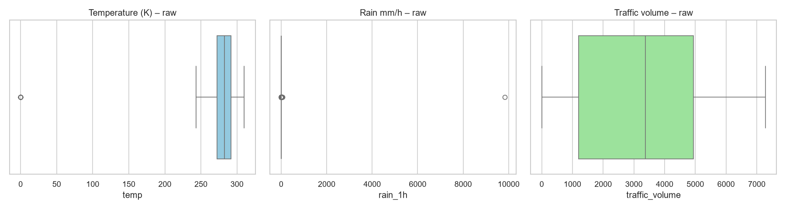
Figure 1: Outlier inspection on raw data – temperature of 0 K and 9,831 mm rain are sensor errors
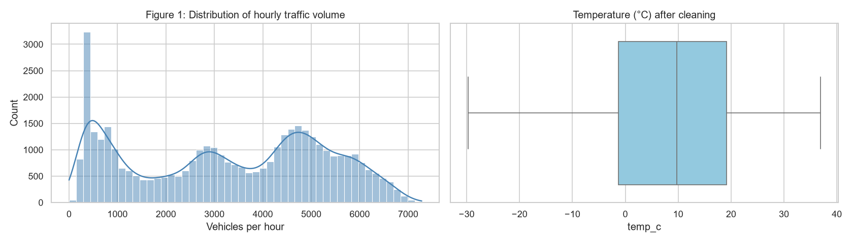
Figure 2: Distribution of hourly traffic volume after cleaning (bimodal: night vs day)
The volume distribution is bimodal: one peak below 1,000 vehicles/hour (night) and a broad peak at 4,000–6,000 (daytime), already pointing to hour of day as the key predictor. Figure 3 shows the three congestion classes are roughly balanced, so accuracy is meaningful, but per-class metrics are still reported.
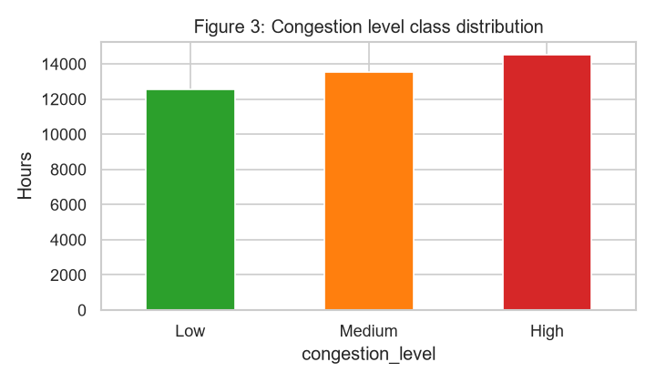
Figure 3: Congestion level class distribution

6. Exploratory Data Analysis and Statistical Analysis

6.1 Univariate analysis
Temperature ranges from about −30 °C to +37 °C. rain_1h and snow_1h are zero in about 95 % and 99.9 % of hours, so they are highly skewed and carry little information; weather is better described by the categorical weather_main. Clouds and Clear are the most common weather types.
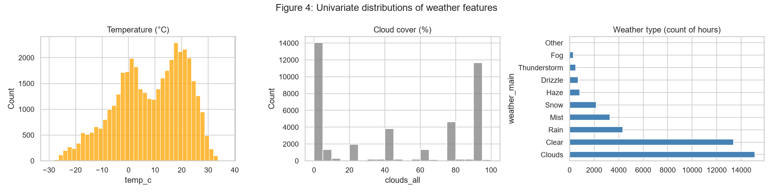
Figure 4: Univariate distributions of temperature, cloud cover and weather type

6.2 Bivariate analysis
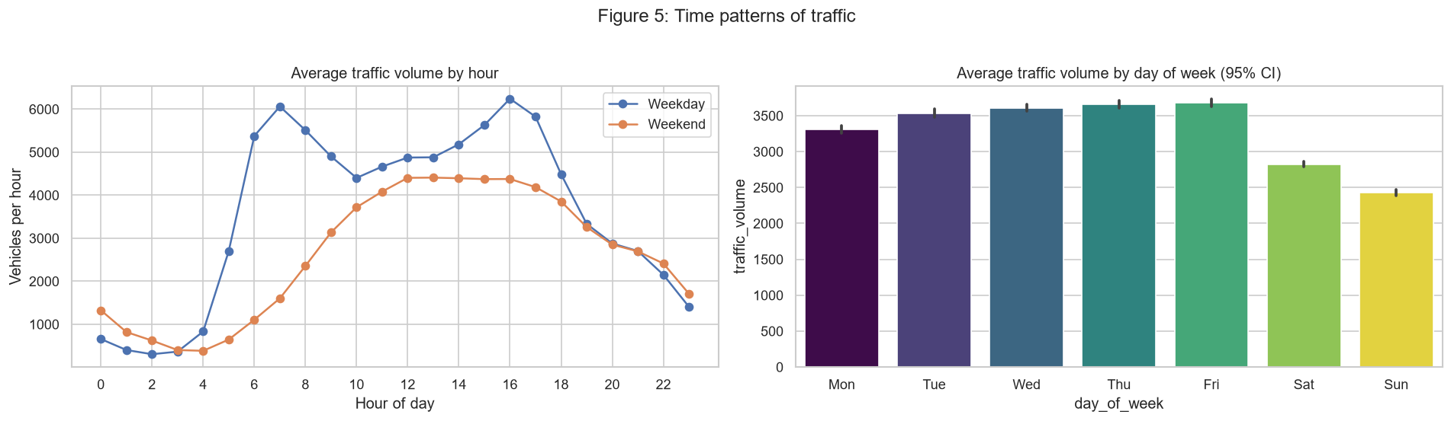
Figure 5: Average traffic by hour (weekday vs weekend) and by day of week with 95 % CI
Weekdays show two sharp peaks – the morning rush around 7 AM and the evening rush around 4 PM – while weekends have no morning peak and a single gentle midday hump. Monday–Friday carry clearly more traffic than Saturday and especially Sunday. Month-to-month differences are small (Figure 6).
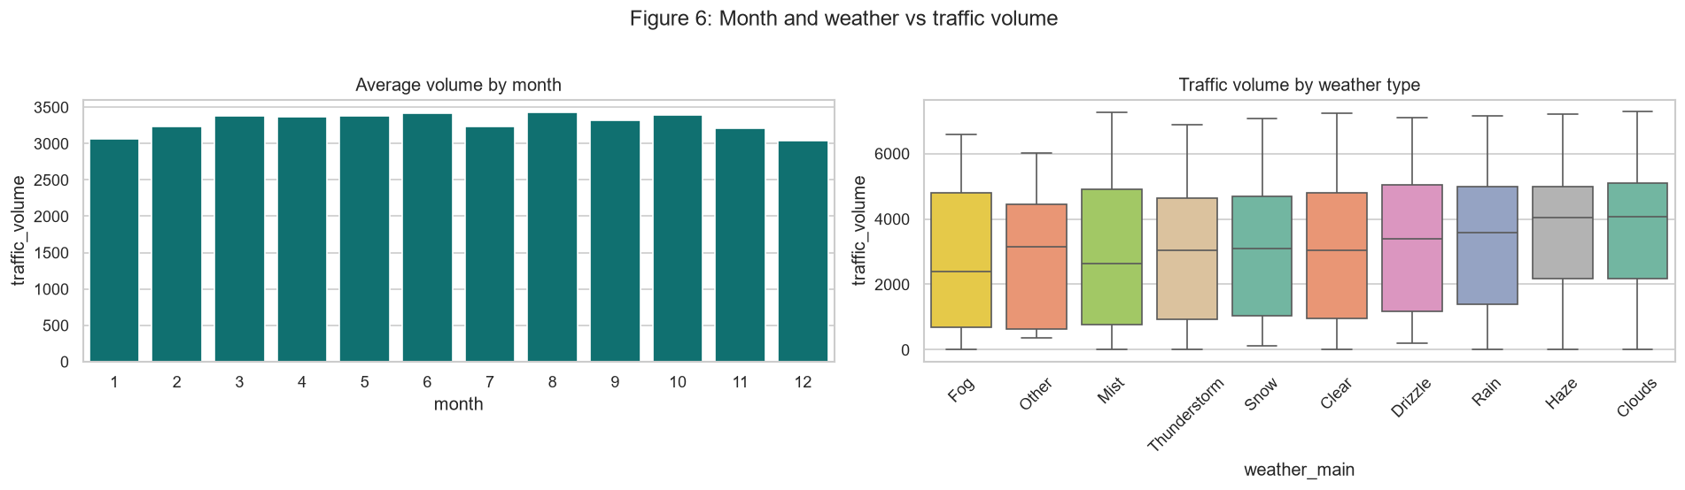
Figure 6: Average volume by month and traffic volume by weather type

6.3 Multivariate analysis
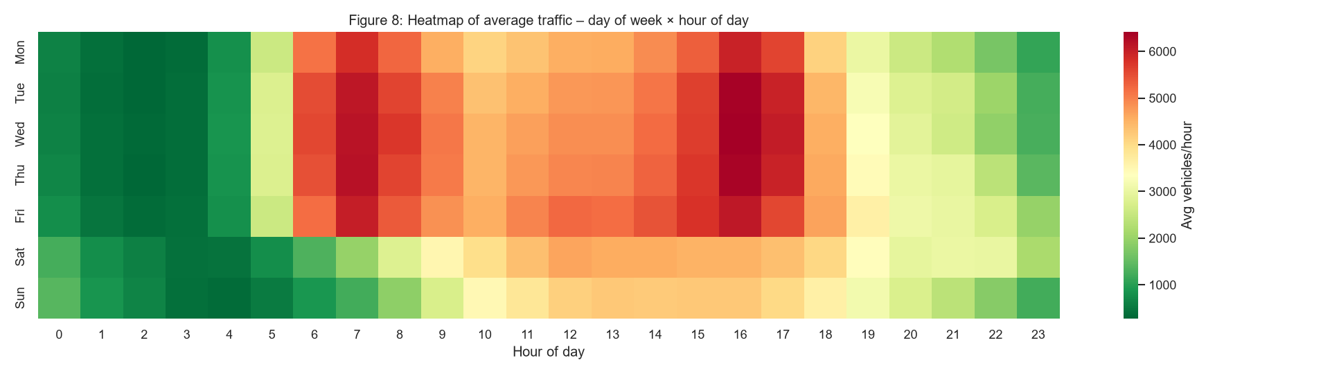
Figure 7: Heatmap of average traffic volume by day of week and hour of day
The heatmap is the key insight of the project: weekday 6–8 AM and 2–6 PM are the most congested time slots, nights are always quiet, and weekends never reach weekday peak levels.
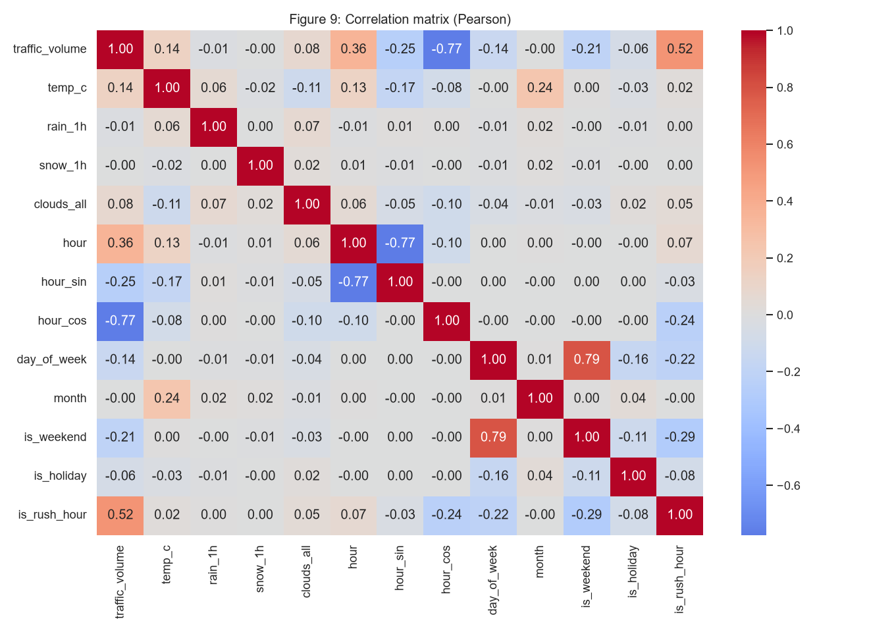
Figure 8: Pearson correlation matrix of numeric and engineered features
hour_cos has the strongest correlation with traffic volume (−0.77), followed by is_rush_hour (0.52) and is_weekend (−0.21). Weather variables have near-zero linear correlation. Raw hour has a weaker correlation (0.36) because its relationship with volume is non-linear, which motivated the cyclical and one-hot encodings.

6.4 Statistical tests (α = 0.05)
Table 6: Statistical tests and results
Test | Hypothesis | Result | Conclusion
Welch's t-test (7 AM–7 PM) | H0: weekday mean = weekend mean | 5,074 vs 3,703; t = 88.5; p < 0.001; 95 % CIs (5,058–5,089) vs (3,677–3,729) | Weekday daytime traffic is ~37 % higher
One-way ANOVA (7 AM–7 PM) | H0: equal mean volume across weather types | F = 19.0; p ≈ 1e-28; means 4,287 (Fog) to 4,746 (Clouds) | Significant but small (~10 %) weather effect
Chi-square independence | H0: congestion level independent of weekend | χ² = 3,996; dof = 2; p < 0.001; Cramér's V = 0.31 | Moderate association: 45 % High on weekdays vs 12 % on weekends

EDA conclusions: (1) hour of day is the dominant driver; (2) working day vs weekend/holiday changes the daily shape; (3) weather is statistically significant but much weaker than time; (4) the hour–volume relation is non-linear, so tree-based models are expected to perform best.

7. Model Development
A baseline and seven or more models were trained for each module. All models share the same preprocessing pipeline and time-series cross-validation; only the training data is used for tuning.
Table 7: Regression models and tuned hyperparameters
Model | Hyperparameters searched | Best
Baseline (mean) | – | –
Linear Regression | – | –
Polynomial Regression + Ridge | degree {2, 3}, alpha {0.1, 1, 10} | degree 3, alpha 10
Ridge | alpha {0.1, 1, 10, 100} | alpha 10
Lasso | alpha {0.1, 1, 10} | alpha 0.1
Elastic Net | alpha {0.01, 0.1, 1}, l1_ratio {0.2, 0.5, 0.8} | alpha 0.01, l1_ratio 0.8
Decision Tree | max_depth {4–12}, min_samples_leaf {1, 5, 20} | depth 10, leaf 5
Random Forest (150 trees) | max_depth {8, 10, 12}, min_samples_leaf {5, 20} | depth 12, leaf 5

Table 8: Classification models and tuned hyperparameters
Model | Hyperparameters searched | Best
Baseline (most frequent) | – | –
Logistic Regression | C {0.1, 1, 10} | C 10
KNN | k {5, 15, 31}, weights {uniform, distance} | k 15, uniform
Gaussian Naive Bayes | var_smoothing {1e-9, 1e-6, 1e-3} | 1e-3
Decision Tree | max_depth {6–16}, min_samples_leaf {1, 5, 20} | depth 8, leaf 20
Random Forest (150 trees) | max_depth {10, 14, 20}, min_samples_leaf {1, 5} | depth 20, leaf 1
SVM (RBF kernel)* | C {1, 10} | C 1

*SVM training cost grows roughly with the square of the number of samples, so SVM was trained on every third training hour (~10,600 rows, still covering all years). Model selection used RMSE (regression) and macro F1 (classification).

8. Results and Model Comparison

8.1 Module 1 – Traffic volume regression
Table 9: Regression results on the test year (Oct 2017 – Sep 2018)
Model | CV RMSE | Test MAE | Test RMSE | Test R² | Train R²
Baseline (Mean) | 1970.6 | 1733.3 | 1977.8 | -0.000 | 0.000
Linear Regression | 485.6 | 295.1 | 459.3 | 0.946 | 0.945
Polynomial Regression | 485.2 | 288.2 | 452.5 | 0.948 | 0.946
Ridge | 485.1 | 296.0 | 459.3 | 0.946 | 0.945
Lasso | 485.4 | 295.2 | 459.3 | 0.946 | 0.945
Elastic Net | 486.6 | 303.1 | 461.7 | 0.945 | 0.944
Decision Tree | 471.1 | 251.5 | 418.5 | 0.955 | 0.962
Random Forest | 442.7 | 234.9 | 395.0 | 0.960 | 0.969

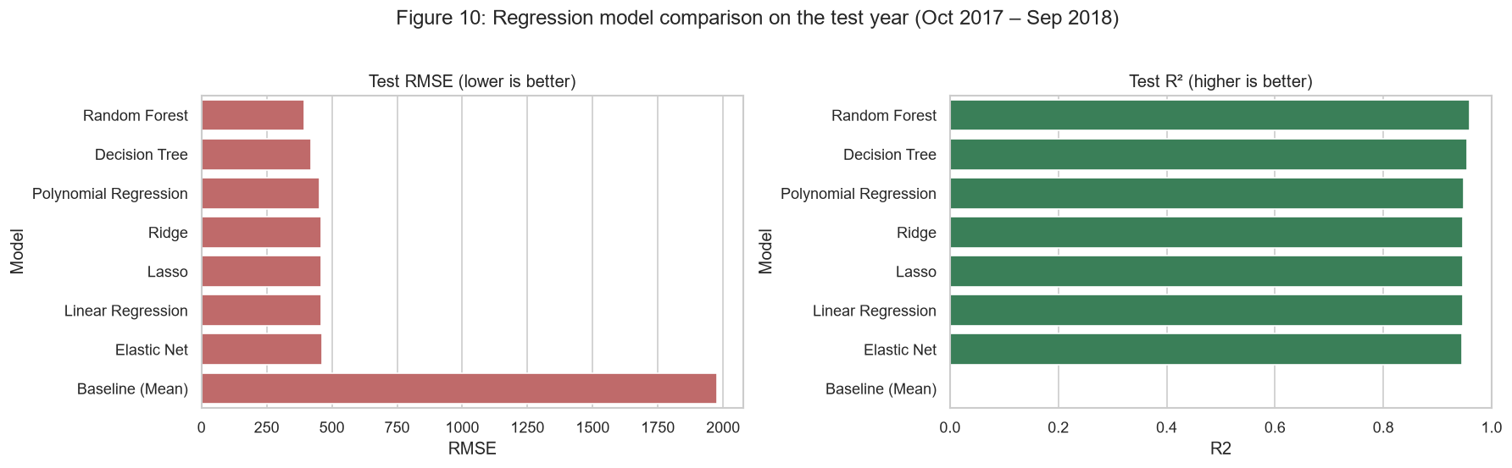
Figure 9: Regression model comparison – test RMSE and R²
Every model beats the baseline (R² = 0, MAE = 1,733) by a wide margin. Linear, Ridge, Lasso and Elastic Net all reach R² ≈ 0.946 thanks to one-hot hour and the daytype_hour interaction; regularisation adds little because the linear model is not overfitting (train R² ≈ test R²). Lasso set 33 of 110 encoded coefficients exactly to zero, acting as automatic feature selection. Tree models capture the remaining non-linear interactions; the Random Forest is best with MAE = 235 vehicles/hour, RMSE = 395 and R² = 0.960, with only a small gap between train (0.969) and test R², so it generalises well.
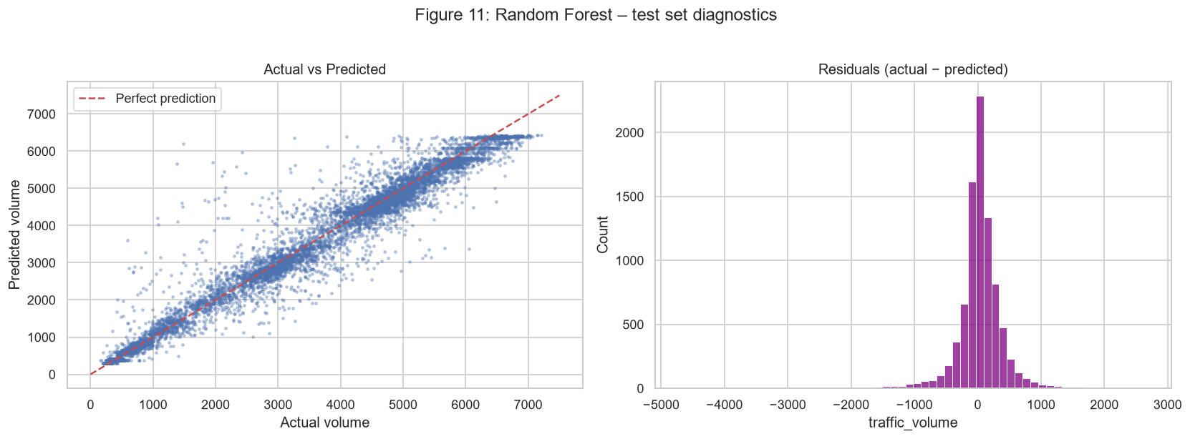
Figure 10: Random Forest – actual vs predicted volume and residual distribution
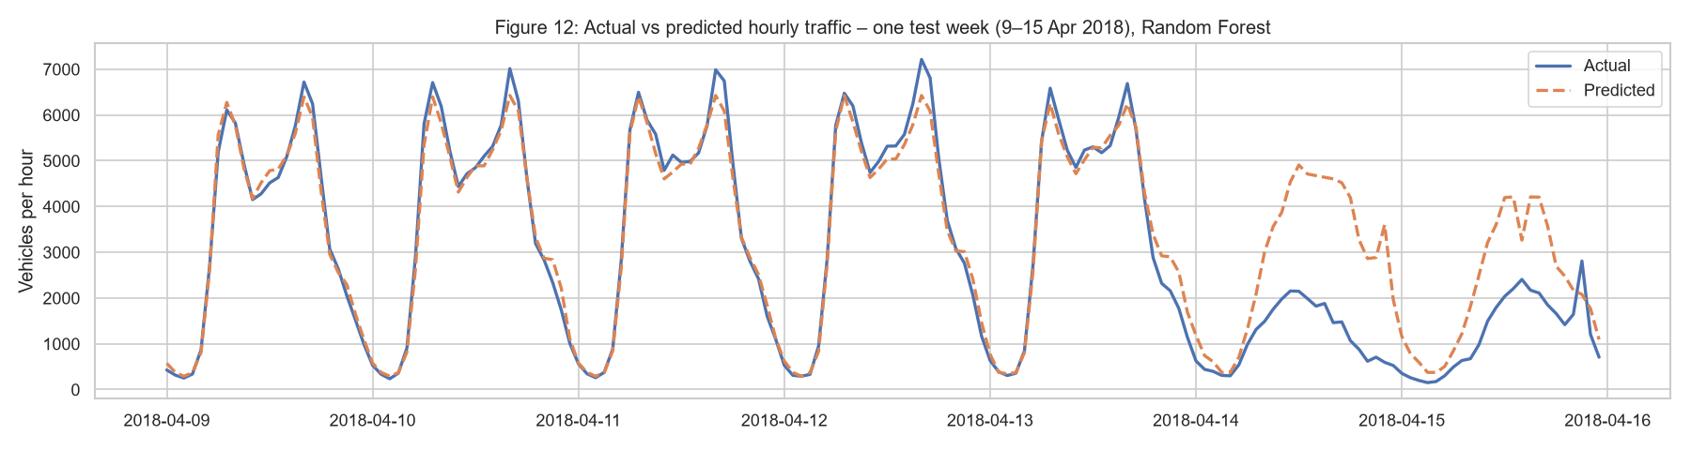
Figure 11: Actual vs predicted traffic for one test week (9–15 April 2018)
The model reproduces the weekday double peak closely. On 14–15 April 2018 it over-predicted weekend traffic: that weekend Minneapolis had a record April blizzard, but snow_1h is almost always zero in the dataset, so the model could not 'see' the storm – a clear example of a data limitation.
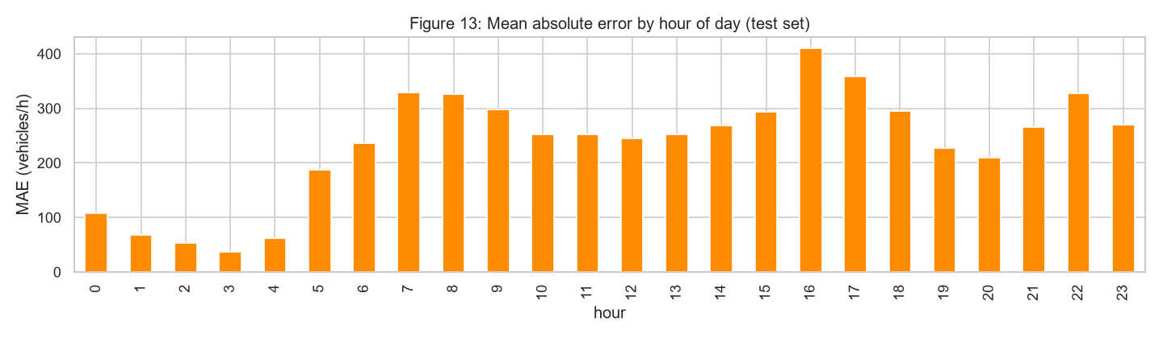
Figure 12: Mean absolute error by hour of day (test set)
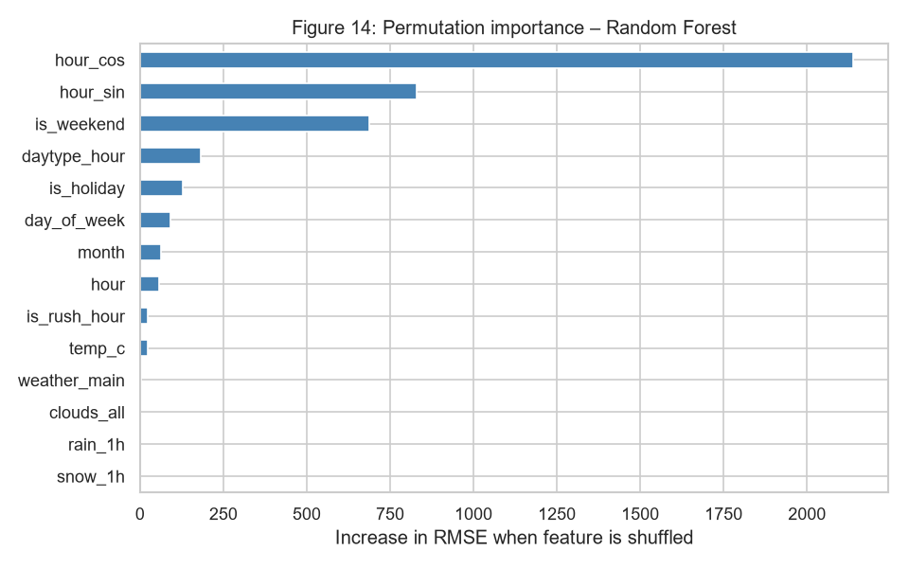
Figure 13: Permutation feature importance of the Random Forest regressor
Errors are largest at rush hours (7–8 AM and 4–5 PM, MAE up to ~400) and smallest at night (~50). Permutation importance confirms the EDA: hour_cos, hour_sin, is_weekend, daytype_hour and is_holiday dominate, while the weather features contribute very little.

8.2 Module 2 – Congestion classification
Table 10: Classification results on the test year
Model | Accuracy | Precision | Recall | F1 (macro) | ROC-AUC | Recall High
Baseline (Most Frequent) | 0.371 | 0.124 | 0.333 | 0.180 | 0.500 | 1.000
Logistic Regression | 0.902 | 0.903 | 0.903 | 0.903 | 0.979 | 0.901
KNN | 0.908 | 0.909 | 0.908 | 0.909 | 0.978 | 0.918
Naive Bayes | 0.859 | 0.869 | 0.857 | 0.852 | 0.965 | 0.960
Decision Tree | 0.911 | 0.913 | 0.910 | 0.911 | 0.978 | 0.942
Random Forest | 0.912 | 0.913 | 0.913 | 0.913 | 0.982 | 0.919
SVM (RBF) | 0.906 | 0.906 | 0.907 | 0.907 | 0.976 | 0.918

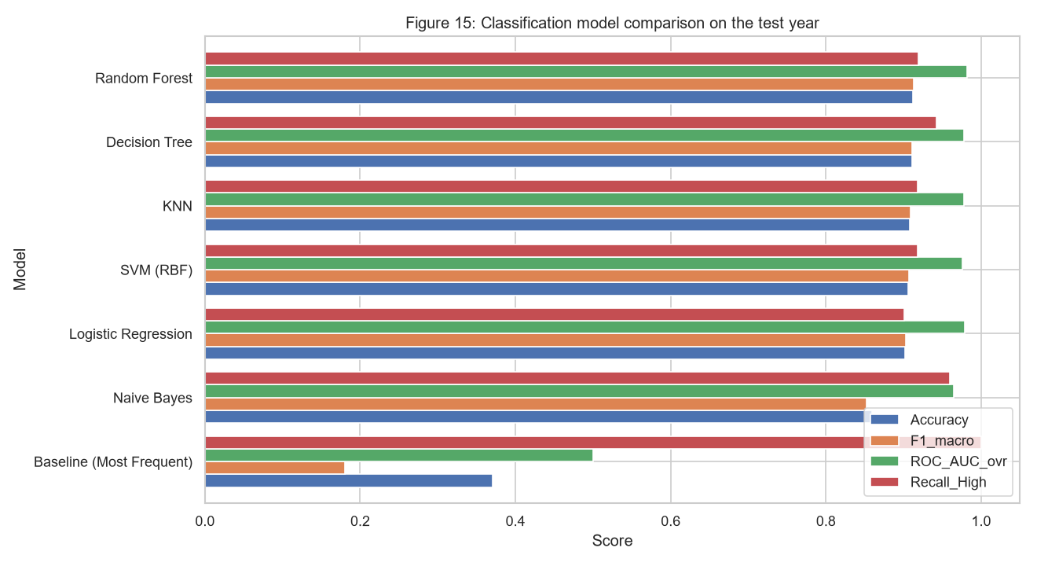
Figure 14: Classification model comparison on the test year
The baseline always predicts 'High' (accuracy 0.371, macro F1 0.18, ROC-AUC 0.50), which shows why a single metric is not enough. Logistic Regression already reaches macro F1 0.903. Naive Bayes is weakest (0.852) because its feature-independence assumption is violated (hour, hour_sin and is_rush_hour are related). KNN, SVM and the Decision Tree score 0.907–0.911. The Random Forest is best with accuracy 0.912, macro F1 0.913, ROC-AUC 0.982 and High-class recall 0.919, and also has the best cross-validation F1 (0.894).
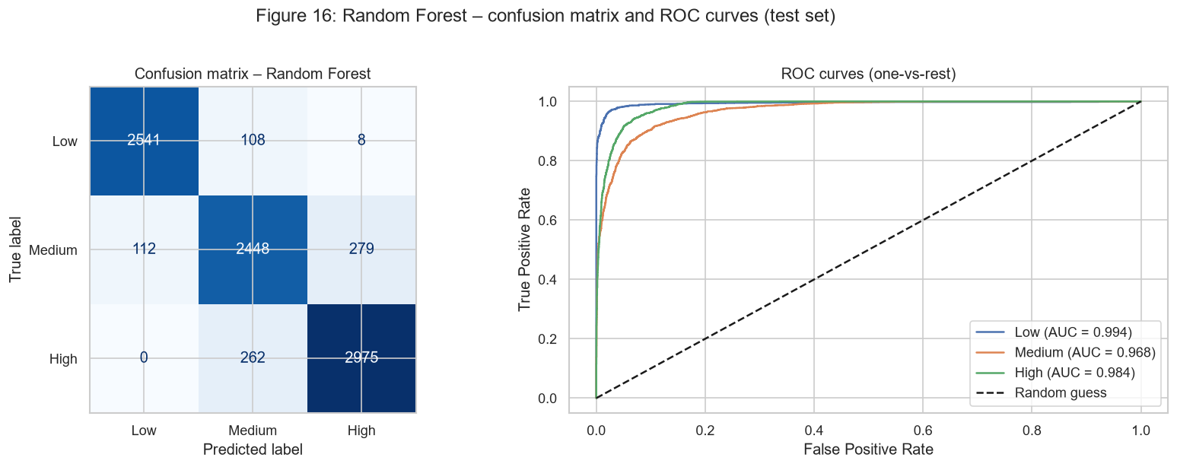
Figure 15: Random Forest – confusion matrix and one-vs-rest ROC curves
Table 11: Per-class performance of the Random Forest classifier
Class | Precision | Recall | F1-score | Support
Low | 0.958 | 0.956 | 0.957 | 2,657
Medium | 0.869 | 0.862 | 0.865 | 2,839
High | 0.912 | 0.919 | 0.916 | 3,237

Almost all errors are between neighbouring classes: no High hour was predicted as Low and only 8 Low hours were predicted as High. Medium is the hardest class because it lies between two thresholds (an hour with 4,400 vehicles is Medium, one with 4,600 is High). As an extra check, converting the Random Forest regression output into classes gives accuracy 0.915 and macro F1 0.916, consistent with the direct classifier.
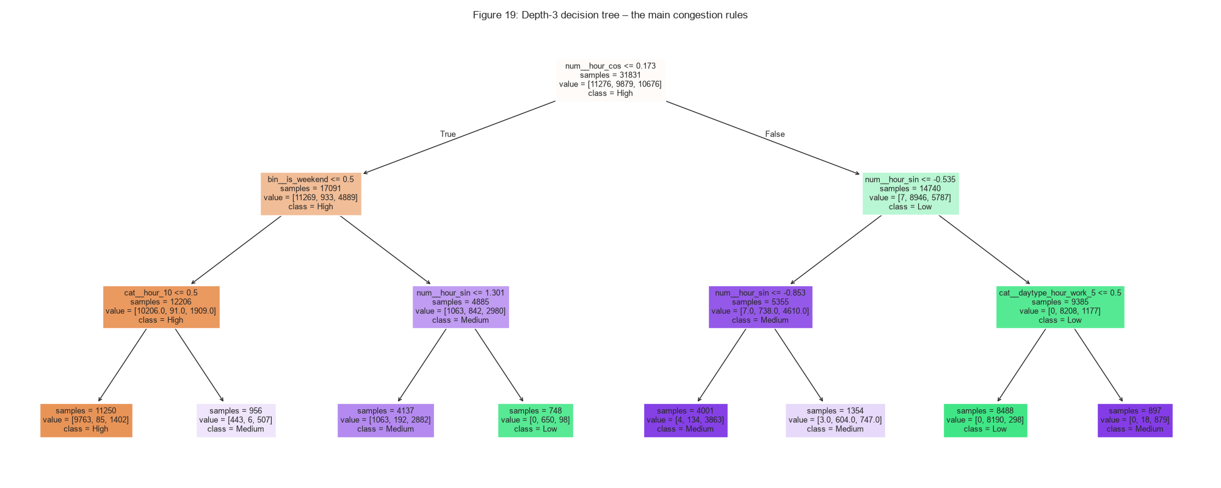
Figure 16: A depth-3 decision tree showing the main congestion rules (86 % test accuracy)
Even this three-level tree reaches 86 % accuracy; its first splits are hour_cos (day vs night) and is_weekend – the same rules visible in the EDA heatmap.

8.3 Final model justification
Random Forest is selected for both modules because it has the best cross-validation score and the best test metrics, meets all success criteria, and shows limited overfitting. Its disadvantages are longer training time and lower interpretability; the depth-3 tree and permutation importance were used to explain its behaviour. If interpretability were the priority, Logistic Regression or a shallow Decision Tree would be reasonable alternatives at a cost of about 1 % F1.

9. Streamlit Dashboard
The dashboard is deployed publicly on Streamlit Community Cloud at https://anwarhusain150-smart-traffic-management-system-appapp-h521pm.streamlit.app/. It (app/app.py, run locally with 'streamlit run app/app.py') lets a user choose a date, hour, holiday flag and weather conditions. It shows the predicted traffic volume, the congestion level with the classifier's confidence, a suggested action (e.g. extend green time and divert traffic when High), a colour-coded 24-hour forecast and the best hours to travel. Further tabs show the main EDA charts and the model comparison tables. If trained models are missing, src/train_models.py retrains them automatically from the saved best hyperparameters. Example: for a Thursday at 8 AM with cloudy weather the dashboard predicts about 5,800 vehicles/hour (High); at 3 AM about 400 vehicles/hour (Low).

10. Conclusion
The project delivered a complete, reproducible ML workflow for traffic management. Data cleaning removed duplicated hours and sensor errors; EDA and statistical tests showed that time of day and working-day status drive traffic far more than weather. With leakage-free pipelines and a strictly future test year, a Random Forest predicts hourly volume with R² = 0.960 and classifies congestion with macro F1 = 0.913, meeting all success criteria. A key learning is that good feature engineering (cyclical hour, holiday propagation and the weekday-hour interaction) allowed even linear models to reach R² ≈ 0.95, and that evaluating on future data gives an honest estimate of real-world performance.

11. Limitations and Future Work
- No information on accidents, roadworks, events or live traffic; extreme events (e.g. the April 2018 blizzard) are missed.
- Snowfall is poorly recorded and weather is historical, whereas real forecasts would add uncertainty.
- Single road segment and direction; models must be retrained for other roads or cities.
- Congestion thresholds are project-defined; hours near a threshold are inherently hard to classify.
- 2014–2015 data gap reduces training data for those years.
- Future work: add lag features (traffic in previous hours), event and incident data, gradient-boosting models, prediction intervals, a live data feed, and cloud deployment of the dashboard.

12. References
[1] Hogue, J. (2019). Metro Interstate Traffic Volume [Dataset]. UCI Machine Learning Repository. https://doi.org/10.24432/C5X60B
[2] Pedregosa, F., et al. (2011). Scikit-learn: Machine Learning in Python. Journal of Machine Learning Research, 12, 2825–2830.
[3] McKinney, W. (2010). Data Structures for Statistical Computing in Python. Proceedings of the 9th Python in Science Conference, 56–61.
[4] Harris, C. R., et al. (2020). Array programming with NumPy. Nature, 585, 357–362.
[5] Hunter, J. D. (2007). Matplotlib: A 2D Graphics Environment. Computing in Science & Engineering, 9(3), 90–95.
[6] Waskom, M. L. (2021). seaborn: statistical data visualization. Journal of Open Source Software, 6(60), 3021.
[7] Virtanen, P., et al. (2020). SciPy 1.0: fundamental algorithms for scientific computing in Python. Nature Methods, 17, 261–272.
[8] Streamlit Inc. (2024). Streamlit documentation. https://docs.streamlit.io
[9] Breiman, L. (2001). Random Forests. Machine Learning, 45(1), 5–32.

13. Project Links
GitHub repository: https://github.com/anwarhusain150/Smart-Traffic-Management-System
Contains the README, dataset, notebooks 01–04, source code, Streamlit app, figures, result tables and this report. Development used feature branches merged through six pull requests.
Live Streamlit dashboard: https://anwarhusain150-smart-traffic-management-system-appapp-h521pm.streamlit.app/
LinkedIn post: ____________________ (URL and dated screenshot submitted separately)

