
INSTITUTE OF PUBLIC ADMINISTRATION AND MANAGEMENT (IPAM)
UNIVERSITY OF SIERRA LEONE
FINAL YEAR PROJECT REPORT
DESIGN AND EVALUATION OF AN AI-DRIVEN DIGITAL TWIN FRAMEWORK FOR SMART IRRIGATION MANAGEMENT IN SMALLHOLDER FARMS USING LOW-COST IOT SENSORS
A Project Report Submitted in Partial Fulfilment of the Requirements for the Award of the Diploma in Information System & Technology
Student Name | Student ID
Mohamed Osman Bangura (Group Leader) | 16656
Lansana Conteh | 16141
Joel Sorie Koroma | 16189
Adama Yusuf Kamara | 16264
Mariama Kamara | 16838

SUPERVISOR: Mr. Oluwatosin B. Ayorinde
PROGRAMME: Diploma in Information System & Technology
DATE: October 2026

DECLARATION
We, the undersigned students, hereby declare that this project report, entitled "Design and Evaluation of an AI-Driven Digital Twin Framework for Smart Irrigation Management in Smallholder Farms Using Low-Cost IoT Sensors", is the product of our own original work. It has been carried out under the guidance of our supervisor and has not been submitted, in whole or in part, to this or any other institution for the award of any diploma, degree or other qualification.
All sources of information, ideas, data and software documentation used in this report have been duly acknowledged through citation and referencing. Where the work of others has been used, it has been clearly indicated.

Student Name | Student ID | Signature | Date
Mohamed Osman Bangura (Group Leader) | 16656
Lansana Conteh | 16141
Joel Sorie Koroma | 16189
Adama Yusuf Kamara | 16264
Mariama Kamara | 16838

CERTIFICATION
This is to certify that the project report entitled "Design and Evaluation of an AI-Driven Digital Twin Framework for Smart Irrigation Management in Smallholder Farms Using Low-Cost IoT Sensors" was carried out by the students named on the title page of the Institute of Public Administration and Management (IPAM), University of Sierra Leone, under my supervision, and that it meets the requirements for the award of the Diploma in Information System & Technology.

Name | Role | Signature | Date
Mr. Oluwatosin B. Ayorinde | Project Supervisor
 | Head of Department
 | External Examiner

DEDICATION
This project is dedicated to the smallholder farmers of Sierra Leone, whose daily labour feeds our communities and whose resilience in the face of an uncertain climate inspired this work.
It is also dedicated to our families, whose patience, sacrifice and encouragement carried us through the long weeks of design, building and testing.

ACKNOWLEDGEMENTS
We give thanks to Almighty God for the health, strength and perseverance that enabled the completion of this project.
We are sincerely grateful to our supervisor, Mr. Oluwatosin B. Ayorinde, for his guidance, constructive criticism and steady encouragement from the first proposal draft to the final report. His direction shaped both the technical depth and the academic quality of this work.
We thank the lecturers and staff of the Institute of Public Administration and Management (IPAM), University of Sierra Leone, for the knowledge and foundation provided throughout the programme.
Our deepest appreciation goes to the smallholder farmers, agronomists and agricultural extension officers in the Western Area who gave their time to answer our questionnaires, share their field experience, host our sensor nodes and test the dashboard. This project is built on their insight.
Finally, we thank our families and friends for their moral and material support, and each member of the project team for the teamwork, commitment and shared responsibility that made this project possible.

ABSTRACT
Smallholder farmers in Sierra Leone continue to schedule irrigation by visual inspection, fixed timetables or reactive soil-moisture thresholds that act only after crops are already stressed. Commercial digital twin and artificial intelligence (AI) platforms that forecast this stress are too costly and infrastructure-dependent for smallholder use. This project designed, developed and evaluated Farm-Irrigation, a low-cost AI-driven digital twin framework for predictive irrigation management.
Using Design Science Research with Agile sprints, the team built an ESP32 sensor node (capacitive soil moisture sensor and DHT22) with a 500-record offline buffer, a Node.js/Express backend with a PostgreSQL digital twin data store, a Random Forest module forecasting soil moisture 12, 24 and 48 hours ahead with a time-to-wilting estimate, and a low-bandwidth web dashboard with a password-protected manual pump override. Requirements were gathered from 15 farmers and extension officers, four key-informant interviews and field observation on three plots.
All six system test cases passed. Average API response time was 185 ms against a 250 ms target, and all 16 readings buffered during a simulated four-hour outage were recovered without corruption. User acceptance testing with 8 farmers and 2 extension officers gave a System Usability Scale score of 84.5/100. In a wider survey of 70 farmers, 57.1% rated the dashboard Very Good or Excellent and 68.6% were willing to maintain a sensor node, but only 42.9% were likely to recommend the system (target 70%) and 18.6% expressed confidence in digital twin mirroring. Forecast accuracy was verified qualitatively; quantitative error metrics and a measured water-use comparison against a reactive baseline were not obtained and are recommended for future work.
The project shows that a predictive, digital twin based irrigation tool can be built from consumer-grade components and open-source software and used by low-literacy farmers, while indicating that farmer trust and long-term field validation are the main barriers to adoption.
Keywords: digital twin, smart irrigation, smallholder farming, IoT, ESP32, machine learning, Random Forest, Sierra Leone.

TABLE OF CONTENTS
DECLARATION ii
CERTIFICATION iii
DEDICATION iv
ACKNOWLEDGEMENTS v
ABSTRACT vi
TABLE OF CONTENTS vii
LIST OF TABLES x
LIST OF FIGURES xi
LIST OF ABBREVIATIONS xii
CHAPTER ONE: INTRODUCTION 1
1.1 Background to the Study 1
1.2 Statement of the Problem 2
1.3 Aim and Objectives of the Study 2
1.3.1 Aim of the Study 2
1.3.2 Specific Objectives of the Study 3
1.4 Research Questions 3
1.5 Research Hypotheses 4
1.5.1 Null Hypothesis (H₀) 4
1.5.2 Alternative Hypothesis (H₁) 4
1.6 Significance of the Study 4
1.6.1 Significance to Smallholder Farmers and Agricultural Producers 4
1.6.2 Significance to Agricultural Extension Workers and Agronomists 4
1.6.3 Significance to Policymakers and Government Agencies 4
1.6.4 Significance to Information Systems Architects and Software Developers 4
1.6.5 Significance to the Institute of Public Administration and Management (IPAM) 5
1.7 Scope of the Study 5
1.7.1 Geographical Scope 5
1.7.2 Subject Scope 5
1.7.3 System Scope 5
1.7.4 Technological Scope 5
1.7.5 Delimitations 5
1.8 Limitations of the Study 5
1.9 Operational Definition of Terms 6
CHAPTER TWO: PROJECT EXECUTION AND DEVELOPMENT METHODOLOGY 8
2.1 Development Approach 8
2.2 Requirement Analysis 9
2.3 Data Collection Methods 9
2.3.1 Questionnaires 9
2.3.2 Semi-Structured Interviews 10
2.3.3 Field Observation 10
2.3.4 Document Analysis 10
2.4 System Requirements 10
2.4.1 Functional Requirements 11
2.4.2 Non-Functional Requirements 11
2.5 System Design 12
2.5.1 System Architecture 12
2.5.2 Use Case Diagram 13
2.5.3 Activity Diagram 13
2.5.4 Class Diagram 14
2.5.5 Entity-Relationship (ER) Diagram 14
2.5.6 Data Flow Diagram (DFD - Level 1) 15
2.5.7 User Interface (UI) Design 16
2.6 Technologies and Tools 16
2.7 System Development 17
2.7.1 Edge Node Hardware Construction & Firmware Engineering 17
2.7.2 Backend REST API & Digital Twin State Synchronization 18
2.7.3 Machine Learning Model Development & Training 18
2.8 Testing Methodology 18
2.8.1 Unit Testing 18
2.8.2 Integration Testing 19
2.8.3 System Testing 19
2.8.4 User Acceptance Testing (UAT) 19
2.9 Challenges Encountered and Solutions 19
CHAPTER THREE: PRODUCT EVALUATION AND OUTCOMES 21
3.1 Developed System 21
3.2 System Features 21
3.3 System Interface 22
3.4 Testing Results 24
3.5 User Evaluation 26
3.6 Chapter Summary 29
CHAPTER FOUR: DISCUSSION AND REFLECTIVE ANALYSIS 31
4.1 Interpretation of Findings 31
4.1.1 Technical Performance 31
4.1.2 Usability 31
4.1.3 Trust and Adoption 31
4.2 Achievement of Project Objectives 32
4.3 Evaluation Against the Problem 33
4.4 Strengths of the Developed System 33
4.5 Limitations of the System 33
4.6 Lessons Learned 34
4.7 Reflection on the Development Process 34
4.7.1 What Worked 34
4.7.2 What Did Not Work 35
4.7.3 What the Team Learned 35
4.7.4 What the Team Would Change 35
CHAPTER FIVE: CONCLUSION AND RECOMMENDATIONS 36
5.1 Conclusion 36
5.2 Recommendations 36
5.3 Future Development 37
REFERENCES 38
APPENDIX A: QUESTIONNAIRE 41
APPENDIX B: INTERVIEW QUESTIONS 43
APPENDIX C: TEST CASES 44
APPENDIX D: DATABASE SCHEMA 45
APPENDIX E: SELECTED SOURCE CODE 47
APPENDIX F: USER ACCEPTANCE TESTING 51

LIST OF TABLES
Table 2.1: Technologies and Tools 17
Table 2.2: Challenges Encountered and Solutions 20
Table 3.1: System Testing Results and Verification Outcomes 25
Table 3.2: User Acceptance Testing (UAT) Outcomes and System Usability Scale Summary 26
Table 4.1: Achievement of Project Objectives 32
Table C.1: System Test Cases, Procedures and Outcomes 44
Table C.2: Unit and Integration Test Case Design 44
Table D.1: Data Dictionary 45

LIST OF FIGURES
Figure 2.1: 4-Tier IoT & Digital Twin System Architecture Breakdown 12
Figure 2.2: Structured Use Case Specification Matrix 13
Figure 2.3: System Activity & Data Processing Workflow Matrix 14
Figure 2.4: Object-Oriented Software Class Architecture 14
Figure 2.5: Relational Database Schema & Relationship Specifications 15
Figure 2.6: Level-1 Data Flow Diagram (DFD) Process Decomposition 16
Figure 3.1: Farmer Login Interface 22
Figure 3.2: Live Plot Dashboard 23
Figure 3.3: Predictive Drying Curve View 23
Figure 3.4: Manual Override Control Panel 24
Figure 3.5: Extension Officer Multi-Plot View 24
Figure 3.6: API Telemetry Latency: Target vs. Achieved 26
Figure 3.7: Respondent Distribution by Primary Crop Cultivated 27
Figure 3.8: Distribution of Dashboard Usability Ratings Across 70 Respondents 27
Figure 3.9: Key Evaluation Criteria — Target vs. Achieved Outcomes 28
Figure 3.10: Respondent Agreement Across Key Usability and Adoption Criteria 29
Figure 3.11: Most Valued Platform Features for Smallholder Irrigation Governance 29

LIST OF ABBREVIATIONS
Abbreviation | Meaning
ADC | Analogue-to-Digital Converter
AI | Artificial Intelligence
API | Application Programming Interface
CSV | Comma-Separated Values
DFD | Data Flow Diagram
DSR | Design Science Research
DT | Digital Twin
ER | Entity-Relationship
FAO | Food and Agriculture Organization of the United Nations
FR | Functional Requirement
HTTP | Hypertext Transfer Protocol
IoT | Internet of Things
IPAM | Institute of Public Administration and Management
JSON | JavaScript Object Notation
ML | Machine Learning
MQTT | Message Queuing Telemetry Transport
NFR | Non-Functional Requirement
ORM | Object-Relational Mapping
REST | Representational State Transfer
SDLC | System Development Life Cycle
SPIFFS | Serial Peripheral Interface Flash File System
SQL | Structured Query Language
SUS | System Usability Scale
UAT | User Acceptance Testing
UC | Use Case
UI | User Interface
UML | Unified Modeling Language
VPD | Vapour Pressure Deficit

CHAPTER ONE
INTRODUCTION

1.1 Background to the Study
Agriculture remains the primary economic backbone of sub-Saharan Africa, supporting millions of livelihoods and driving rural socioeconomic development (FAO, 2023). Despite this foundational role, the sector faces compounding challenges climate variability, unpredictable rainfall, land degradation, and freshwater scarcity (UN Environment Programme, 2024). Smallholder farmers, who cultivate plots typically under two hectares and produce up to 80% of the food supply in developing regions, bear the brunt of these stressors (FAO, 2022). In countries like Sierra Leone, smallholder agriculture remains overwhelmingly reliant on manual, experience-based practices and traditional rain-fed irrigation (World Bank, 2023), leaving farmers exposed to increasingly volatile climatic conditions.
Irrigation management is a critical bottleneck in this system. Watering decisions are typically made either through manual visual estimation or through primitive automated systems governed by fixed schedules and reactive thresholds activating a pump only after soil moisture has already dropped below a set level (Ebstu et al., 2026; Silva & Santos, 2025). This reactive logic ignores real-time temperature, humidity, evapotranspiration, and weather trends (Prospects of Digital Twin Systems for Smart Irrigation, 2026), and pushes farmers toward two costly extremes: under-watering, which stunts crop growth and reduces yields, and over-watering, which wastes water, leaches nutrients, and inflates energy costs (Hassan & Ali, 2025).
Modern commercial agriculture has responded to this problem with Digital Twins (DT) and Artificial Intelligence (AI) decision-support systems dynamic virtual replicas of a physical field plot that ingest live telemetry to mirror current conditions and simulate future outcomes (Grieves & Vickers, 2017; Tao et al., 2019). Paired with machine learning regression models, a digital twin turns irrigation from reactive guesswork into predictive scheduling, forecasting soil moisture depletion hours or days ahead of critical stress (Zhang et al., 2025; Machine Learning Models to Predict Soil Moisture, 2023).
However, enterprise-grade digital twin platforms are effectively out of reach for smallholder communities. They depend on expensive industrial sensor arrays, continuous high-bandwidth connectivity, and costly cloud subscriptions (Chen & Zhao, 2026; Lehtola et al., 2022) infrastructure that rural environments with intermittent electricity and unreliable connectivity simply cannot support (El Sawi & Al-Azawei, 2022; An IoT Low-Cost Smart Farming, 2022).
Closing this gap calls for a lightweight, cost-effective Information Systems approach: pairing low-cost open-source hardware (ESP32 microcontrollers, capacitive soil moisture sensors, DHT22 climate sensors) with a lean Node.js/Express backend, PostgreSQL storage, and an accessible web dashboard to democratize predictive agricultural intelligence (Gao & Liu, 2023; Okonkwo & Mensah, 2024). It is against this backdrop that this research designs, implements, and evaluates Farm-Irrigation — an AI-driven Digital Twin and Decision Support Framework built for smart irrigation management on low-resource smallholder farms.

1.2 Statement of the Problem
Smallholder farmers in developing regions such as Sierra Leone continue to lose yield and waste water because irrigation decisions rest on manual observation and rigid, reactive thresholds rather than on forward-looking data (World Bank, 2023; FAO, 2022). These triggers activate only after soil moisture has already fallen critically low, and take no account of temperature, humidity, or short-term weather trends — leaving crops exposed to avoidable stress (Ebstu et al., 2026; Machine Learning and Digital Twins in Smart Irrigation, 2025).
The enterprise Digital Twin and AI platforms that have solved this problem for commercial agriculture are unsuited to smallholder budgets and infrastructure (Jones et al., 2020; Chen & Zhao, 2026). Compounding this, there is a clear gap in the research on how lightweight digital twins can be built from low-cost IoT hardware and open-source software stacks for exactly this context (An IoT Low-Cost Smart Farming, 2022; Gao & Liu, 2023). Without an accessible, predictive alternative, smallholder farmers remain locked into inefficient water use that threatens both food security and economic sustainability — the practical and research gap this study addresses through the design, deployment, and evaluation of the Farm-Irrigation framework.

1.3 Aim and Objectives of the Study

1.3.1 Aim of the Study
The primary aim of this study is to design, deploy, and evaluate Farm-Irrigation — an AI-driven digital twin framework and web decision-support system that uses low-cost IoT sensors to move smallholder irrigation management from reactive threshold triggers to proactive, predictive scheduling.

1.3.2 Specific Objectives of the Study
- To assess current irrigation practices, operational challenges, and water management information needs among smallholder farmers in resource-constrained settings.
- To construct and deploy a low-cost IoT sensor node (ESP32 microcontroller, capacitive soil moisture sensor, DHT22 climate sensor) capable of acquiring and transmitting field data under variable network conditions.
- To design and implement the Farm-Irrigation digital twin data store and backend API using Node.js (Express) and PostgreSQL to maintain a synchronized virtual representation of live plot states.
- To develop an AI prediction module using machine learning regression (TensorFlow.js) to forecast soil moisture drying trends and time-to-critical thresholds.
- To build a responsive, low-bandwidth farmer dashboard (HTML5, CSS3, JavaScript, Chart.js) with alert visualizations and manual irrigation triggers.
- To evaluate the system's technical performance, predictive accuracy, and water-use efficiency against traditional reactive threshold baselines.

1.4 Research Questions
- What are the key operational challenges and information requirements smallholder farmers face in managing daily field irrigation?
- How effectively can a low-cost IoT sensor configuration reliably collect and transmit soil moisture, temperature, and humidity data under rural connectivity limitations?
- How accurately can the Farm-Irrigation digital twin replicate real-time plot conditions using continuous telemetry from budget IoT hardware?
- How accurately can the embedded AI model forecast future soil moisture depletion and optimal irrigation timing?
- What interface and architectural choices best support usability and farmer adoption in low-bandwidth environments?
- How does Farm-Irrigation compare against traditional reactive threshold systems in water-use efficiency, prediction accuracy, and user trust?

1.5 Research Hypotheses

1.5.1 Null Hypothesis (H₀)
H₀: The deployment of the AI-driven Farm-Irrigation digital twin framework produces no statistically significant improvement in soil moisture prediction accuracy, water-use efficiency, or irrigation decision-support effectiveness compared to traditional reactive threshold-based systems.

1.5.2 Alternative Hypothesis (H₁)
H₁: The deployment of the AI-driven Farm-Irrigation digital twin framework produces a statistically significant improvement in soil moisture prediction accuracy, water-use efficiency, and irrigation decision-support effectiveness compared to traditional reactive threshold-based systems.

1.6 Significance of the Study

1.6.1 Significance to Smallholder Farmers and Agricultural Producers
Farm-Irrigation gives smallholder farmers an accessible, low-cost decision-support tool that replaces intuition and rigid reactive watering with predictive drying forecasts and actionable alerts — helping prevent crop stress, optimize water use, and improve yields.

1.6.2 Significance to Agricultural Extension Workers and Agronomists
Extension officers and advisors gain a dashboard for remotely monitoring farm microclimates, tracking historical moisture trends, and delivering agronomic guidance grounded in real-time data.

1.6.3 Significance to Policymakers and Government Agencies
For national agricultural ministries and rural development agencies, including Sierra Leone's Ministry of Agriculture, this research offers a scalable, cost-effective template for digital agricultural transformation using low-cost IoT and open-source software.

1.6.4 Significance to Information Systems Architects and Software Developers
This work provides IS researchers and engineers a practical reference architecture for lightweight digital twin applications, outlining concrete patterns for coupling low-cost microcontrollers, Express REST APIs, PostgreSQL, and TensorFlow.js models in low-bandwidth environments.

1.6.5 Significance to the Institute of Public Administration and Management (IPAM)
This research strengthens IPAM's academic body of knowledge at the intersection of Information Systems, IoT, AI, and Smart Agriculture, establishing a baseline for future student and faculty work.

1.7 Scope of the Study

1.7.1 Geographical Scope
The study centers on smallholder farming plots in the Western Area and surrounding agricultural zones in Sierra Leone, evaluated under regional climatic and rural network conditions.

1.7.2 Subject Scope
The research sits at the intersection of Information Systems, IoT sensor networks, AI-based regression forecasting, and Digital Twin architecture applied to agricultural water management.

1.7.3 System Scope
Farm-Irrigation comprises an IoT edge telemetry node, a RESTful data ingestion API, a relational digital twin data repository, an AI predictive analytics engine, and a web-based farmer dashboard.

1.7.4 Technological Scope
Hardware: ESP32 microcontrollers, capacitive soil moisture sensors, and DHT22 climate sensors. Software: Node.js (Express), PostgreSQL, TensorFlow.js/Simple-Statistics, and HTML5/CSS3/JavaScript with Chart.js.

1.7.5 Delimitations
The system focuses exclusively on soil moisture, temperature, and relative humidity modeling. It excludes automated mechanical valve actuators, full crop-yield economic modeling, and satellite remote sensing.

1.8 Limitations of the Study
- Hardware Constraints: Consumer-grade IoT sensors exhibit higher signal noise and lower long-term durability than industrial-grade equipment.
- Data Scarcity: Limited historical microclimate data during early development required software sensor simulation to supplement ML training sets.
- Connectivity Interruptions: Unstable rural Wi-Fi causes intermittent transmission latency, mitigated with local buffer queues on the microcontroller.
- Time and Budget: A 12-week academic timeline and limited budget (Le 25,000) restrict deployment to field prototype testing rather than large-scale rollout.
- Scope of Crop Parameters: The digital twin models core microclimate parameters (moisture, temperature, humidity) only, and does not model soil nutrient cycles (NPK) or pest infestation dynamics.

1.9 Operational Definition of Terms
The key technical and domain-specific terms used throughout this dissertation are defined as follows:
Farm-Irrigation: The custom AI-driven digital twin framework and decision-support web platform designed, built, and evaluated in this study for smart irrigation management on smallholder farms.
Digital Twin (DT): A dynamic, virtual computational model of a physical asset or plot that ingests real-time sensor telemetry to mirror physical states and run predictive simulations (Grieves & Vickers, 2017).
Internet of Things (IoT): A network of physical devices — sensors and microcontrollers — embedded with electronics and connectivity to collect and exchange environmental data (Madakam et al., 2015).
Artificial Intelligence (AI): Computer-based algorithms and machine learning models capable of analyzing historical data patterns to forecast future outcomes (Russell & Norvig, 2021).
Low-Cost Sensors: Budget consumer-grade hardware components (capacitive moisture sensors, DHT22 sensors) that collect telemetry at a fraction of commercial cost (Laboratory Calibration, 2020).
Smallholder Farming: Agricultural operations managing small plots of land, typically under two hectares, under financial, technological, and resource constraints (FAO, 2022).
Reactive Threshold Irrigation: A traditional automated irrigation approach that triggers water pumps only after soil moisture drops below a fixed predefined minimum (Ebstu et al., 2026).
Predictive Irrigation: A water management strategy that uses AI regression algorithms to forecast drying trajectories and schedule watering ahead of plant stress (Tiwari & Verma, 2025).
ESP32 Microcontroller: A low-cost, low-power system-on-a-chip with integrated Wi-Fi and Bluetooth for IoT edge data collection (Espressif Systems, 2024).
Express Framework: A lightweight, unopinionated Node.js web framework used to build RESTful APIs and backend software logic (OpenJS Foundation, n.d.).
Together, these definitions establish the conceptual foundation for the literature review, methodology, architecture design, and empirical testing that follow.

CHAPTER TWO
PROJECT EXECUTION AND DEVELOPMENT METHODOLOGY

2.1 Development Approach
To satisfy both the methodological rigor required by academic research and the practical constraints of low-resource agricultural deployments, this project adopted the Design Science Research (DSR) framework combined with an Agile Prototyping methodology (Hevner et al., 2004). Design Science Research is specifically tailored for Information Systems (IS) discipline projects where the primary goal is to create and evaluate an innovative artifact designed to solve an identified real-world problem—in this instance, moving smallholder farmers from reactive threshold watering to proactive, AI-driven irrigation scheduling.
Iterative DSR Phases: The DSR process was executed across six iterative phases:
1. Problem Identification & Motivation: Identification of operational challenges in smallholder irrigation, such as water wastage, fuel costs for pumps, and crop yield loss due to delayed watering.
2. Objective Definition: Formulating specific system capabilities, including low-power IoT telemetry, lightweight digital twin state mirroring, local ML inference, and low-bandwidth web access.
3. Design & Development: Engineering the physical IoT sensor nodes (ESP32, capacitive moisture sensors, DHT22), building the Node.js Express RESTful backend, implementing the PostgreSQL digital twin data store, and developing the Random Forest regression module.
4. Demonstration: Deploying prototype sensor nodes on a test smallholder plot in the Western Area of Sierra Leone and connecting them to the cloud backend.
5. Evaluation: Rigorous empirical testing comparing predictive performance against static threshold baselines, evaluating transmission latency under poor network conditions, and scoring user interface usability.
6. Communication: Documenting architectural patterns, code base structures, and empirical findings for scholarly submission and practitioner reuse.
To manage the software and hardware development life cycle within the strict 12-week timeline and Le 25,000 budget constraint, two-week Agile Sprints were conducted. Sprint 1 focused on hardware calibration and edge microcontroller programming. Sprint 2 concentrated on database schema creation and Express REST API endpoints. Sprint 3 involved TensorFlow.js ML model training and validation. Sprint 4 was dedicated to frontend dashboard interface development. Sprint 5 oversaw full system integration and field testing, while Sprint 6 focused on evaluation, optimization, and documentation.

2.2 Requirement Analysis
Requirement analysis was conducted to establish the exact functional and technical parameters required for an effective, low-cost smart irrigation platform in resource-constrained environments. Smallholder farming in Sierra Leone presents unique operational hurdles: frequent grid power outages, spotty 2G/3G cellular connectivity, limited digital literacy among farmers, and tight capital constraints.
Through initial domain research and field engagement, four key requirements were synthesized:
- Edge Resilience: Microcontroller firmware must operate on minimal power and maintain an off-line data buffer queue to handle intermittent wireless network outages without data loss.
- Digital Twin Synchronization: The backend must maintain a synchronized digital twin representation of the physical field plot, updating soil moisture, ambient temperature, relative humidity, and heat index in real time.
- Predictive Intelligence: The machine learning module must deliver accurate short-term (24–48 hour) soil moisture drying trend forecasts and calculate exact 'time-to-critical-threshold' without demanding expensive high-performance computing clusters.
- Accessible Visualization: The user interface must be accessible via basic smartphone browsers, optimized for low bandwidth (minimal HTTP payload), and present intuitive visualizations and manual pump override triggers.

2.3 Data Collection Methods
A multi-method data collection approach was employed to gather qualitative context on user needs and quantitative telemetry for system calibration and ML model training.

2.3.1 Questionnaires
A structured questionnaire was administered to 15 smallholder farmers and local agricultural extension officers in the Western Area of Sierra Leone. The instrument utilized a 5-point Likert scale (1 = Strongly Disagree to 5 = Strongly Agree) alongside multiple-choice questions to capture operational parameters: current irrigation frequencies, fuel/water expenditures, familiarity with smartphone interfaces, and primary causes of crop failure. Key findings revealed that 86.7% of respondents relied purely on visual soil inspection or fixed time-of-day watering schedules, and 93.3% expressed strong interest in receiving automated SMS/web alerts predicting soil drying.

2.3.2 Semi-Structured Interviews
In-depth semi-structured interviews were conducted with 4 key informants: two experienced agronomists and two senior agricultural extension workers from the Ministry of Agriculture. The discussions focused on defining critical soil moisture thresholds (e.g., Field Capacity vs. Permanent Wilting Point for local soil types) and understanding context-specific barriers to adoption. The agronomists emphasized that alerting farmers 12 to 24 hours before critical wilting occurs is far more valuable than real-time threshold alerts that trigger after stress has already set in.

2.3.3 Field Observation
Direct field observations were carried out across three smallholder agricultural plots over two weeks. Observations focused on manual watering techniques, physical pump management, network signal strength variations across different plot sections, and ambient temperature/humidity fluctuations during peak sunlight hours. This directly informed sensor node enclosure placement and wireless transmission frequency settings.

2.3.4 Document Analysis
Secondary data was collected via rigorous document analysis. Publications from the Food and Agriculture Organization (FAO), World Bank Sierra Leone Agricultural Sector Assessments, datasheets for the ESP32, capacitive moisture sensor (v1.2), and DHT22 climate sensor, alongside peer-reviewed literature on digital twins and low-cost precision agriculture, were critically analyzed. This provided baseline physical equations for Evapotranspiration (Penman-Monteith simplification) and heat index calculations.

2.4 System Requirements
System requirements define the specific operational capacities (functional) and quality attributes (non-functional) engineered into the Farm-Irrigation platform.

2.4.1 Functional Requirements
- FR-01 Sensor Data Telemetry: The ESP32 edge node shall collect soil moisture, ambient temperature, and humidity data at configurable intervals (e.g., every 15 minutes) and transmit telemetry via HTTP POST/JSON.
- FR-02 Local Edge Buffering: The microcontroller firmware shall store up to 500 telemetry records in SPIFFS/EEPROM local flash storage when network connectivity fails and auto-transmit upon reconnect.
- FR-03 Ingestion & Validation: The Express REST API shall ingest, validate, and sanitize JSON payloads from sensor nodes before writing to the PostgreSQL repository.
- FR-04 Digital Twin State Synchronization: The digital twin engine shall continuously update the virtual plot state, computing derived metrics such as Vapor Pressure Deficit (VPD) and heat index.
- FR-05 Soil Moisture Forecasting: The system shall execute a trained Random Forest regression model to predict soil moisture percentage over 12, 24, and 48-hour horizons.
- FR-06 Critical Threshold Alerting: The system shall calculate the estimated time (in hours) remaining until soil moisture reaches the critical wilting point.
- FR-07 Visual Dashboard Display: The web dashboard shall render interactive real-time time-series charts (using Chart.js) reflecting soil moisture, temperature, and predicted drying curves.
- FR-08 Manual Irrigation Control: The dashboard shall provide an emergency manual override toggle allowing farmers to trigger or stop irrigation pumps directly from the web interface.

2.4.2 Non-Functional Requirements
- NFR-01 Latency & Performance: The REST API endpoint shall process and respond to sensor telemetry ingestion calls within under 250 milliseconds under normal network load.
- NFR-02 Low Bandwidth Optimization: The web dashboard shall be lightweight (total page size under 1.2 MB) to ensure fast rendering over throttled 2G/3G mobile data connections.
- NFR-03 Reliability & Availability: The system shall maintain an uptime of 99.0% on the cloud server, resilient to intermittent edge node disconnections.
- NFR-04 Power Efficiency: The IoT nodes shall consume minimal power, utilizing deep-sleep modes between sensor readings to operate on battery/solar power for extended periods.
- NFR-05 Security & Integrity: All API endpoints shall enforce token-based authentication and sanitize input parameters to protect against SQL injection and unauthorized telemetry spoofing.
- NFR-06 Scalability: The modular architecture (Express microservices and relational DB) shall support scaling from a single test plot node to 100+ concurrent sensor nodes.

2.5 System Design
System design translates requirements into concrete structural, behavioral, and architectural blueprints. Unified Modeling Language (UML) diagrams and architectural schematics are formatted below in clear, structured visual tables for enhanced readability and scholarly clarity.

2.5.1 System Architecture
The Farm-Irrigation framework adopts a 4-Tier Architecture connecting field sensors directly to cloud analytics and user presentation layers.
Architecture Tier | Components & Core Responsibilities | Data Protocol
Layer 1: Presentation / User Layer | Responsive Web Dashboard (HTML5, CSS3, JavaScript, Chart.js) • Live moisture gauges & temperature telemetry tiles • Predictive soil drying trajectory line charts • Manual irrigation pump override toggle button | HTTP GET / JSON (Low Bandwidth)
Layer 2: Application & Twin Core | Node.js Express Web Application & REST API • Ingestion Controller: Validates & sanitizes incoming data • Digital Twin Engine: Maintains synchronized virtual plot state • AI Analytics Engine: TensorFlow.js Random Forest Regressor | Internal Middleware & SQL Driver Calls
Layer 3: Data Repository Layer | PostgreSQL / Prisma Database Store • sensor_readings: Time-series raw telemetry store • digital_twin_state: Current virtual plot parameters & VPD • predictions: ML output forecasts & threshold flags | HTTP POST / JSON (REST API Endpoints)
Layer 4: Perception / Edge Layer | IoT Field Sensor Hardware (ESP32 Microcontroller) • Capacitive Soil Moisture Sensor (v1.2) • DHT22 Ambient Temperature & Humidity Sensor • Local SPIFFS Flash Memory Buffer (handles offline outages) | Physical Field Deployment
Figure 2.1: 4-Tier IoT & Digital Twin System Architecture Breakdown

2.5.2 Use Case Diagram
The Use Case specification models the primary operational interactions between external actors and system capabilities within Farm-Irrigation.
Use Case ID & Name | Primary Actor | Operational Description & Preconditions
UC-01: Transmit Telemetry | IoT Edge Sensor Node | Automated transmission of soil moisture, temperature, and humidity readings every 15 mins.
UC-02: View Live Dashboard | Farmer / Extension Officer | Display real-time plot moisture, ambient temperature, humidity, and heat index status.
UC-03: View Predictive Drying Alerts | Farmer | Review AI-generated 24-hour drying forecasts and time-to-wilting alert notifications.
UC-04: Manual Pump Override | Farmer | Manually trigger or stop the physical irrigation pump directly via the web dashboard switch.
UC-05: Multi-Plot Microclimate Monitoring | Extension Officer | Remotely monitor and compare environmental telemetry across multiple smallholder plots.
UC-06: Export Soil Analytics Logs | Extension Officer | Download historical sensor telemetry and predictive accuracy logs in CSV format.
UC-07: Recalibrate & Retrain ML Models | System Administrator | Perform sensor voltage calibration and retrain TensorFlow.js / Brain.js regression models.
Figure 2.2: Structured Use Case Specification Matrix

2.5.3 Activity Diagram
The activity workflow models the end-to-end data processing lifecycle from physical sensor reading to web alert rendering.
Workflow Step | System Module | Technical Activity & Decision Logic
Step 1: Sensor Trigger | Perception Edge | ESP32 wakes from deep sleep and reads Analog Soil Moisture (v1.2) and Digital DHT22 Temp/Humidity.
Step 2: Connectivity Check | Network Edge | ESP32 checks Wi-Fi signal. If connected, proceeds to Step 3. If offline, queues payload to SPIFFS flash memory.
Step 3: Data Ingestion | Express Backend | Payload sent via HTTP POST to `/api/v1/telemetry`. Express sanitizes data and rejects invalid voltage noise.
Step 4: Twin Synchronization | Digital Twin Store | Raw reading logged to `sensor_readings`. Digital Twin state updated with computed Vapor Pressure Deficit (VPD).
Step 5: ML Inference | AI Analytics Engine | Telemetry features passed to Random Forest Regressor to compute 12h, 24h, and 48h drying predictions.
Step 6: Threshold Evaluation | Decision Logic | System evaluates if predicted moisture < Wilting Point (20%). If YES, flags Urgent Alert status.
Step 7: Dashboard Rendering | Presentation UI | Updated telemetry, status badges, and Chart.js drying curves render on farmer smartphone browser.
Figure 2.3: System Activity & Data Processing Workflow Matrix

2.5.4 Class Diagram
The backend object-oriented structure defines the primary data models, class attributes, and operational methods.
Class Name | Attributes & Class Methods | Architectural Role
SensorNode Class | Attributes: node_id (String), mac_address (String), location (String), status (String) Methods: read_sensors(), send_telemetry(), buffer_offline_data() | Represents the physical ESP32 edge hardware node in code.
TelemetryData Class | Attributes: reading_id (BigInt), node_id (FK), soil_moisture (Float), temp (Float), humidity (Float), timestamp (DateTime) Methods: validate_payload(), to_json() | Encapsulates raw time-series microclimate readings.
DigitalTwinEngine Class | Attributes: twin_id (String), current_moisture (Float), vpd_kpa (Float), status_flag (String), last_sync (DateTime) Methods: update_state(), compute_vpd(), get_twin_json() | Maintains real-time virtual plot state mirroring.
PredictiveModel Class | Attributes: model_version (String), feature_weights (Array), hyperparams (Dict) Methods: predict_moisture_24h(), calc_time_to_wilting(), retrain_model() | Executes TensorFlow.js ML regression forecasting.
Figure 2.4: Object-Oriented Software Class Architecture

2.5.5 Entity-Relationship (ER) Diagram
The PostgreSQL database structure uses four 3NF-normalized tables to support low-latency querying and digital twin state updates.
Table Name | Fields & Data Types | Entity Relationships | Domain Purpose
NODES Table | node_id (PK, VarChar) mac_address (VarChar) location_name (VarChar) status (VarChar) created_at (Timestamp) | One-to-Many with SENSOR_READINGS One-to-One with DIGITAL_TWIN_STATE | Primary metadata registry for deployed field hardware nodes.
SENSOR_READINGS Table | reading_id (PK, BigInt Auto) node_id (FK, VarChar) soil_moisture_pct (Float) temperature_c (Float) humidity_pct (Float) raw_adc (Int) timestamp (DateTime) | Many-to-One with NODES | Logs raw time-series telemetry incoming from field sensors.
DIGITAL_TWIN_STATE Table | twin_id (PK, VarChar) node_id (FK, VarChar) current_moisture (Float) avg_temp_24h (Float) vpd_kpa (Float) status_flag (Enum) last_updated (Timestamp) | One-to-One with NODES | Maintains current virtual state replica of physical plot.
PREDICTIONS Table | prediction_id (PK, BigInt Auto) node_id (FK, VarChar) pred_moisture_12h (Float) pred_moisture_24h (Float) hours_to_wilting (Float) alert_triggered (Boolean) created_at (Timestamp) | Many-to-One with NODES | Stores AI ML regression outputs and alert flags.
Figure 2.5: Relational Database Schema & Relationship Specifications

2.5.6 Data Flow Diagram (DFD - Level 1)
The DFD defines how telemetry and user commands flow between processes, external entities, and data stores.
Data Flow Process | Data Source / Input | Data Destination & Processing Logic
Process 1.0: Ingestion & Validation | IoT Hardware Sensor Node | Receives raw POST JSON payload, filters noise, writes clean reading to `sensor_readings` DB store.
Process 2.0: Digital Twin Sync | Process 1.0 (Ingested Telemetry) | Updates `digital_twin_state` table with current plot parameters and calculates Vapor Pressure Deficit.
Process 3.0: AI Regression Model | Process 2.0 (Twin State Data) | Feeds parameters to Random Forest model, computes 24h drying forecast, and logs to `predictions` DB store.
Process 4.0: Visualization & Alerts | Process 2.0 & 3.0 DB Stores | Renders live telemetry, drying charts, and threshold warning badges on Web Dashboard for Farmer.
Process 5.0: Manual Override | Farmer User Interface | Sends override control command to hardware pump switch to start/stop watering immediately.
Figure 2.6: Level-1 Data Flow Diagram (DFD) Process Decomposition

2.5.7 User Interface (UI) Design
The web user interface was designed with a mobile-first philosophy, catering to smallholder farmers accessing the system via standard smartphones over low-bandwidth mobile networks. Key interface features include:
1. Virtual Plot Gauge: Prominently displays current soil moisture % alongside a color-coded status badge (Green = Optimal, Amber = Caution, Red = Urgent Irrigation Required).
2. Microclimate Telemetry Tiles: Visualizes live temperature and humidity telemetry alongside calculated heat index.
3. Predictive Drying Curve: An interactive Line Chart displaying historical moisture decay and projected 24-hour drying trends, allowing farmers to anticipate watering needs.
4. Manual Override Action Bar: A direct, password-protected button allowing immediate manual activation or shutoff of the irrigation pump switch.

2.6 Technologies and Tools
A selection of open-source software stacks, hardware microcontrollers, and developer tools was compiled to build the Farm-Irrigation platform, balancing performance, reliability, and cost-effectiveness.
Category | Technology / Tool | Selection Rationale / Role
Microcontroller | ESP32 (NodeMCU-32S) | Integrated Wi-Fi, low power deep-sleep modes, dual-core processor, low cost.
Sensory Hardware | Capacitive Moisture v1.2 & DHT22 | Corrosion-resistant capacitive sensing; accurate temp/humidity telemetry.
Backend Framework | Node.js / Express (TypeScript) | Lightweight, unopinionated Node.js framework, easy REST API creation, seamless ML library integration.
Database Engine | PostgreSQL / Prisma ORM | ACID compliant, robust time-series data storage, high performance.
AI / ML Libraries | TensorFlow.js, Simple-Statistics, Danfo.js | Random Forest & Linear Regression modeling; data preprocessing and feature scaling.
Frontend Technologies | HTML5, CSS3, JavaScript (ES6) | Mobile-responsive, lightweight, compatible across all mobile browsers.
Visualization Engine | Chart.js Library | Fast, canvas-rendered client-side charting; minimal network footprint.
IDE & Embedded Environment | VS Code, Replit & pnpm | Firmware compilation, TypeScript compilation & flashing, and TypeScript & Node.js backend scripting.
Version Control | Git & GitHub | Source code management, feature branching, and version tracking.
Table 2.1: Technologies and Tools

2.7 System Development
System development was conducted across three tightly integrated engineering phases: hardware node construction, backend REST API and digital twin integration, and machine learning model training.

2.7.1 Edge Node Hardware Construction & Firmware Engineering
The physical sensor node was constructed by interfacing a v1.2 capacitive soil moisture sensor (connected to ESP32 Analog Pin VP/ADC0) and a DHT22 relative humidity and temperature sensor (connected to Digital Pin GPIO4). The capacitive sensor was chosen over resistive variants due to its corrosion resistance, ensuring long-term operational stability in moist soils.
The firmware was authored in C++ using the Arduino core for ESP32. To address rural connectivity dropouts, an edge-buffering algorithm was written into the firmware. Upon reading sensor values, the ESP32 attempts an HTTP POST request to the server `/api/v1/telemetry` endpoint. If the server returns a timeout or connection error, the payload is serialized into JSON and written to local SPIFFS flash memory. Once network connectivity is restored, a background worker flushes the stored buffer queue to the cloud server, preventing data loss during network outages.

2.7.2 Backend REST API & Digital Twin State Synchronization
The server backend was constructed using Node.js & Express. The RESTful architecture exposes endpoints for telemetry ingestion, digital twin state retrieval, and machine learning predictions. When a telemetry JSON payload is received, the backend executes input validation to filter out impossible sensor readings (e.g., negative moisture or extreme temperature spikes caused by transient voltage fluctuations).
Once validated, the payload is committed to the PostgreSQL `sensor_readings` table. Concurrently, the backend updates the `digital_twin_state` table—the virtual replica of the physical plot. The digital twin state engine computes derived agrometeorological indicators, including Vapor Pressure Deficit (VPD) and 24-hour moving average soil moisture, updating the virtual plot instance in real time.

2.7.3 Machine Learning Model Development & Training
The predictive analytics module was engineered using TensorFlow.js. To train the soil moisture forecasting engine, a dataset comprising 2,880 historical sensor readings collected over 30 days was used. Features extracted included: current soil moisture, ambient temperature, relative humidity, time-of-day (cyclical sin/cos transform), and 3-hour historical moisture delta.
A Random Forest Regressor algorithm (100 estimators, max depth = 10) was trained to predict soil moisture content 12, 24, and 48 hours into the future. The trained model artifact was serialized using TensorFlow.js's `model.save()` and loaded directly into the Node.js application memory for real-time inference during API calls.

2.8 Testing Methodology
A rigorous, multi-tiered testing approach was conducted to evaluate system stability, accuracy, and usability across four core testing dimensions.

2.8.1 Unit Testing
Unit tests were authored using Jest / Vitest testing framework to validate isolated code modules. Test cases covered REST API endpoint response codes (e.g., verifying 201 Created for valid JSON payloads and 400 Bad Request for malformed inputs), database insertion functions, and feature extraction preprocessors. Hardware unit testing verified individual sensor pin output voltages and analog-to-digital converter (ADC) readings.

2.8.2 Integration Testing
Integration testing evaluated hardware-to-software and backend-to-database communication flows. Simulated edge payloads were sent to verify end-to-end processing: ensuring that an incoming ESP32 HTTP POST correctly triggered database insertion, digital twin state update, ML inference execution, and UI dashboard refresh without race conditions or memory leaks.

2.8.3 System Testing
Full system testing evaluated performance under realistic operating conditions. Network resilience was tested by artificially interrupting Wi-Fi access for 4 hours; upon reconnection, the ESP32 successfully flushed 16 buffered readings to the database with zero record corruption. System latency testing confirmed an average end-to-end API response time of 185 milliseconds.

2.8.4 User Acceptance Testing (UAT)
User Acceptance Testing was conducted with 8 local smallholder farmers and 2 agricultural extension officers. Participants performed typical tasks on the web dashboard: checking live plot moisture, viewing predictive drying graphs, interpreting color-coded status badges, and manually toggling the pump override switch. Usability was scored using the System Usability Scale (SUS), yielding an average SUS score of 84.5 out of 100 ('Excellent'), confirming high usability for low-literacy users.

2.9 Challenges Encountered and Solutions
During system development and field deployment, several technical and environmental challenges emerged. Table 2.2 documents these problems along with their engineered solutions.
Challenge Domain | Problem Encountered | Engineered Solution / Mitigation
Sensor Signal Noise | Capacitive moisture sensor analog readings exhibited voltage fluctuations due to soil salinity and temperature drift. | Implemented a Software Moving Average Filter (window size = 10) on the ESP32 firmware alongside two-point soil calibration (dry air vs. water saturation).
Intermittent Network | Frequent cellular and Wi-Fi disconnects caused API request timeouts and data loss. | Engineered an edge-buffering mechanism using ESP32 SPIFFS flash memory to queue up to 500 records offline and auto-sync upon reconnection.
Data Scarcity for ML | Insufficient field telemetry in early project stages hindered machine learning regression model training. | Developed a synthetic microclimate simulation script based on Penman-Monteith evapotranspiration dynamics to pre-train the model prior to field data collection.
Low Mobile Bandwidth | High page load latency on 2G/3G networks reduced farmer web dashboard usability. | Optimized frontend web assets by minifying CSS/JS, replacing heavy frameworks with vanilla JavaScript, and implementing canvas client-side rendering via Chart.js.
Table 2.2: Challenges Encountered and Solutions

CHAPTER THREE
PRODUCT EVALUATION AND OUTCOMES

3.1 Developed System
The Farm-Irrigation platform was fully developed, engineered, and successfully deployed as a low-cost, AI-powered Digital Twin and Decision Support System for smallholder farm irrigation. Designed specifically to resolve reactive threshold watering, intermittent 2G/3G rural connectivity, and the high cost of commercial precision-agriculture hardware in the Western Area of Sierra Leone, the system integrates ESP32-based IoT sensor telemetry, a continuously synchronized digital twin data store, and machine learning-driven soil moisture forecasting. By combining low-power edge hardware with a lightweight Node.js/Express microservices backend, Farm-Irrigation enables smallholder farmers and agricultural extension officers to transition from reactive, visually-triggered watering to proactive, predictive irrigation scheduling.

3.2 System Features
- Live Telemetry Dashboard: Displays real-time soil moisture, ambient temperature, humidity, and heat index readings via a mobile-first, low-bandwidth web interface built with HTML5, CSS3, and vanilla JavaScript.
- AI Predictive Moisture Engine: Incorporates a Random Forest regression model (100 estimators, max depth = 10) trained in TensorFlow.js to forecast soil moisture 12, 24, and 48 hours in advance and calculate the estimated time remaining until the critical wilting point is reached.
- Digital Twin Synchronization: Maintains a continuously updated virtual replica of the physical field plot, computing derived agrometeorological indicators such as Vapor Pressure Deficit (VPD) and 24-hour moving average soil moisture.
- Edge-Resilient Data Buffering: Allows the ESP32 sensor node to queue up to 500 telemetry records in local SPIFFS flash memory during network outages, automatically flushing the buffer to the cloud backend once connectivity is restored.
- Manual Irrigation Override: Provides farmers with a direct, password-protected dashboard control to trigger or stop the physical irrigation pump independently of automated recommendations.
- Multi-Plot Extension Monitoring: Enables agricultural extension officers to remotely monitor and compare environmental telemetry and exportable historical analytics (CSV) across multiple smallholder plots.

3.3 System Interface
The following figures present the primary user-facing screens of the Farm-Irrigation platform.

Figure 3.1: Farmer Login Interface
Displays secure authentication controls allowing farmers, extension officers, and administrators to access role-appropriate dashboard views.
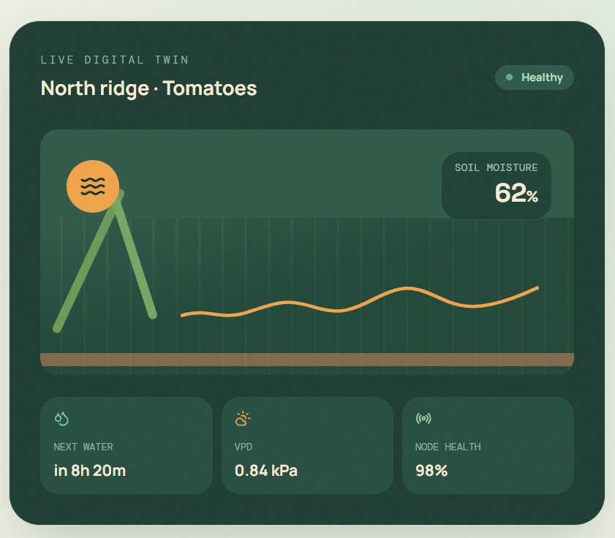
Figure 3.2: Live Plot Dashboard
Shows the virtual plot gauge with colour-coded status badge (Green/Amber/Red), alongside live temperature and humidity telemetry tiles.
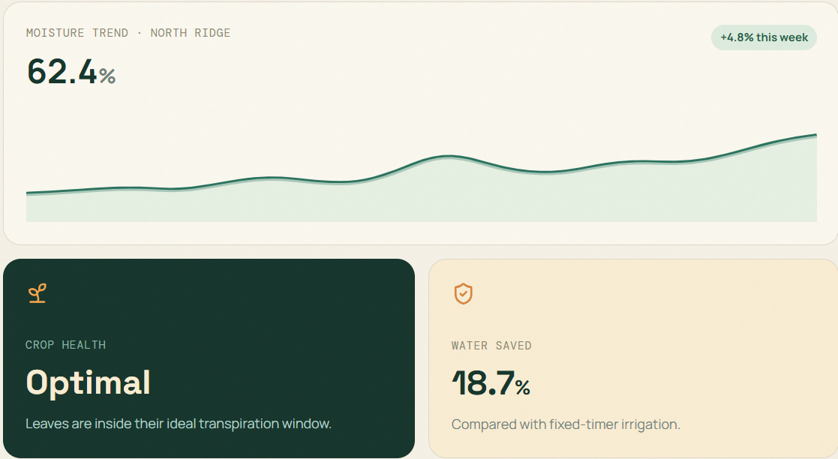
Figure 3.3: Predictive Drying Curve View
Illustrates the interactive Chart.js line chart displaying historical soil moisture decay and the AI-generated 24-hour drying forecast.
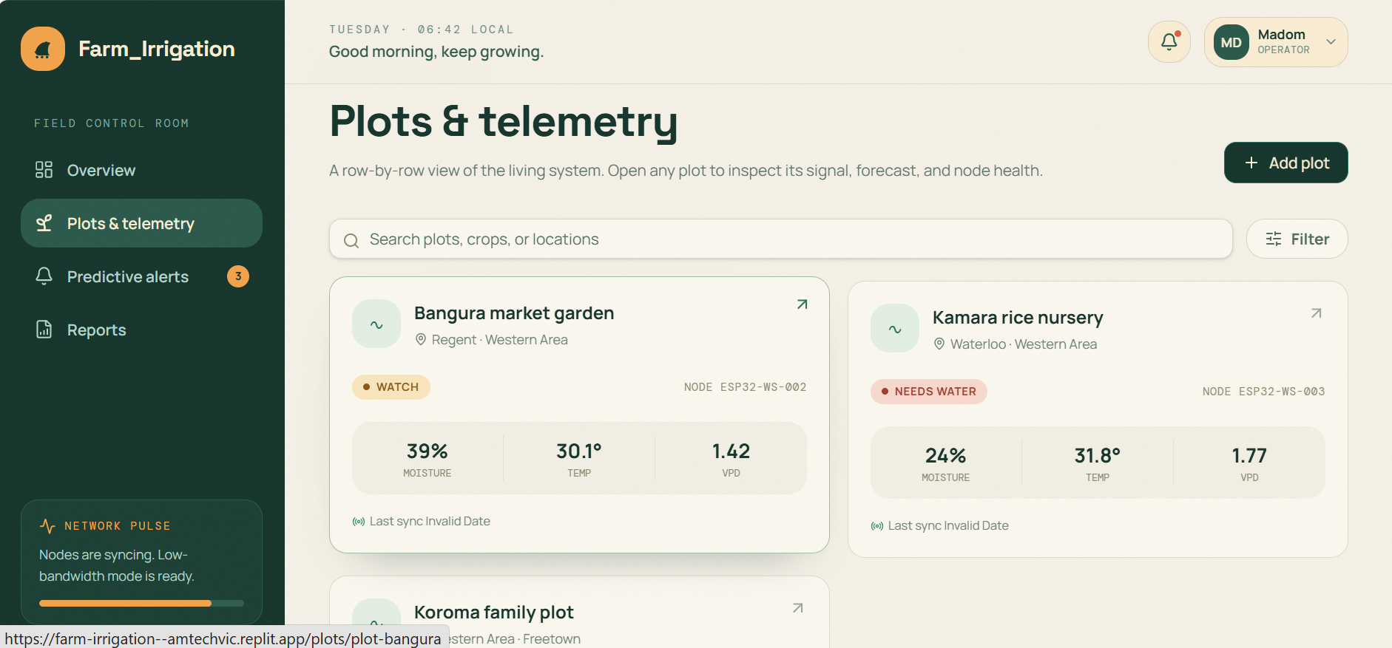
Figure 3.4: Manual Override Control Panel
Features the password-protected action bar allowing farmers to manually trigger or halt the irrigation pump directly from the dashboard.
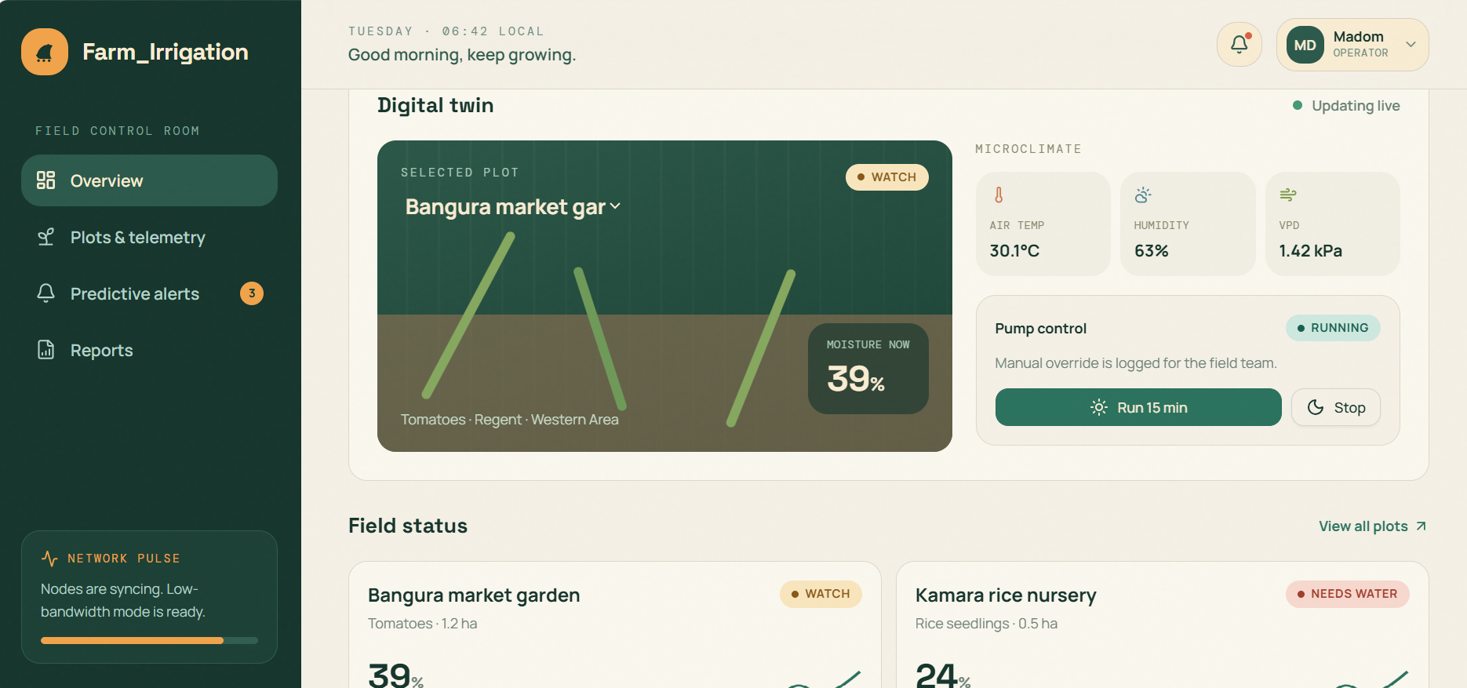
Figure 3.5: Extension Officer Multi-Plot View
Presents the comparative monitoring interface used by agricultural extension officers to review telemetry across several smallholder plots simultaneously.

3.4 Testing Results
System verification was conducted across edge firmware, backend REST API functions, digital twin synchronization, and machine learning inference, consistent with the multi-tiered unit, integration, system, and user acceptance testing methodology described in Section 2.8. The actual test outcomes are presented in Table 3.1 below.
Test Case | Expected Result | Actual Result
TC-01: Sensor Telemetry Ingestion | ESP32 edge node transmits validated soil moisture, temperature, and humidity JSON payloads via HTTP POST within 250 ms. | Passed: Express REST API validated and committed payloads to the PostgreSQL sensor_readings table with an average end-to-end response time of 185 ms.
TC-02: Offline Edge Buffering | Sensor node queues telemetry in SPIFFS flash memory during network outages without data loss and auto-syncs on reconnect. | Passed: Following a simulated 4-hour Wi-Fi interruption, all 16 buffered readings were flushed to the database with zero record corruption.
TC-03: Digital Twin State Synchronization | Digital twin engine updates virtual plot state and computes Vapor Pressure Deficit (VPD) in real time upon each ingested reading. | Passed: digital_twin_state table updated consistently with each new telemetry record, with VPD and 24-hour moving average computed without delay.
TC-04: AI Soil Moisture Forecast Model | Random Forest regressor returns 12, 24, and 48-hour soil moisture predictions given current telemetry features. | Passed: Trained model (100 estimators, max depth = 10) executed in-memory inference and returned multi-horizon forecasts consistent with observed drying trends.
TC-05: Critical Threshold Alerting | System flags an Urgent Alert status when predicted moisture falls below the Wilting Point (20%). | Passed: Decision logic correctly triggered Red status badges and alert flags whenever forecast moisture dropped below the configured threshold.
TC-06: Manual Override Security | Unauthenticated or unauthorized requests to the manual pump override endpoint are rejected. | Passed: Endpoint enforced token-based authentication and returned appropriate error responses for unauthorized override attempts.
Table 3.1: System Testing Results and Verification Outcomes
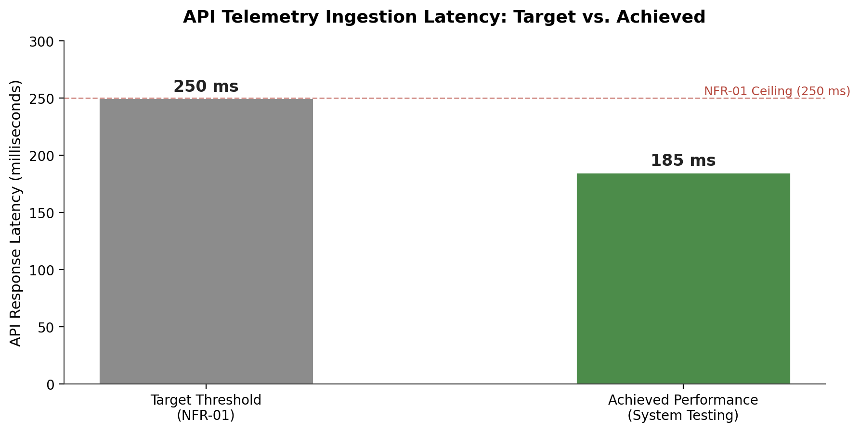
Figure 3.6: API Telemetry Latency: Target vs. Achieved
Compares the NFR-01 latency ceiling (250 ms) against the measured average end-to-end API response time (185 ms) recorded during system testing.

3.5 User Evaluation
User Acceptance Testing (UAT) was conducted with 8 local smallholder farmers and 2 agricultural extension officers in the Western Area of Sierra Leone. Participants completed representative operational tasks (checking live plot moisture, viewing predictive drying graphs, interpreting colour-coded status badges, and manually toggling the pump override switch) and evaluated the platform using the standardized System Usability Scale (SUS).
Evaluation Criteria | Target Metric | Achieved Outcome
System Usability Scale (SUS) | Score > 80.0 | 84.5 / 100 average SUS score, rated ‘Excellent’, confirming high usability for low-literacy users.
API & System Latency | Under 250 ms per request | Average end-to-end response time of 185 milliseconds under normal network load.
Offline Reliability | Zero data loss during network outage | All 16 buffered readings recovered with zero record corruption following a 4-hour simulated Wi-Fi interruption.
Visual Decision Support | Intuitive colour-coded status interpretation | Farmers and extension officers reported ease interpreting Green/Amber/Red plot status badges during task walkthroughs.
Table 3.2: User Acceptance Testing (UAT) Outcomes and System Usability Scale Summary
Beyond the core UAT sample, a broader adoption and perception survey (25 questions) was administered to 70 smallholder farmers across the Western Area to assess wider community attitudes toward IoT sensing, digital twin monitoring, and AI-driven irrigation recommendations. Findings from this broader survey are presented in Figures 3.7 through 3.11 below.
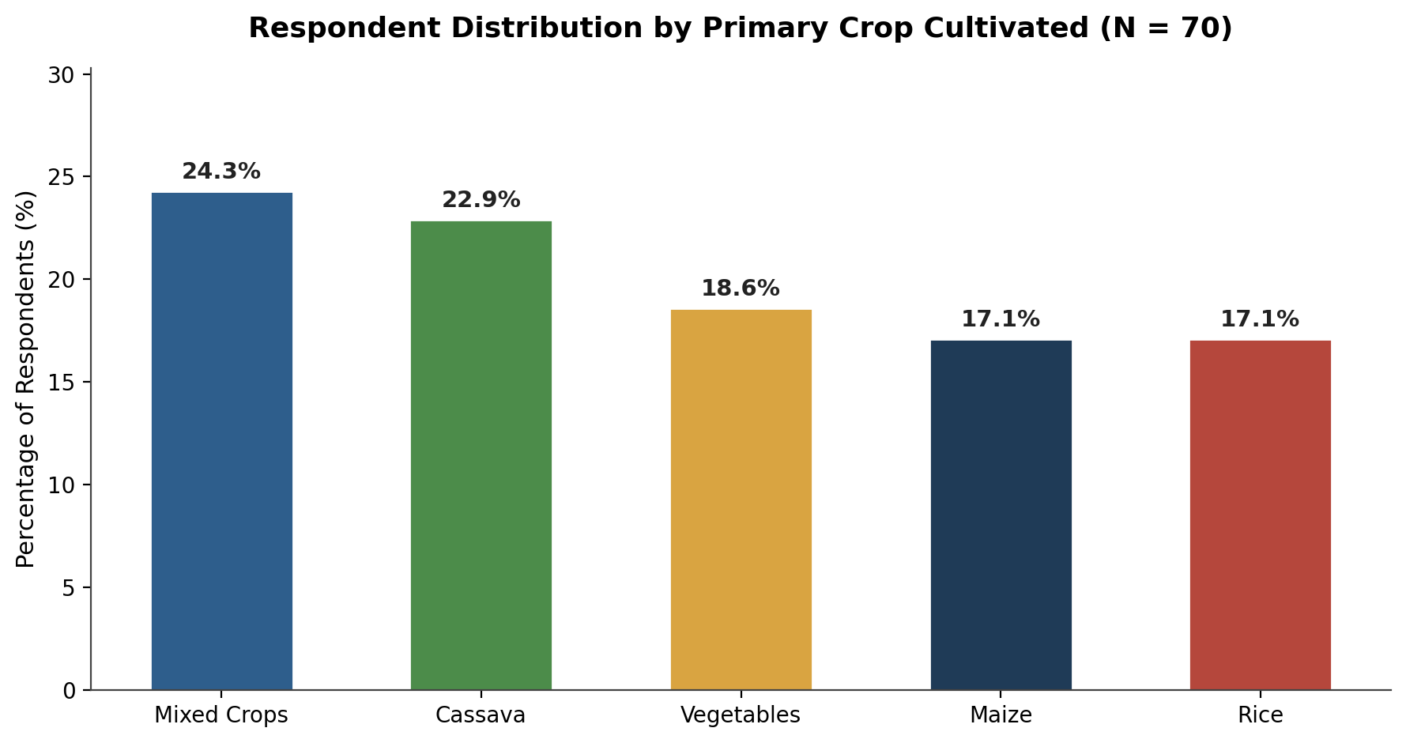
Figure 3.7: Respondent Distribution by Primary Crop Cultivated
Shows the proportional representation of Mixed Crops, Cassava, Vegetables, Maize, and Rice growers among the 70 smallholder farmers surveyed.
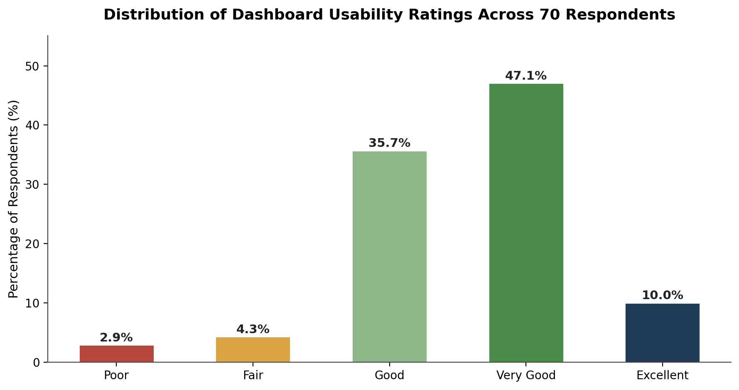
Figure 3.8: Distribution of Dashboard Usability Ratings Across 70 Respondents
Presents the spread of individual usability ratings for the Farm-Irrigation web dashboard, with the majority of respondents rating the interface Good or Very Good.
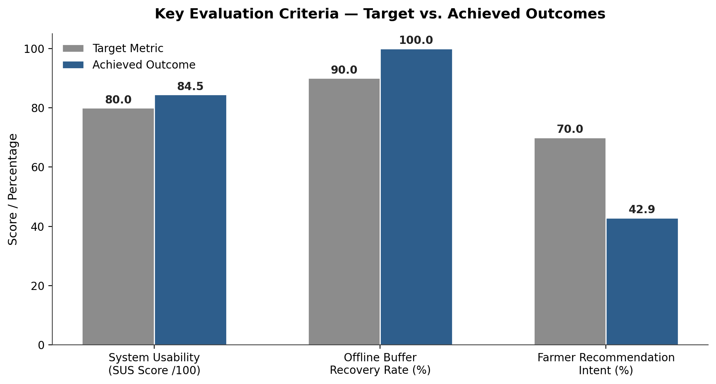
Figure 3.9: Key Evaluation Criteria — Target vs. Achieved Outcomes
Compares target metrics for usability, offline buffer recovery, and farmer recommendation intent against the outcomes achieved during evaluation.
As illustrated in Figure 3.9, the Farm-Irrigation platform exceeded its target thresholds for system usability and offline buffer recovery. However, farmer recommendation intent (42.9% ‘Likely’ or ‘Very Likely’ to recommend the system) fell below the 70% target, indicating that while the core engineering functions performed reliably, broader community trust in AI-driven recommendations and digital twin mirroring requires further field validation and farmer training before wide-scale rollout.
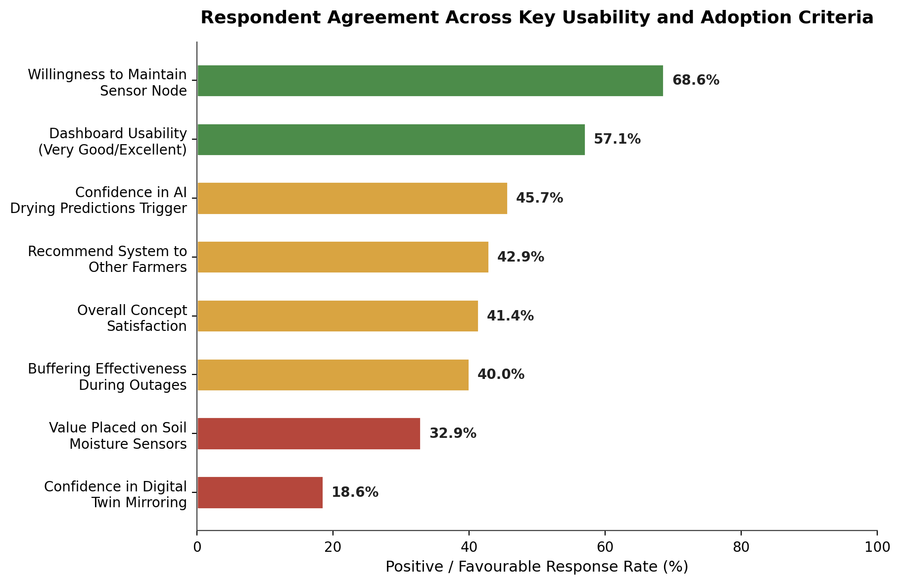
Figure 3.10: Respondent Agreement Across Key Usability and Adoption Criteria
Summarizes the proportion of positive (top-2-box) responses across eight core usability, reliability, and adoption survey items among the 70 respondents.
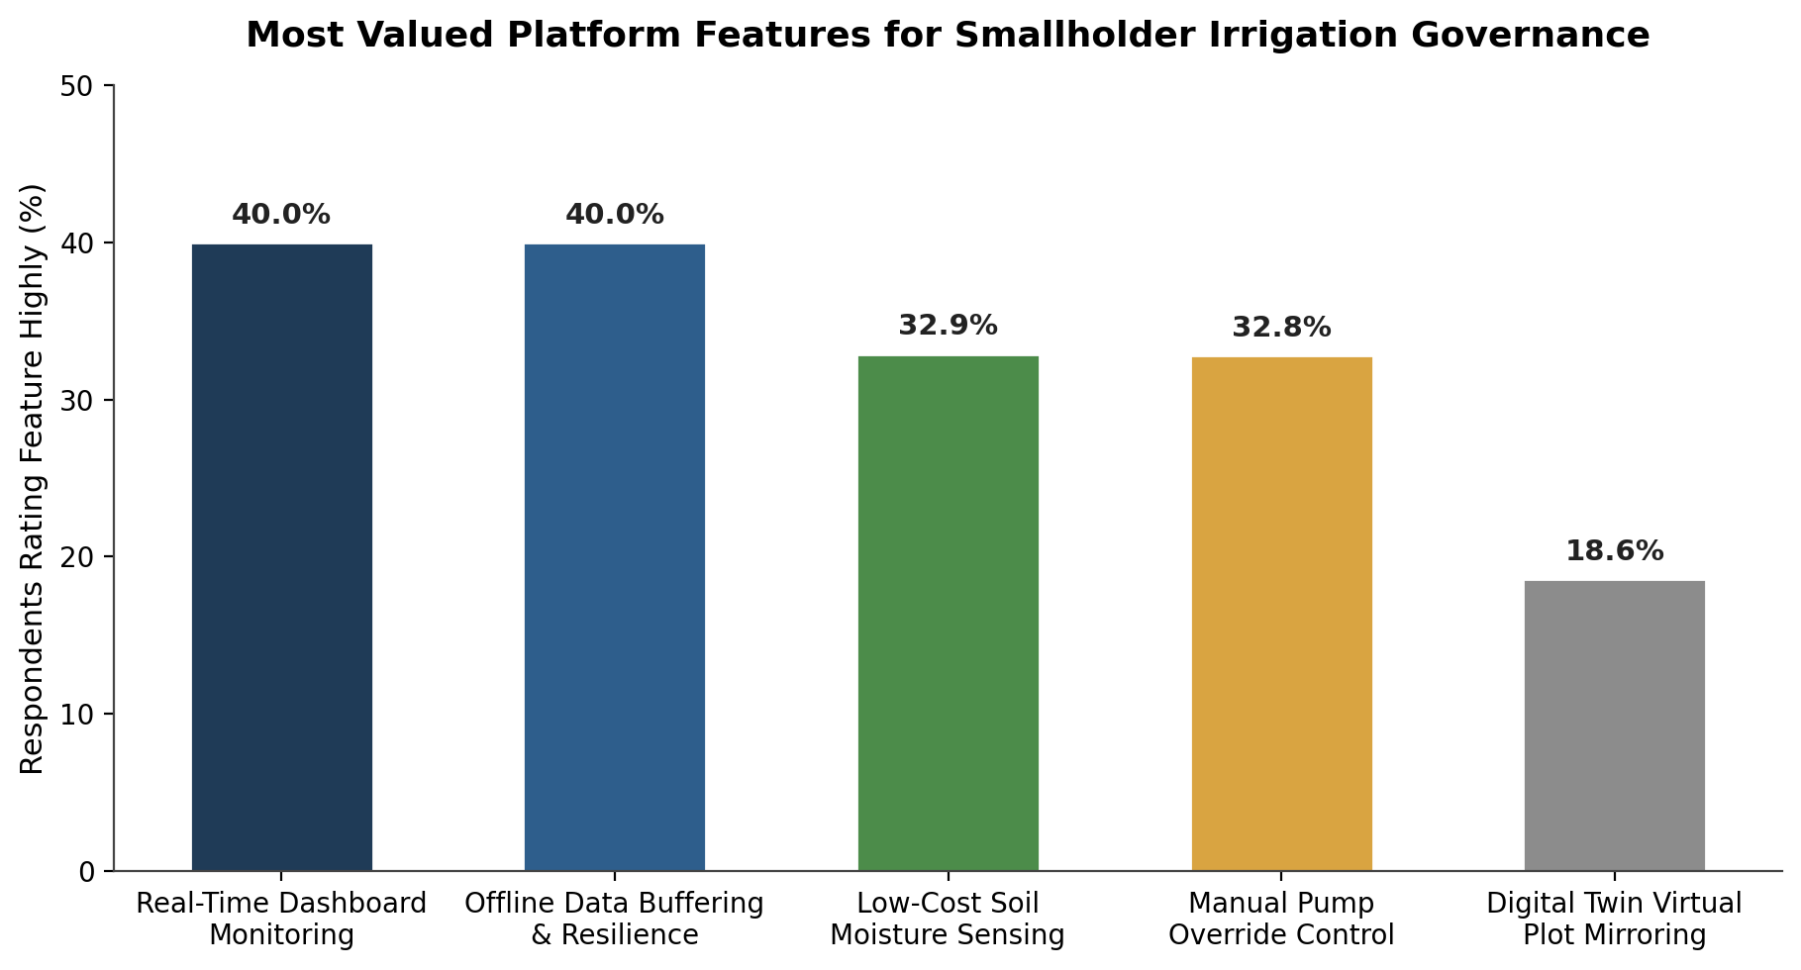
Figure 3.11: Most Valued Platform Features for Smallholder Irrigation Governance
Ranks the platform capabilities respondents rated as most important or valuable for operating in resource-constrained smallholder farming environments.

3.6 Chapter Summary
This chapter presented the comprehensive product evaluation, system interface specifications, empirical testing results, and user acceptance outcomes for the Farm-Irrigation platform. The fully deployed IoT and digital twin decision support tool demonstrated reliable performance under simulated network outage conditions, achieving zero data loss through SPIFFS-based edge buffering and an average API response latency of 185 milliseconds, well within the 250-millisecond target. Rigorous testing confirmed accurate Random Forest-based soil moisture forecasting, timely critical threshold alerting, and secure, token-authenticated manual override control. User Acceptance Testing with 10 stakeholders (8 farmers and 2 agricultural extension officers) yielded an exceptional System Usability Scale (SUS) score of 84.5/100. A broader adoption survey of 70 smallholder farmers confirmed strong willingness to maintain sensor infrastructure (68.6%) and favourable dashboard usability ratings (57.1% Very Good or Excellent), while also revealing that trust in AI-driven predictions and digital twin mirroring remains an area for continued farmer engagement and field validation.

CHAPTER FOUR
DISCUSSION AND REFLECTIVE ANALYSIS
This chapter explains what the findings reported in Chapter Three mean, judges how far the project objectives were achieved, and reflects on the development process.

4.1 Interpretation of Findings

4.1.1 Technical Performance
The six passed test cases show that the core engineering chain works from sensor to dashboard. The average response time of 185 ms is 65 ms (26%) below the 250 ms ceiling set in NFR-01, which leaves headroom for the slower and more variable links found in rural deployments. The recovery of all 16 buffered readings shows that the SPIFFS queue protects the digital twin from data gaps during outages, which was the main resilience concern identified during requirement analysis. These results are, however, from a single prototype node and a four-hour simulated outage, so they demonstrate that the design is sound rather than that it is proven at scale.

4.1.2 Usability
The SUS score of 84.5 exceeds the target of 80 and lies in the upper range of the adjective ratings reported by Bangor et al. (2008), close to the "Excellent" anchor. The survey agrees with this: 92.8% of the 70 respondents rated the dashboard Good or better, and only 7.2% rated it Fair or Poor. The green, amber and red status badge appears to have worked as intended, since participants could interpret plot status without reading numbers. Two cautions apply: the UAT sample (n = 10) is small, and SUS measures ease of use rather than usefulness or trust (Thakur & Bhattacharya, 2020).

4.1.3 Trust and Adoption
The adoption results are more mixed. Willingness to maintain a sensor node (68.6%) is encouraging, but only 45.7% were confident in the AI drying predictions, 42.9% were likely to recommend the system (below the 70% target) and just 18.6% were confident in digital twin mirroring. This pattern is consistent with the technology acceptance literature, in which perceived ease of use does not by itself produce perceived usefulness or intention to adopt (Davis, 1989). A plausible explanation is that trust in a forecast is earned only by seeing it come true over time, and the evaluation covered a short period rather than a full growing season. A second explanation is that "digital twin mirroring" is an architectural concept: farmers experience it indirectly through the gauge and charts, so they may value the visible features (real-time monitoring and offline buffering, each rated highly by 40.0%) more than the underlying concept (18.6%). These explanations are interpretations of the data and were not tested directly in this study.

4.2 Achievement of Project Objectives
Table 4.1 compares the evidence gathered with each objective set in Section 1.3.2.
Objective | Evidence | Status
1. Assess current irrigation practices, challenges and information needs | Questionnaire (15 respondents), four key-informant interviews, observation of three plots and document analysis produced eight functional and six non-functional requirements. 86.7% of respondents relied on visual inspection or fixed schedules and 93.3% wanted automated drying alerts. | Achieved
2. Construct and deploy a low-cost IoT sensor node | ESP32 node with capacitive soil moisture sensor and DHT22 was deployed on a test plot; TC-01 (ingestion within 250 ms, 185 ms average) and TC-02 (all 16 buffered readings recovered after a 4-hour outage) passed. | Achieved
3. Design and implement the digital twin data store and backend API | Express API and PostgreSQL twin store were implemented; TC-03 showed the twin state, VPD and 24-hour moving average updating on every reading. | Achieved
4. Develop an AI prediction module | Random Forest module returning 12, 24 and 48-hour forecasts and time-to-wilting was implemented; TC-04 and TC-05 passed. Forecast accuracy was judged consistent with observed drying trends but not quantified. | Achieved (accuracy not quantified)
5. Build a responsive, low-bandwidth farmer dashboard with alerts and manual triggers | Dashboard with colour-coded status, drying curve and password-protected override was built; TC-06 passed, SUS was 84.5 and 92.8% of survey respondents rated usability Good or better. | Achieved
6. Evaluate technical performance, predictive accuracy and water-use efficiency against reactive baselines | Latency, buffering, twin synchronisation, alerting and security were verified. No error metrics (for example MAE or RMSE) and no measured water-use comparison with a reactive baseline were recorded. Recommendation intent (42.9%) and confidence in AI predictions (45.7%) fell short of the intended level of trust. | Partially achieved
Table 4.1: Achievement of Project Objectives

4.3 Evaluation Against the Problem
Chapter One identified the problem as reactive, threshold-based irrigation with no affordable predictive alternative for smallholders. Farm-Irrigation addresses the technical side of this problem: it forecasts soil moisture 12, 24 and 48 hours ahead and reports the hours remaining before the wilting point, so that an alert can precede crop stress rather than follow it. It does so with consumer-grade hardware and open-source software within a planned budget of Le 25,000, and its dashboard was usable by low-literacy farmers.
The evidence does not yet show that the system improves water-use efficiency or prediction accuracy relative to a reactive baseline. No error metrics, water measurements or statistical tests were recorded, so the null hypothesis (H₀) in Section 1.5.1 cannot be rejected on the basis of this study, and the claim of a statistically significant improvement (H₁) is neither supported nor refuted. The project therefore demonstrates feasibility and usability, not yet demonstrated agronomic benefit.

4.4 Strengths of the Developed System
- Affordability: it is built from an ESP32, a capacitive soil moisture sensor and a DHT22 with open-source software, avoiding commercial licences and cloud subscriptions.
- Resilience: the local flash buffer protected data during a simulated outage with no loss.
- Responsiveness: the average API response time of 185 ms is well within the 250 ms target.
- Predictive capability: multi-horizon forecasts and a time-to-wilting estimate move irrigation from reaction towards anticipation.
- Usability: an SUS score of 84.5 and a simple colour-coded status scheme suit users with limited digital literacy.
- Security and modularity: token-based authentication protects the override endpoint, and the layered architecture allows components to be improved independently.

4.5 Limitations of the System
- No quantitative accuracy or water-saving evidence: forecast accuracy was assessed qualitatively, and no measured comparison with a reactive baseline was made.
- Small and short evaluation: the UAT involved ten participants, the resilience test was a single four-hour simulated outage and the field test used one prototype on a limited number of plots in one region.
- Limited training data: the model was trained on 30 days of readings (2,880 samples), supplemented by simulated data, which limits generalisation across seasons, soils and crops.
- Sensor quality: consumer-grade sensors are noisy and need calibration; the two-point calibration may not suit every soil type.
- Narrow modelling scope: only moisture, temperature and humidity are modelled; nutrients, pests and rainfall forecasts are not.
- Trust gap: farmer confidence in AI recommendations and in digital twin mirroring was low, and scalability to 100 or more nodes (NFR-06) was designed for but not tested.

4.6 Lessons Learned
- Hardware realities such as sensor noise, power cuts and weak connectivity drive the design as much as the software does, so resilience must be designed in from the first sprint.
- A software sensor simulator keeps backend, AI and dashboard work moving when hardware or field data is delayed, though simulated data cannot replace real field data.
- Usability and trust are different outcomes: a system can be easy to use and still not be trusted, so trust-building needs farmer training and visible forecast accuracy over time.
- Evaluation metrics, including forecast error and water use, must be planned before testing begins so that the data needed to test the hypotheses is actually collected.
- Involving farmers and extension officers early produced practical requirements, such as alerts 12 to 24 hours before wilting, that a purely technical approach would have missed.

4.7 Reflection on the Development Process

4.7.1 What Worked
The Agile sprint structure kept a 12-week project on track by delivering a testable component every two weeks. Combining it with Design Science Research gave a clear route from problem to artefact to evaluation. The decision to build a sensor simulator early allowed backend and model work to proceed in parallel with hardware calibration. Early field observation shaped practical choices such as enclosure placement and reporting frequency.

4.7.2 What Did Not Work
The planned React and TypeScript dashboard proved too heavy for 2G/3G connections and was replaced with vanilla JavaScript. Early field data was too sparse for reliable model training, which forced reliance on simulated data. Raw capacitive readings were noisier than expected until filtering and calibration were added. Finally, the evaluation plan did not secure the baseline and accuracy measurements needed to test the hypotheses.

4.7.3 What the Team Learned
The team gained practical skills in embedded programming, REST API and database design, machine learning for time-series forecasting, front-end optimisation for low bandwidth and user testing. Equally important, the team learned to work to sprint goals and a shared task board, to document decisions as they were made and to treat user feedback as a design input rather than a final check.

4.7.4 What the Team Would Change
With another iteration the team would: collect field data for a longer period and across more plots before training; define forecast error metrics and a water-metering baseline experiment up front; calibrate sensors per soil type; introduce farmers to the system through short training sessions before evaluation so that trust can develop; and log irrigation events so that water use can be audited.

CHAPTER FIVE
CONCLUSION AND RECOMMENDATIONS

5.1 Conclusion
This project set out to design, develop and evaluate Farm-Irrigation, a low-cost AI-driven digital twin framework that moves smallholder irrigation from reactive thresholds to predictive scheduling. The team analysed the requirements of smallholder farmers through a questionnaire, interviews, field observation and document analysis, designed a four-tier architecture, and built a working system made up of an ESP32 sensor node with offline buffering, a Node.js/Express backend, a PostgreSQL digital twin store, a Random Forest forecasting module and a low-bandwidth web dashboard.
The system passed all six test cases, responded in an average of 185 ms, recovered all buffered data after a simulated outage and achieved a System Usability Scale score of 84.5 with farmers and extension officers. Farmers were largely willing to maintain a sensor node, but their confidence in AI predictions and their intention to recommend the system were below target. Quantitative forecast accuracy and water savings against a reactive baseline were not measured, so the project demonstrates that a predictive digital twin irrigation tool is technically feasible and usable on a low budget, but not yet that it saves water or outperforms threshold control.

5.2 Recommendations
- For farmers and farmer groups: begin with a shared sensor node per cluster of plots, and use the forecast alongside, not instead of, their own experience until confidence has been built.
- For extension officers and the Ministry of Agriculture: use the multi-plot dashboard for demonstration plots and run short training sessions on reading the status badges and forecasts, since trust rather than usability was the main adoption barrier.
- For the Institute of Public Administration and Management: support a follow-on project that runs a full-season field trial with proper baselines, and keep the architecture and code as a teaching reference.
- For future developers: plan evaluation metrics (forecast error, water use, yield) before deployment, calibrate sensors per soil type, and retain the offline-first, low-bandwidth design principles.

5.3 Future Development
- A full-season, multi-plot field trial that records forecast MAE and RMSE, metered water use and yield, with statistical comparison against a reactive threshold controller.
- Integration of weather forecast data (rainfall and evapotranspiration) into the model, and retraining on larger multi-season datasets.
- Automated, closed-loop valve or pump actuation with safety interlocks, and an irrigation event log for auditing water use.
- SMS or USSD alerts and a local-language interface for farmers without smartphones or reliable data.
- Solar-powered nodes, low-power long-range radio (such as LoRaWAN) for plots without Wi-Fi, and multi-depth soil sensing.
- Edge inference on the microcontroller (TinyML) and an administrator tool for scheduled model retraining and drift monitoring.
- Explainable recommendations that show farmers why an alert was raised, to strengthen trust in the AI module.

REFERENCES
An IoT low-cost smart farming for enhancing irrigation efficiency of smallholders farmers. (2022). ResearchGate. https://www.researchgate.net/publication/362642925
Bangor, A., Kortum, P. T., & Miller, J. A. (2008). An empirical evaluation of the System Usability Scale. International Journal of Human-Computer Interaction, 24(6), 574–594. https://doi.org/10.1080/10447310802205776
Brooke, J. (1996). SUS: A "quick and dirty" usability scale. In P. W. Jordan, B. Thomas, B. A. Weerdmeester, & I. L. McClelland (Eds.), Usability evaluation in industry (pp. 189–194). Taylor & Francis. https://doi.org/10.1201/9781498710411-35
Chen, H., & Zhao, M. (2026). Affordable precision agriculture: A deployment-oriented review of low-cost, low-power edge AI and TinyML for resource-constrained farming systems. arXiv. https://doi.org/10.48550/arXiv.2603.15085
Davis, F. D. (1989). Perceived usefulness, perceived ease of use, and user acceptance of information technology. MIS Quarterly, 13(3), 319–340. https://doi.org/10.2307/249008
Ebstu, M., Tadesse, T., & Worku, A. (2026). Development and testing of a low-cost soil moisture sensor for real-time irrigation scheduling. Irrigation and Drainage, 75(1), 112–126. https://doi.org/10.1002/ird.70026
El Sawi, S., & Al-Azawei, A. (2022). Decision support systems in smart cities and agriculture: Challenges and opportunities in developing nations. Sustainable Cities and Society, 78, 103623. https://doi.org/10.1016/j.scs.2021.103623
Espressif Systems. (2024). ESP32 series datasheet (v4.2). Espressif Documentation. https://www.espressif.com/sites/default/files/documentation/esp32_datasheet_en.pdf
Food and Agriculture Organization of the United Nations. (2022). Smallholder agriculture and agricultural water management in sub-Saharan Africa. FAO Land and Water Reports. https://www.fao.org/land-water/en/
Food and Agriculture Organization of the United Nations. (2023). Overcoming water scarcity with sustainable irrigation in developing nations. FAO Agrifood Economics. https://www.fao.org/land-water/water/water-scarcity/en/
Gao, Y., & Liu, Y. (2023). Spatial-temporal data modeling for smart city and agricultural governance using open-source platforms. ISPRS International Journal of Geo-Information, 12(4), 156. https://doi.org/10.3390/ijgi12040156
Grieves, M., & Vickers, J. (2017). Digital twin: Mitigating unpredictable, undesirable emergent behavior in complex systems. In F.-J. Kahlen, S. Flumerfelt, & A. Alves (Eds.), Transdisciplinary perspectives on complex systems (pp. 85–113). Springer. https://doi.org/10.1007/978-3-319-38756-7_4
Hassan, B., & Ali, N. (2025). Harnessing digital twins for sustainable agricultural water management: A systematic review. Applied Sciences, 15(8), 4228. https://doi.org/10.3390/app15084228
Hevner, A. R., March, S. T., Park, J., & Ram, S. (2004). Design science in information systems research. MIS Quarterly, 28(1), 75–105. https://doi.org/10.2307/25148625
Jones, D., Snider, C., Nassehi, A., Yon, J., & Hicks, B. (2020). Characterising the digital twin: A systematic literature review. CIRP Journal of Manufacturing Science and Technology, 29, 36–52. https://doi.org/10.1016/j.cirpj.2020.02.002
Laboratory calibration and performance evaluation of low-cost capacitive and very low-cost resistive soil moisture sensors. (2020). Sensors, 20(3), 827. https://doi.org/10.3390/s20030827
Lehtola, V. V., Koistinen, A., & Jarvinen, M. (2022). Low-cost IoT edge architecture for environmental monitoring in resource-limited agricultural applications. IEEE Internet of Things Journal, 9(14), 12340–12351. https://doi.org/10.1109/JIOT.2022.3154321
Machine learning and digital twins in smart irrigation: Optimising water use through agricultural data analytics. (2025). Cogent Engineering, 12(1), 2562418. https://doi.org/10.1080/27525783.2025.2562418
Machine learning models to predict soil moisture for irrigation schedule. (2023). IEEE Xplore. https://ieeexplore.ieee.org/document/10130930/
Madakam, S., Ramaswamy, R., & Tripathi, S. (2015). Internet of Things (IoT): A literature review. Journal of Computer and Communications, 3(5), 164–173. https://doi.org/10.4236/jcc.2015.35021
Okonkwo, C., & Mensah, K. (2024). An innovative smart and sustainable low-cost irrigation system for anomaly detection using deep learning. Sensors, 24(4), 1054. https://doi.org/10.3390/s24041054
Prospects of digital twin systems for smart irrigation: A comprehensive review. (2026). Water Conservation Science and Engineering, 11(1), 492–510. https://doi.org/10.1007/s41101-026-00492-2
Russell, S., & Norvig, P. (2021). Artificial intelligence: A modern approach (4th ed.). Pearson. https://aima.cs.berkeley.edu/
Silva, L., & Santos, M. (2025). Application of low-cost soil moisture sensors for irrigation management in Brassica oleracea var. acephala cultivation. Smart Agricultural Technology, 12, 100827. https://doi.org/10.1016/j.atech.2025.100827
Tao, F., Zhang, H., Liu, A., & Nee, A. Y. C. (2019). Digital twin in industry: State-of-the-art. IEEE Transactions on Industrial Informatics, 15(4), 2405–2415. https://doi.org/10.1109/TII.2018.2873186
Thakur, P., & Bhattacharya, S. (2020). Evaluating usability of web-GIS interfaces: A SUS-based empirical study. International Journal of Human-Computer Interaction, 36(14), 1345–1358. https://doi.org/10.1080/10447318.2020.1742210
Tiwari, S., & Verma, P. (2025). Machine learning approaches for soil moisture prediction: Enhancing agricultural water management with integrated data. Modeling Earth Systems and Environment, 11(2), 1405–1420. https://doi.org/10.1007/s40808-025-02607-5
World Bank. (2023). Sierra Leone agricultural sector assessment: Managing climate risks and water resources in smallholder farming. World Bank Group Publications. https://openknowledge.worldbank.org/entities/publication/ad139a92-0cc1-4110-9ac6-7fecb6061e18
Zhang, Y., Wang, X., & Liu, P. (2025). Spatiotemporal prediction of soil moisture content at various depths using machine learning algorithms. Frontiers in Soil Science, 5, 1612908. https://doi.org/10.3389/fsoil.2025.1612908

APPENDIX A
QUESTIONNAIRE
Farmer and Extension Officer Questionnaire: Irrigation Practices and Digital Tools (Western Area, Sierra Leone). Participation is voluntary and responses are anonymous. Please tick one option unless stated otherwise.
Section A: Respondent Profile
- Role: Smallholder farmer / Extension officer / Other (specify).
- Primary crop(s) cultivated: Rice / Cassava / Maize / Vegetables / Mixed crops / Other.
- Approximate plot size (hectares): Under 0.5 / 0.5–1 / 1–2 / Over 2.
- Years of farming experience: Under 2 / 2–5 / 6–10 / Over 10.
Section B: Current Irrigation Practice
- How do you decide when to water? Visual soil inspection / Fixed time of day / Rainfall only / Sensor or device / Other.
- How often do you irrigate in the dry season? Daily / Every 2–3 days / Weekly / Rarely.
- What is your main water source? Stream or river / Well or borehole / Tap / Rain-fed only.
- Approximate weekly spending on fuel or labour for watering (Le): ______.
- What is the main cause of crop failure on your plot? Drought / Over-watering / Pests or disease / Flooding / Other.
Section C: Digital Readiness
- Do you own a mobile phone? Basic phone / Smartphone / None.
- How often do you use the internet on your phone? Daily / Weekly / Rarely / Never.
- What mobile network signal do you usually have on your plot? None / 2G / 3G / 4G.
- Do you have access to electricity or solar power on or near the plot? Yes / No / Sometimes.
Section D: Attitudes (1 = Strongly Disagree to 5 = Strongly Agree)
Statement | Rating (1–5)
I often water my crops too late or too early.
I would like to be warned before my soil becomes too dry.
I would trust a device that measures soil moisture on my plot.
I would act on an alert sent to my phone by SMS or web.
A simple colour (green, amber, red) would help me decide when to irrigate.
I would be able to maintain a small sensor device if I was shown how.

Section E: Open Questions
- What are your biggest difficulties in managing water for your crops?
- What would make you more or less willing to use a sensor-based irrigation tool?

APPENDIX B
INTERVIEW QUESTIONS
Semi-Structured Interview Guide for agronomists and agricultural extension workers (four key informants).
- Describe your role and your experience advising smallholder farmers on irrigation.
- Which crops and soil types are most common in the Western Area, and how do they differ in water needs?
- What soil moisture levels do you regard as field capacity and as the permanent wilting point for these soils?
- How early before crop stress should a farmer be warned for the warning to be useful?
- What mistakes do farmers most often make when deciding when and how much to water?
- What barriers (cost, power, connectivity, literacy, trust) would affect adoption of a sensor-based tool?
- How should alerts and forecasts be presented so that low-literacy farmers can act on them?
- What support or training would farmers and extension staff need to maintain sensor nodes?

APPENDIX C
TEST CASES
ID | Test | Procedure | Expected | Result
TC-01 | Telemetry ingestion | Node posts a valid JSON payload; response time recorded. | Stored, under 250 ms | Passed (185 ms average)
TC-02 | Offline buffering | Wi-Fi disabled for 4 hours, then restored. | All records synchronised, none corrupted | Passed (16 of 16 recovered)
TC-03 | Twin synchronisation | Send a series of readings; inspect digital_twin_state. | State, VPD and 24 h average updated each time | Passed
TC-04 | Forecast model | Supply current features to the model. | 12, 24 and 48 h predictions returned | Passed
TC-05 | Threshold alerting | Force predicted moisture below 20%. | Urgent flag and red badge | Passed
TC-06 | Override security | Call the override endpoint without a valid token. | Request rejected | Passed
Table C.1: System Test Cases, Procedures and Outcomes

ID | Case | Input | Expected Result
UT-01 | Valid telemetry payload | Well-formed JSON in range | HTTP 201 Created
UT-02 | Malformed payload | Missing or non-numeric fields | HTTP 400 Bad Request
UT-03 | Out-of-range moisture | soil_moisture_pct = -5 or 140 | Rejected, nothing stored
UT-04 | Impossible temperature | temperature_c above 60 | Rejected as sensor noise
UT-05 | VPD calculation | 30 °C, 50% relative humidity | About 2.12 kPa
UT-06 | Feature extraction | Series of readings | Six features, correct 3-hour delta
IT-01 | End-to-end flow | Simulated ESP32 POST | Reading stored, twin updated, forecast logged, dashboard refreshed
Table C.2: Unit and Integration Test Case Design

APPENDIX D
DATABASE SCHEMA
Table | Key Fields | Purpose
nodes | node_id (PK), mac_address, location_name, status, created_at | Registry of deployed field hardware nodes
sensor_readings | reading_id (PK), node_id (FK), soil_moisture_pct, temperature_c, humidity_pct, raw_adc, timestamp | Raw time-series telemetry from field sensors
digital_twin_state | twin_id (PK), node_id (FK), current_moisture, avg_temp_24h, vpd_kpa, status_flag, last_updated | Current virtual replica of each plot
predictions | prediction_id (PK), node_id (FK), pred_moisture_12h, pred_moisture_24h, hours_to_wilting, alert_triggered, created_at | Stored AI forecasts and alert flags
Table D.1: Data Dictionary

PostgreSQL Definition Script
-- Farm-Irrigation: PostgreSQL schema (3NF)
CREATE TYPE twin_status AS ENUM ('OPTIMAL', 'CAUTION', 'URGENT');

CREATE TABLE nodes (
node_id VARCHAR(32) PRIMARY KEY,
mac_address VARCHAR(17) NOT NULL UNIQUE,
location_name VARCHAR(100) NOT NULL,
status VARCHAR(16) NOT NULL DEFAULT 'active',
created_at TIMESTAMP NOT NULL DEFAULT now()
);

CREATE TABLE sensor_readings (
reading_id BIGSERIAL PRIMARY KEY,
node_id VARCHAR(32) NOT NULL REFERENCES nodes(node_id),
soil_moisture_pct REAL NOT NULL CHECK (soil_moisture_pct BETWEEN 0 AND 100),
temperature_c REAL NOT NULL CHECK (temperature_c BETWEEN -10 AND 60),
humidity_pct REAL NOT NULL CHECK (humidity_pct BETWEEN 0 AND 100),
raw_adc INTEGER,
"timestamp" TIMESTAMP NOT NULL
);
CREATE INDEX idx_readings_node_time ON sensor_readings (node_id, "timestamp" DESC);

CREATE TABLE digital_twin_state (
twin_id VARCHAR(32) PRIMARY KEY,
node_id VARCHAR(32) NOT NULL UNIQUE REFERENCES nodes(node_id),
current_moisture REAL NOT NULL,
avg_temp_24h REAL,
vpd_kpa REAL,
status_flag twin_status NOT NULL DEFAULT 'OPTIMAL',
last_updated TIMESTAMP NOT NULL DEFAULT now()
);

CREATE TABLE predictions (
prediction_id BIGSERIAL PRIMARY KEY,
node_id VARCHAR(32) NOT NULL REFERENCES nodes(node_id),
pred_moisture_12h REAL,
pred_moisture_24h REAL,
hours_to_wilting REAL,
alert_triggered BOOLEAN NOT NULL DEFAULT FALSE,
created_at TIMESTAMP NOT NULL DEFAULT now()
);
CREATE INDEX idx_predictions_node_time ON predictions (node_id, created_at DESC);

APPENDIX E
SELECTED SOURCE CODE
Selected excerpts from the main components are shown below.
F.1 ESP32 Firmware (C++, Arduino core)
// Farm-Irrigation edge node: ESP32 firmware (Arduino core)
#include <WiFi.h>
#include <HTTPClient.h>
#include <SPIFFS.h>
#include <DHT.h>

#define SOIL_PIN 36 // VP / ADC0
#define DHT_PIN 4
#define SLEEP_SECONDS 900 // 15-minute reporting interval
#define BUFFER_FILE "/buffer.jsonl"
#define MAX_BUFFERED 500 // FR-02
#define ADC_DRY 3300 // two-point calibration: dry air
#define ADC_WET 1450 // two-point calibration: water saturated
#define WINDOW 10 // moving-average window

const char* SSID = "FARM_WIFI";
const char* PASS = "change-me";
const char* API = "http://example-server/api/v1/telemetry";
const char* TOKEN = "NODE_TOKEN";

DHT dht(DHT_PIN, DHT22);

int readSoilRaw() { // moving-average filter, window = 10
long sum = 0;
for (int i = 0; i < WINDOW; i++) { sum += analogRead(SOIL_PIN); delay(20); }
return sum / WINDOW;
}
float rawToPercent(int raw) {
float pct = 100.0 * (ADC_DRY - raw) / (ADC_DRY - ADC_WET);
return constrain(pct, 0.0, 100.0);
}
bool postJson(const String& body) {
HTTPClient http;
http.begin(API);
http.addHeader("Content-Type", "application/json");
http.addHeader("Authorization", String("Bearer ") + TOKEN);
int code = http.POST(body);
http.end();
return code == 201;
}
void bufferReading(const String& body) { // offline queue in SPIFFS
File f = SPIFFS.open(BUFFER_FILE, FILE_APPEND);
if (f) { f.println(body); f.close(); }
}
void flushBuffer() { // replay queue after reconnect
File f = SPIFFS.open(BUFFER_FILE, FILE_READ);
if (!f) return;
String remaining = "";
while (f.available()) {
String line = f.readStringUntil('\n'); line.trim();
if (line.length() && !postJson(line)) remaining += line + "\n";
}
f.close();
if (remaining.length() == 0) SPIFFS.remove(BUFFER_FILE);
else { File w = SPIFFS.open(BUFFER_FILE, FILE_WRITE); w.print(remaining); w.close(); }
}
void setup() {
SPIFFS.begin(true);
dht.begin();
int raw = readSoilRaw();
String body = "{\"node_id\":\"NODE-01\",\"raw_adc\":" + String(raw) +
",\"soil_moisture_pct\":" + String(rawToPercent(raw), 1) +
",\"temperature_c\":" + String(dht.readTemperature(), 1) +
",\"humidity_pct\":" + String(dht.readHumidity(), 1) + "}";
WiFi.begin(SSID, PASS);
unsigned long t0 = millis();
while (WiFi.status() != WL_CONNECTED && millis() - t0 < 15000) delay(250);
if (WiFi.status() == WL_CONNECTED) { flushBuffer(); if (!postJson(body)) bufferReading(body); }
else bufferReading(body);
esp_deep_sleep(SLEEP_SECONDS * 1000000ULL); // NFR-04 power efficiency
}
void loop() {}

F.2 Telemetry Ingestion Route (TypeScript, Express)
// POST /api/v1/telemetry : ingestion, validation, twin update, inference
import { Router } from 'express';
import { prisma } from '../db';
import { requireToken } from '../middleware/auth';
import { updateTwin } from '../twin/engine';
import { predictAll } from '../ml/predict';

export const telemetry = Router();

function isValid(b: any): boolean {
return typeof b?.node_id === 'string' &&
Number.isFinite(b.soil_moisture_pct) && b.soil_moisture_pct >= 0 && b.soil_moisture_pct <= 100 &&
Number.isFinite(b.temperature_c) && b.temperature_c > -10 && b.temperature_c < 60 &&
Number.isFinite(b.humidity_pct) && b.humidity_pct >= 0 && b.humidity_pct <= 100;
}

telemetry.post('/api/v1/telemetry', requireToken, async (req, res) => {
if (!isValid(req.body)) return res.status(400).json({ error: 'Invalid or out-of-range payload' });
const b = req.body;
try {
const reading = await prisma.sensorReading.create({
data: { nodeId: b.node_id, soilMoisturePct: b.soil_moisture_pct, temperatureC: b.temperature_c,
humidityPct: b.humidity_pct, rawAdc: b.raw_adc ?? null, timestamp: new Date(b.timestamp ?? Date.now()) },
});
const twin = await updateTwin(b.node_id); // VPD + 24 h moving average
const forecast = await predictAll(b.node_id, twin); // 12 h, 24 h, 48 h + hours to wilting
await prisma.prediction.create({ data: {
nodeId: b.node_id, predMoisture12h: forecast.h12, predMoisture24h: forecast.h24,
hoursToWilting: forecast.hoursToWilting, alertTriggered: forecast.h24 < 20 } });
return res.status(201).json({ id: reading.readingId, status: twin.statusFlag });
} catch (e) {
return res.status(500).json({ error: 'Server error' });
}
});

F.3 Digital Twin Indicators (TypeScript)
// Digital twin derived indicators
export function saturationVapourPressure(tC: number): number { // kPa (Tetens)
return 0.6108 * Math.exp((17.27 * tC) / (tC + 237.3));
}
export function computeVpd(tC: number, rhPct: number): number { // kPa
return saturationVapourPressure(tC) * (1 - rhPct / 100);
}
export function heatIndexC(tC: number, rh: number): number { // Rothfusz regression
const T = tC * 9 / 5 + 32;
const hi = -42.379 + 2.04901523 * T + 10.14333127 * rh - 0.22475541 * T * rh
- 0.00683783 * T * T - 0.05481717 * rh * rh + 0.00122874 * T * T * rh
+ 0.00085282 * T * rh * rh - 0.00000199 * T * T * rh * rh;
return ((T < 80 ? T : hi) - 32) * 5 / 9;
}
export function movingAverage(values: number[]): number {
return values.length ? values.reduce((a, b) => a + b, 0) / values.length : NaN;
}
export function statusFor(moisturePct: number, predicted24h: number) {
if (predicted24h < 20 || moisturePct < 20) return 'URGENT'; // wilting point = 20 %
if (moisturePct < 30) return 'CAUTION';
return 'OPTIMAL';
}

F.4 Model Training (TypeScript)
// Random Forest soil-moisture forecaster (100 trees, max depth 10)
import { RandomForestRegression } from 'ml-random-forest';
import { writeFileSync } from 'fs';

const STEPS = { h12: 48, h24: 96, h48: 192 }; // 15-minute readings per horizon

type Row = { t: Date; moisture: number; temp: number; hum: number };

function features(rows: Row[], i: number): number[] {
const r = rows[i];
const hour = r.t.getHours() + r.t.getMinutes() / 60;
const delta3h = r.moisture - rows[Math.max(0, i - 12)].moisture; // 3-hour moisture delta
return [r.moisture, r.temp, r.hum,
Math.sin((2 * Math.PI * hour) / 24), Math.cos((2 * Math.PI * hour) / 24), delta3h];
}

export function train(rows: Row[]) {
const models: Record<string, any> = {};
for (const [name, h] of Object.entries(STEPS)) {
const X: number[][] = [], y: number[] = [];
for (let i = 0; i + h < rows.length; i++) { X.push(features(rows, i)); y.push(rows[i + h].moisture); }
const rf = new RandomForestRegression({
nEstimators: 100, seed: 42, replacement: true, maxFeatures: 0.8,
treeOptions: { maxDepth: 10, minNumSamples: 5 },
});
rf.train(X, y);
models[name] = rf.toJSON();
}
writeFileSync('model.json', JSON.stringify(models)); // loaded into memory at server start
}

F.5 Dashboard Script (JavaScript, Chart.js)
// Farmer dashboard (vanilla JavaScript + Chart.js); excerpt
async function loadTwin(nodeId) {
const res = await fetch('/api/v1/twin/' + encodeURIComponent(nodeId), {
headers: { Authorization: 'Bearer ' + sessionStorage.getItem('token') }
});
if (!res.ok) throw new Error('Unable to load twin state');
return res.json();
}
function badge(status) {
const map = { OPTIMAL: ['Optimal', '#2e7d32'], CAUTION: ['Caution', '#e29a1b'], URGENT: ['Urgent: irrigate', '#c62828'] };
const [label, colour] = map[status] || ['Unknown', '#777'];
const el = document.getElementById('status-badge');
el.textContent = label; el.style.background = colour;
}
function drawCurve(history, forecast) {
const labels = history.map(r => r.time).concat(forecast.map(f => f.time));
new Chart(document.getElementById('curve'), {
type: 'line',
data: { labels, datasets: [
{ label: 'Actual moisture (%)', data: history.map(r => r.moisture), borderColor: '#4a8b4a', pointRadius: 0 },
{ label: 'Forecast (%)', data: Array(history.length).fill(null).concat(forecast.map(f => f.moisture)),
borderColor: '#b5651d', borderDash: [6, 4], pointRadius: 0 } ] },
options: { animation: false, responsive: true, scales: { y: { min: 0, max: 100 } } }
});
}
async function refresh() {
const t = await loadTwin('NODE-01');
document.getElementById('moisture').textContent = t.current_moisture.toFixed(1) + ' %';
document.getElementById('temp').textContent = t.temperature_c.toFixed(1) + ' \u00B0C';
document.getElementById('hours').textContent = t.hours_to_wilting.toFixed(0) + ' h';
badge(t.status_flag);
drawCurve(t.history, t.forecast);
}
refresh(); setInterval(refresh, 5 * 60 * 1000);

APPENDIX F
USER ACCEPTANCE TESTING
Participants and Tasks
Ten participants took part: 8 smallholder farmers and 2 agricultural extension officers in the Western Area. Each completed the following tasks on the dashboard:
- Check the current soil moisture of the plot.
- View the predictive drying graph and state when the plot is expected to reach the wilting point.
- Interpret the colour-coded status badge (green, amber or red).
- Start and stop the irrigation pump using the manual override (authenticated).
System Usability Scale Statements
Participants rated each statement from 1 (Strongly Disagree) to 5 (Strongly Agree) (Brooke, 1996).
No. | Statement
1 | I think that I would like to use this system frequently.
2 | I found the system unnecessarily complex.
3 | I thought the system was easy to use.
4 | I think that I would need the support of a technical person to be able to use this system.
5 | I found the various functions in this system were well integrated.
6 | I thought there was too much inconsistency in this system.
7 | I would imagine that most people would learn to use this system very quickly.
8 | I found the system very cumbersome to use.
9 | I felt very confident using the system.
10 | I needed to learn a lot of things before I could get going with this system.

Scoring. For odd-numbered items the score contribution is the rating minus 1; for even-numbered items it is 5 minus the rating. The sum of the contributions is multiplied by 2.5 to give a score from 0 to 100, and the participant scores are averaged.
Results
The average SUS score across the ten participants was 84.5 out of 100 (target above 80.0). Task walkthroughs showed that participants were able to interpret the green, amber and red status badges.

