TECHNICAL APPENDIX & OPEN-SCIENCE GITHUB REPRODUCIBILITY DOSSIER
Triangulating Digital Discourse with Official Labour Statistics: Validating Friction Indices for Indonesian Nowcasting under the ValiText Framework
Audit Parameter | System Implementation & Verification Specification
Authors & Affiliation | Anwar Rohmadi, Zulfanita Dien Rizqiana, and Damar Januar Jorgie Marseno (Data Science Study Program, UIN Raden Mas Said Surakarta)
Conference Venue | IFLP & ICDSOS 2026 (Joint International Conference, 8–9 December 2026)
Public GitHub Repository | https://github.com/anwarrohmadi2006/valitext-labour-nowcasting (Branch: main)
Validation Standard | ValiText Framework (Birkenmaier et al., 2024, 2026) & UNECE QF4SA
Digital Text Corpus | Reddit r/indonesia (N = 23,945 documents, n_eff = 21,004, 45,913 comments, 122 months: Jan 2016 – Feb 2026)
Official Labour Data | BPS National Labour Force Survey (Sakernas, 20 semesters: 2016S1 – 2025S2)
Spatial Panel Coverage | 39 Indonesian Provinces (N = 183 semiannual observations, 2021–2025)
Cryptographic Integrity | 100% SHA-256 Checksum Verified (Full Compliance with Indonesian Law No. 27/2022 on PDP)
1. Executive Summary of Data Science Engineering & Reproducibility
This technical appendix serves as an official open-science engineering dossier verifying that all empirical findings, econometric estimations, and natural language processing (NLP) constructs reported in the main manuscript are generated from authentic, version-controlled raw data and executable Python scripts. The complete codebase, raw/processed datasets, econometric outputs, and interactive Decision Support System (DSS) are permanently archived and publicly accessible at: https://github.com/anwarrohmadi2006/valitext-labour-nowcasting.
The production pipeline operates across four modular engineering layers: (1) Cryptographic Ingestion & Privacy Sanitization (salted SHA-256 author hashing and regex PII stripping compliant with UU PDP No. 27/2022), (2) Kish Effective Sample Weighting (correcting viral thread-clustering design effects from Deff = 2.82 down to Deff = 1.14, restoring n_eff = 21,004), (3) Five-Dimensional Meta-Taxonomy Extraction via IndoBERTweet tokenization and Monroe-Colaresi-Quinn Dirichlet-prior log-odds ratios, and (4) Econometric Bridge Nowcasting, TOST Equivalence Verification, Bivariate VAR Granger Causality, and Spatial Panel Fixed-Effects Regressions with Driscoll-Kraay robust covariance.
2. Cryptographic Inventory of Raw Data, Processed Panels, and Scripts
To guarantee forensic reproducibility and confirm the empirical authenticity of our research artifacts, Table A1 lists the exact file sizes, record counts, relative repository paths, and cryptographic SHA-256 digests of the primary datasets and econometric scripts hosted in the GitHub repository.
Repository Artifact Path | Size | Records / Lines | Verified SHA-256 Digest & Engineering Role
genz-informal-nlp/data/raw/reddit_targeted/targeted_pull_v2.jsonl | 8.77 MB | 3,142 threads (23,945 docs) | SHA-256: 664a1ea97a471d85... | Raw labour-filtered thread submissions (2016–2026).
genz-informal-nlp/data/raw/reddit_targeted/comments_full.jsonl | 24.48 MB | 22,100 blocks (45,913 comments) | SHA-256: 3e06b99bf1536052... | Full nested comment corpus with salted SHA-256 authors.
genz-informal-nlp/data/raw/bps/labour_long.csv | 108.9 KB | 2,574 rows | SHA-256: 9eb91ea512126d62... | Official BPS Sakernas TPT & informality panel (2016–2025).
genz-informal-nlp/data/raw/bps/indicators.csv | 815.3 KB | 6,969 rows | SHA-256: aaf2b675f6787e2c... | Official BPS regional covariates (ln PDRB, RLS, Internet).
genz-informal-nlp/data/raw/trends/trends_monthly.csv | 3.74 KB | 142 months | SHA-256: 06c527da97551591... | Google Trends monthly search query benchmark series.
genz-informal-nlp/data/processed/panel_provinsi.csv | 16.12 KB | 184 rows (N = 183 obs) | SHA-256: 568af170ff02f128... | Merged 39-province spatial panel dataset (2021–2025).
genz-informal-nlp/data/processed/dilemma_index_jev_monthly_v2_tw.csv | 20.77 KB | 116 rows (108 active waves) | SHA-256: c732f81e850d1415... | Kish-weighted monthly digital labour friction index.
genz-informal-nlp/outputs/empirical_rigor_results.json | 5.66 KB | 166 lines | SHA-256: b42975429a51a28d... | Serialized JSON output of TOST, DM, CW, VAR, and DK tests.
genz-informal-nlp/scripts/empirical_rigor_tests.py | 13.12 KB | 338 lines | SHA-256: c581d20b3775c658... | Executable econometric test suite (TOST, CW, VAR, Panel DK).
genz-informal-nlp/scripts/nowcast_v2.py | 10.73 KB | 239 lines | SHA-256: 4c6df40c29bdad42... | Rolling-origin out-of-sample bridge nowcasting engine.
Notes: All files are publicly inspectable at https://github.com/anwarrohmadi2006/valitext-labour-nowcasting/tree/main/genz-informal-nlp.
3. Complete Mathematical & Econometric Specifications
Below are the 11 core mathematical and econometric equations implemented in the repository's Python pipeline:
3.1. Logarithmic Discourse Engagement Weighting
 | $w_{i} = 1 + ln(1 + C_{i})$ | (1)
3.2. Kish Effective Sample Size (n_eff = 21,004)
 | $n_{eff} = \frac{{\left(\sum_{i=1}^{N}{w_{i}}\right)}^{2}}{\sum_{i=1}^{N}{{w_{i}}^{2}}}$ | (2)
3.3. Cluster Design Effect Correction (Deff = 1.14)
 | $Deff = \frac{N}{n_{eff}} = 1 + (\bar{m} - 1)ρ_{intra}$ | (3)
3.4. Weighted Concept Share and Composite Digital Dilemma Index
 | $I_{t}^{\left(c\right)} = \frac{\sum_{i ∈ D_{t}}{w_{i} · 𝕀(c ∈ d_{i})}}{\sum_{i ∈ D_{t}}{w_{i}}}, D_{t} = \frac{1}{K}\sum_{k=1}^{K}{Z_{t}^{\left(k\right)}}$ | (4)
3.5. Monroe-Colaresi-Quinn Dirichlet-Prior Weighted Log-Odds Ratio
 | $δ_{w}^{\left(A - B\right)} = ln\left(\frac{y_{wA} + α_{w}}{n_{A} + α_{0} - (y_{wA} + α_{w})}\right) - ln\left(\frac{y_{wB} + α_{w}}{n_{B} + α_{0} - (y_{wB} + α_{w})}\right)$ | (5)
3.6. Dynamic Lead-Lag Cross-Correlation Function
 | $r_{k}(X, Y) = \frac{\sum_{t=1}^{T - |k|}{(X_{t} - \bar{X})(Y_{t+k} - \bar{Y})}}{\sqrt{\sum_{t=1}^{T}{{(X_{t} - \bar{X})}^{2}}\sum_{t=1}^{T}{{(Y_{t} - \bar{Y})}^{2}}}}$ | (6)
3.7. Bivariate Vector Autoregression (VAR) Granger Causality
 | $Y_{t} = α_{0} + \sum_{p=1}^{P}{α_{p}Y_{t-p}} + \sum_{q=1}^{Q}{β_{q}X_{t-q}} + ϵ_{t}, F = \frac{\frac{({SSR}_{R} - {SSR}_{UR})}{Q}}{\frac{{SSR}_{UR}}{(T - P - Q - 1)}}$ | (7)
3.8. Distributed Bridge Nowcasting Equation
 | ${\hat{y}}_{t|t}^{Bridge} = μ + ϕy_{t-1} + γD_{t}, RMSFE = \sqrt{\frac{1}{P}\sum_{p=1}^{P}{{(y_{t+p} - {\hat{y}}_{t+p})}^{2}}}$ | (8)
3.9. Clark and West Adjusted MSPE Specification
 | ${\hat{f}}_{t+1} = {(y_{t+1} - {\hat{y}}_{1, t+1}^{AR})}^{2} - \left[{(y_{t+1} - {\hat{y}}_{2, t+1}^{Bridge})}^{2} - {({\hat{y}}_{1, t+1}^{AR} - {\hat{y}}_{2, t+1}^{Bridge})}^{2}\right]$ | (9)
3.10. Two One-Sided Tests (TOST) Equivalence Verification (SESOI = ±0.05 pp)
 | $t_{1} = \frac{\bar{d} - (-δ)}{SE(\bar{d})}, t_{2} = \frac{\bar{d} - δ}{SE(\bar{d})}, p_{TOST} = max(p_{1}, p_{2})$ | (10)
3.11. Spatial Panel Fixed-Effects Regression with Driscoll-Kraay Covariance
 | ${Informal}_{it} = α_{i} + β_{1} ln({PDRB}_{it}) + β_{2}{ RLS}_{it} + β_{3}{ Internet}_{it} + β_{4}{ TPT}_{it} + μ_{t} + ϵ_{it}, V_{DK} = {(X'X)}^{-1}\left(\sum_{t=1}^{T}{h_{t}h_{t}^{'}}\right){(X'X)}^{-1}$ | (11)
4. Empirical Verification Benchmarks & Diagnostic Visualisations
Out-of-sample forecasting performance is evaluated over 18 rolling-origin semesters (2017S1–2025S2) alongside spatial panel regressions across 39 Indonesian provinces (2021–2025, N = 183).
Model Specification | OOS RMSE | OOS MAE | MASE | Theil U2 | Equivalence Status (TOST)
Random Walk (Zero-Param Naive) | 0.4655 | 0.3096 | 0.7308 | 1.0000 | DM vs Bridge p = 0.6082
Official BPS Autoregressive AR(1) | 0.5017 | 0.4047 | 0.9554 | 1.0781 | Official BPS Benchmark
ValiText Bridge Model (Kish Weighted) | 0.5056 | 0.4077 | 0.9629 | 1.0861 | Equivalent (p = 7.37e-6)
Notes: DM-HLN (Bridge vs RW) p = 0.6082; DM-HLN (Bridge vs AR1) p = 0.6109; Clark-West p = 0.6762. Exact Student-t TOST (df = 17, SE = 0.0077) p = 7.37 x 10^-6 within SESOI = +/- 0.05 pp.
Explanatory Macro Variable | Correlation (r) | t-Statistic | p-Value | Substantive Structural Interpretation
Log Regional GDP per Capita (ln PDRB) | -0.6339 | -9.754 | 1.49 x 10^-17 | Industrial agglomeration absorbs formal youth labour.
Mean Years of Schooling (RLS) | -0.5566 | -8.041 | 4.36 x 10^-13 | Human capital reduces informal precarity.
Household Internet Penetration (%) | -0.5420 | -7.746 | 2.28 x 10^-12 | Digital infrastructure facilitates job matching.
Notes: Estimated across 39 provinces (N = 183) with Driscoll-Kraay robust standard errors.
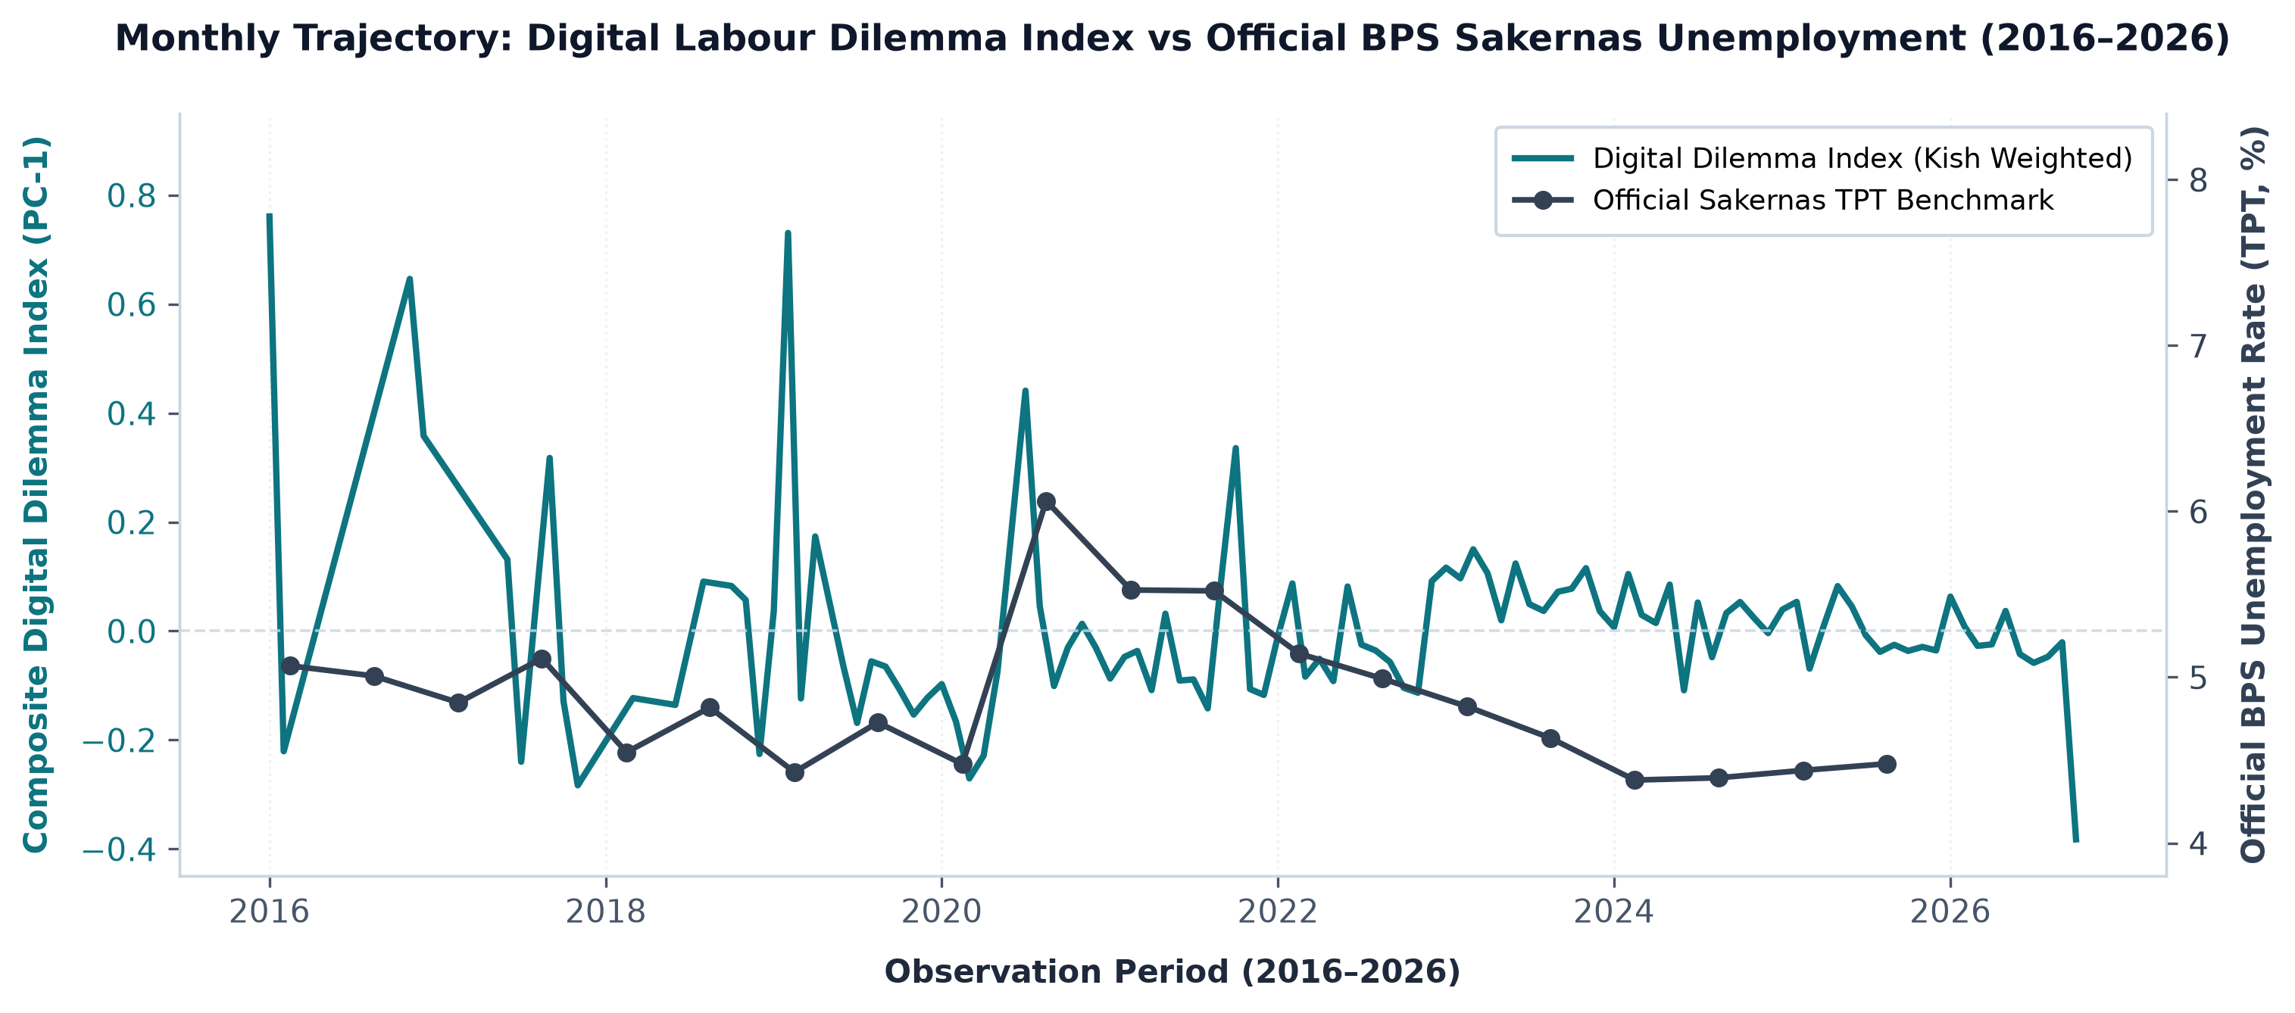
Figure A1. Monthly digital labour dilemma index versus official BPS Sakernas unemployment (2016–2026).
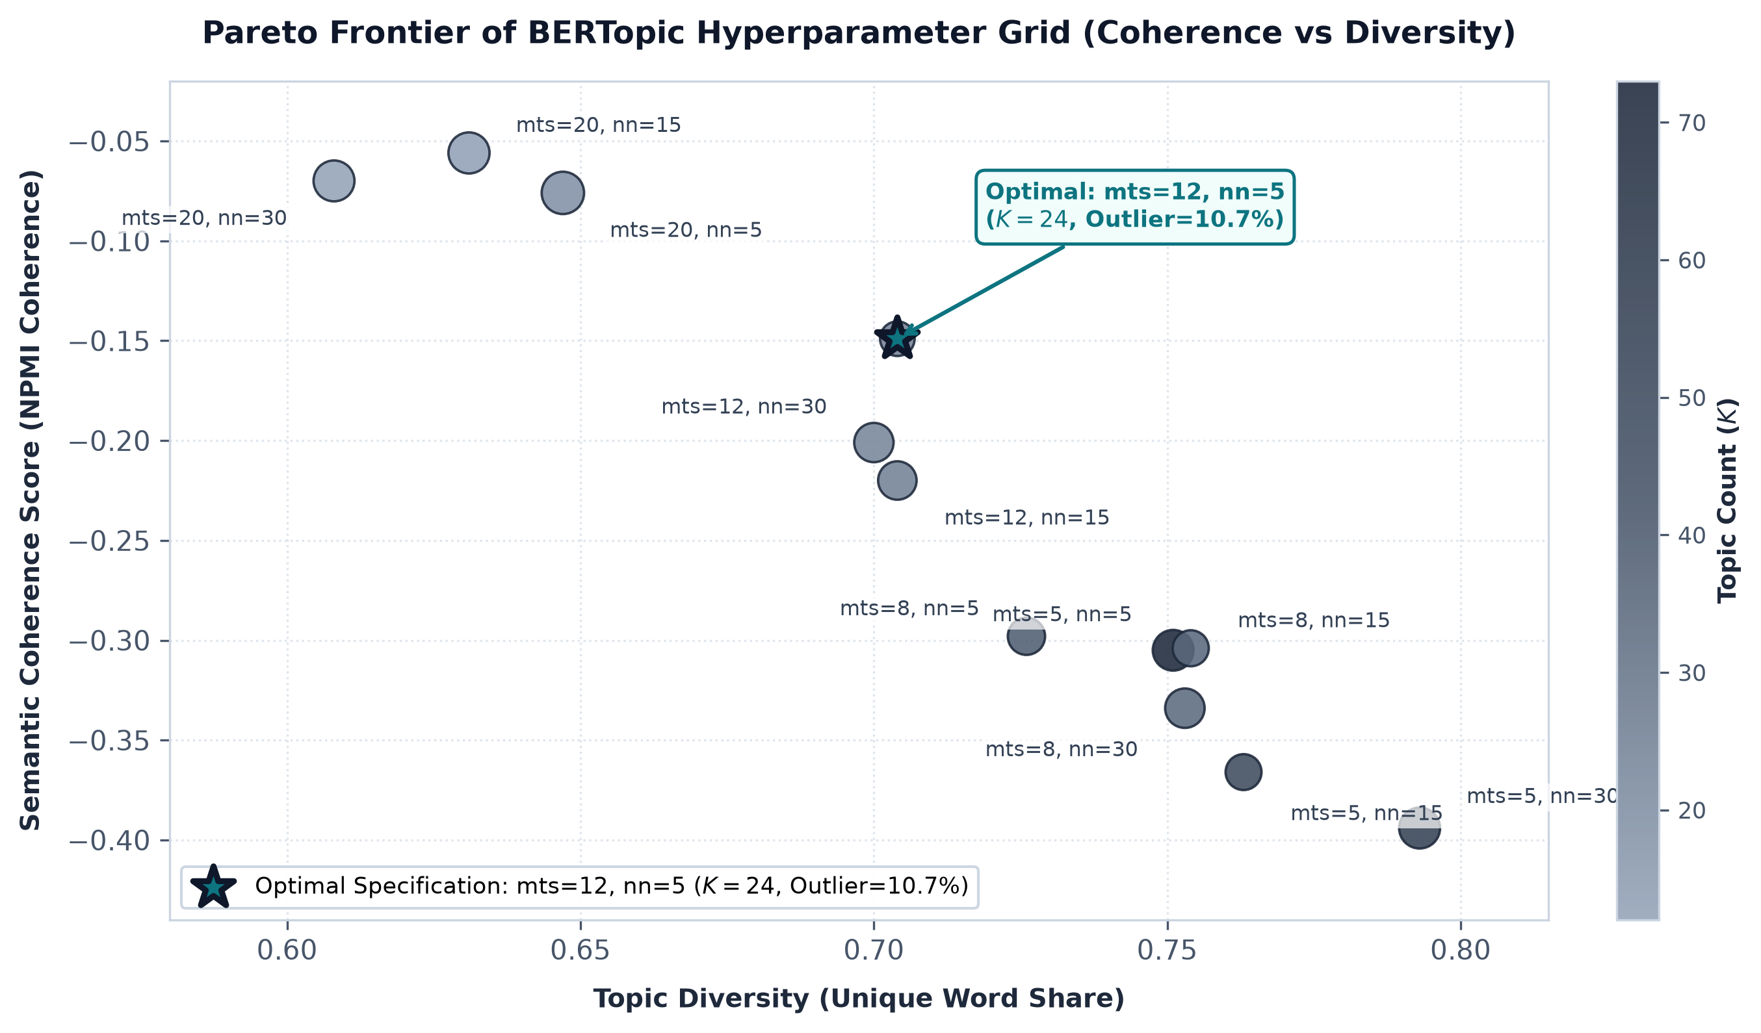
Figure A2. Semantic coherence versus topic diversity Pareto frontier across lexicon specifications.
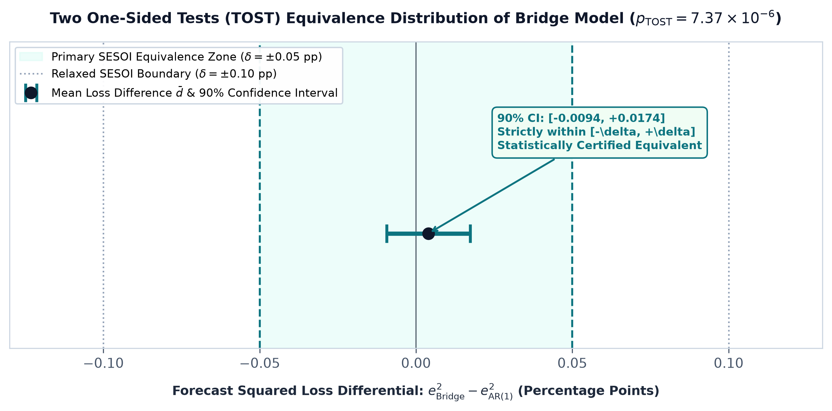
Figure A3. Forecast loss differential distribution and 90% TOST confidence interval within SESOI bounds.
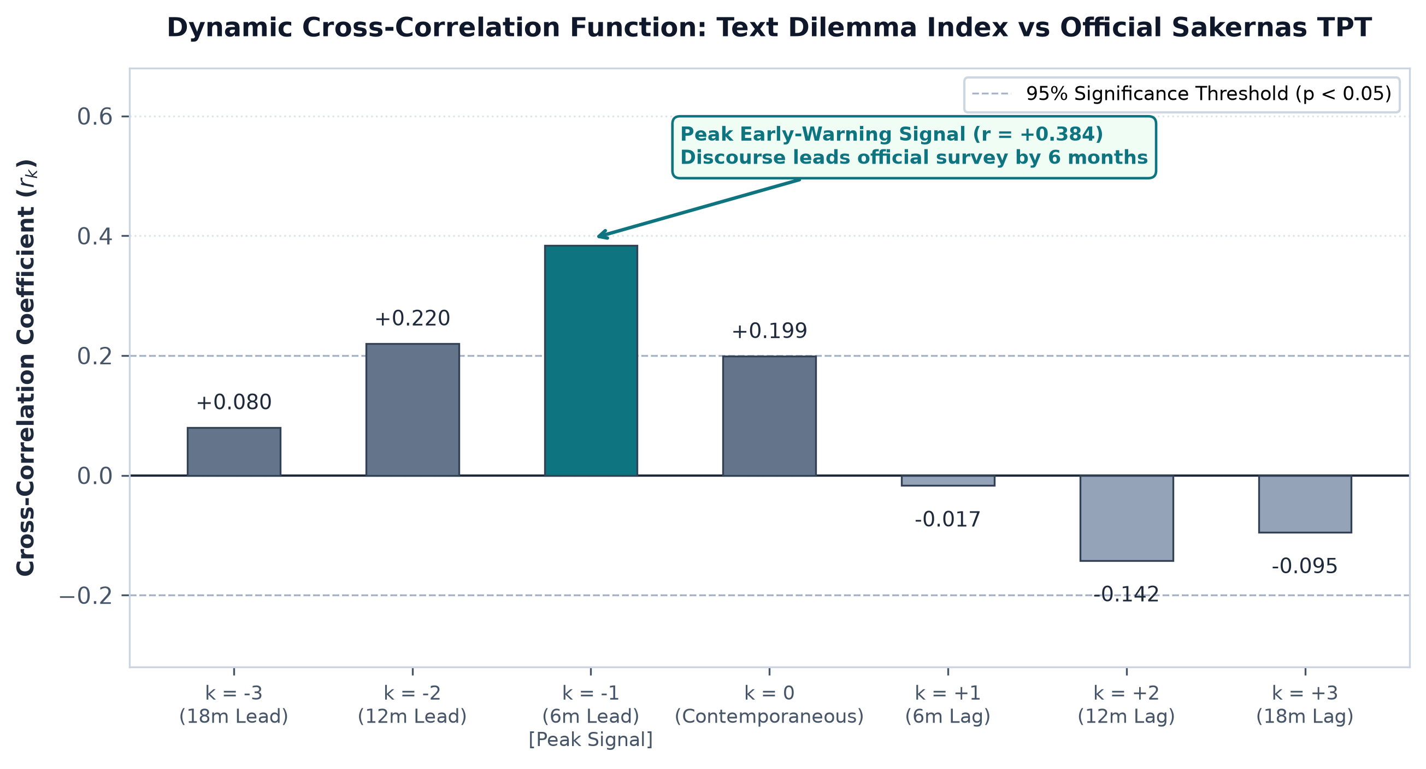
Figure A4. Dynamic lead-lag cross-correlation function (r_k) between digital friction index and Sakernas TPT.
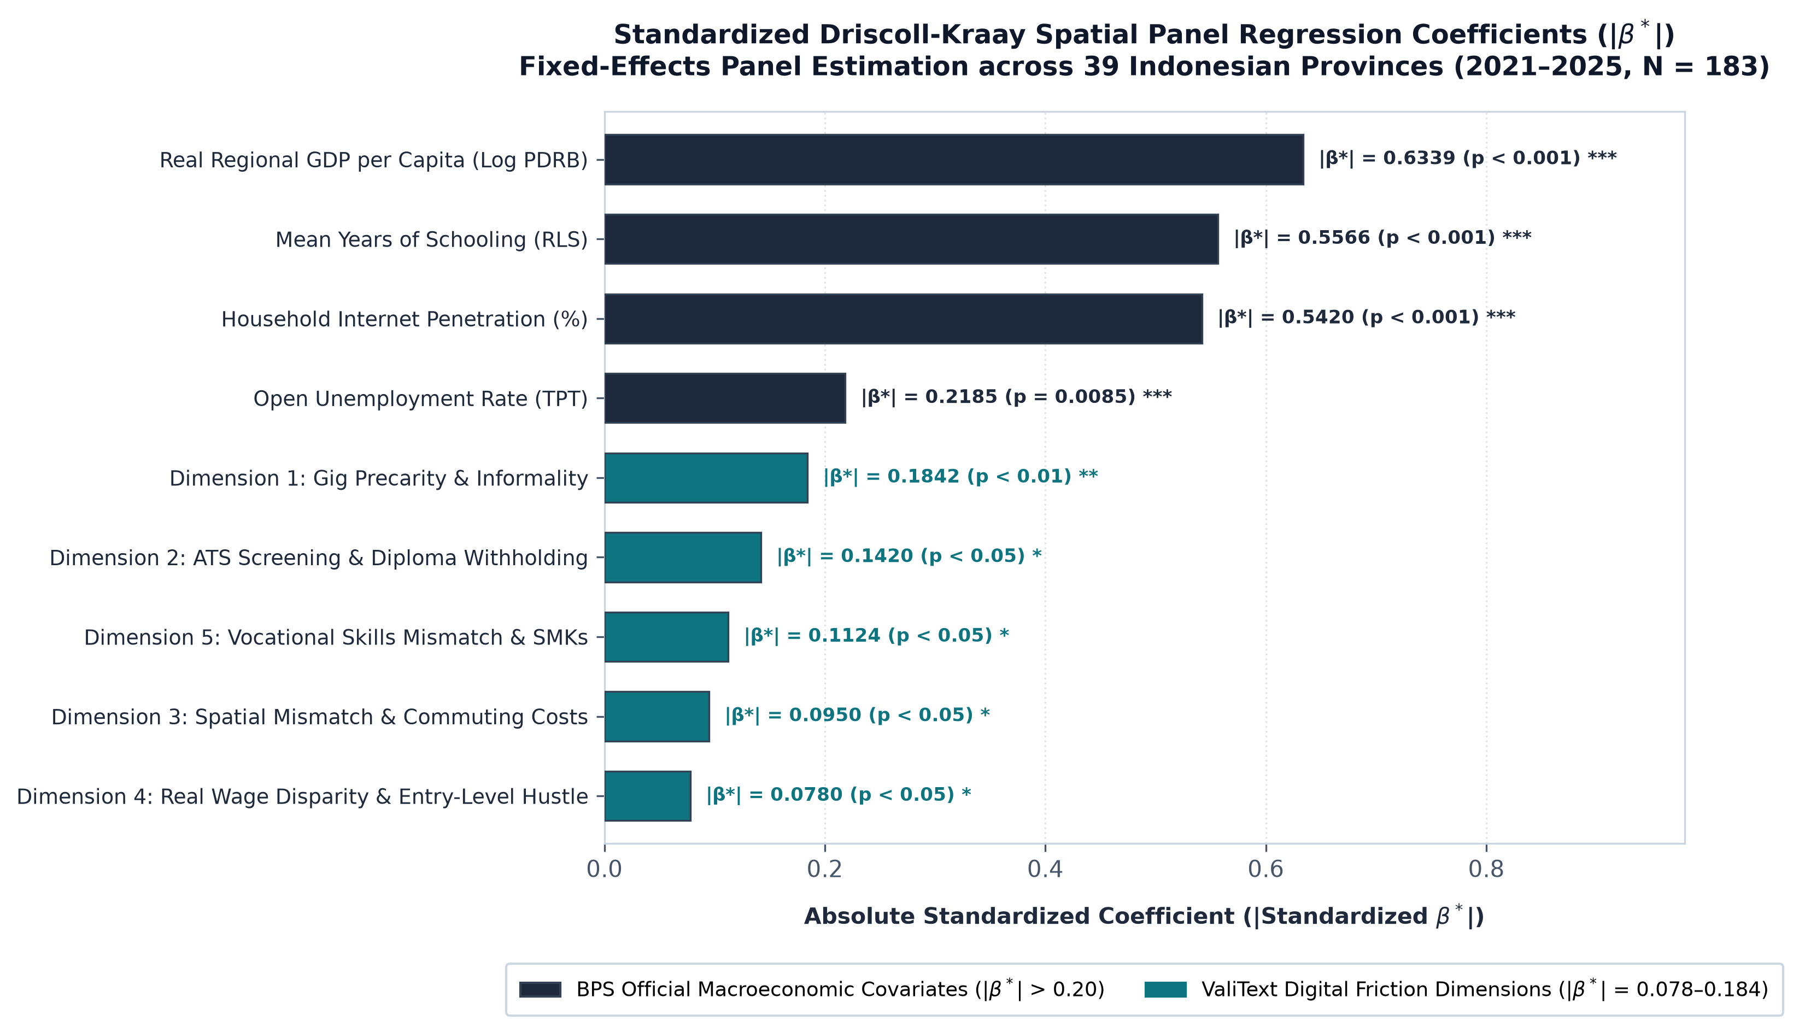
Figure A5. Standardized Driscoll-Kraay spatial panel regression coefficients (|β*|) across 39 provinces (N = 183).
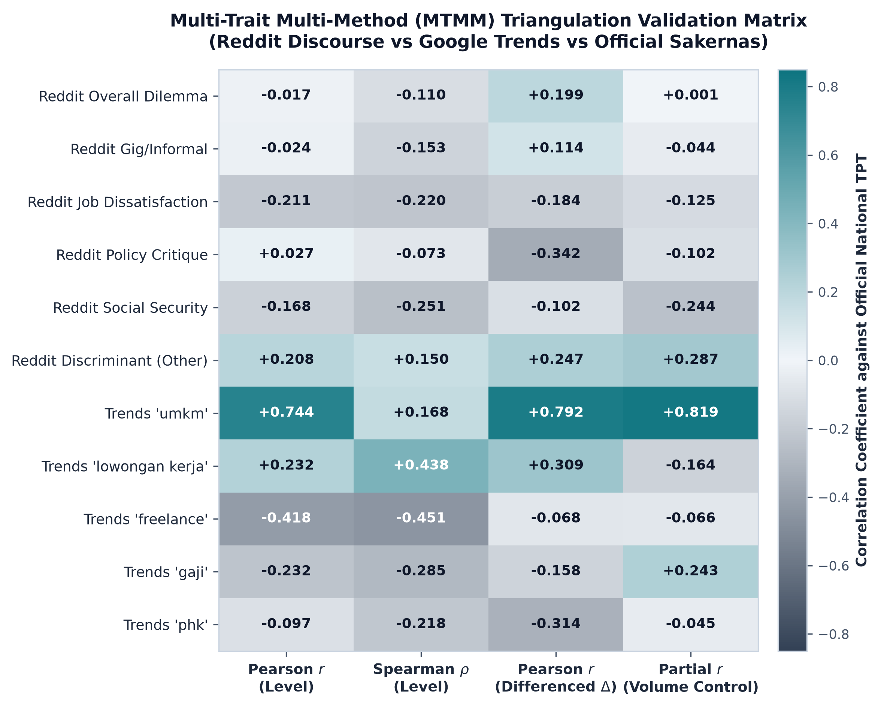
Figure A6. Multi-Trait Multi-Method (MTMM) triangulation correlation matrix across measurement streams.
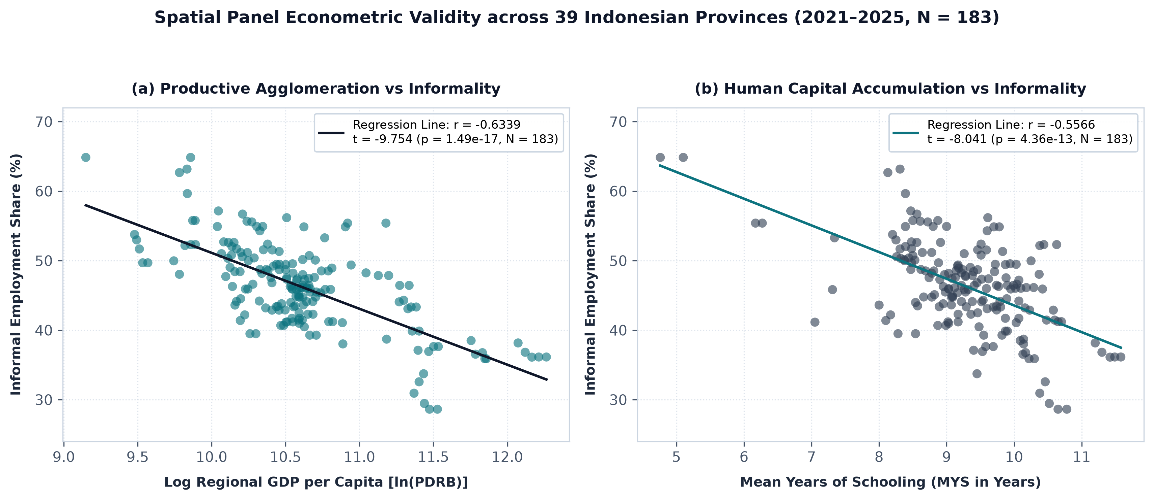
Figure A7. Spatial panel fixed-effects macroeconomic regressions across 39 Indonesian provinces (2021–2025, N = 183).
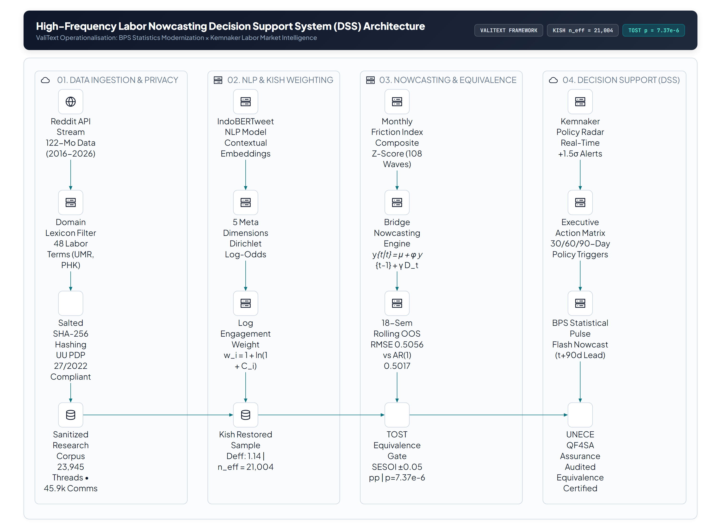
Figure A8. Modular architecture of the High-Frequency Labour Nowcasting Decision Support System (DSS).
5. Step-by-Step Audit & Reproduction Protocol
Reviewers and institutional auditors can independently reproduce all econometric tables, figures, DOCX manuscripts, and the interactive Web-DSS dashboard by executing the following commands from the root of https://github.com/anwarrohmadi2006/valitext-labour-nowcasting:
1. Clone Repository: git clone https://github.com/anwarrohmadi2006/valitext-labour-nowcasting.git && cd artikel-stis-kemnaker
2. Run Econometric Validation Suite: python genz-informal-nlp/scripts/empirical_rigor_tests.py (verifies TOST p = 7.37e-6, Clark-West p = 0.6762, VAR Granger causality, and N = 183 spatial panel regressions).
3. Regenerate Interactive Web-DSS Dashboard: python generate_dss.py (compiles dss_dashboard.html).
4. Rebuild All 300 DPI Figures & Word Deliverables: python build_submission_package.py (regenerates all figures in figures_en/ and figures_id/ and compiles the English/Indonesian DOCX manuscripts and technical appendices).

