LDR LIGHT SENSOR
Automatic Light Control with Arduino Uno
Made by Sir Anwar Siraj, DS & AI Robotics

1. Project Overview
This project uses a Light Dependent Resistor (LDR) to detect light. Arduino reads the light level through pin A0 and switches an LED on when it is dark and off when it is bright, like an automatic street light.

2. What Is an LDR?

Definition
An LDR is a passive semiconductor device whose resistance decreases as light intensity increases.

Working Principle (Photoconductivity)
An LDR works on the principle of photoconductivity: light gives energy to electrons, so the material conducts better.
Step | What happens
Step 1 – No Light (Dark Condition) | Very few electrons are free, so current cannot flow easily. Resistance becomes very high and current is low.
Step 2 – Light Falls on the LDR | Photons strike the semiconductor material. Electrons gain energy and more free electrons are created.
Step 3 – Conductivity Increases | More free electrons are available, so current flows more easily and resistance decreases rapidly.
Step 4 – Arduino Reads the Voltage | The LDR and the 10 kΩ resistor form a voltage divider. Arduino reads the voltage at A0, compares it with the threshold and controls the LED.

Voltage Divider Result
Condition | LDR resistance | Value at A0 | LED (pin 13)
Dark | High | Low (70 or below) | ON
Bright | Low | High (above 70) | OFF

Note: This result is for this circuit, where the LDR is on the 5V side and the 10 kΩ resistor is on the GND side. If you swap their positions, the readings are reversed.

3. Components Required
# | Component | Quantity | Note
1 | Arduino Uno with USB cable | 1 | Controller
2 | LDR (photoresistor) | 1 | Light sensor
3 | 10 kΩ resistor | 1 | Voltage divider
4 | LED (any color) | 1 | Output
5 | 220 Ω resistor | 1 | Protects the LED
6 | Breadboard and jumper wires | 1 set | Connections

4. Circuit Diagram
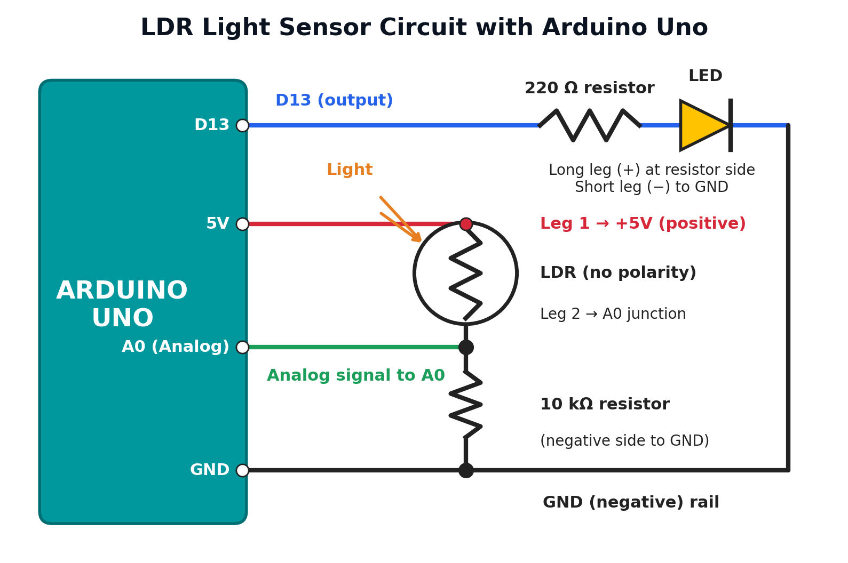

Connection Table
Component / leg | Arduino connection | Role
LDR leg 1 | 5V (positive) | Supply side of the voltage divider
LDR leg 2 | Junction with 10 kΩ resistor and pin A0 | Signal point read by analogRead()
10 kΩ resistor leg 1 | Same junction as LDR leg 2 and A0 | Pull-down resistor of the divider
10 kΩ resistor leg 2 | GND (negative) | Completes the divider to ground
LED long leg (+) | Pin D13 through a 220 Ω resistor | Output indicator
LED short leg (−) | GND (negative) | Return path

Important Points
- LDR has no polarity. Either leg can go to 5V. One leg goes to 5V (positive) and the other goes to the A0 junction.
- A0 is connected at the point between the LDR and the 10 kΩ resistor.
- The 10 kΩ resistor goes from the A0 junction to GND (negative).
- LED: the long leg (+) goes toward pin 13 through a 220 Ω resistor; the short leg (−) goes to GND.

5. Complete Arduino Code
// MADE BY SIR ANWAR SIRAJ DS & AI ROBOTICS

int ldrPin = A0;
int led = 13;
int threshold = 70;

void setup()
{
Serial.begin(9600);
pinMode(led, OUTPUT);
}

void loop()
{
int data = analogRead(ldrPin);
Serial.println("");
Serial.print("Light Sensor ");
Serial.print("Value = ");
Serial.print(data);
if(data <= threshold)
{
digitalWrite(led, HIGH);
}
else
{
digitalWrite(led, LOW);
}
}

6. Line-by-Line Code Explanation
The line numbers below count the lines in the code above (blank lines included).
Line | Code | Explanation
Step A – Credit and variables
1 | // MADE BY ... | A comment. The compiler ignores it. It credits the author.
3 | int ldrPin = A0; | Creates a variable named ldrPin and stores analog pin A0, where the LDR voltage divider is connected.
4 | int led = 13; | Stores pin 13, where the LED is connected through a 220 Ω resistor.
5 | int threshold = 70; | The limit value. Readings of 70 or below mean it is dark. Change it to adjust sensitivity.
Step B – setup() runs once at start
7 | void setup() | Starts the setup function. Arduino runs it one time after power-on or reset.
8, 11 | { and } | Opening and closing braces that mark the start and end of the function.
9 | Serial.begin(9600); | Starts serial communication at 9600 baud so values can be shown on the Serial Monitor.
10 | pinMode(led, OUTPUT); | Sets pin 13 as an output so Arduino can switch the LED on and off. (A0 is an input by default.)
Step C – loop() runs again and again
13 | void loop() | Starts the main function. Arduino repeats everything inside it continuously.
15 | int data = analogRead(ldrPin); | Reads the voltage at A0 and converts it to a number from 0 to 1023. The number is saved in data.
Step D – Showing the value on the Serial Monitor
16 | Serial.println(""); | Prints an empty line, so each new reading starts on a new line.
17 | Serial.print("Light Sensor "); | Prints the text Light Sensor without moving to a new line.
18 | Serial.print("Value = "); | Prints the text Value = on the same line.
19 | Serial.print(data); | Prints the reading stored in data. Example: Light Sensor Value = 45.
Step E – Decision: control the LED
20 | if(data <= threshold) | Checks if the reading is less than or equal to 70 (dark). If true, the next block runs.
22 | digitalWrite(led, HIGH); | Sends 5V to pin 13, so the LED turns ON in the dark.
24 | else | Runs when the condition is false, meaning the reading is above 70 (bright).
26 | digitalWrite(led, LOW); | Sends 0V to pin 13, so the LED turns OFF in the light.
27–28 | } | The closing brace of the else block, then of loop(). The program jumps back to the start of loop().

7. Working of the Program
- Arduino reads the light level from A0 as a number (0 to 1023).
- The number is printed on the Serial Monitor.
- If the number is 70 or below, it is dark and the LED turns ON.
- If the number is above 70, it is bright and the LED turns OFF.
- The loop repeats continuously.

8. Tips
- Open the Serial Monitor (9600 baud) and cover the LDR to see the values drop. Change threshold to match your room.
- Optional: add delay(200); at the end of loop() to make the Serial Monitor easier to read.
- Use the same pin order shown in the circuit diagram to avoid wrong readings.

