SMART TRAFFIC
CONTROL SYSTEM
Arduino Traffic Light Controller
Educator Renaissance Campus
Made by Sir Anwar Siraj, DS AI Robotics

1. Project Overview
The Smart Automated Traffic Control System is an Arduino-based robotics project that simulates real traffic management. The program switches Red, Yellow and Green LEDs in a fixed timed sequence, showing how timing and automated logic manage vehicle flow.

Key Features
- Precise timing: Red 4 seconds, Yellow 2 seconds, Green 4 seconds.
- Clean code: one helper function, showLight(), controls all three lights.
- Modular: the module plugs straight into the Arduino header and can join a larger Smart City model.

2. Components Required
# | Component | Quantity | Note
1 | Arduino Uno with USB cable | 1 | Controller
2 | Traffic light LED module (G, Y, R, GND) | 1 | 3 LEDs on one board
3 | Jumper wires (only if not plugged directly) | 4 | Male to female

3. Traffic Light Module and Pins
The module has four pins, marked G, Y, R and GND from left to right. The photo shows the module plugged directly onto the Arduino Uno header, where these four pins line up with pins 11, 12, 13 and GND.
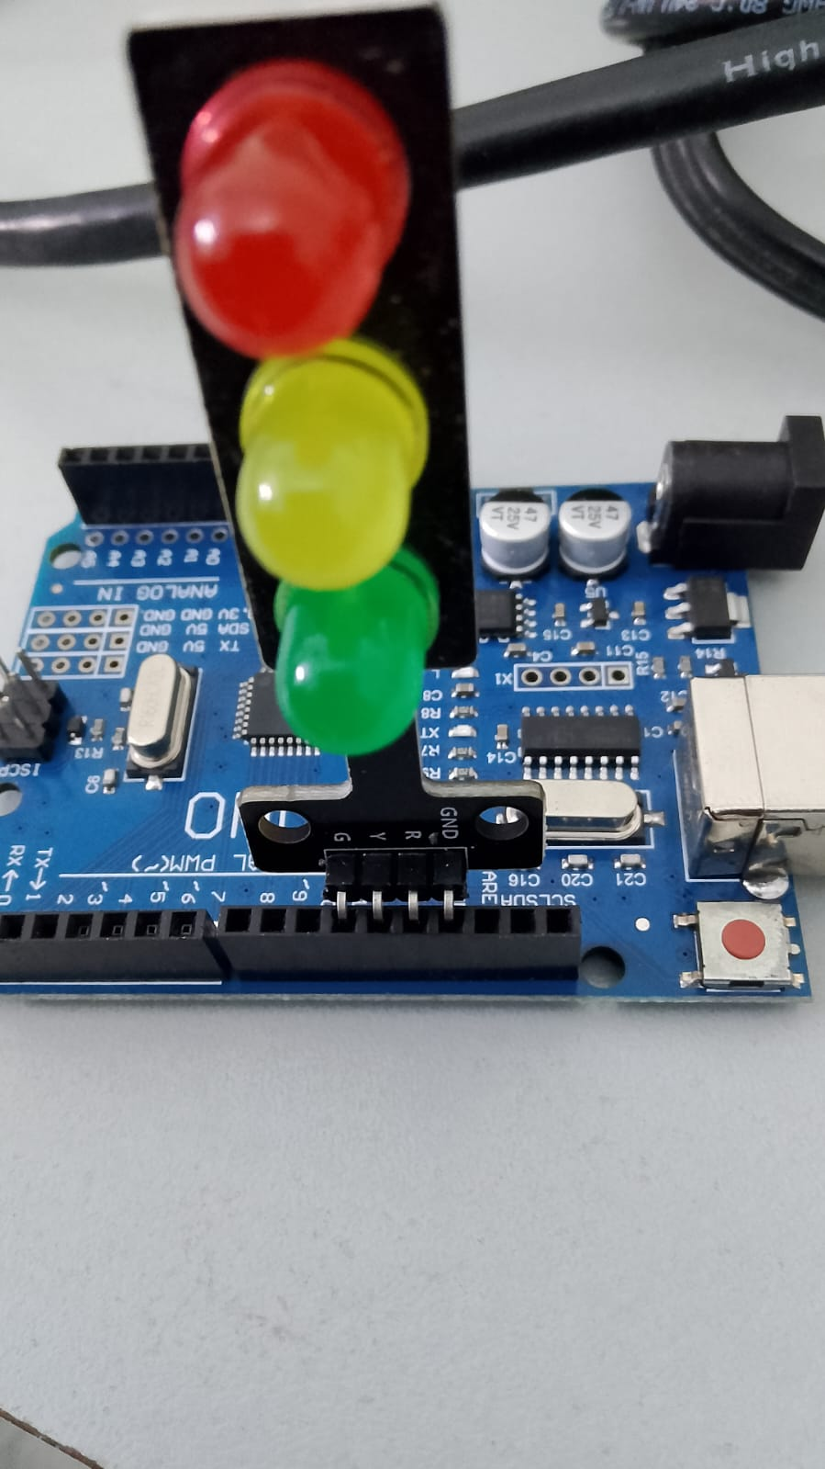
Real setup: module plugged on the Arduino Uno

Connection Table
Module pin | Arduino pin | Meaning
G | Pin 11 | Green LED (Go)
Y | Pin 12 | Yellow LED (Caution)
R | Pin 13 | Red LED (Stop)
GND | GND | Ground (negative) for all three LEDs

4. Circuit Diagram
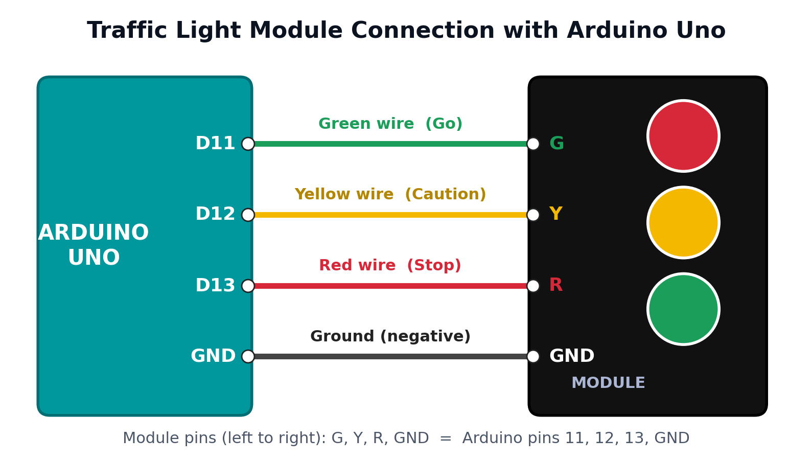
Note: If your module does not have built-in resistors, add a 220 Ω resistor in series with each of the G, Y and R lines to protect the LEDs.

5. Timing Sequence
Order | Light | Duration | Meaning
1st | RED | 4 seconds | Stop
2nd | YELLOW | 2 seconds | Caution
3rd | GREEN | 4 seconds | Go
Total cycle |  | 10 seconds | Then repeats

6. Complete Arduino Code
/*
* PROJECT: SMART TRAFFIC CONTROL SYSTEM
* ORGANIZATION: EDUCATOR RENAISSANCE CAMPUS
* MADE BY SIR ANWAR SIRAJ, DS & AI ROBOTICS
*/

const int redLED = 13;
const int yellowLED = 12;
const int greenLED = 11;

void setup() {
pinMode(redLED, OUTPUT);
pinMode(yellowLED, OUTPUT);
pinMode(greenLED, OUTPUT);
}

// Turn on only the chosen LED; the other two go OFF
void showLight(int pin) {
digitalWrite(redLED, pin == redLED ? HIGH : LOW);
digitalWrite(yellowLED, pin == yellowLED ? HIGH : LOW);
digitalWrite(greenLED, pin == greenLED ? HIGH : LOW);
}

void loop() {
showLight(redLED); // RED (STOP) for 4 seconds
delay(4000);

showLight(yellowLED); // YELLOW (CAUTION) for 2 seconds
delay(2000);

showLight(greenLED); // GREEN (GO) for 4 seconds
delay(4000);
}

7. Line-by-Line Code Explanation
Line numbers count every line of the code above, including blank lines.
Line | Code | Explanation
Step 1 – Project heading (comment)
1–5 | /* ... */ | A multi-line comment with the project name, organization and author. The compiler ignores it.
Step 2 – Pin names (constants)
7 | const int redLED = 13; | Gives pin 13 the name redLED. const means the value never changes.
8 | const int yellowLED = 12; | Gives pin 12 the name yellowLED.
9 | const int greenLED = 11; | Gives pin 11 the name greenLED.
Step 3 – setup() runs once
11 | void setup() { | Starts the setup function. Arduino runs it one time after power-on or reset.
12 | pinMode(redLED, OUTPUT); | Makes pin 13 an output so Arduino can send voltage to the red LED.
13 | pinMode(yellowLED, OUTPUT); | Makes pin 12 an output for the yellow LED.
14 | pinMode(greenLED, OUTPUT); | Makes pin 11 an output for the green LED.
15 | } | Ends the setup function.
Step 4 – showLight() helper function
17 | // Turn on only ... | A comment: this function turns on one LED and turns the other two off.
18 | void showLight(int pin) { | Creates our own function. The value passed in (pin) tells it which LED to turn on.
19 | digitalWrite(redLED, pin == redLED ? HIGH : LOW); | Checks: is pin equal to redLED? If yes, send HIGH (red ON). If no, send LOW (red OFF).
20 | digitalWrite(yellowLED, pin == yellowLED ? HIGH : LOW); | Same check for yellow: ON only when yellow was chosen.
21 | digitalWrite(greenLED, pin == greenLED ? HIGH : LOW); | Same check for green: ON only when green was chosen.
22 | } | Ends the function. Result: exactly one light is ON at a time.
Step 5 – loop() repeats forever
24 | void loop() { | Starts the main function. Arduino repeats it again and again.
25 | showLight(redLED); | Turns RED on (Stop). Yellow and green go OFF.
26 | delay(4000); | Waits 4000 milliseconds = 4 seconds, so red stays on.
28 | showLight(yellowLED); | Turns YELLOW on (Caution). Red and green go OFF.
29 | delay(2000); | Waits 2 seconds with yellow on.
31 | showLight(greenLED); | Turns GREEN on (Go). Red and yellow go OFF.
32 | delay(4000); | Waits 4 seconds with green on.
33 | } | Ends loop(). Arduino jumps back to line 25 and the cycle starts again with red.

8. How the Program Works
- Arduino starts and setup() sets pins 13, 12 and 11 as outputs.
- loop() calls showLight(redLED): red is ON, the others are OFF, for 4 seconds.
- Then showLight(yellowLED): yellow is ON for 2 seconds.
- Then showLight(greenLED): green is ON for 4 seconds.
- loop() ends and starts again at red. The 10-second cycle repeats forever.

9. Tips
- To change a duration, edit the number inside delay(). 1000 equals 1 second.
- To change a pin, edit only the three const int lines at the top.
- Make sure the module is plugged in the correct way round: G toward pin 11 and GND toward the GND header pin.

