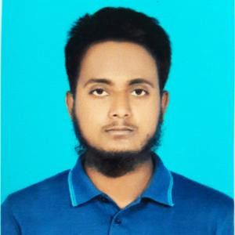

**ANWARUL ISLAM**

WEB | SOFTWARE DEVELOPER

**Profile**

Seeking a challenge position in a reputed organization where I can learn new sk expand my knowledge, and leverage my learning. To get an opportunity where I make the best of my potential and contribute to the organization growth.

**CONTACT**

01730646690

anwarulbd@gmail.com

Nalitabari, Sherpur, Dhaka

**WORK EXPERIENCE**

e – Leaning & Earning Ltd | Kallyanpur IT Support Exicutive

* Hardware diagnostics
* User support and troubleshooting
* Hardware diagnostics
* User support and troubleshooting
* Hardware diagnostics
* User support and troubleshooting

**EDUCATION**

2024 – Running Sherpur Gopv t College

* Bachelor of Arts
* 1st Year - running

**CORE QUALIFIACTION**

* Hardware diagnostics
* User support and troubleshooting
* Hardware diagnostics
* User support and troubleshooting
* Hardware diagnostics
* User support and troubleshooting



Marker