CISCO NETWORKING PROJECT
ENTERPRISE NETWORK
DHCP & PORT SECURITY
Cisco Packet Tracer Implementation

PROJECT TYPE
Networking/Network Engineering
TECHNOLOGIES IMPLEMENTED
IPv4 Addressing • VLANs • 802.1Q Trunking
Router-on-a-Stick • Inter-VLAN Routing
DHCP • Port Security • MAC Address Security
Network Verification • Troubleshooting

PREPARED BY
Anwar Ul Haq
TOOL USED
Cisco Packet Tracer
PROJECT
Project 02
DATE
October 2026

TABLE OF CONTENT
1. PROJECT OVERVIEW 5
2. PROJECT OBJECTIVES 6
3. NETWORK SCENARIO 7
Department and VLAN Structure 7
Network Architecture 7
4. NETWORK TOPOLOGY 8
5. IP ADDRESSING & VLAN DESIGN 9
5.1 VLAN Design 9
5.2 IP Addressing Plan 9
5.3 VLAN-to-Port Assignment 9
6. CONFIGURATION 11
6.1 VLAN Configuration 11
6.2 Access Port Configuration 11
6.3 Trunk Configuration 11
6.4 Router-on-a-Stick Configuration 11
6.5 DHCP Configuration 12
6.6 Port Security Configuration 12
6.7 Configuration Summary 13
7. VERIFICATION & TESTING 14
7.1 VLAN Verification 14
7.2 Trunk Verification 15
7.3 Router Interface Verification 16
7.4 DHCP Pool Verificattion 16
7.5 DHCP Binding Verification 17
7.6 PC DHCP Configuration Verification 18
7.7 Same-VLAN Connectivity Test 18
7.8 Inter-VLAN Connectivity Test 19
7.9 Port Security Verification 21
7.10 Port Security Violation Test 22
7.11 Port Security Recovery 22
7.12 Router Configuration Verification 23
7.13 Switch Configuration Verification 26
8. TROUBLESHOOTING CASE STUDY 28
8.1 Problem Introduction 28
8.2 Security Violation Condition 28
8.3 Connectivity Failure 28
8.4 Configuration Correction and Recovery 29
8.5 Verification After Correction 29
8.6 Root Cause Analysis 29
9. RESULTS 30
10. FUTURE IMPROVEMENTS 31

LIST OF FIGURES
Figure 1 Enterprise Network Topology 8
Figure 2 VLAN Configuration Verification 14
Figure 3 Trunk Link Verification 15
Figure 4 Router Interface Verification 16
Figure 5 DHCP POOL VERIFICATION 17
Figure 6 DHCP Binding Verification 17
Figure 7 PC DHCP Configuration Verification 18
Figure 8 Same Vlan Connectivity Test 19
Figure 9 Inter-VLAN Connectivity Test — IT 20
Figure 10. Inter-VLAN Connectivity Test — Finance 21
Figure 11 Port Security Configuration Verification 21
Figure 12 Port Security Violation Test 22
Figure 13 Port Security Recovery 23
Figure 14 Router Running Configuration — Part 1 24
Figure 15 Router Running Configuration — Part 2 25
Figure 16 Switch Running Configuration — Part 1 26
Figure 17 Switch Running Configuration — Part 2 27

1. PROJECT OVERVIEW
This project presents the design and implementation of a small enterprise network using Cisco Packet Tracer. The network consists of three departments: Human Resources (HR), Information Technology (IT), and Finance.
The network was designed using VLAN segmentation to logically separate departmental traffic. Router-on-a-Stick was implemented to provide communication between the VLANs through a single router interface using IEEE 802.1Q trunking.
Building on the VLAN and inter-VLAN routing concepts from Project 01, this project introduces two important enterprise networking concepts: Dynamic Host Configuration Protocol (DHCP) and switch port security.
DHCP was configured on the Cisco router to automatically provide IP addresses, subnet masks, default gateways, and DNS server information to the client PCs. Port security was configured on the access ports to restrict the number of allowed MAC addresses and prevent unauthorized devices from accessing the network.
The project also includes connectivity testing, DHCP verification, port-security violation testing, recovery of a secured port, and configuration verification using Cisco IOS commands.

2. PROJECT OBJECTIVES
The main objectives of this project are:
- Design and implement a small enterprise network using Cisco Packet Tracer.
- Segment the network into separate departmental VLANs for HR, IT, and Finance.
- Configure IEEE 802.1Q trunking between the switch and router.
- Implement Router-on-a-Stick for inter-VLAN communication.
- Configure the Cisco router as a DHCP server.
- Automatically assign IP addresses and network parameters to client PCs.
- Configure switch port security to control authorized devices.
- Implement static and sticky MAC address security.
- Simulate an unauthorized-device connection and observe the security violation.
- Recover the secured port and restore authorized network access.
- Verify network operation using Cisco IOS commands and connectivity tests.
- Document the configuration, verification, troubleshooting, and results.

3. NETWORK SCENARIO
The network is designed for a small enterprise organization consisting of three departments: Human Resources (HR), Information Technology (IT), and Finance. Each department contains two end devices and is assigned to a separate VLAN to provide logical network segmentation.
A Cisco 2960 Layer 2 switch is used to connect the end devices, while a Cisco 2911 router provides Layer 3 gateway functionality and enables communication between the different VLANs. The switch and router are connected through a single trunk link configured using IEEE 802.1Q encapsulation.

Department and VLAN Structure
Department | VLAN | Network Address | Default Gateway | Devices
Human Resources (HR) | 10 | 192.168.10.0/24 | 192.168.10.1 | PC1, PC2
Information Technology (IT) | 20 | 192.168.20.0/24 | 192.168.20.1 | PC3, PC4
Finance | 30 | 192.168.30.0/24 | 192.168.30.1 | PC5, PC6

Network Architecture
The network follows a centralized design in which the Cisco switch provides connectivity for all six end devices. The router is connected to the switch using a trunk link and uses separate subinterfaces for VLAN 10, VLAN 20, and VLAN 30.
Each VLAN represents a separate broadcast domain. Devices within the same VLAN can communicate directly through the switch, while communication between different VLANs is handled by the router through Router-on-a-Stick configuration.
The design provides a simple and scalable foundation for an enterprise network while demonstrating essential concepts including VLAN segmentation, access ports, trunking, router subinterfaces, and inter-VLAN routing.

4. NETWORK TOPOLOGY
The network topology was implemented in Cisco Packet Tracer using one Cisco 2911 router, one Cisco 2960 switch, and six end devices. The six PCs are divided into three departments: Human Resources (HR), Information Technology (IT), and Finance.
The switch provides Layer 2 connectivity for all end devices. The connection between the switch and router is configured as an IEEE 802.1Q trunk, allowing traffic from VLAN 10, VLAN 20, and VLAN 30 to traverse a single physical link.
The router uses Router-on-a-Stick configuration, with separate subinterfaces assigned to each VLAN. These subinterfaces provide the default gateways required for communication between different VLANs.
Figure 1 shows the complete network topology implemented for this project.

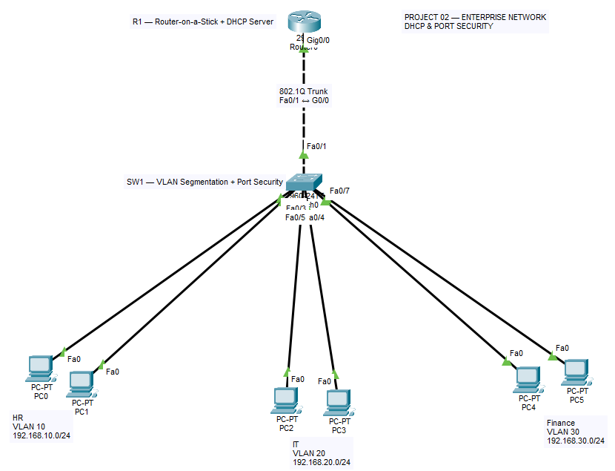

Figure 1 Enterprise Network Topology

5. IP ADDRESSING & VLAN DESIGN
VLAN segmentation was implemented to logically separate the three departments within the enterprise network. Each department was assigned a unique VLAN and IPv4 subnet. DHCP was configured on the Cisco 2911 router to automatically assign IP addresses and network parameters to the end devices.

5.1 VLAN Design
Three VLANs were created on the Cisco 2960 switch. VLAN 10 was assigned to the Human Resources department, VLAN 20 to the Information Technology department, and VLAN 30 to the Finance department.
VLAN ID | VLAN Name | Department | Network
10 | HR | Human Resources | 192.168.10.0/24
20 | IT | Information Technology | 192.168.20.0/24
30 | FINANCE | Finance | 192.168.30.0/24

5.2 IP Addressing Plan
P addresses were assigned automatically to the end devices using DHCP. The router subinterface for each VLAN was configured as the default gateway for devices within that VLAN.
Device | Department | VLAN | IP Address | Subnet Mask | Default Gateway
PC1 | HR | 10 | 192.168.10.13 | 255.255.255.0 | 192.168.10.1
PC2 | HR | 10 | 192.168.10.12 | 255.255.255.0 | 192.168.10.1
PC3 | IT | 20 | 192.168.20.11 | 255.255.255.0 | 192.168.20.1
PC4 | IT | 20 | 192.168.20.12 | 255.255.255.0 | 192.168.20.1
PC5 | Finance | 30 | 192.168.30.12 | 255.255.255.0 | 192.168.30.1
PC6 | Finance | 30 | 192.168.30.11 | 255.255.255.0 | 192.168.30.1

5.3 VLAN-to-Port Assignment
The switch access ports were assigned according to the department structure. Each department's two PCs are connected to access ports belonging to the same VLAN.
Switch Port | Connected Device | VLAN | Mode
Fa0/2 | PC1 | 10 | Access
Fa0/3 | PC2 | 10 | Access
Fa0/4 | PC3 | 20 | Access
Fa0/5 | PC4 | 20 | Access
Fa0/6 | PC5 | 30 | Access
Fa0/7 | PC6 | 30 | Access
Fa0/1 | R1 G0/0 | 10, 20, 30 | Trunk

6. CONFIGURATION
The network devices were configured using the Cisco IOS command-line interface in Cisco Packet Tracer. The configuration process involved creating the required VLANs, assigning switch access ports, configuring the trunk connection, implementing Router-on-a-Stick, configuring DHCP services, and enabling switch port security.

6.1 VLAN Configuration
Three VLANs were created on the Cisco 2960 switch to provide logical separation between the three departments.
vlan 10
name HR

vlan 20
name IT

vlan 30
name FINANCE

6.2 Access Port Configuration
Three VLANs were created on the Cisco 2960 switch to provide logical separation between the three departments.
vlan 10
name HR

vlan 20
name IT

vlan 30
name FINANCE

6.3 Trunk Configuration
The connection between SW1 Fa0/1 and R1 G0/0 was configured as an IEEE 802.1Q trunk. This allows traffic from multiple VLANs to travel through the same physical link.
interface fa0/1
switchport mode trunk

6.4 Router-on-a-Stick Configuration
Router subinterfaces were configured on R1 to provide default gateways for the three VLANs and enable inter-VLAN routing.
interface g0/0
no shutdown

interface g0/0.10
encapsulation dot1Q 10
ip address 192.168.10.1 255.255.255.0

interface g0/0.20
encapsulation dot1Q 20
ip address 192.168.20.1 255.255.255.0

interface g0/0.30
encapsulation dot1Q 30
ip address 192.168.30.1 255.255.255.0

6.5 DHCP Configuration
The Cisco 2911 router was configured as a DHCP server to automatically assign IP addresses, default gateways, and DNS information to the end devices.
ip dhcp excluded-address 192.168.10.1 192.168.10.10
ip dhcp excluded-address 192.168.20.1 192.168.20.10
ip dhcp excluded-address 192.168.30.1 192.168.30.10

ip dhcp pool HR
network 192.168.10.0 255.255.255.0
default-router 192.168.10.1
dns-server 8.8.8.8

ip dhcp pool IT
network 192.168.20.0 255.255.255.0
default-router 192.168.20.1
dns-server 8.8.8.8

ip dhcp pool Finance
network 192.168.30.0 255.255.255.0
default-router 192.168.30.1
dns-server 8.8.8.8

6.6 Port Security Configuration
Port Security was configured on the switch access ports to limit each port to one authorized MAC address and protect the network from unauthorized devices.
Fa0/2 was configured with a manually assigned static MAC address, while Fa0/3 to Fa0/7 were configured to learn MAC addresses using sticky learning.
interface fa0/2
switchport mode access
switchport port-security
switchport port-security mac-address 00d0.d344.6cb1
switchport port-security maximum 1
switchport port-security violation shutdown
interface fa0/3
switchport mode access
switchport port-security
switchport port-security maximum 1
switchport port-security violation shutdown
switchport port-security mac-address sticky
interface range fa0/4-7
switchport mode access
switchport port-security
switchport port-security maximum 1
switchport port-security violation shutdown
switchport port-security mac-address sticky

6.7 Configuration Summary
The completed configuration establishes three separate VLANs, assigns the appropriate end devices to each VLAN, carries VLAN traffic through the trunk link, and provides inter-VLAN routing through Router-on-a-Stick. DHCP automatically assigns network parameters to the end devices, while Port Security restricts access to authorized MAC addresses.
The complete router and switch configurations are also provided separately in the project Configuration folder.

7. VERIFICATION & TESTING
After completing the network configuration, verification commands and connectivity tests were performed in Cisco Packet Tracer. The purpose of verification was to confirm that the VLANs, trunk link, router subinterfaces, DHCP services, port security, and inter-VLAN communication were operating correctly.

7.1 VLAN Verification
The show vlan brief command was used on SW1 to verify that VLAN 10, VLAN 20, and VLAN 30 were successfully created and that the appropriate switch ports were assigned to each VLAN.
Figure 2. VLAN Configuration Verification

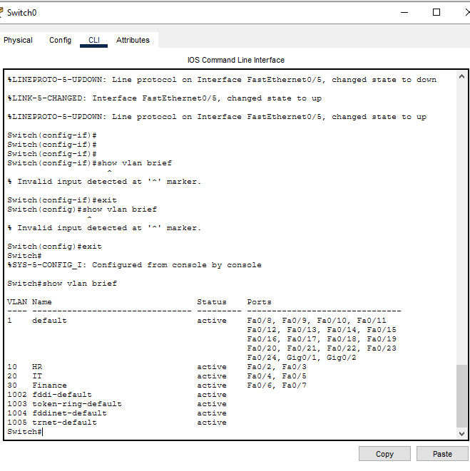
Figure 2 VLAN Configuration Verification
The verification output confirms that the required VLANs are present and that the end-device ports are assigned to their corresponding VLANs.

7.2 Trunk Verification
The show interfaces trunk command was used to verify the trunk connection between SW1 Fa0/1 and R1 G0/0.
Figure 3. Trunk Link Verification
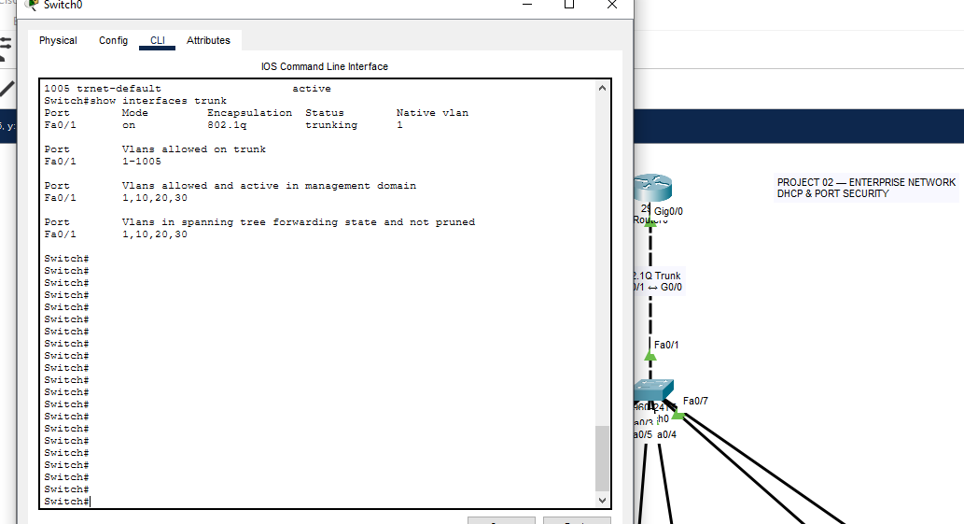
Figure 3 Trunk Link Verification
The output confirms that Fa0/1 is operating in trunking mode using IEEE 802.1Q encapsulation and that VLANs 10, 20, and 30 are active on the trunk.
.

7.3 Router Interface Verification
The show ip interface brief command was used on R1 to verify the operational status of the router's physical interface and VLAN subinterfaces. The verification confirms that the configured interfaces are operational and available for inter-VLAN routing.
Figure 4 Router Interface Verification
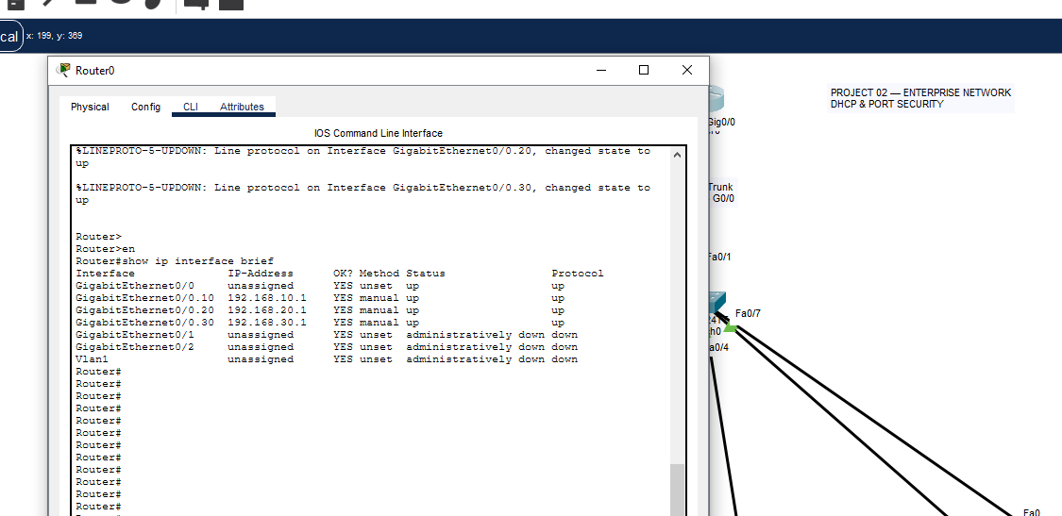
Figure 4 Router Interface Verification
The output shows that the router subinterfaces for VLAN 10, VLAN 20, and VLAN 30 are configured with the correct gateway addresses and are operational. The output shows that the router subinterfaces for VLAN 10, VLAN 20, and VLAN 30 are configured with the correct gateway addresses and are operational.

7.4 DHCP Pool Verificattion
The show ip dhcp pool command was used on R1 to verify the DHCP pools configured for the HR, IT, and Finance departments. The verification confirms that each pool contains the correct network address and that DHCP is actively providing addresses to the corresponding VLANs.
Figure 5 DHCP POOL VERIFICATION:
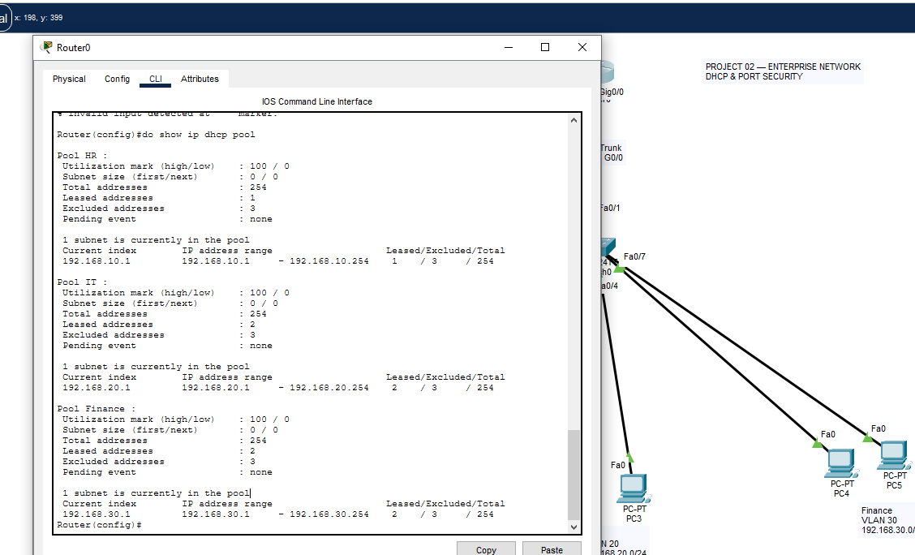
Figure 5 DHCP POOL VERIFICATION

7.5 DHCP Binding Verification
The show ip dhcp binding command was used on R1 to verify the IP addresses dynamically assigned to the connected PCs. The output displays the leased IP addresses and corresponding MAC addresses of the DHCP clients.
Figure 6 DHCP Binding Verification
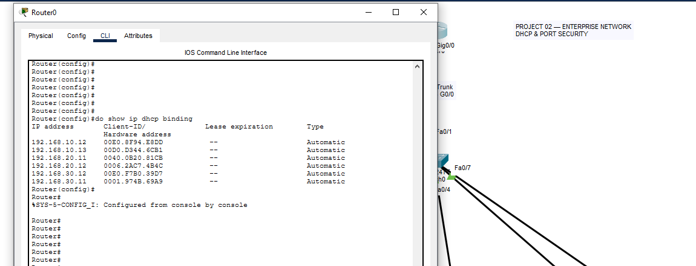
Figure 6 DHCP Binding Verification
The verification output confirms that DHCP successfully assigned IP addresses to all six end devices across VLAN 10, VLAN 20, and VLAN 30.

7.6 PC DHCP Configuration Verification
The ipconfig command was used on PC1 to verify the network configuration received from the DHCP server. The output was checked to confirm the assigned IPv4 address, subnet mask, and default gateway.
Figure 7 PC DHCP Configuration Verification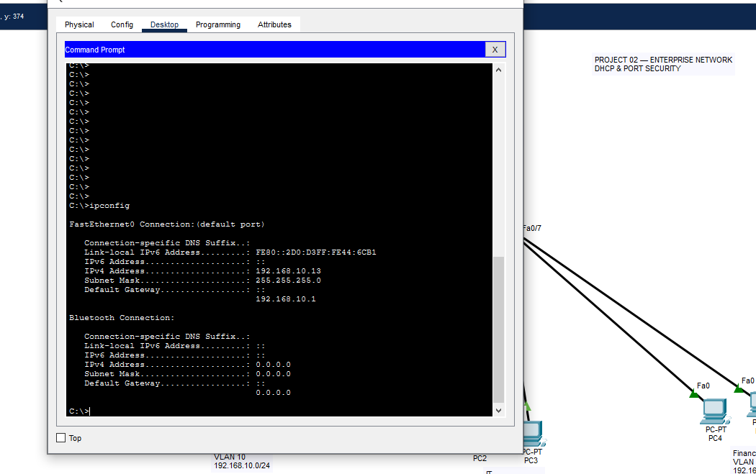
Figure 7 PC DHCP Configuration Verification
The output confirms that PC1 successfully received its IPv4 configuration through DHCP, including the IP address 192.168.10.13, subnet mask 255.255.255.0, and default gateway 192.168.10.1.

7.7 Same-VLAN Connectivity Test
A connectivity test was performed between PC1 and PC2, which are both members of VLAN 10 (HR). The test verifies communication between devices within the same VLAN after obtaining their IP addresses through DHCP.
Figure 8. Same-VLAN Connectivity Test

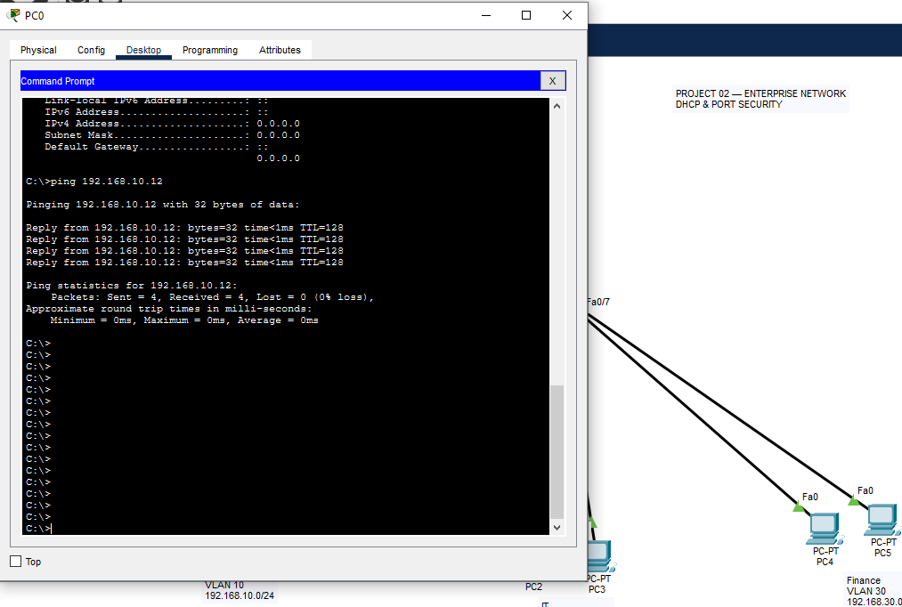
Figure 8 Same Vlan Connectivity Test
The successful ping responses confirm that PC1 and PC2 can communicate within VLAN 10.

7.8 Inter-VLAN Connectivity Test
Inter-VLAN connectivity was tested by sending ICMP ping traffic between devices belonging to different VLANs. PC1 in VLAN 10 was tested against PC3 in VLAN 20 and PC5 in VLAN 30.
Figure 9 Inter-VLAN Connectivity Test — IT
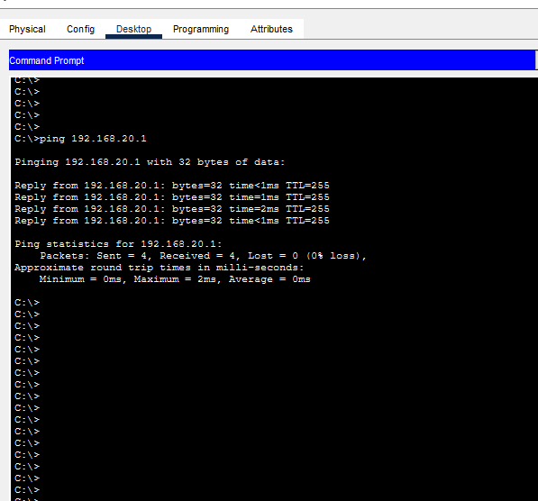
Figure 9 Inter-VLAN Connectivity Test — IT
The successful ping responses confirm that PC1 in VLAN 10 can communicate with PC3 in VLAN 20 through the Router-on-a-Stick configuration.
Figure 10. Inter-VLAN Connectivity Test — Finance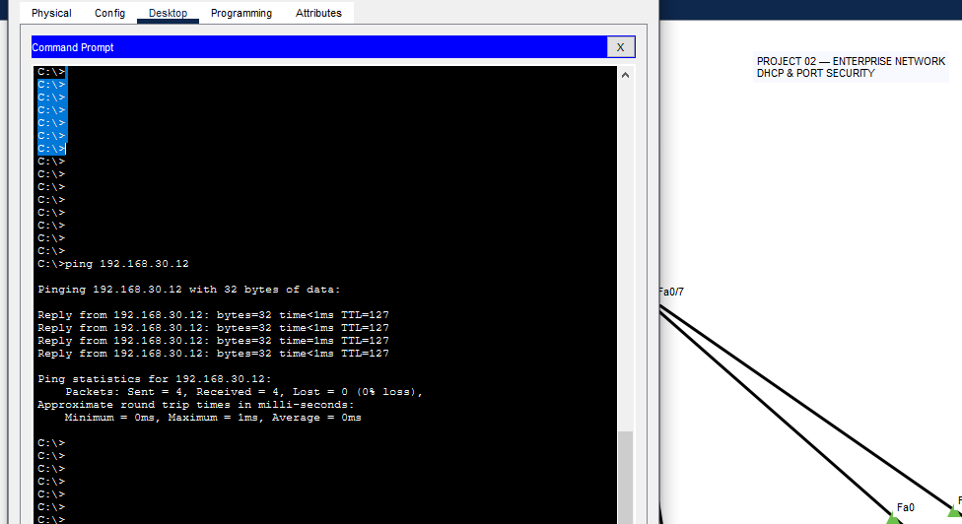
Figure 10. Inter-VLAN Connectivity Test — Finance

The successful ping responses confirm that PC1 in VLAN 10 can communicate with PC5 in VLAN 30 through the Router-on-a-Stick configuration.

7.9 Port Security Verification
Port Security was configured on the switch access ports to restrict each port to one authorized MAC address. The show port-security command was used on SW1 to verify the Port Security status and configuration of the protected access ports.
Figure 11 Port Security Configuration Verification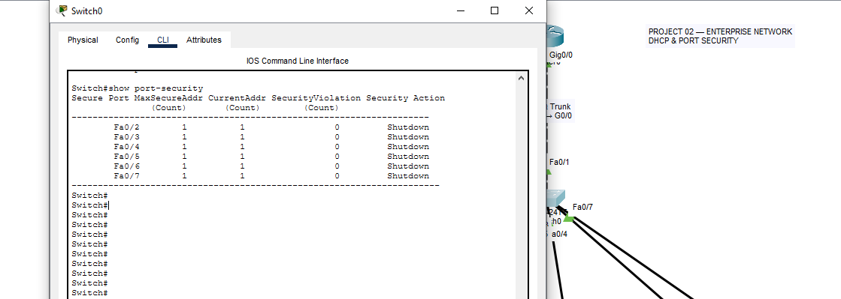
Figure 11 Port Security Configuration Verification
The verification output confirms that Port Security is enabled on Fa0/2 through Fa0/7, with a maximum of one secure MAC address configured for each port. The violation mode is set to Shutdown, and no security violations were recorded during normal operation.

7.10 Port Security Violation Test
An unauthorized-device test was performed to verify the operation of Port Security. PC2 was temporarily connected to switch port Fa0/2, which was configured with the authorized MAC address of PC1.
A ping was attempted from the unauthorized device, causing a MAC address security violation. The switch detected the unauthorized MAC address and placed Fa0/2 into the Secure-shutdown state according to the configured violation mode.
Figure 12 Port Security Violation Test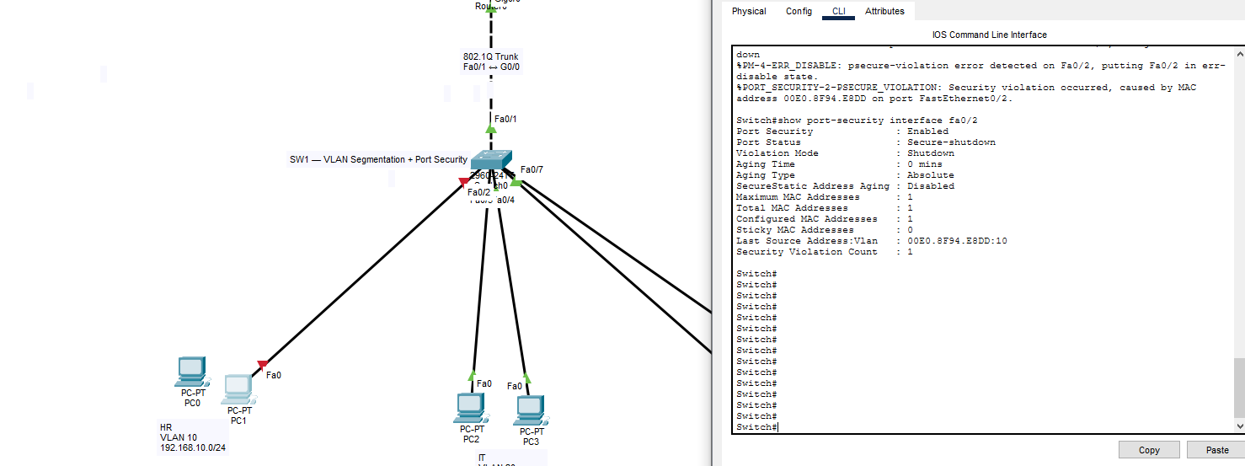
Figure 12 Port Security Violation Test
The verification output shows that the port entered Secure-shutdown status and recorded a security violation. The last source address displayed the unauthorized MAC address detected on the port.

7.11 Port Security Recovery
After the security violation, the authorized PC1 was reconnected to Fa0/2. The secured port was manually recovered by shutting down and reactivating the interface.
The port was then verified using the show port-security interface fa0/2 command to confirm that the port returned to the Secure-up state and that the authorized MAC address was active.
Figure 13 Port Security Recovery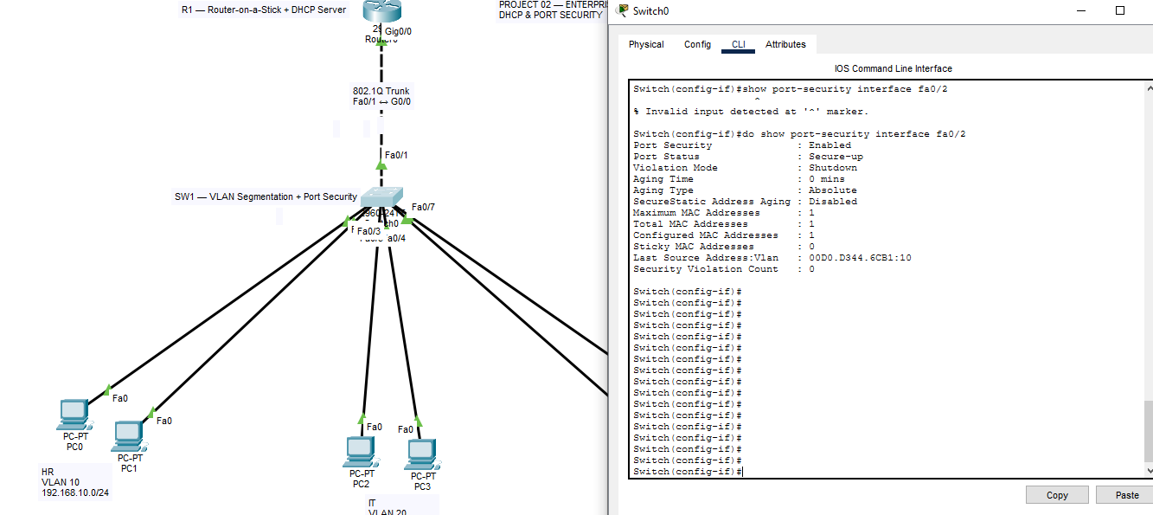
Figure 13 Port Security Recovery
The verification output confirms that Fa0/2 returned to the Secure-up state with the authorized MAC address configured and no active security violation.

7.12 Router Configuration Verification
The show running-config command was used on R1 to review the complete active router configuration. The configuration was verified to confirm the DHCP exclusions, DHCP pools, Router-on-a-Stick subinterfaces, VLAN encapsulation, and gateway addresses.
Figure 14 Router Running Configuration — Part 1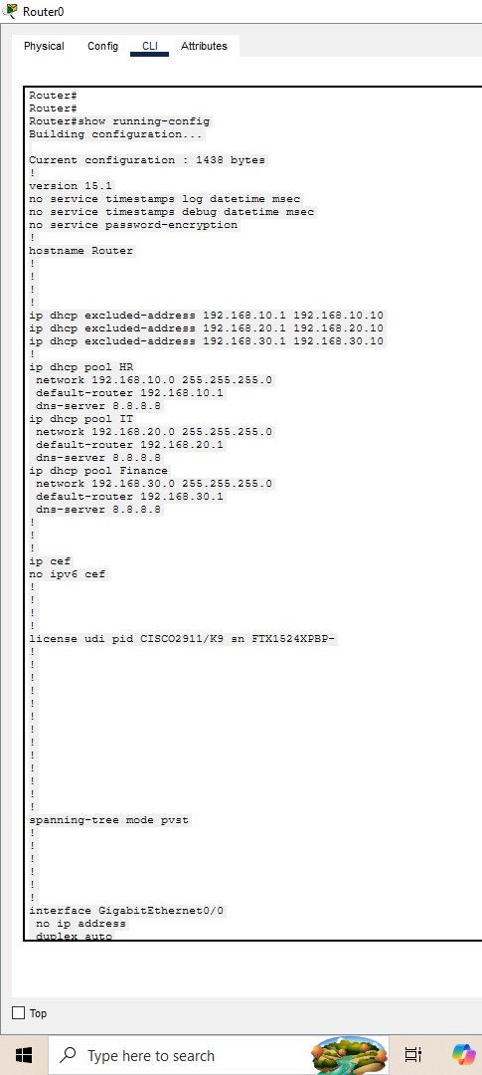
Figure 14 Router Running Configuration — Part 1
Figure 15 Router Running Configuration — Part 2

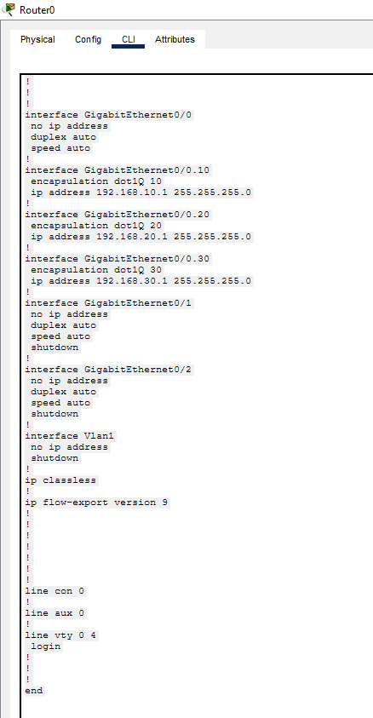
Figure 15 Router Running Configuration — Part 2
The configuration output confirms that the router contains the required DHCP services and Router-on-a-Stick configuration for VLAN 10, VLAN 20, and VLAN 30.

7.13 Switch Configuration Verification
The show running-config command was used on SW1 to review the complete active switch configuration. The configuration was verified to confirm the VLANs, access port assignments, 802.1Q trunk configuration, and Port Security settings.
Figure 16 Switch Running Configuration — Part 1
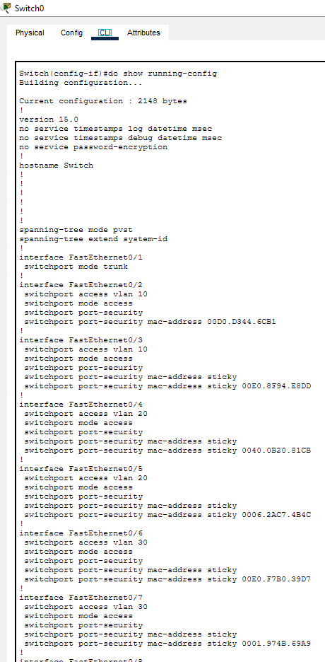
Figure 16 Switch Running Configuration — Part 1

Figure 17 Switch Running Configuration — Part 2
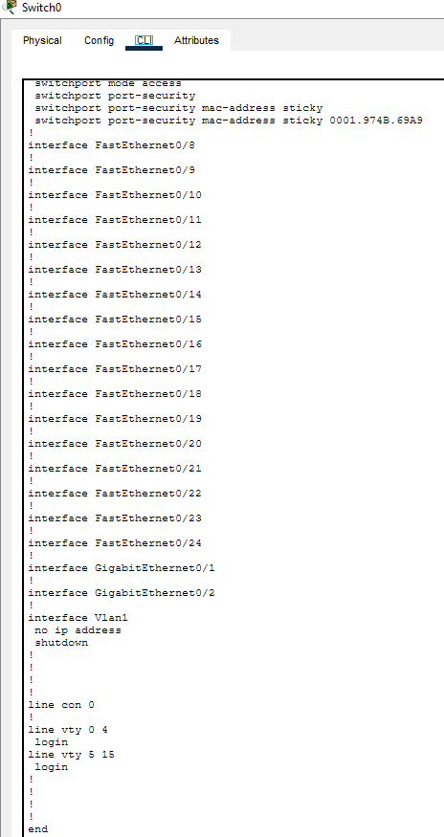
Figure 17 Switch Running Configuration — Part 2
The configuration output confirms that the switch contains the required VLAN configuration, access port assignments, trunk configuration, and Port Security settings for the enterprise network.

8. TROUBLESHOOTING CASE STUDY

8.1 Problem Introduction
During the testing phase, a Port Security violation was intentionally simulated to verify the network's ability to detect and block an unauthorized device. Fa0/2 on SW1 was configured with the authorized MAC address of PC1 and a maximum limit of one MAC address.
PC2 was then temporarily connected to Fa0/2. Because PC2 had a different MAC address, the switch detected a security violation and placed the interface into the Secure-shutdown state. This demonstrated the effectiveness of Port Security in preventing unauthorized devices from accessing the network.

8.2 Security Violation Condition
Before the test, Fa0/2 was configured to allow only the authorized MAC address of PC1. The port was limited to one secure MAC address, and the violation mode was set to shutdown.
The relevant Port Security configuration was:
interface fa0/2
switchport mode access
switchport port-security
switchport port-security mac-address 00d0.d344.6cb1
switchport port-security maximum 1
switchport port-security violation shutdown
The configuration was intentionally left unchanged while PC2 was connected to the port. Since PC2 had a different MAC address, its connection triggered the Port Security violation.

8.3 Connectivity Failure
PC2 was temporarily connected to Fa0/2, which was configured with the authorized MAC address of PC1. A connectivity test was performed by attempting to ping the router gateway at 192.168.10.1.
The connection was blocked because the MAC address of PC2 did not match the secure MAC address configured on Fa0/2. The switch detected the violation and automatically placed the interface into the Secure-shutdown state.
Figure 12 Port Security Violation Test
The verification output showed the unauthorized MAC address as the last source address and recorded a security violation on Fa0/2. This confirmed that Port Security successfully detected and blocked the unauthorized device.

8.4 Configuration Correction and Recovery
To restore authorized network access, PC2 was disconnected from Fa0/2 and the authorized PC1 was reconnected to the port. The interface was then reset using the following commands:
interface fa0/2
shutdown
no shutdown
After the interface was reset, PC1 was able to access the network through Fa0/2. The show port-security interface fa0/2 command was then used to verify that the port had returned to the Secure-up state.
Figure 13 Port Security Recovery
The verification output confirmed that Fa0/2 was operational, had one configured secure MAC address, and recorded no active security violation after recovery.

8.5 Verification After Correction
After the port was recovered, the authorized PC1 was tested again to confirm normal network operation. The show port-security interface fa0/2 command verified that the interface was in the Secure-up state and that the authorized MAC address was present.
The security violation count returned to zero after recovery, confirming that the unauthorized device was no longer connected and that the port was operating normally.
Connectivity from PC1 was restored successfully, demonstrating that the Port Security violation had been resolved without affecting the authorized device.

8.6 Root Cause Analysis
The root cause of the connectivity failure was a mismatch between the MAC address authorized on Fa0/2 and the MAC address of the connected device.
Fa0/2 was configured to allow only one specific MAC address belonging to PC1. When PC2 was connected, its different MAC address exceeded the security policy configured on the port. The switch therefore detected a Port Security violation and placed the interface into the Secure-shutdown state.
The issue was resolved by removing the unauthorized device, reconnecting the authorized PC1, and resetting the interface. This troubleshooting process demonstrated how Port Security can detect unauthorized access and how a secured interface can be recovered after a violation.

9. RESULTS
The enterprise network was successfully implemented and tested in Cisco Packet Tracer. The following results were achieved:
- Successfully created and configured VLANs for HR, IT, and Finance.
- Successfully assigned access ports and configured IEEE 802.1Q trunking.
- Successfully implemented Router-on-a-Stick for inter-VLAN communication.
- Successfully configured DHCP on the router and automatically assigned IP addresses and network parameters to all six PCs.
- Successfully verified DHCP pools, bindings, and client configurations.
- Successfully implemented Port Security with static and sticky MAC address configurations.
- Successfully detected and blocked an unauthorized device through the Port Security violation test.
- Successfully recovered the secured interface and restored authorized network connectivity.
- Successfully verified same-VLAN and inter-VLAN connectivity.
- Successfully verified the final router and switch configurations using Cisco IOS commands.
Overall, the project demonstrated the practical implementation of VLAN segmentation, inter-VLAN routing, DHCP, MAC address security, network verification, and troubleshooting in a small enterprise network environment.

10. FUTURE IMPROVEMENTS
The current project provides a foundation for further development into a larger and more secure enterprise network. The following improvements can be implemented in future projects:
- Implement OSPF for dynamic routing between multiple routers.
- Configure standard and extended ACLs to control network traffic.
- Implement NAT and PAT for external network connectivity.
- Configure SSH for secure remote management of network devices.
- Implement STP and EtherChannel for Layer 2 redundancy and improved network availability.
- Introduce firewall, VPN, and IDS/IPS concepts for advanced network security.
- Use Linux and Python for network automation and device management.
- Expand the topology to include multiple switches, routers, and additional departments.
- Explore cloud networking concepts and integrate enterprise networking with cloud infrastructure.
These improvements will build upon the networking concepts demonstrated in this project and provide a pathway toward advanced Network Engineering, Network Security, Automation, and Cloud Networking.

