SMSLib开发指南

一、SMSLib简介
SMSLib是一个开放源代码的短信猫二次开发包，有JAVA和.Net两个版本，目前最新版为v3.5.2。
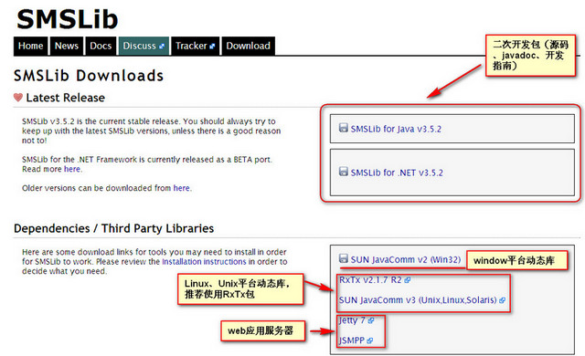 图1-1
二、Window平台

1、在smslib官网下载“SMSLib for Java v3.5.2”开发包，并解压，目录结构如下图所示：
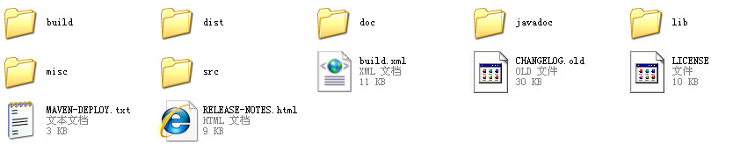
图2-1
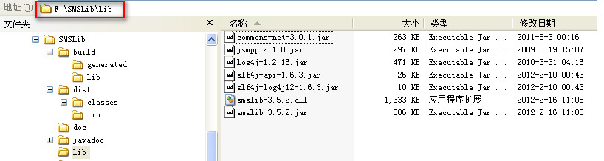
图2-2
lib：存放二次开发包（smslib-3.5.2.jar）和运行时的依赖包（slf4j、log4j、commons-net、jsmpp等）（重要）
dist：存放短信猫服务开发包（smsserver-3.5.2.jar），该包包括了smslib-3.5.2.jar中的所有核心类。如果是将短信猫作为服务的方式部署，不需要额外写代码开发短信发送和接收的接口，直接部署短信服务即可，详细的步聚，可以参考《短信猫服务安装与配置指南》。（重要）
doc：smslib介绍、使用指南、smsserver安装与配置等文档（重要）
javadoc：二次开发包API
src：存放二次开发包源码和示例源码
misc：smslib日志（log4j）配置配置模板、smsserver数据库建库脚本及服务接口等文件
build：项目管理相关文件（不重要）

2、下载SUN JavaComm v2 (Win32)动态库，并解压，目录结构如下图所示：
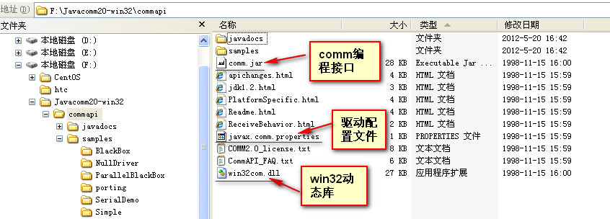
图3-1
3、运行环境配置
- 复制“图3-1”中javax.comm.properties文件到%JAVA_HOME%\jre\lib目录下，win32com.dll文件到%JAVA_HOME%\jre\bin目录下
- 复制“图3-1”中comm.jar和图2-2中所有jar文件到CLASSPATH目录下（如果是用eclipse等IDE工具，将这些jar包导入到工程中)
注意： win32com.dll只支持32位jdk
4、运行示例程序并测试
修改图2-1中src\java\examples\modem目录下的SendMessage.java和ReadMessages.java程序发送短信的参数配置，编译并运行。如下图所示：
[java] view plaincopy
- // SendMessage.java - Sample application.
- // 短信发送测试程序
- // This application shows you the basic procedure for sending messages.
- // You will find how to send synchronous and asynchronous messages.
- //
- // For asynchronous dispatch, the example application sets a callback
- // notification, to see what's happened with messages.

- package examples.modem;

- import org.smslib.AGateway;
- import org.smslib.IOutboundMessageNotification;
- import org.smslib.Library;
- import org.smslib.OutboundMessage;
- import org.smslib.Service;
- import org.smslib.modem.SerialModemGateway;

- public class SendMessage
- {
- public void doIt() throws Exception
- {
- OutboundNotification outboundNotification = new OutboundNotification();
- System.out.println("Example: Send message from a serial gsm modem.");
- System.out.println(Library.getLibraryDescription());
- System.out.println("Version: " + Library.getLibraryVersion());
- /*
- modem.com1:网关ID（即短信猫端口编号）
- COM4:串口名称（在window中以COMXX表示端口名称，在linux,unix平台下以ttyS0-N或ttyUSB0-N表示端口名称），通过端口检测程序得到可用的端口
- 115200：串口每秒发送数据的bit位数,必须设置正确才可以正常发送短信，可通过程序进行检测。常用的有115200、9600
- Huawei：短信猫生产厂商，不同的短信猫生产厂商smslib所封装的AT指令接口会不一致，必须设置正确.常见的有Huawei、wavecom等厂商
- 最后一个参数表示设备的型号，可选
- */
- SerialModemGateway gateway = new SerialModemGateway("modem.com1", "COM4", 115200, "Huawei", "");
- gateway.setInbound(true); //设置true，表示该网关可以接收短信,根据需求修改
- gateway.setOutbound(true);//设置true，表示该网关可以发送短信,根据需求修改
- gateway.setSimPin("0000");//sim卡锁，一般默认为0000或1234
- // Explicit SMSC address set is required for some modems.
- // Below is for VODAFONE GREECE - be sure to set your own!
- gateway.setSmscNumber("+306942190000");//短信服务中心号码
- Service.getInstance().setOutboundMessageNotification(outboundNotification); //发送短信成功后的回调函方法
- Service.getInstance().addGateway(gateway); //将网关添加到短信猫服务中
- Service.getInstance().startService(); //启动服务，进入短信发送就绪状态
- System.out.println();
- //打印设备信息
- System.out.println("Modem Information:");
- System.out.println(" Manufacturer: " + gateway.getManufacturer());
- System.out.println(" Model: " + gateway.getModel());
- System.out.println(" Serial No: " + gateway.getSerialNo());
- System.out.println(" SIM IMSI: " + gateway.getImsi());
- System.out.println(" Signal Level: " + gateway.getSignalLevel() + " dBm");
- System.out.println(" Battery Level: " + gateway.getBatteryLevel() + "%");
- System.out.println();
- // Send a message synchronously.
- OutboundMessage msg = new OutboundMessage("306974000000", "Hello from SMSLib!"); //参数1：手机号码 参数2：短信内容
- Service.getInstance().sendMessage(msg); //执行发送短信
- System.out.println(msg);
- // Or, send out a WAP SI message.
- //OutboundWapSIMessage wapMsg = new OutboundWapSIMessage("306974000000",
- //new URL("http://www.smslib.org/"), "Visit SMSLib now!");
- //Service.getInstance().sendMessage(wapMsg);
- //System.out.println(wapMsg);
- // You can also queue some asynchronous messages to see how the callbacks
- // are called...
- //msg = new OutboundMessage("309999999999", "Wrong number!");
- //srv.queueMessage(msg, gateway.getGatewayId());
- //msg = new OutboundMessage("308888888888", "Wrong number!");
- //srv.queueMessage(msg, gateway.getGatewayId());
- System.out.println("Now Sleeping - Hit <enter> to terminate.");
- System.in.read();
- Service.getInstance().stopService();
- }

- /*
- 短信发送成功后，调用该接口。并将发送短信的网关和短信内容对象传给process接口
- */
- public class OutboundNotification implements IOutboundMessageNotification
- {
- public void process(AGateway gateway, OutboundMessage msg)
- {
- System.out.println("Outbound handler called from Gateway: " + gateway.getGatewayId());
- System.out.println(msg);
- }
- }

- public static void main(String args[])
- {
- SendMessage app = new SendMessage();
- try
- {
- app.doIt();
- }
- catch (Exception e)
- {
- e.printStackTrace();
- }
- }
- }
[java] view plaincopy
- // ReadMessages.java - Sample application.
- // 短信读取程序
- // This application shows you the basic procedure needed for reading
- // SMS messages from your GSM modem, in synchronous mode.
- //
- // Operation description:
- // The application setup the necessary objects and connects to the phone.
- // As a first step, it reads all messages found in the phone.
- // Then, it goes to sleep, allowing the asynchronous callback handlers to
- // be called. Furthermore, for callback demonstration purposes, it responds
- // to each received message with a "Got It!" reply.
- //
- // Tasks:
- // 1) Setup Service object.
- // 2) Setup one or more Gateway objects.
- // 3) Attach Gateway objects to Service object.
- // 4) Setup callback notifications.
- // 5) Run

- package examples.modem;

- import java.util.ArrayList;
- import java.util.List;
- import javax.crypto.spec.SecretKeySpec;
- import org.smslib.AGateway;
- import org.smslib.AGateway.GatewayStatuses;
- import org.smslib.AGateway.Protocols;
- import org.smslib.ICallNotification;
- import org.smslib.IGatewayStatusNotification;
- import org.smslib.IInboundMessageNotification;
- import org.smslib.IOrphanedMessageNotification;
- import org.smslib.InboundMessage;
- import org.smslib.InboundMessage.MessageClasses;
- import org.smslib.Library;
- import org.smslib.Message.MessageTypes;
- import org.smslib.Service;
- import org.smslib.crypto.AESKey;
- import org.smslib.modem.SerialModemGateway;

- public class ReadMessages
- {
- public void doIt() throws Exception
- {
- // Define a list which will hold the read messages.
- List<InboundMessage> msgList;
- // Create the notification callback method for inbound & status report
- // messages.
- InboundNotification inboundNotification = new InboundNotification();
- // Create the notification callback method for inbound voice calls.
- CallNotification callNotification = new CallNotification();
- //Create the notification callback method for gateway statuses.
- GatewayStatusNotification statusNotification = new GatewayStatusNotification();
- OrphanedMessageNotification orphanedMessageNotification = new OrphanedMessageNotification();
- try
- {
- System.out.println("Example: Read messages from a serial gsm modem.");
- System.out.println(Library.getLibraryDescription());
- System.out.println("Version: " + Library.getLibraryVersion());
- // Create the Gateway representing the serial GSM modem.
- SerialModemGateway gateway = new SerialModemGateway("modem.com4", "COM4", 115200, "Huawei", "E160");
- // Set the modem protocol to PDU (alternative is TEXT). PDU is the default, anyway...
- gateway.setProtocol(Protocols.PDU);
- // Do we want the Gateway to be used for Inbound messages?
- gateway.setInbound(true);
- // Do we want the Gateway to be used for Outbound messages?
- gateway.setOutbound(true);
- // Let SMSLib know which is the SIM PIN.
- gateway.setSimPin("0000");
- // Set up the notification methods.
- Service.getInstance().setInboundMessageNotification(inboundNotification);
- Service.getInstance().setCallNotification(callNotification);
- Service.getInstance().setGatewayStatusNotification(statusNotification);
- Service.getInstance().setOrphanedMessageNotification(orphanedMessageNotification);
- // Add the Gateway to the Service object.
- Service.getInstance().addGateway(gateway);
- // Similarly, you may define as many Gateway objects, representing
- // various GSM modems, add them in the Service object and control all of them.
- // Start! (i.e. connect to all defined Gateways)
- Service.getInstance().startService();
- // Printout some general information about the modem.
- System.out.println();
- System.out.println("Modem Information:");
- System.out.println(" Manufacturer: " + gateway.getManufacturer());
- System.out.println(" Model: " + gateway.getModel());
- System.out.println(" Serial No: " + gateway.getSerialNo());
- System.out.println(" SIM IMSI: " + gateway.getImsi());
- System.out.println(" Signal Level: " + gateway.getSignalLevel() + " dBm");
- System.out.println(" Battery Level: " + gateway.getBatteryLevel() + "%");
- System.out.println();
- // In case you work with encrypted messages, its a good time to declare your keys.
- // Create a new AES Key with a known key value.
- // Register it in KeyManager in order to keep it active. SMSLib will then automatically
- // encrypt / decrypt all messages send to / received from this number.
- Service.getInstance().getKeyManager().registerKey("+306948494037",
- new AESKey(new SecretKeySpec("0011223344556677".getBytes(), "AES")));
- // Read Messages. The reading is done via the Service object and
- // affects all Gateway objects defined. This can also be more directed to a specific
- // Gateway - look the JavaDocs for information on the Service method calls.
- msgList = new ArrayList<InboundMessage>();
- Service.getInstance().readMessages(msgList, MessageClasses.ALL);
- for (InboundMessage msg : msgList)
- System.out.println(msg);
- // Sleep now. Emulate real world situation and give a chance to the notifications
- // methods to be called in the event of message or voice call reception.
- System.out.println("Now Sleeping - Hit <enter> to stop service.");
- System.in.read();
- System.in.read();
- }
- catch (Exception e)
- {
- e.printStackTrace();
- }
- finally
- {
- Service.getInstance().stopService();
- }
- }

- public class InboundNotification implements IInboundMessageNotification
- {
- public void process(AGateway gateway, MessageTypes msgType, InboundMessage msg)
- {
- if (msgType == MessageTypes.INBOUND) System.out.println(">>> New Inbound message detected from Gateway: "
- + gateway.getGatewayId());
- else if (msgType == MessageTypes.STATUSREPORT) System.out.println(">>> New Inbound Status " +
- "Report message detected from Gateway: " + gateway.getGatewayId());
- System.out.println(msg);
- }
- }

- public class CallNotification implements ICallNotification
- {
- public void process(AGateway gateway, String callerId)
- {
- System.out.println(">>> New call detected from Gateway: " + gateway.getGatewayId() + " : " + callerId);
- }
- }

- public class GatewayStatusNotification implements IGatewayStatusNotification
- {
- public void process(AGateway gateway, GatewayStatuses oldStatus, GatewayStatuses newStatus)
- {
- System.out.println(">>> Gateway Status change for " + gateway.getGatewayId() + ", OLD: " + oldStatus + " -> NEW: " + newStatus);
- }
- }

- public class OrphanedMessageNotification implements IOrphanedMessageNotification
- {
- public boolean process(AGateway gateway, InboundMessage msg)
- {
- System.out.println(">>> Orphaned message part detected from " + gateway.getGatewayId());
- System.out.println(msg);
- // Since we are just testing, return FALSE and keep the orphaned message part.
- return false;
- }
- }

- public static void main(String args[])
- {
- ReadMessages app = new ReadMessages();
- try
- {
- app.doIt();
- }
- catch (Exception e)
- {
- e.printStackTrace();
- }
- }
- }
三、Linux、Unix、Solaris平台
与window平台不同的地方就在于动态库和二次开发包不一致，其它基本类似
rxtx与comm的编码方式是不一样的。
1、下载RxTx v2.1.7 R2
2、解压，目录结构如下图所示：
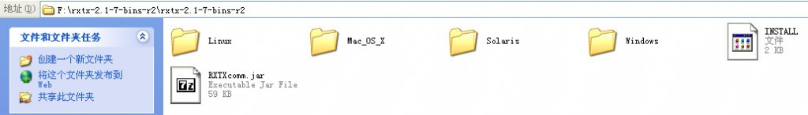
图4-1
3、运行环境配置
- 复制图4-1中Linux目录下的librxtxSerial.so文件至$JAVA_HOME/jre/lib/$(ARCH)/目录下，复制RXTXcomm.jar到应用程序的CLASSPATH或$JAVA_HOME/jre/lib/ext目录下
- 复制图3-1中的javax.comm.properties文件至$JAVA_HOME/jre/lib目录下，并将文件中的Driver=com.sun.comm.Win32Driver改成Driver=gnu.io.CommDriver。文件内容如下图所示：
- 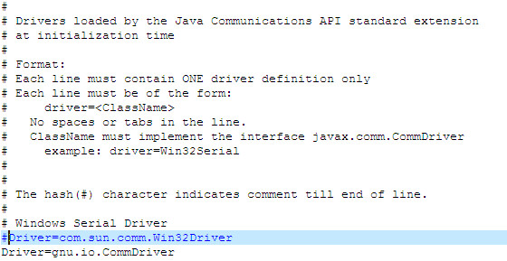
4、修改示例程序，编译并运行

四、短信猫设备可用端口检测程序
[java] view plaincopy
- import gnu.io.*;
- import java.util.*;
- import java.io.*;

- public class CommTest
- {
- static CommPortIdentifier portId;
- static Enumeration portList;
- static int bauds[] = { 9600, 19200, 57600, 115200 }; //检测端口所支持的波特率

- public static void main(String[] args)
- {
- portList = CommPortIdentifier.getPortIdentifiers();
- System.out.println("短信设备端口连接测试...");
- while (portList.hasMoreElements())
- {
- portId = (CommPortIdentifier) portList.nextElement();
- if (portId.getPortType() == CommPortIdentifier.PORT_SERIAL)
- {
- System.out.println("找到串口: " + portId.getName());
- for (int i = 0; i < bauds.length; i++)
- {
- System.out.print(" Trying at " + bauds[i] + "...");
- try
- {
- SerialPort serialPort;
- InputStream inStream;
- OutputStream outStream;
- int c;
- String response;
- serialPort = (SerialPort) portId.open("SMSLibCommTester", 1971);
- serialPort.setFlowControlMode(SerialPort.FLOWCONTROL_RTSCTS_IN);
- serialPort.setSerialPortParams(bauds[i], SerialPort.DATABITS_8, SerialPort.STOPBITS_1, SerialPort.PARITY_NONE);
- inStream = serialPort.getInputStream();
- outStream = serialPort.getOutputStream();
- serialPort.enableReceiveTimeout(1000);
- c = inStream.read();
- while (c != -1)
- c = inStream.read();
- outStream.write('A');
- outStream.write('T');
- outStream.write('\r');
- try
- {
- Thread.sleep(1000);
- }
- catch (Exception e)
- {
- }
- response = "";
- c = inStream.read();
- while (c != -1)
- {
- response += (char) c;
- c = inStream.read();
- }
- if (response.indexOf("OK") >= 0)
- {
- try
- {
- System.out.print(" 获取设备信息...");
- outStream.write('A');
- outStream.write('T');
- outStream.write('+');
- outStream.write('C');
- outStream.write('G');
- outStream.write('M');
- outStream.write('M');
- outStream.write('\r');
- response = "";
- c = inStream.read();
- while (c != -1)
- {
- response += (char) c;
- c = inStream.read();
- }
- System.out.println(" 发现设备: " + response.replaceAll("\\s+OK\\s+", "").replaceAll("\n", "").replaceAll("\r", ""));
- }
- catch (Exception e)
- {
- System.out.println(" 没有发现设备!");
- }
- }
- else System.out.println(" 没有发现设备!");
- serialPort.close();
- }
- catch (Exception e)
- {
- System.out.println(" 没有发现设备!");
- }
- }
- }
- }
- }
- }
五、短信猫设备使用minicom检测

1、linux下端口配置
软件安装完毕后，采用minicom进行配置
执行sudo minicom -s，进入配置界面，
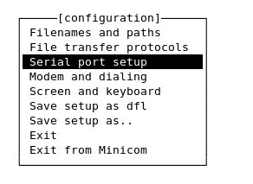
在第三项『串口配置』，设置端口为全面查询到的端口，速率是9600（根据短信猫设备来定，不同的厂家可能会不一样）
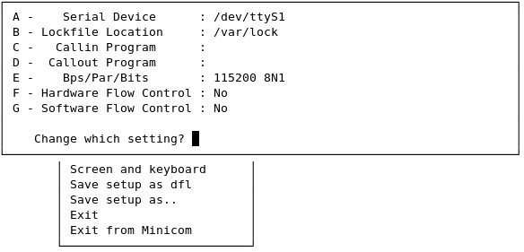
Serial Device :/dev/ttyS1（此为串口端口，可以在ttyS0~~ttyS4中挨个试）
然后在主菜单Save setup as dfl
可选择Exit推出配置进入minicom，就可以使用at命令测试配置是否成功；也可选择Exit from Minicom推出minicom。
接下在再次执行minicom，进入主界面，这时候应该就可以输入AT指令了。要注意的是，我是重新插拔了一下短信猫才成功连上的
六、minicom使用方法
1、启动minicom命令
sudo miniscom
2、输入命令
同时按Ctrl+a 后按e键，不按e键不能输入命令。
输入at回车，会输出OK。证明短信猫连接成功。如果没有返回可以修改端口再试
at发短信命令 at+cmgs=手机号码
ctrl+z发送短信
3、退出命令
同时按Ctrl+a 后按x键
七、linux虚拟机需要注意是否共享串口
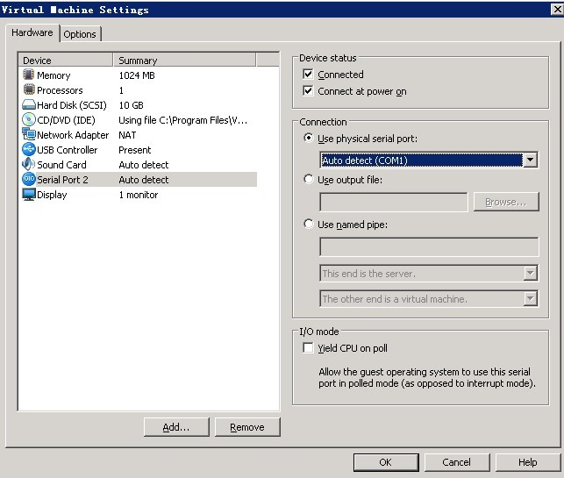
配置成功后会在“vm”菜单中看到共享的端口
八、java环境变量
注意事项：
1、使用smslib库之前，如果你的设备是usb数据线，先检查系统中该设备驱动程序是否已安装，在window环境下，厂商一般会提供设备的驱动程序，在linux环境下，内核2.6.32或以上版本，预装了常用设备的USB转串口驱动，如果系统未自动识别该设备，就需要自行安装该设备的驱动程序了。
2、在开发过程中，org.smslib.TimeoutException: No response from device是最常遇到的一个异常，解决方案请参考：短信猫JAVA二次开发包SMSLib，org.smslib.TimeoutException: No response from device解决方案

