**DAY-15 ASSIGNMENT**

Task-1 : Verify Home page title :

Open the ArtOfTesting Sample Webpage.

Verify that the homepage title contains the expected text ”Sample Webpage for Automation”.

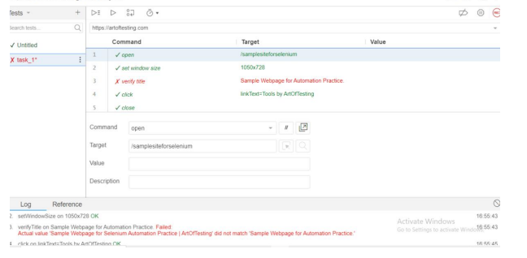

Task-2 : Click on a Link:

Locate the link with the text “This is a link”.

Click the link.

Verify that the expected page loads.

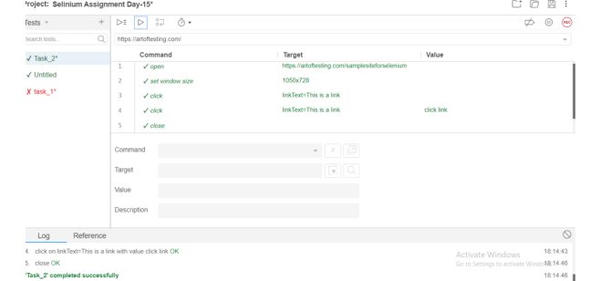

Task 3 : Fill in a Textbox and Submit:

Find the text box labeled “TextBox”.

Enter any text (e.g “Hello”, Selenium!).

Click the “Submit” button.

Verify that the submission is successful.

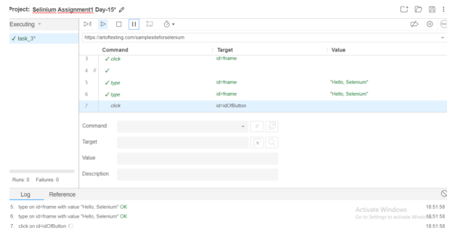

Task-4 : Select a Radio button:

Locate the radio buttons named as “Male” or “Female”.

Choose the “Female” option.

Confirm that the “Female” radio button is selected.

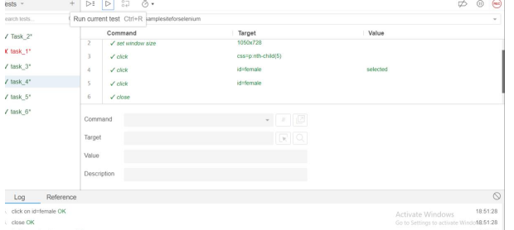

Task -5 : Check a check box:

Find the check box labeled “Automation Testing”.

Check the checkbox.

Validate that it is selected.

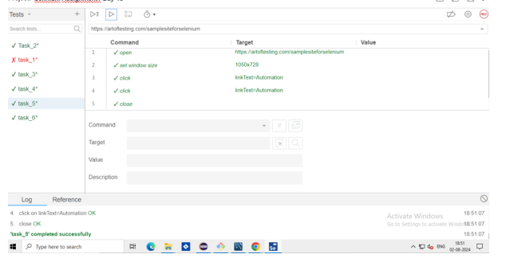

Task-6 : Dropdown Selection :

Visit the “Performance Testing” dropdown.

Choose an option (e.g “Load Testing”).

Verify that the selected option is displayed.

