**ASSIGNMENT – DAY-15(b)**

Task 1 : open the guru99 demo website.

Store title of the webpage to a variable named page title.

Verify that the stored value matches the expected title(“Welcome:Mercury Tours”).

Output – test case run successful and verify the title.

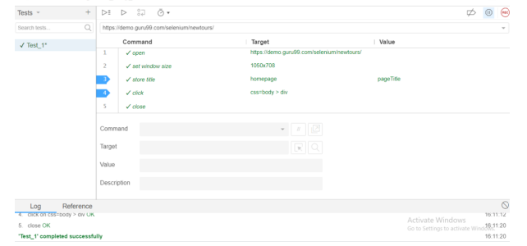

Task 2: Navigate to the “REGISTER” page. Echo the current URL. Verified that the echoed URL corresponds to the “REGISTER” page.

Output : Test case run successfully and verify the URL.

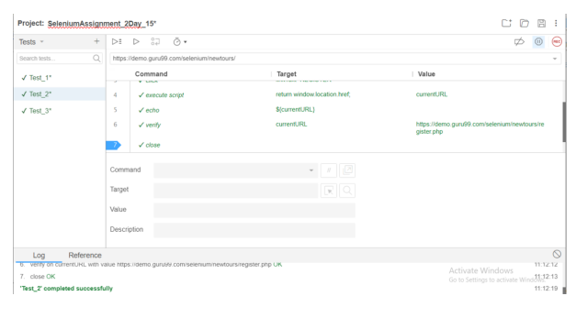

Task 3 : Visit the “Flights” page. Verify the presenve of the “One Way” radio button using the assertElementPresent command. Store the inner text of the “SIGN-ON” link into a variable. Verify that the stored text matches the expected link label.

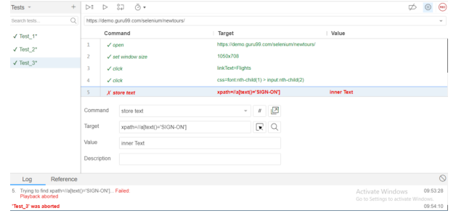

Task 4 : Go to the “Cruises” page. Verify that the “Cruise Line” dropdown contains specific options(e.g, “Carnval”,”Royal Caribbean”).

Output : It will give an error.

