**DAY-30 ASSIGNMENT(Jenkins)**

**Installed Jenkins successfully –**

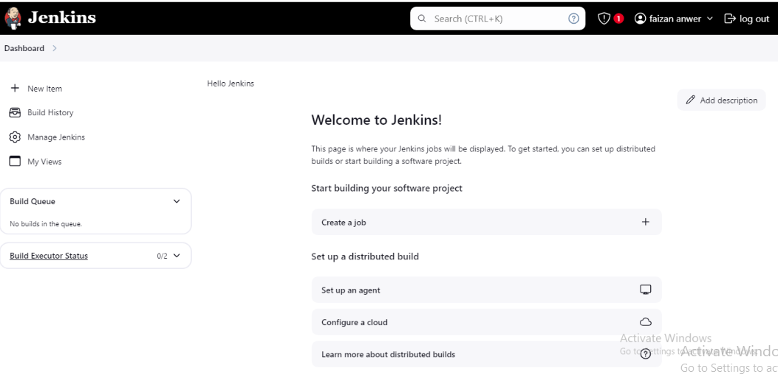

**Configure Tools –**

**Configure git –**

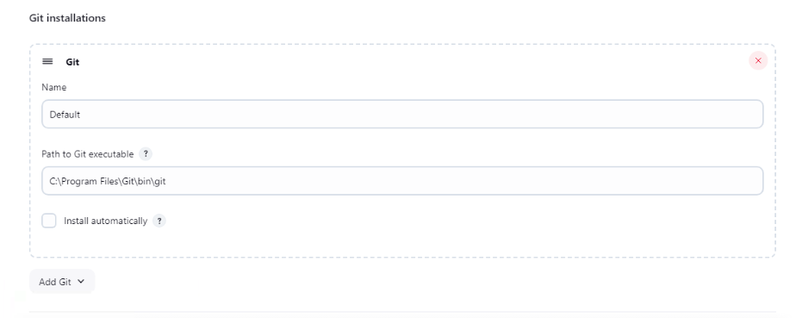

**Configure maven –**

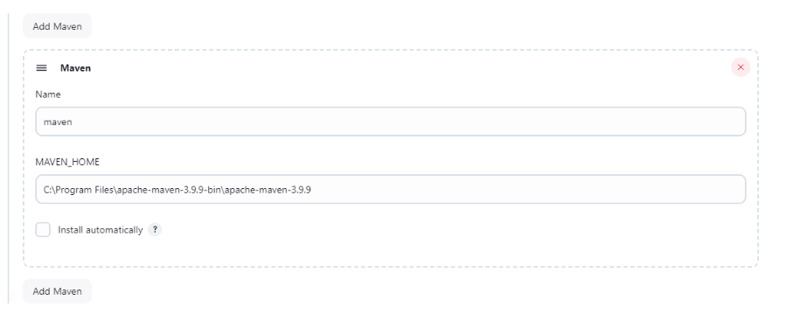

**Configure jdk –**

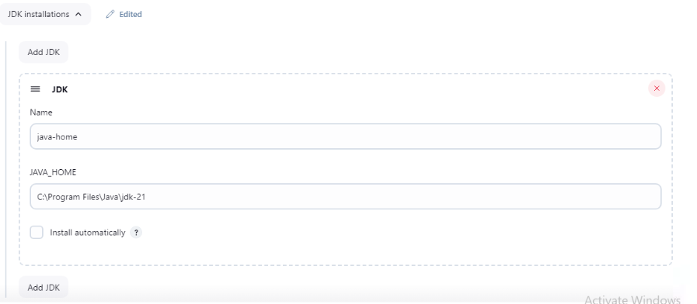

**Security settings –**

**Add or modify user account**

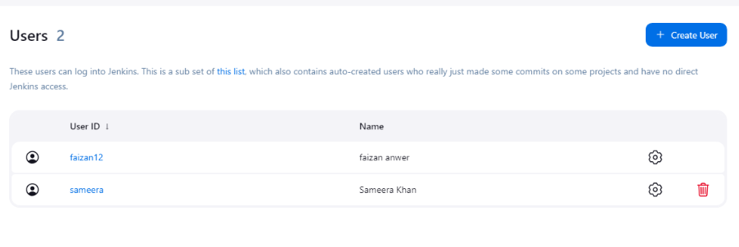

**Getting started with new job**

**create a new job –**

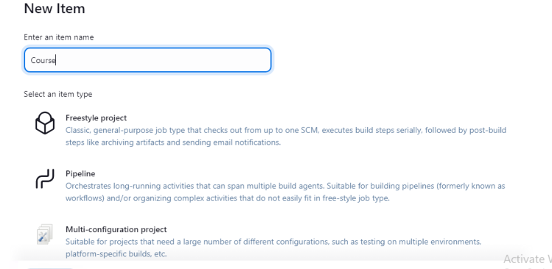

**Configure job –**

General: Provide a description.

Source Code Management: Select "Git" and provide the repository URL.

Build Triggers: Set up triggers like "Build periodically" or "GitHub hook trigger".

Build: Add build steps, e.g., execute Windows batch commands.

Post-build Actions: Add actions like "Archive the artifacts".

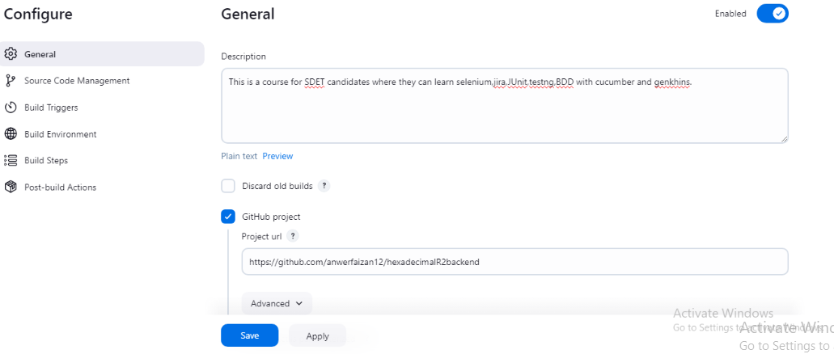

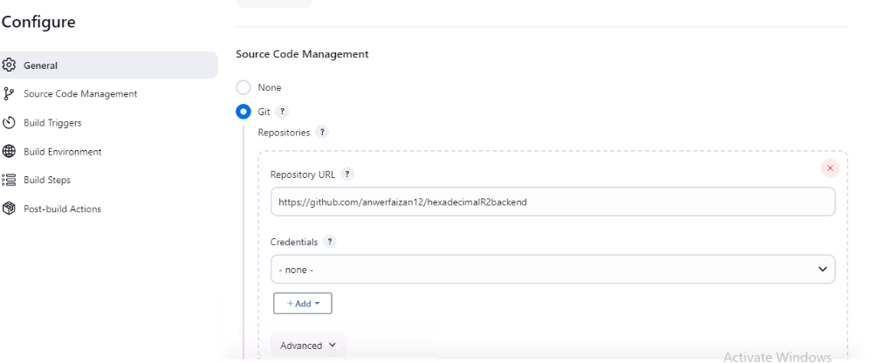

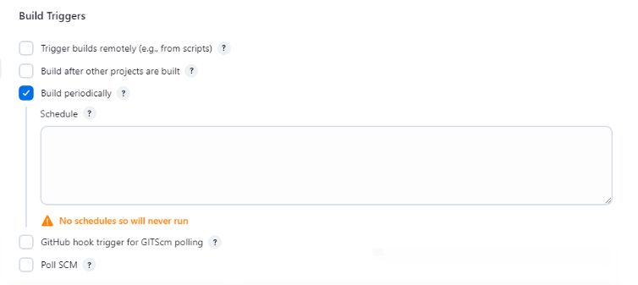

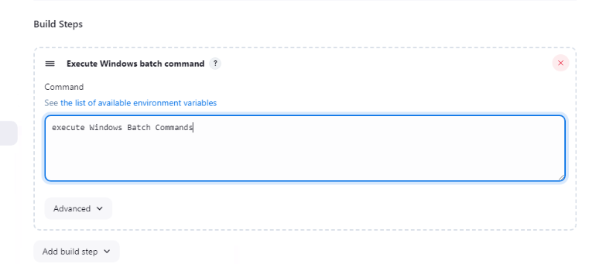

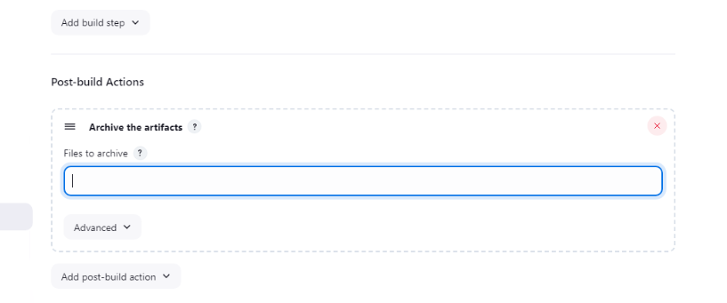

**Configure git in Jenkins job –**

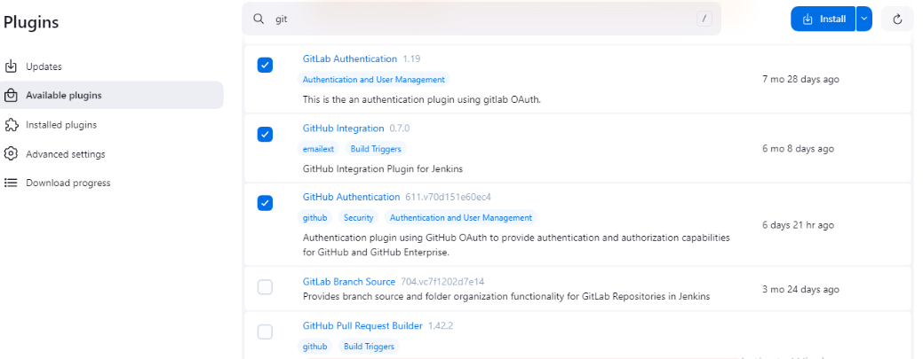

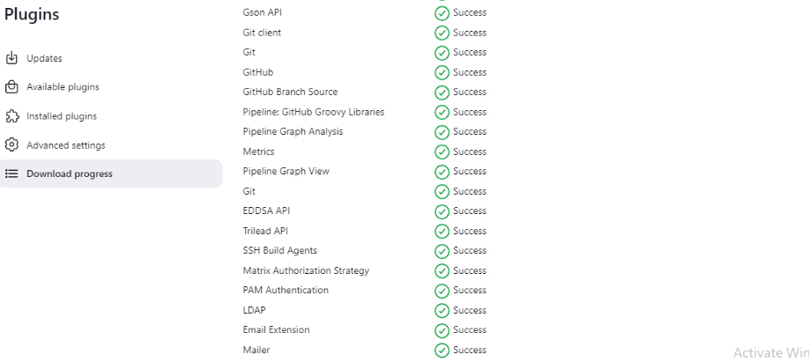

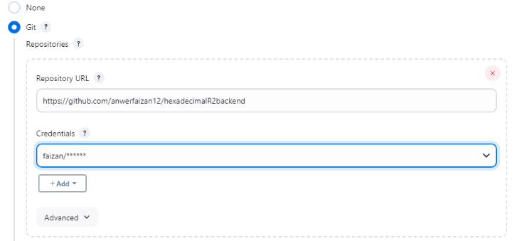

**Email notification -**

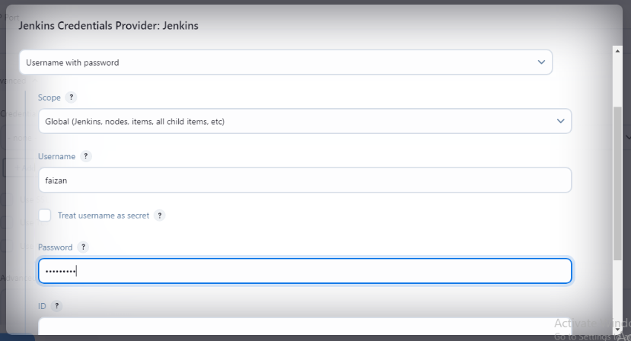

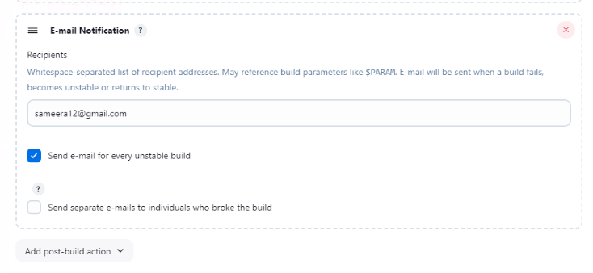

**Setting up delivery Pipeline**

**Installation -**

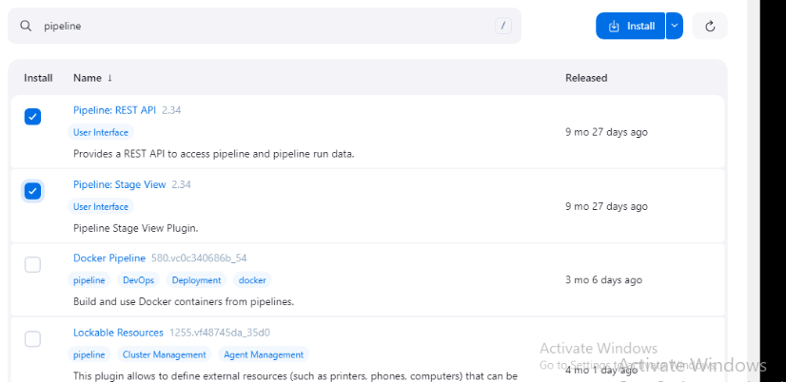

**Create a pipeline job –**

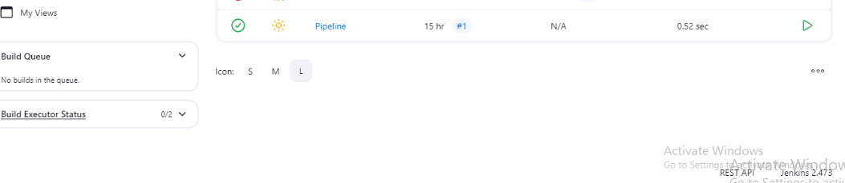

**Result –**

