|  |  |
| --- | --- |
| Topic | To become Familiar with OLTP System Implementation |
| Objectives | * To learn physical Database Design |

|  |
| --- |
| Lab Tasks |
| **Submitted by 16SW31** |

1. For each of the descriptions below, perform the following tasks:

i. Physically implement the systems in any suitable OLTP product with proper keys, data types and relationships.

ii. Insert dummy data up to 5 rows.

1. A book is identified by its ISBN number, and it has a title, a price, and a date of publication. It is published by a publisher, which has its own ID number and a name. Each book has exactly one publisher, but one publisher typically publishes multiple books over time.

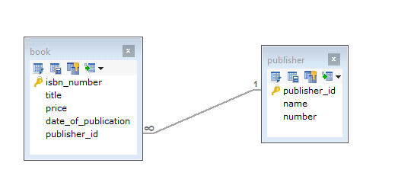

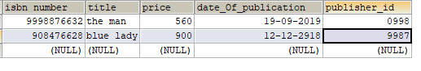

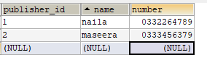

1. A piano manufacturer wants to keep track of all the pianos it makes individually. Each piano has an identifying serial number and a manufacturing completion date. Each instrument represents exactly one piano model, all of which have an identification number and a name. In addition, the company wants to maintain information about the designer of the model. Over time, the company often manufactures thousands of pianos of a certain model, and the model design is specified before any single piano exists

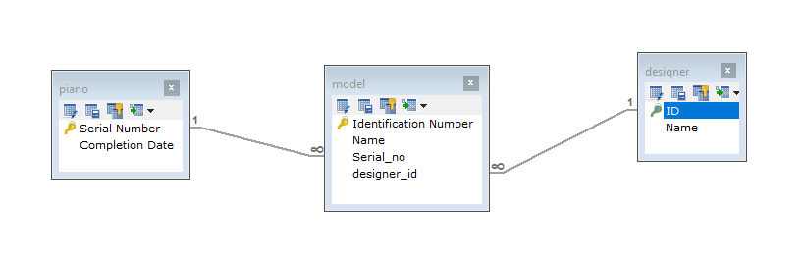

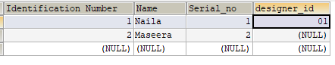

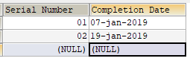

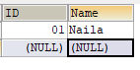

1. A piano manufacturer (see above) employs piano technicians who are responsible for inspecting the instruments before they are shipped to the customers. Each piano is inspected by at least two technicians (identified by their employee number). For each separate inspection, the company needs to record its date and a quality evaluation grade.

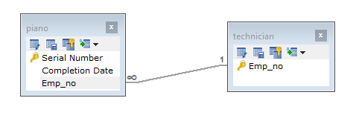

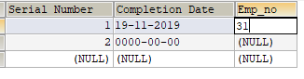



1. The piano technicians (see above) have a hierarchy of reporting relationships: Some of them have supervisory responsibilities in addition to their inspection role and have multiple other technicians report to them. The supervisors themselves report to the chief technician of the company.

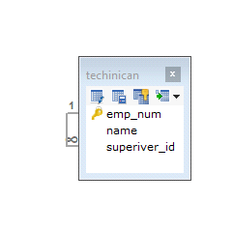

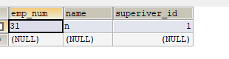

1. The entity type STUDENT has the following attributes: Student Name, Address, Phone, Age, Activity, and No of Years. Activity represents some campus-based student activity, and No of Years represents the number of years the student has engaged in this activity. A given student may engage in more than one activity. Draw a logical ERD for this situation. What attribute or attributes did you designate as the identifier for the STUDENT entity? Why?

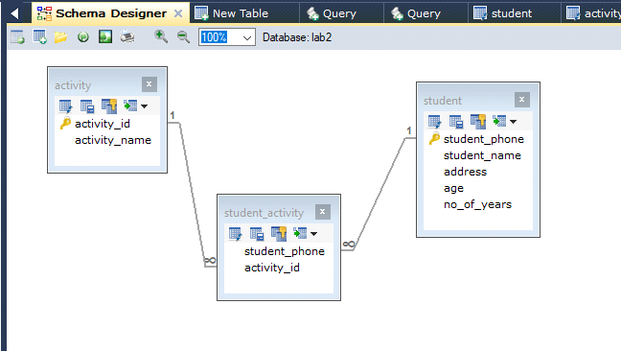

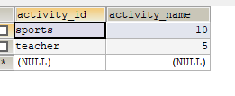

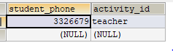

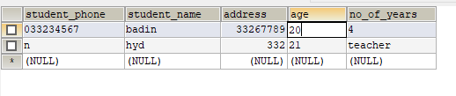

1. A college course may have one or more scheduled sections or may not have a scheduled section. Attributes of COURSE include Course ID, Course Name, and Units. Attributes of SECTION include Section Number and Semester ID. Semester ID is composed of two parts: Semester and Year. Section Number is an integer (such as 1 or 2) that distinguishes one section from another for the same course but does not uniquely identify a section. How did you model SECTION? Why did you choose this way versus alternative ways to model SECTION?

