Architecture Document
chaos: Network Latency & Packet-Loss Chaos Emulator
Field | Detail
Project | chaos: Network Latency & Packet-Loss Chaos Emulator
Student name | [YOUR NAME]
Roll no. / ID | [YOUR ROLL NO]
Course | [COURSE NAME / CODE]
Instructor | [INSTRUCTOR NAME]
Version / date | 1.0, October 2026
Repository | [GITHUB REPOSITORY URL]

1. Introduction
This document describes the structure of chaos and the reasons behind the main design decisions. Requirement IDs (FR-x, NFR-x) refer to the SRS; the UML Diagrams document contains the detailed class, sequence and state diagrams.

1.1 Architectural drivers
Driver | Consequence for the design
Safety (NFR-1, NFR-2) | Run external commands without a shell, whitelist input, TTL auto-revert, isolated lab, SSH guard
Correctness (NFR-3) | Impairment logic is a pure function with a seeded RNG, so it can be checked against closed-form theory
Usable without root (FR-13) | A userspace proxy backend in addition to the kernel backend
One definition of "bad network" | A single Profile structure used by simulator, proxy and netem
Verifiability | Built-in probe/echo to measure the effect, instead of trusting the configuration

2. System context and overview
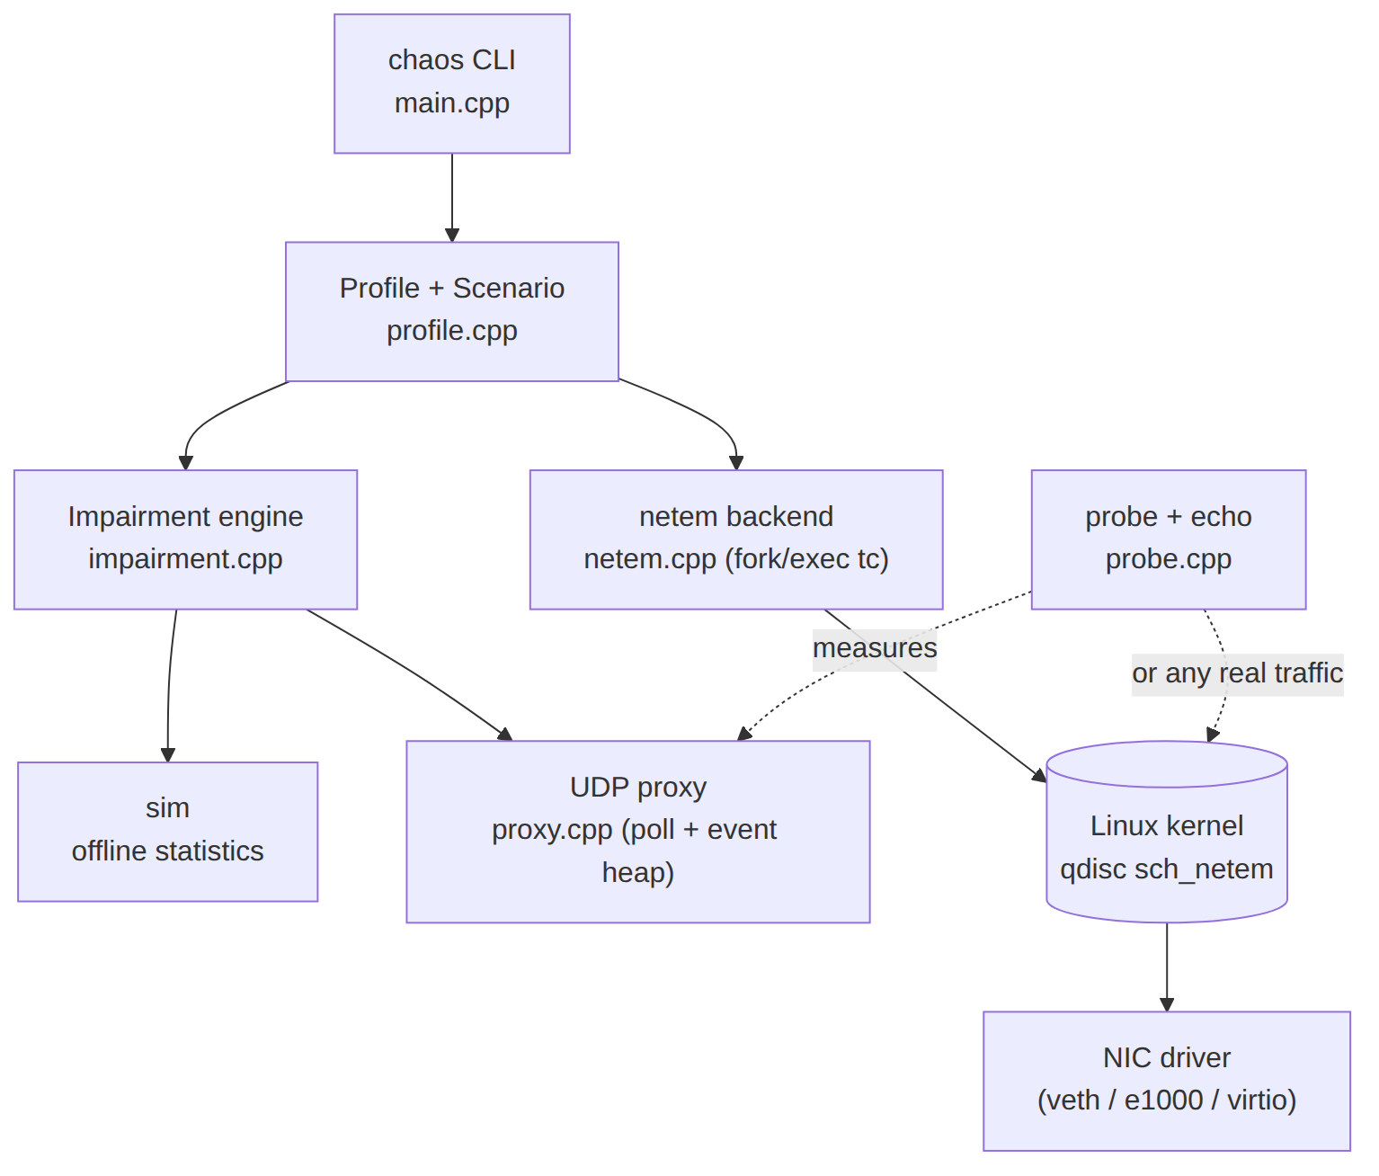
Figure 1: Components of chaos and the Linux kernel path (from the CLI down to the NIC driver).
The command-line front end parses and validates arguments, builds a Profile (or a Scenario, a list of timed profiles) and hands it to one of three consumers: the offline simulator, the userspace UDP proxy, or the kernel netem backend. The first two share the same impairment engine. The probe/echo pair measures any path, whether it is impaired by the proxy or by the kernel.

3. Module view
Module | Files (lines) | Responsibility | Depends on
CLI | main.cpp (254) | Argument parsing, strict validation, "did you mean", dispatch, exit codes | all modules
Profile | profile.h/.cpp (184) | Profile struct, presets, key=value parsing and ranges, validation, scenario parser, describe | -
Impairment engine | impairment.h/.cpp (115) | process(t, size): Gilbert-Elliott and Bernoulli loss, token-bucket shaper, delay/jitter, reorder, duplicate, corrupt, counters | Profile
Simulator | sim.h/.cpp (104) | Drives the engine with synthetic traffic; computes loss, bursts, delay percentiles, jitter, goodput | Engine, stats
UDP proxy | proxy.h/.cpp (253) | poll loop, event min-heap, per-client upstream sockets, idle expiry, LRU eviction, scenario timeline | Engine, Profile
Probe / echo | probe.h/.cpp (187) | Echo server; measuring client (RTT percentiles, RFC 3550 jitter, loss, dup, reorder, corruption, timeline) | stats
Netem backend | netem.h/.cpp (205) | Maps Profile to tc netem arguments; preflight safety; apply/hold/TTL; scenario runner; show/reset | Profile
Statistics | stats.h (32) | Percentile summary and monotonic clock helper | -

Total: 1334 lines in src/, plus 211 lines of tests. The dependency direction is strictly downward: Profile and stats depend on nothing, the engine depends only on Profile, and no module other than proxy, probe, and netem touches the operating system.

4. Key design decisions
# | Decision | Rationale | Alternative rejected
D1 | Engine is a pure function of (time, size) with a seeded RNG; no sockets, no clock | Unit-testable, reproducible, same code in simulator and proxy | Embedding random decisions in the socket loop
D2 | One Profile for all backends | Consistent behaviour; user learns one vocabulary | Separate config per backend
D3 | Single thread, poll() with timeout = earliest due event in a min-heap | Accurate release of delayed packets, no busy-wait, no thread per packet, bounded memory | Thread or sleep per packet
D4 | One connected upstream socket per client | Replies are attributed to the right client without parsing payloads | One shared upstream socket + NAT-style table
D5 | Idle expiry + LRU eviction on EMFILE | Proxy keeps serving new clients (defect found in review) | Never release sockets
D6 | fork + execvp with argv vector for tc | No shell, so eth0; rm -rf / cannot execute | system("tc ...")
D7 | TTL dead-man switch + signal handlers | Interface is restored even if the user forgets or the terminal closes | Leave impairment until manual reset
D8 | Own engine and kernel backend | Userspace: safe, deterministic, timeline. Kernel: any traffic at line rate | Wrapper around netem only

5. Runtime behaviour

5.1 Impairment pipeline
For every arriving packet the engine applies, in this order: (1) loss decision (Gilbert-Elliott state update and loss, then independent loss); (2) token-bucket shaper: tokens may go negative, the debt divided by the rate is the waiting time, and a packet whose wait exceeds queue_ms is tail-dropped; (3) reordering and delay: a fraction of packets skip the delay and so overtake delayed ones, the rest get delay plus uniform or normal jitter (never below zero); (4) duplication and corruption (one random bit flipped). The result is zero or more departure times.

5.2 Proxy data flow
A datagram arrives on the listening socket, a Client entry (with its own upstream socket) is found or created, and the engine decides its fate. Surviving packets are pushed on the event heap with their due time; the loop sleeps in poll() until the earliest event is due or a socket becomes readable, then sends everything due. Replies from the target are processed the same way with the downstream profile. See the sequence diagram "Proxy round trip" in the UML Diagrams document.

5.3 Concurrency, memory and failure handling
- One thread, no locks; signal handlers only set a sig_atomic_t flag.
- Event queue capped at 200 000; overflow is counted, not fatal. At most 64 datagrams drained per socket per wake-up so one flooding client cannot starve the others.
- Socket errors (for example ICMP port-unreachable when the target is down) are consumed and counted; without this poll() returned immediately forever (100% CPU), a defect fixed in review.
- Out of file descriptors: evict the least-recently-used client with nothing queued and retry.

6. Safety architecture
Layer | Mechanism | Protects against
Input | Strict argument parser, range-checked numbers, interface-name whitelist | Typos running with no impairment; injection; overflow
Preflight | Interface exists, root required, SSH guard (--force to override) | Impairing the link that carries your own session
Execution | fork/execvp, waitpid retry on EINTR, no shell | Command injection; abandoned tc on Ctrl+C
Time | TTL dead-man switch, wall-clock scenario timing | Forgotten impairment; timing drift
Signals | SIGINT/SIGTERM/SIGHUP remove the qdisc | Closed terminal leaving the NIC degraded
Environment | scripts/lab.sh network namespaces + veth; --dry-run | Any risk to the real network

7. Deployment views

7.1 Userspace mode (no root)
probe --> [chaos proxy :9001, profile] --> echo server :9000
(impairment in both directions, per-client sockets)

7.2 Kernel mode in the safe lab
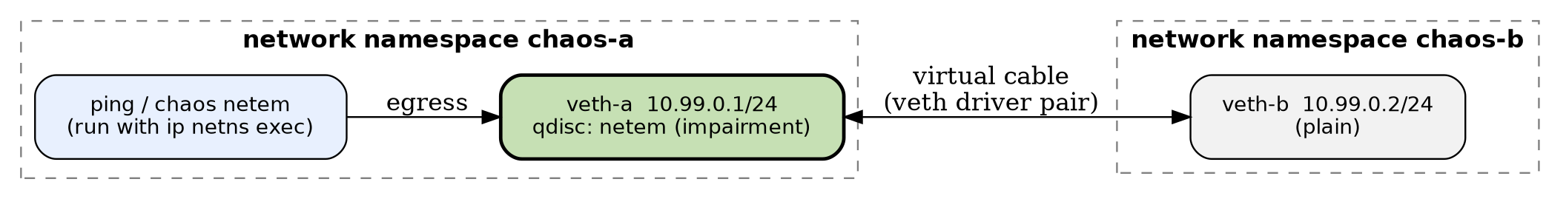
Figure 2: `scripts/lab.sh` topology. netem shapes egress of veth-a, so only a-to-b traffic is impaired.
For a real interface the same command is used with --dev eth0; the SSH guard prevents impairing the interface of the current SSH session.

8. Kernel integration and the device-driver layer
The course syllabus covers device drivers. The honest position is: chaos does not contain a device driver; it is a user-space program. It does, however, depend on and cooperate with kernel components that sit directly beside the driver, and this section explains that relationship so it can be assessed against the syllabus.

8.1 Where netem sits in the transmit path
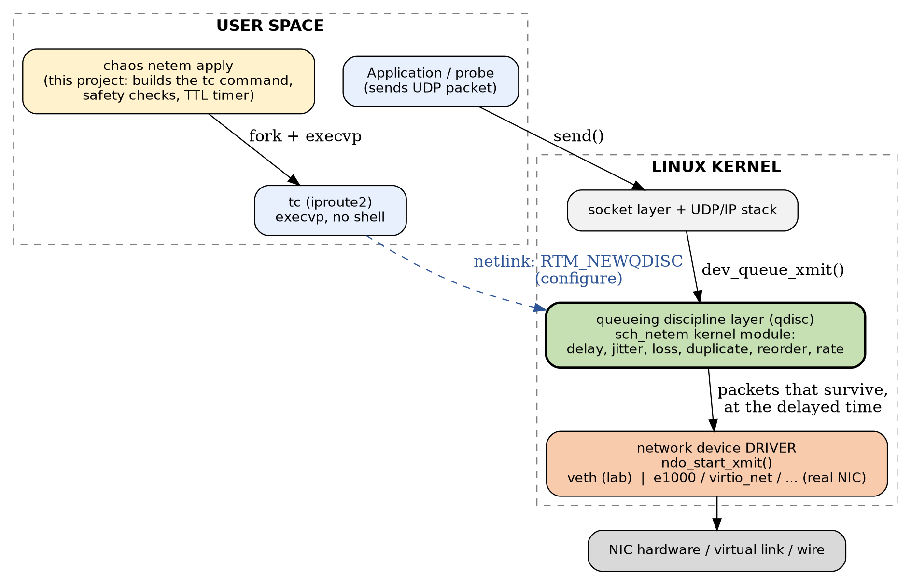
Figure 3: Transmit path in Linux. netem is a queueing discipline between the IP stack and the network device driver.
An outgoing packet travels application, socket layer, UDP/IP, qdisc layer, network device driver (ndo_start_xmit), hardware. tc qdisc replace dev IF root netem ... installs the sch_netem module as the root qdisc of the device. netem holds, drops, duplicates, reorders or delays the packet and only passes survivors to the driver at the scheduled time. The driver and NIC are unaware that the packets were manipulated: this is why netem can impair traffic of any application without changing it.

8.2 Mapping of driver-related concepts to this project
Driver / kernel concept | Where it appears in the project
Network device driver (struct net_device, ndo_start_xmit) | The lab uses the kernel veth driver (virtual Ethernet pair). On real hardware the NIC driver (e1000, virtio_net, ...) is the layer below netem. ethtool -i veth-a shows driver: veth (captured by collect_evidence.sh).
Loadable kernel module | sch_netem is a module: modprobe sch_netem, lsmod, modinfo sch_netem. lab.sh tells the user to run modprobe sch_netem if applying fails.
User-kernel interface | tc configures the qdisc over netlink (RTM_NEWQDISC, RTM_DELQDISC). Classic drivers use ioctl/character devices; chaos also reads /sys/class/net/<dev> to check that the device exists.
Privilege model | Changing a device's queueing discipline needs CAP_NET_ADMIN (root); hence the root check and the safe lab.
Device lifecycle | ip link add veth-a type veth peer name veth-b, move into namespaces, bring up/down in scripts/lab.sh.
Interrupts, DMA, ring buffers | Handled by the NIC driver below netem; not part of this project.

8.3 Conclusion and options
The kernel backend demonstrates how a user-space tool controls the network stack around a device driver (qdisc layer, virtual device driver, module loading, netlink). Writing a new driver is outside the scope of this project. Options, depending on the instructor's answer: (a) accept this mapping, supported by the captured ethtool -i, lsmod and modinfo output; (b) add a short study of the veth driver and the ndo_start_xmit path to the report; (c) as a future extension, write a minimal virtual network device module (see Roadmap, item RM-9).

9. Testing architecture
Level | What it checks | Command
Unit (69 checks) | Engine statistics vs theory, shaper behaviour, parsing, scenario parser, netem command strings, injection resistance | make test
End-to-end (6 assertions, 4 scenarios) | probe -> proxy -> echo over real sockets: latency, loss, duplication, timeline step | make e2e
CLI/robustness (25 checks) | Option and number validation; proxy with dead target; socket recycling and fd exhaustion | make cli
Sanitizers | AddressSanitizer + UndefinedBehaviorSanitizer on all of the above (CI matrix) | CI / make CXXFLAGS=...
Kernel lab | Real tc, qdisc, ping before/after, auto-revert | sudo scripts/collect_evidence.sh

10. Known limitations
- Userspace proxy: UDP and IPv4 only. Kernel backend: egress only; burst and queue are modelled by the userspace engine, while the kernel uses netem's own rate/limit.
- Proxy timing accuracy is bounded by poll() granularity (about 1 ms).
- Kernel commands are verified as strings, dry-run output and in the VM lab; they cannot run on kernels without netem.

